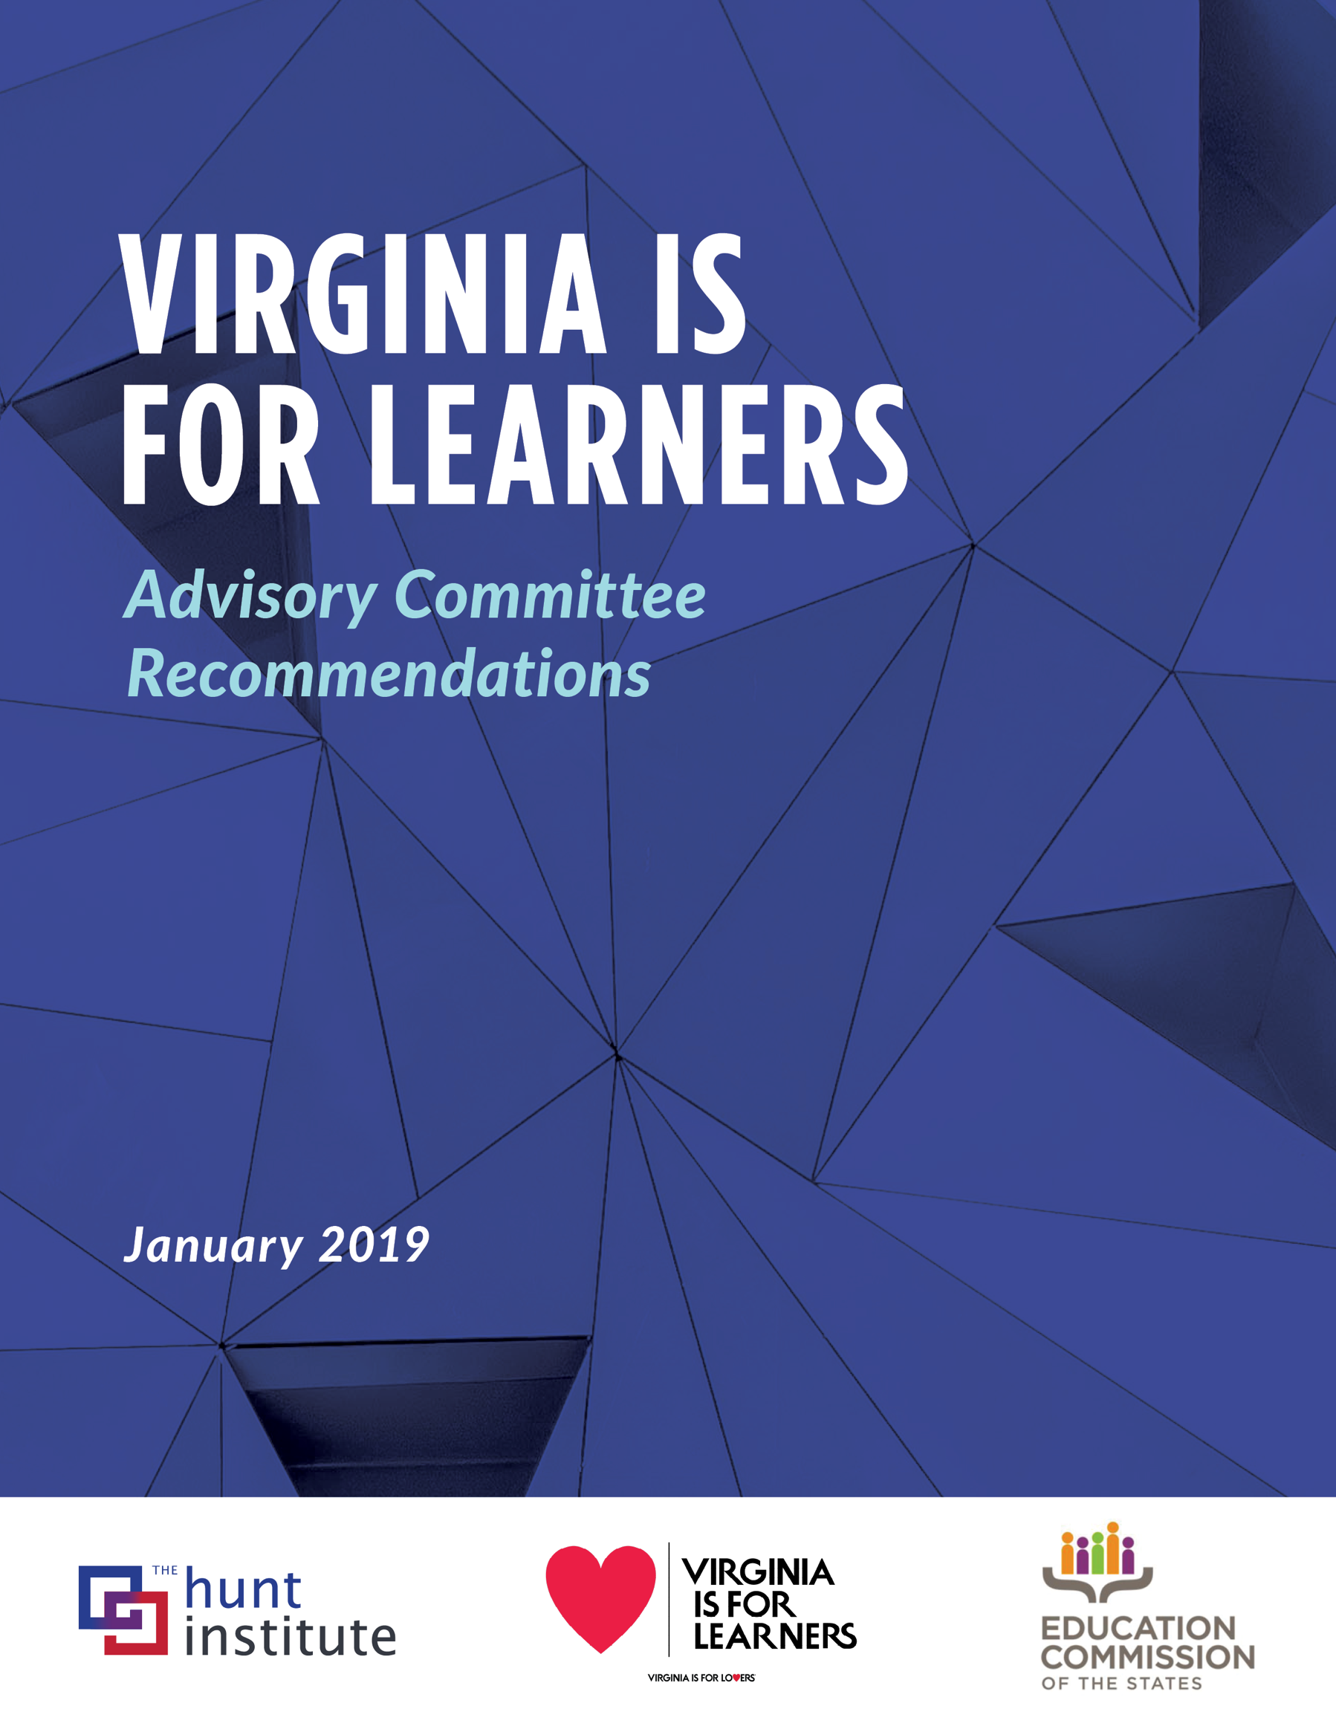
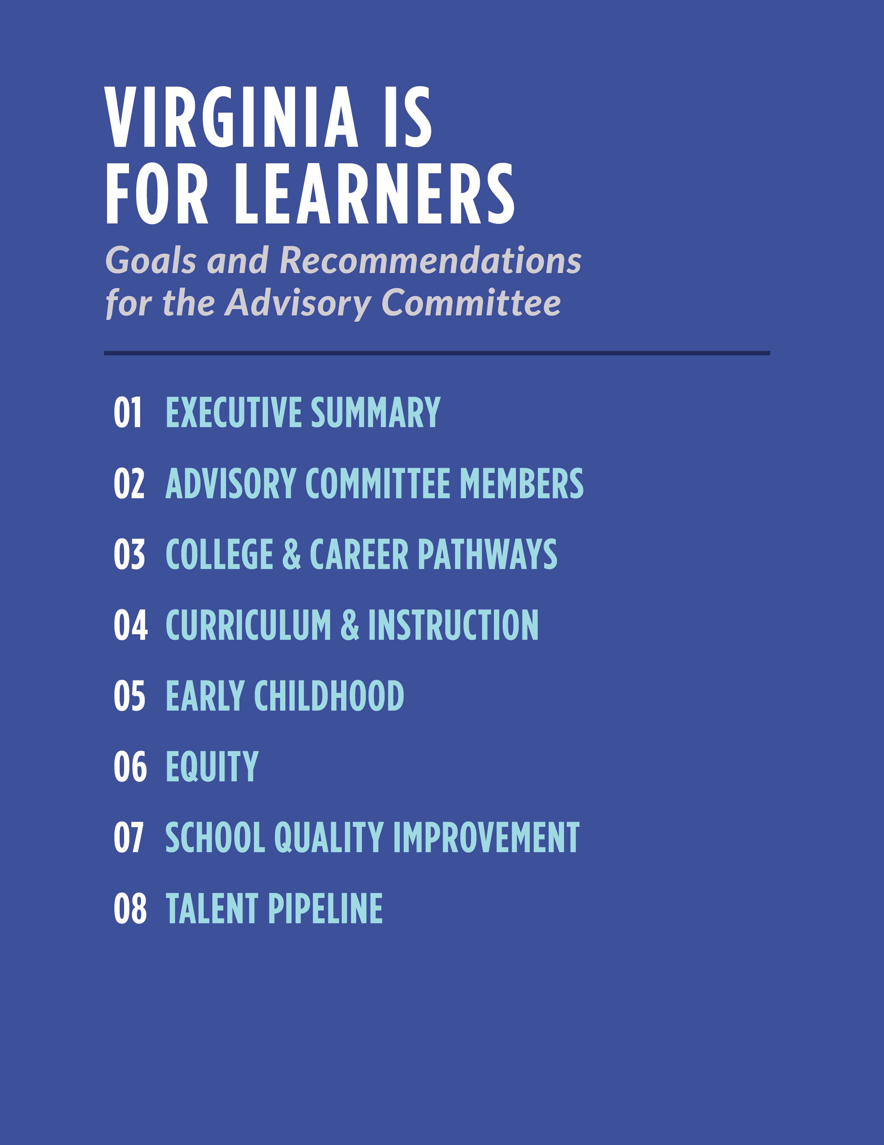
EXECUTIVE SUMMARY
Children and young people must be provided with challenging, supportive, and equitable learning opportunities in order to ensure that the Commonwealth of Virginia maintains an educated citizenry and a globally competitive workforce. In the spirit of continuous improvement, education leaders from across Virginia came together in the fall of 2018 to serve as members of the Virginia is
for Learners Advisory Committee (“Committee”).
The Committee was created to support Virginia Superintendent of Public Instruction Dr. James Lane as he works to ensure that all students have opportunities to maximize their potential. The
Committee evaluated the successes and challenges of the Commonwealth’s current education landscape and identified a number of areas for further growth.
In order to convene the Committee, the Virginia Department of Education, in partnership with the Hunt Institute and the Education Commission of the States (ECS), identified 28 bipartisan education leaders from across the Commonwealth who represented a diverse range of perspectives – including representatives from the governor’s office, the legislature, and the Virginia Board of Education as well as district superintendents, principals, teachers, and other constituencies (see next page for full list of Committee members).
Dr. Billy Cannaday, who brought a wealth of experience as a local and state leader in education, chaired the Committee by leading three meetings on a broad range of critical issues in education. The Committee identified recommendations for the Commonwealth across the following foundational topics:
- College & Career Pathways
- Curriculum & Instruction
- Early Childhood
- Equity
- School Quality Improvement
- Talent Pipeline
These recommendations are designed to support Superintendent Lane as he continues to refine the Department of Education’s priorities. Each recommendation reflects the conversations that occurred at the three meetings; there was consensus on the importance of each topic. All Committee members had the opportunity to provide feedback.
This Committee is a continuation of the many important conversations that are regularly occurring across the Commonwealth, and this report is meant to spur further meaningful dialogue and help move education forward in Virginia.
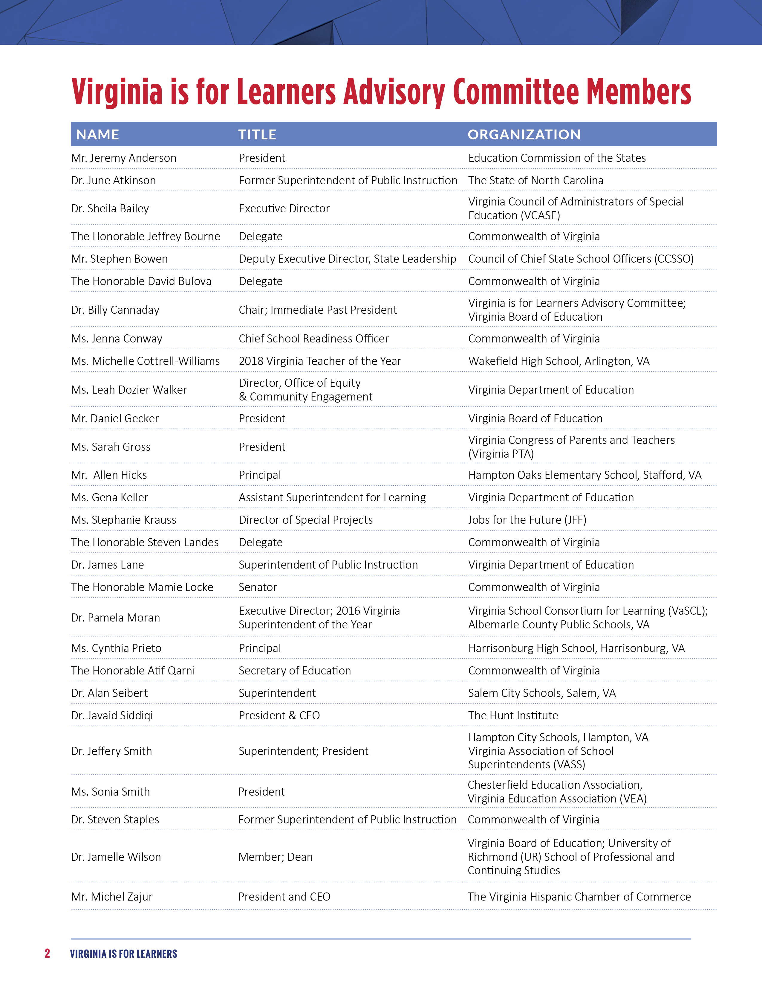

College & Career Pathways

Committee Recommendations
❶ Create a statewide education-business advisory council on public education: Education leaders need input from business leaders in order to ensure that education programs are continuing to meet shifting workforce demands.
  - The advisory council will consist of workforce partners, leaders from Virginia’s universities and community colleges, as well as K-12 leaders.
  - The advisory council will foster communication and build relationships among education leaders, businesses, and communities.
  - The council will serve a variety of purposes, including advising educators on what new skills are needed in the workforce, advocating for aligned curricula and learning opportunities, and supporting the implementation of programs, including work-based learning.

❷ Develop a statewide framework on work-based learning:
As work-based learning opportunities proliferate, it is imperative that clear and consistent guidelines and best practices are provided to local school divisions to ensure that all students are being equitably served.
  - The Virginia Department of Education (VDOE) needs to develop a framework that provides guidance
to local programs to ensure consistent implementation and quality.
  - This framework should be created with input from workforce leaders, leveraging the proposed education-business advisory council.
  - This framework should also offer best practices for local school divisions to engage with students, parents, and the community to build support and participation.
  - This framework should align with and support the VDOE’s High School Innovation Grants, emphasizing personalized learning and the use of performance assessments to measure student achievement.
  - Guidance for counselors should be embedded in this framework to ensure that meaningful support is being provided to all students as they identify appropriate coursework while
in high school and how it will prepare them for the next step.

Curriculum & Instruction

Committee Recommendations

❶ Innovate in Instruction:
In order to innovate and prepare students for the skills they will need in the future, teachers will need support to make the requisite instructional shifts. Personalized learning and competency-based instruction offer opportunities for growth but will also require careful planning and professional development.
  - Innovations in curriculum need to be aligned to standards and assessments, which will dictate actual classroom instruction.
  - Updates in instruction must maintain a focus on rigor, ensuring that all students have access to challenging curricula and instruction.

❷ Equip Teachers:
The state should play a role in creating instructional content for teachers to utilize for their lesson plan development and provide the resources necessary for teachers to succeed in delivering their lesson plans.
  - The VDOE should offer an online platform for high-quality open educational resources that teachers can use/draw from when designing lessons.
  - Professional development needs to have more coherence, with sessions building on one another and an emphasis on building the cultural competencies of teachers.
  - Teacher preparation needs to align to updates in curriculum and instruction to ensure
that new teachers are prepared to implement these new practices.

❸ Increase Access to Innovative Options:
The VDOE can play a role in building the capacity of all districts to innovate and offer diverse curriculum and instruction options to students by offering innovative and expanded options to all students, including those in under-resourced districts.
  - The VDOE needs to invest in content for Virtual Virginia to ensure that is getting the outcomes that it desires.
  - Virtual programs should be used to provide access to course offerings that many students otherwise would lack, especially those in high-need districts.
  - The VDOE need to provide resources in a transferable format so that they can be
imported into any platform/Learning Management System.

Early Childhood

Committee Recommendations

❶ Increase Access:
Many of Virginia’s youngest children lack access to an affordable early childhood care and education option, including 70 percent of disadvantaged children from birth to five.
  - The Commonwealth needs to identify gaps in access to high-quality early learning settings, based on geography and economic need, across Virginia.
  - High-quality child care needs to become more affordable for low-income families, and the Commonwealth needs to increase the number of seats for children from birth to age five.

❷ Improve Quality:
Only 60 percent of Virginia’s children enter Kindergarten ready to learn, but offering children access to early learning opportunities will only help if the programs are high quality. Clear and uniform standards for early learning programs will be important.
  - The Commonwealth needs to develop a shared definition of Kindergarten readiness.
  - The Commonwealth needs to define what makes a high-quality curriculum quality and have a universal list of quality early learning curricula from which programs can choose.
  - The Commonwealth also needs to define what a quality early learning classroom experience looks like and to have a system to identify low-quality programs.
  - Quality rating and improvement systems need to be more unified and should focus on health, safety, and, most importantly, age-appropriate instruction, including cognitive, social, and emotional learning.

❸ Strengthen the Teacher Workforce:
Virginia needs to think critically about how to prepare, certify, and support its early childhood workforce.
  - The Commonwealth needs to identify ways to pay early learning teachers competitively and to reward quality teaching.
  - The system needs to be aligned to focus less on professional development and degrees and more on instructional effectiveness, with micro-credentials offering an opportunity to continually recognize teachers based on competencies gained.

❹ Think Holistically & Increase Coordination:
The achievement gap starts before the first day of school and a holistic approach from birth will be required to eliminate gaps.
  - Improved access to quality early learning opportunities will ensure more equitable learning outcomes as more students are prepared when entering the K-12 system.
  - The Commonwealth needs to be positioned to support a portfolio of operators, including local early childhood providers.
  - The Commonwealth should unify efforts and use data to measure quality, set standards, and support improvement among early learning programs.
  - Local school divisions should be equipped and resourced to lead at the local level.

Equity

Committee Recommendations

❶ Develop a vision of equity:
The VDOE should articulate a clear definition and vision of equity that can serve as guidance to districts.
  - This vision should provide school and district leaders with clarity on how to lead with equity and rigor for all students.
  - This vision should also outline measurable, clearly-defined metrics that can be used to track progress.

❷ Focus on teaching and leading:
Virginia should focus on developing the cultural competencies of its existing teachers and leaders, retaining its best teachers, and increasing the diversity of its educator workforce.
  - The VDOE should focus on developing a pipeline of diverse educators.
  - The current teacher and leader workforce should further develop their capacity to create culturally responsive learning environments.
  - The VDOE needs to ensure that there is an equitable distribution of quality teachers and leaders across Virginia and among schools serving diverse populations.

❸ Use an equity lens on school funding:
Virginia should consider how the school funding formula can be used to address students at risk of not achieving at the same level as other students.
  - The VDOE needs to consider the data available on per-pupil expenditures, especially as it relates to new requirements under the Every Student Succeeds Act (ESSA).
  - Policymakers need access to the data, to prioritize the analysis of the data, and to craft responsive policies.

❹ Ensure that all students have access to high-quality curricula and programs, including gifted programs:
Virginia needs to ensure that resources are equitably accessible to all teachers, providing every student with a rigorous curriculum that prepares them for the future.
  - The VDOE needs to continue to grow its ranks of qualified specialized instructional support personnel, such as counselors, nurses, psychologists, etc., in order to provide all students with the supports and resources they need to access high-quality curricula and programs.
  - The VDOE needs to place a focus on its shifting demographics, recognizing the significant achievement gaps that currently exist, in order to ensure that its reforms are aligned with achieving equitable academic outcomes.

School Quality Improvement

Committee Recommendations
❶ Establish a commission to identify model approaches to school improvement: ESSA has given power to states to identify how to address school improvement. It is important that the Commonwealth focuses intently on what best practices can help schools improve, tailored to the unique needs of schools, districts, and students.
  - The commission will provide guidance on best practices in school improvement, drawing on lessons from Virginia and other states.
  - The commission will offer specific guidance on what type of support is most effective, including what level of stakeholder to engage for support (district, school, etc.).
  - The commission should seek input from practitioners across the Commonwealth and nation as well as community stakeholders.

❷ Focus on teachers, principals, and district leadership:
Many districts struggle to recruit and retain quality teachers, school leaders, and superintendents. Strong leadership is necessary for strengthening schools, achieving student success, and coordinating among stakeholders.
  - The VDOE needs to focus on improving the pipeline of superintendents and supporting them in their work in order to increase retention. The VDOE also needs to develop systems within districts that will be able to continue beyond any single superintendent.
  - Building administrative capacity across districts needs to be a priority, ensuring that all districts have the requisite capacity.
  - Recruiting and retaining high-quality teachers and leaders is especially challenging for low-achieving and low-resourced schools and districts. The Commonwealth needs to identify ways that it can support districts facing especially great challenges at developing and retaining its educators.

Talent Pipeline

Committee Recommendations

❶ Accelerate improvement in teacher recruitment and retention:
Teachers are the most impactful school-based factor driving student achievement. Some districts in Virginia have suffered from persistent teacher shortages, and teacher turnover remains a challenge.
  - In order to stem the loss of quality teachers and to attract the best talent, the Commonwealth needs to explore ways to address the following:
    - Competitive compensation
    - Effective training and participation
    - Support for new teachers
    - Teacher conditions, including supportive leadership
    - Ways to attract a diverse workforce
    - Opportunities for growth and development
  - School leaders need to be prepared to develop a school culture that fosters academic success and attract and retain high-quality teachers.
  - The VDOE needs to further collaborate with universities to develop and offer robust and systematic pathways into the teaching profession, including teacher residency models.
  - The VDOE should explore the expanded use of “Grow Your Own” programs to develop pathways for local community members to enter the teaching profession.

❷ Build teacher expertise:
Teachers who are not well-prepared for the challenges of the classroom are less likely to remain in the classroom. Teacher preparation programs should ensure that teachers are experts in their subjects and how to work with all students, both as it relates to conveying content and
to student-teacher interactions.
  - Teachers need to be experts in effective instructional methods and have opportunities to continue to refine their skills.
  - In order to effectively instruct students, teachers need to excel in what are traditionally referred to as “soft skills” but that are critical skills to developing the necessary relationships and trust with students. The VDOE should equip teachers with specific training to work with students, including in positive behavior interventions and supports and trauma-informed strategies.

❸ Increase teacher leadership roles without requiring that they leave the classroom: Many teachers who take on leadership roles move into administrative positions, meaning they must leave the classroom in order to advance in their career.
  - The VDOE should explore advanced teaching roles that offer highly-effective teachers an opportunity to become instructional leaders and grow in their profession while remaining directly connected to students.

