Virginia Department of Education

Submitted to the Governor, the Chairmen of the House Committee on Education, and the Senate Committee on Education and Health

January 24, 2019

DRAFT
REPORT
Virginia Department of Education

House Bill 1530
High School Diploma Options and
Stigma in Career and Technical Education

Contents
Executive Summary 3
Background 4
Part 1 – CTE Stigma 4
Research, Perceptions, and Challenges 4
Strategy for Consideration 5
Part 2 – One Diploma 6
Current Diploma Options 6
Past Diploma Proposals for One Diploma 8
Recommendations 10
Appendices 12
Appendix I: HB1530 Full Text 12
Appendix II: Relevant Sections of the Regulations Establishing Standards for Accrediting Public Schools in Virginia 17
Appendix III: 12.12.18 Workgroup Meeting Participants 37
Appendix IV: 12.12.18 Workgroup Meeting PowerPoint 39
Appendix V: 12.12.18 Workgroup Meeting Handout - Strawman Proposal 51
Appendix VI: 12.12.18 Workgroup Meeting Handout - One Diploma vs. Two Diplomas 57
Appendix VII: Resources for Strategic Marketing Plan 60
Endnotes 63

Executive Summary
House Bill 1530 was enacted by the General Assembly of Virginia on March 29, 2018. This bill requires the Virginia Department of Education to make recommendations relating to (i) strategies for eliminating any stigma associated with high school career and technical education, and (ii) the consolidation of the standard and advanced studies diplomas into a single diploma. The Virginia Department of Education conducted an analysis of historical data and research, and convened a workgroup of stakeholders to discuss the bill.
Career and Technical Education (CTE) programs have encountered a stigma which dates back decades to a time when CTE was known as “vocational education” and was languished as a “track” for students who underperform academically. Although education policy has changed, the stigma remains. Recent national studies suggest that CTE programs face two challenges: outdated perceptions and low levels of awareness.
It is unclear as to whether moving from Virginia’s two diplomas to a single Virginia Diploma would eliminate the perception of stigma associated with career and technical education. In 2016, the Virginia Board of Education evaluated proposals for moving to one diploma, the Virginia Diploma, or maintaining the Standard and Advanced Studies Diplomas. In the February 24, 2016 Committee on School and Division Accountability meeting, it was reported that 43 states have one diploma, 7 states have two diplomas, and 1 state has three diplomas. The Board further discussed the issue during the May 25, 2016 Retreat Meeting (Decision Brief 2) and concluded that the proposal would need further development, consideration, and feedback; and, more efficacy data was requested.

Currently Virginia provides students with two diploma options, the Advanced Studies Diploma and the Standard Diploma. In 2018, Virginia revised the Standards of Accreditation and established the Profile of a Virginia Graduate, effective with 2018-2019 first time ninth graders, which focuses on providing multiple paths toward college, career, and citizenship readiness for students. Since 2013-2014, on average, 48 percent of Virginia CTE completers have graduated with an Advanced Studies Diploma.

On December 12, 2018, the Virginia Department of Education (VDOE) convened a workgroup meeting to discuss HB1530. Participants included Delegate Davis; representatives from the Virginia Manufacturing Association, Virginia Chamber of Commerce, Virginia Career and Technical Association, State Council of Higher Education in Virginia, Virginia Association of School Superintendents, Virginia School Board Association, Virginia Community College System, school division Superintendent, Assistant Superintendent of Instruction, Career and Technical Education Administrator, school counselor, teachers, and student. During the meeting, Delegate Davis expressed his desire to see this bill implemented and for Virginia to go to a single diploma option. Although there was much discussion regarding the single diploma option, no consensus was reached, recognizing the complexity of consolidating Virginia’s two diploma options into one Virginia diploma. Several strategies were discussed that could impact the public perceptions regarding career and technical education.

The workgroup recommended that the Commonwealth develop and execute a highly visible, statewide, promotional campaign to change public perceptions and raise awareness; create opportunities for K-12 education and business and industry partnerships to offer rich work-based learning experiences; provide competitive 21st Century skills innovation Career and Technical Education grants to inspire innovation; and, provide incentives for comprehensive high schools to offer innovative in-demand Career and Technical Education programs that align with regional sector pathways to meet local, state, and global workforce needs.

Background

Part 1 – CTE Stigma

Research, Perceptions, and Challenges
For decades, going back to a time when CTE was known as “vocational education,” CTE has languished as a “track” for students who underperform academically. Over the years, vocational education has served to differentiate educational success along racial, ethnic, and socioeconomic lines, with affluent students taking an academic path to postsecondary education and those with lower socioeconomic status or perceived to be lower-performing students pushed through vocational education courses.
Throughout the 1970s and 1980s, education policy changed, but the perception of vocational education as a viable path to the workforce for the student with poorer academic skills, lower socioeconomic status, or challenging behaviors remained. That stigma still exists with respect to views on CTE programs. In a 2010 report on public perceptions of CTE in Nebraska, 47 percent of respondents in a study agreed that “CTE tends to focus on students who probably won’t go to college.” The same study also found that nearly 70 percent agreed that CTE courses emphasize academic achievement as much as competency in the skills learned, and more than 90 percent agreed that CTE is just as important as academic subjects.
While the term “Career and Technical Education” has been in use for almost two decades, recognition for the term is only 47% compared to 68% for the outdated term “vocational education.” Although nationwide enrollment in CTE remains stagnant despite robust CTE programs and demand for skilled workers, demand for Virginia CTE has continued to grow. However, students and their parents may not be fully aware of what CTE courses can offer and how the programs complement the traditional high school experience; instead, their perception perpetuates the stigma that it’s an inferior “track” leading to low-wage, low-skill jobs with no hope for postsecondary education.
“In 2017, Advance CTE, with support from the Siemens Foundation, commissioned focus groups and a national survey to explore the attitudes of parents and students currently involved in CTE, as well as prospective CTE parents and students, to better understand the promise and opportunity of CTE.” As result of this 2017 study, Advance CTE concluded that CTE programs face two challenges: outdated perceptions and low levels of awareness.

Strategy for Consideration
To change perceptions about CTE, raise awareness of CTE, and highlight 21st Century and emerging career options, a strategy for consideration is to develop a highly visible marketing campaign that reinforces core CTE messages and is integrated into the larger VDOE marketing effort, Virginia is for Learners. (Resources to support the development of a detailed strategic marketing plan can be found in Appendix VI.) Key components of the campaign include the following:
- Develop effective messaging targeted to external audiences (parents, community members, business and industry, and post-secondary education) and internal audiences (administrators, counselors, teachers, and students). As a result of the 2017 study, the following marketing messages were found to be effective: CTE delivers real options for students for college and rewarding careers, CTE delivers real-world skills for students, and CTE delivers a real high school experience with more value for students.
- Create and fund a statewide promotional campaign which reaches Virginia’s citizens by featuring Virginia leaders endorsing CTE programs and highlighting students, business partners, and higher education partners. Media options include television commercials, billboards, digital media platforms, and print media in Virginia-centered publications.
- Include the CTE message in state leaders’ scheduled speeches and events.
- “Tell the CTE Story”: Increase visibility of CTE by highlighting CTE success stories of students; high-skill, high wage, in-demand course offerings such as cybersecurity, computer science, and robotics; Governor’s STEM Academies and Governor’s Health Sciences Academies; CTE dual enrollment, advanced placement, and international baccalaureate courses; industry credentials; business and industry partnerships; work-based learning (WBL) opportunities; and, secondary to post-secondary transition opportunities that lead to stackable credentials.
- Strengthen and expand partnerships with business and industry.
- Create and promote additional high profile recognition opportunities for CTE student success, outstanding CTE programs, and strong business partnerships to include awards, scholarships, and grants.
- Continue to partner with state CTE association to ensure consistent marketing efforts such as elevating and promoting Career and Technical Education Month® to market the core CTE message in schools and communities. (Career and Technical Education Month®, or CTE Month®, is a public awareness campaign that takes place each February to celebrate the value of CTE and the achievements and accomplishments of CTE programs across the country.)
- Strengthen statewide and local professional development opportunities with counselors, administrators, and teachers; and, leverage student experiences in Career and Technical Student Organizations (CTSOs) to communicate the core message. Advance CTE survey results found that parents and students trust and want to hear from those closest to CTE programs – counselors, educators, and CTE students.
- Enrich career exposure, exploration, and planning in all grades: (elementary grades) development of an Academic and Career Plan Portfolio; (middle grades) course information and planning for education/training after high school, Career Investigation Course or equivalent for students to aid academic and career planning and creation of an Academic and Career Plan completed by 8th grade; (high school) emphasis on workplace skills for ALL students, opportunities for internships and WBL learning, and service learning.
- Continue to actively participate in State committees: Virginia Career Works and the Virginia Board of Workforce Development.

Part 2 – One Diploma

Current Diploma Options
Virginia provides secondary students with two diploma options, the Standard Diploma and the Advanced Studies Diploma. In 2018, Virginia revised the Standards of Accreditation and established the Profile of a Virginia Graduate. The revised graduation requirements (8VAC20-131-51), effective with 2018-2019 first time ninth graders, “shall provide multiple paths toward college, career, and citizenship readiness for students to follow in the later years of high school. Each such pathway shall provide meaningful and rigorous opportunities tied to instruction to achieve workplace and citizenship skills through experiences such as internships, externships, credentialing, and blended learning, which may be offered for credit toward high school graduation.” For the Standard Diploma option, students must earn a total of 22 standard and 5 verified credits. For the Advanced Studies Diploma option, students must earn a total of 26 standard and 5 verified credits. The Profile of a Virginia Graduate describes the knowledge, skills, experiences, and attributes that students must attain to be successful in college and/or the work force and to be “life ready.” In developing the profile, the Board of Education determined that a life-ready Virginia graduate must:
- Achieve and apply appropriate academic and technical knowledge (content knowledge)
- Demonstrate productive workplace skills, qualities, and behaviors (workplace skills)
- Build connections and value interactions with others as a responsible and responsive citizen (community engagement and civic responsibility)
- Align knowledge, skills, and personal interests with career opportunities (career exploration)
Since 2013-2014, more Virginia CTE completers graduated with an Advanced Studies Diploma than with a Standard Diploma.

Virginia CTE Completers by Diploma Type
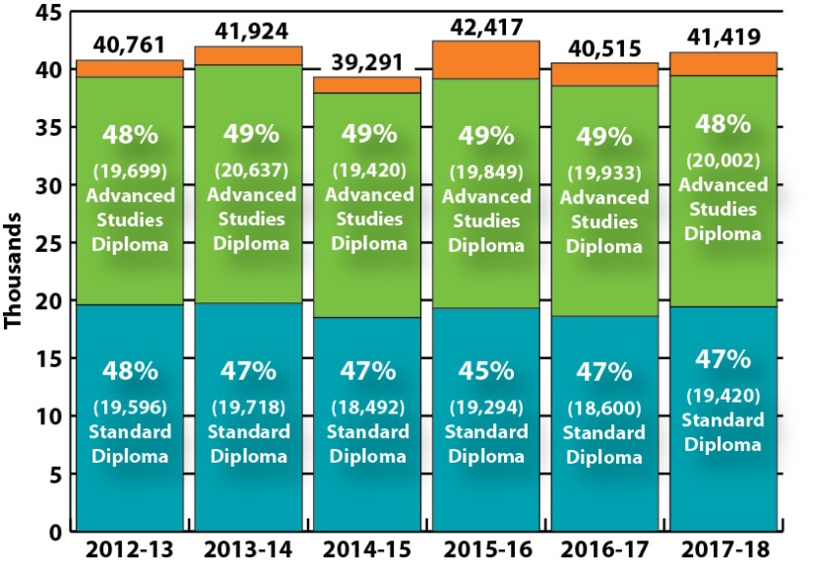

Past Diploma Proposals for One Diploma
In 2016, the Virginia Board of Education evaluated proposals for moving to one diploma, the Virginia Diploma, or maintaining the Standard and Advanced Studies Diplomas. In the February 24, 2016 Committee on School and Division Accountability meeting, it was reported that 43 states have one diploma, 7 states have two diplomas, and 1 state has three diplomas. Regulations establishing the Standards for Accreditation Public Schools in Virginia were also discussed, and it was noted that of the 47 states with high school graduation requirements, 18 states have complete or partial alignment between those requirements and statewide higher education minimum admission requirements. A summary of the presented Rapid Data Review is as follows:
- Nearly 70 percent of students graduating from a Virginia high school in 2008 with an Advanced Studies Diploma enrolled in a four-year institution of higher education (IHE).
- After four years, 64.4 percent were still enrolled.
- Among Virginia students earning a Standard Diploma in 2008, 17.5 percent enrolled in a four-year IHE. Four years later, 12.8 percent were still enrolled.
- Standard Diploma-earners are more likely to enroll in a two-year IHE than their Advanced Studies Diploma-earning peers (32.2 percent to 18.9 percent, respectively). However, persistence among both groups is poor. After four years, only one third of Standard Diploma-earners and half of Advanced Studies Diploma-earners remained enrolled or earned a college credential.
- More than one-third (37.9 percent) of Advanced Studies Diploma-earners also earned a bachelor’s degree within four years of entering an IHE compared to only 3.2 percent of their Standard Diploma-earning peers.
- More Advanced Studies Diploma recipients also earned their associate’s degree (8.3 percent) than their Standard Diploma-earning peers (4.4 percent).

During the meeting, it was shared that any changes to graduation requirements would have significant implications, impacting how schools operate and are organized. It was also shared that the Standard Diploma would need more significant review and redesign than the Advanced Studies Diploma, and that many Standard Diploma graduates do not take mathematics courses after their sophomore year, and then struggle on college placement exams.

The Board further discussed the issue during the May 25, 2016 Retreat Meeting (Decision Brief 2) and concluded that the proposal would need further development, consideration, and feedback; and, more efficacy data was requested. Data as well as comments and concerns that were shared regarding a one diploma model included the following:

Advanced Studies Diploma Data
      - 70% enroll in a four-year institution immediately after high school but only 37.9% have completed a bachelor’s degree in four years.
      - Almost one in five (18%) of graduates are enrolled in a developmental English course.

Standard Diploma Data
- Most complete mathematics requirements by the end of Grade 10 and take no additional math courses during high school.
- Most complete their science requirements by completing year-long courses in Earth Science and Biology. Few enroll in any Chemistry, Physics, or Computer Science courses.
- 65% are enrolled in a developmental mathematics class.
- 60% are enrolled in a developmental English class overall.
- In 2014-2015, 55% of students earned an Advanced Studies Diploma (47,956 out of 86,722 graduates).
- In that same year, 39% earned a Standard Diploma (33,918 graduates).
- The remaining students earned a Modified or Special Diploma, a GED, or a Certificate.

Comments and Concerns
- Moving to one diploma is beneficial for many students, and the importance is in the transcript, not the name of the diploma.
- Concerns with what will be in the one diploma and the impact on high school innovation grantees, English Language Learners (ELL), and special education students.
- Concerns with the impact on staffing needs, and how to ensure that students are not locked into pathways.
- Moving to one diploma will create more options, especially for those students who struggle.
- Some educators see no reason to change what is working. Noted that going to one diploma does not provide more flexibility, and students who graduate with an Advanced Studies Diploma have a better transcript.
- Institutions of higher education look at the courses students complete, not what the diploma is called.
- One diploma would rely on appropriate counseling to ensure students on Advanced Studies Diploma track still take the courses they need for prestigious colleges. Current counseling capacity may not be sufficient if these changes are advanced.
The Education Commission of the States (ECS), who collaborated with the National Center for Higher Education Management Systems (NCHEMS), provided additional data on postsecondary outcomes. Research results were presented at the June 22, 2016 Accountability Meeting. Key points that were made during the presentation are as follows:
- Credit requirements, and the ways in which students earn credits, vary across different states.
- When making changes to graduation requirements, states most commonly have amended the credits required within a subject area, rather than changing diploma options. However, some states have changed diploma options—in those instances, most have moved from multiple diplomas to a single diploma. Research data from the states that have changed diplomas is not available yet, as the changes are too recent.
- There is no correlation between state-set high school graduation requirements and completion rates at postsecondary institutions.

Metrics and Diploma Options for Ten States with Successful Postsecondary Outcomes

States with the  Highest % of HS Grads Attending Postsecondary Institutions | Percent of High School Graduates Attending an In-State Postsecondary Institution | Overall Graduation Rates of Postsecondary Institutions | Number of Diploma Options
California | 87.40% | 50.30% | 2
Florida | 86.70% | 51.10% | 1
Massachusetts | 82.10% | 52.40% | 1
Virginia | 81.40% | 57.80% | 2
Minnesota | 81.00% | 52.10% | 1
Pennsylvania | 75.40% | 56.20% | 1
Rhode Island | 74.90% | 51.40% | 1
South Dakota | 68.80% | 51.10% | 1
Washington | 66.30% | 59.30% | 1
Wisconsin | 62.20% | 59.20% | 2

Recommendations
The workgroup did not reach a consensus on consolidating Virginia’s two diplomas into one diploma. However, realizing the significant advances in the rigor and quality of career and technical education programs, the workgroup recommends the following:
- Change Perceptions and Raise Awareness: Develop and execute a highly visible, statewide, promotional campaign that uses effective messaging to change perceptions and raise awareness of Career and Technical Education. Promotional strategies should be tailored to external (parents, community members, business and industry, and postsecondary education) and internal stakeholders (administrators, counselors, teachers, and students). This effort should be a sustained awareness campaign that cultivate relationships with statewide and regional media outlets, and leverages promotional opportunities with business and industry.

- Work-based Learning: Create opportunities for K-12 education and business and industry partnerships to offer relevant work-based learning experiences that expose students to 21st Century work environments and provide students with sustained interaction with industry or community professionals.

- Inspire Innovation: Provide competitive innovation career and technical education grants for the re-design and delivery of instructional and professional development for teachers that focuses on 21st Century Skills.

- Provide Incentives for Comprehensive High School CTE Programs: Provide flexibility for comprehensive high schools to offer innovative in-demand Career and Technical Education programs that align with regional sector pathways to meet local, state, and global workforce needs.

Appendices

Appendix I: HB1530 Full Text

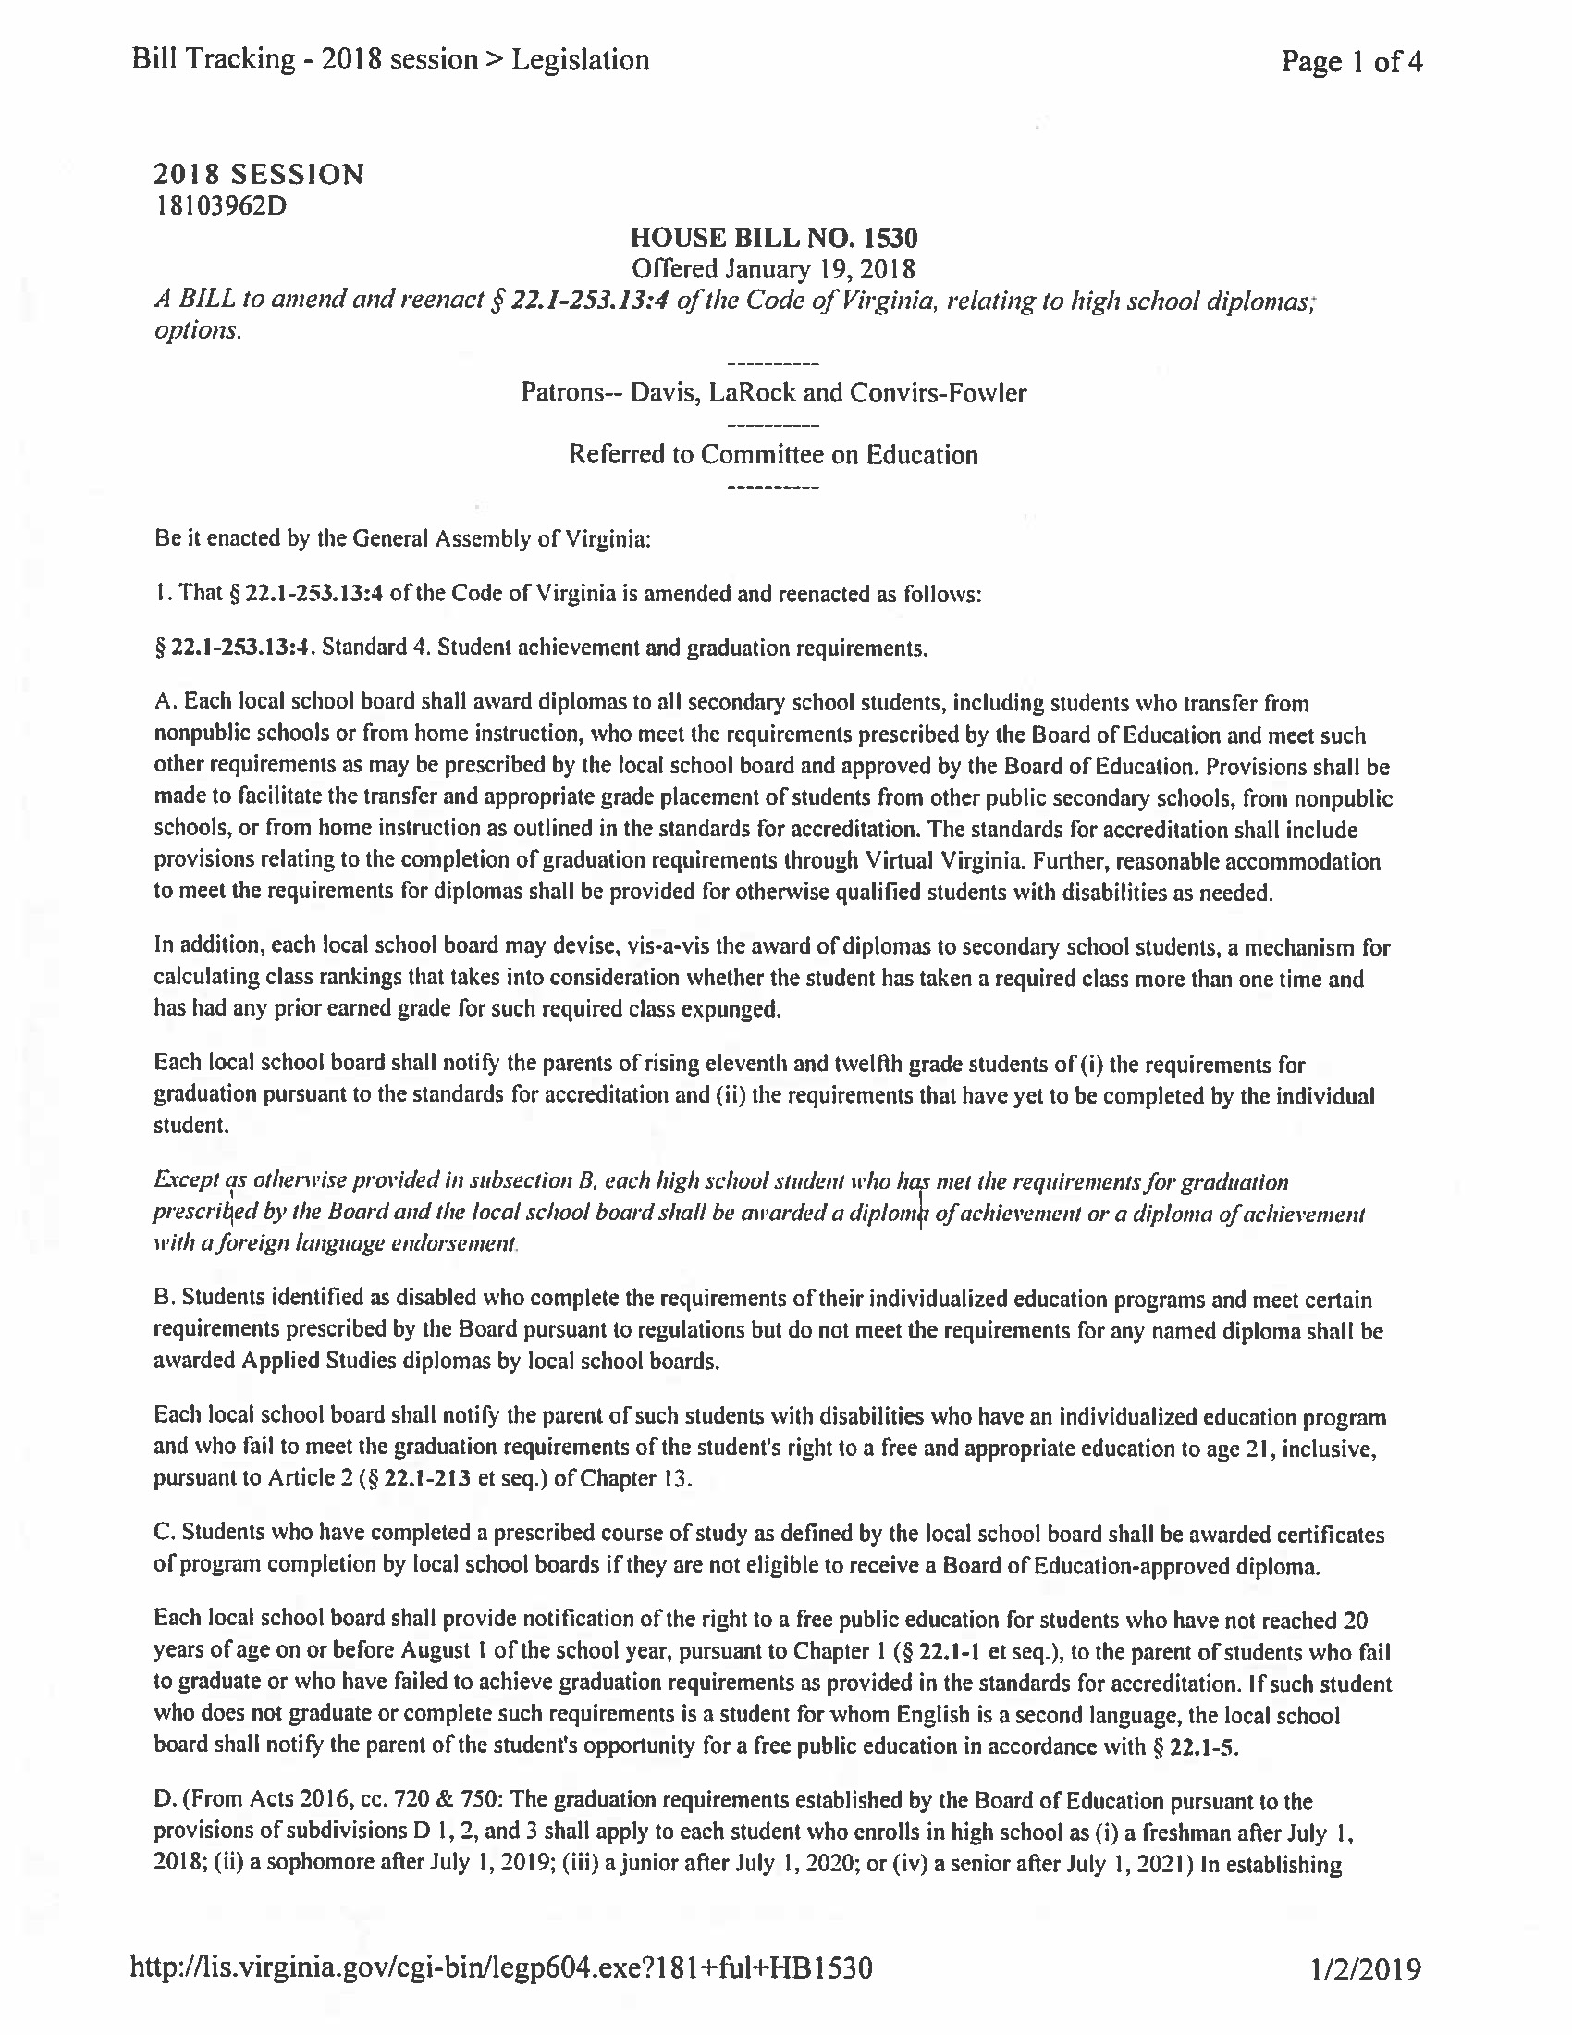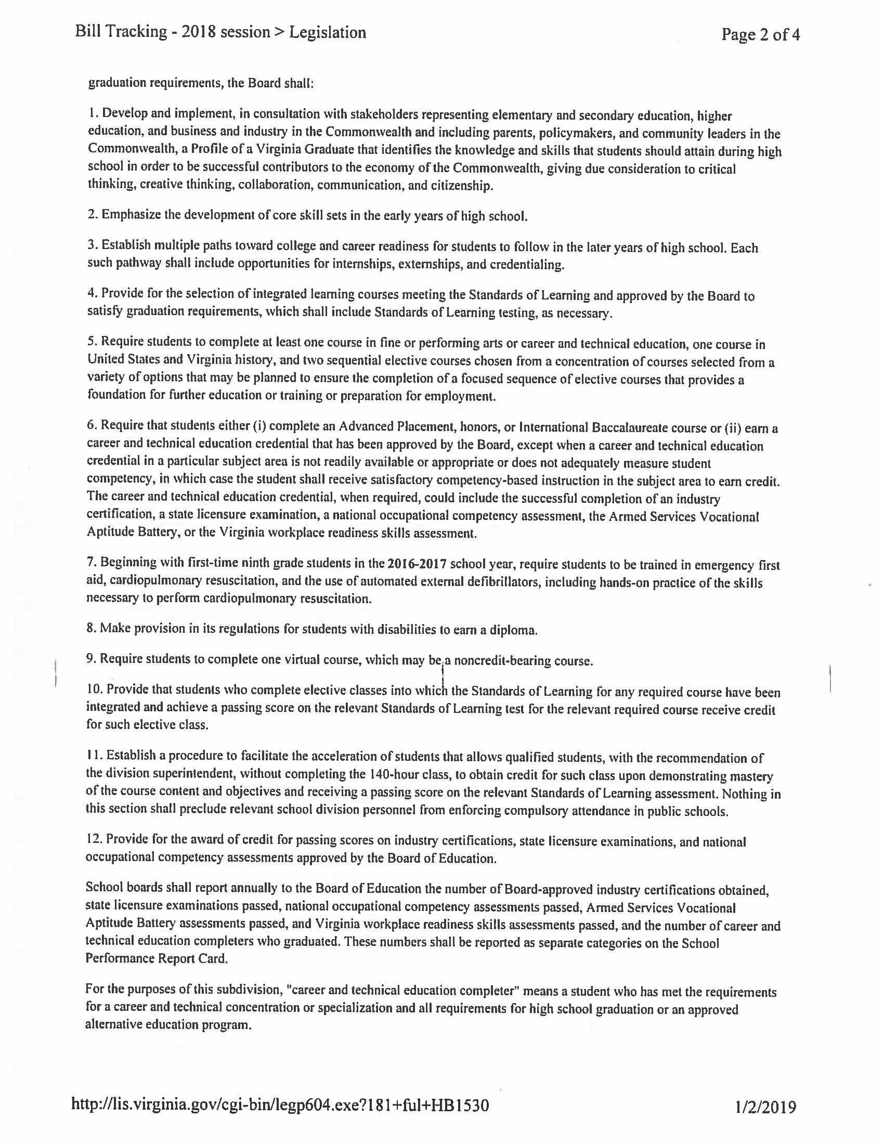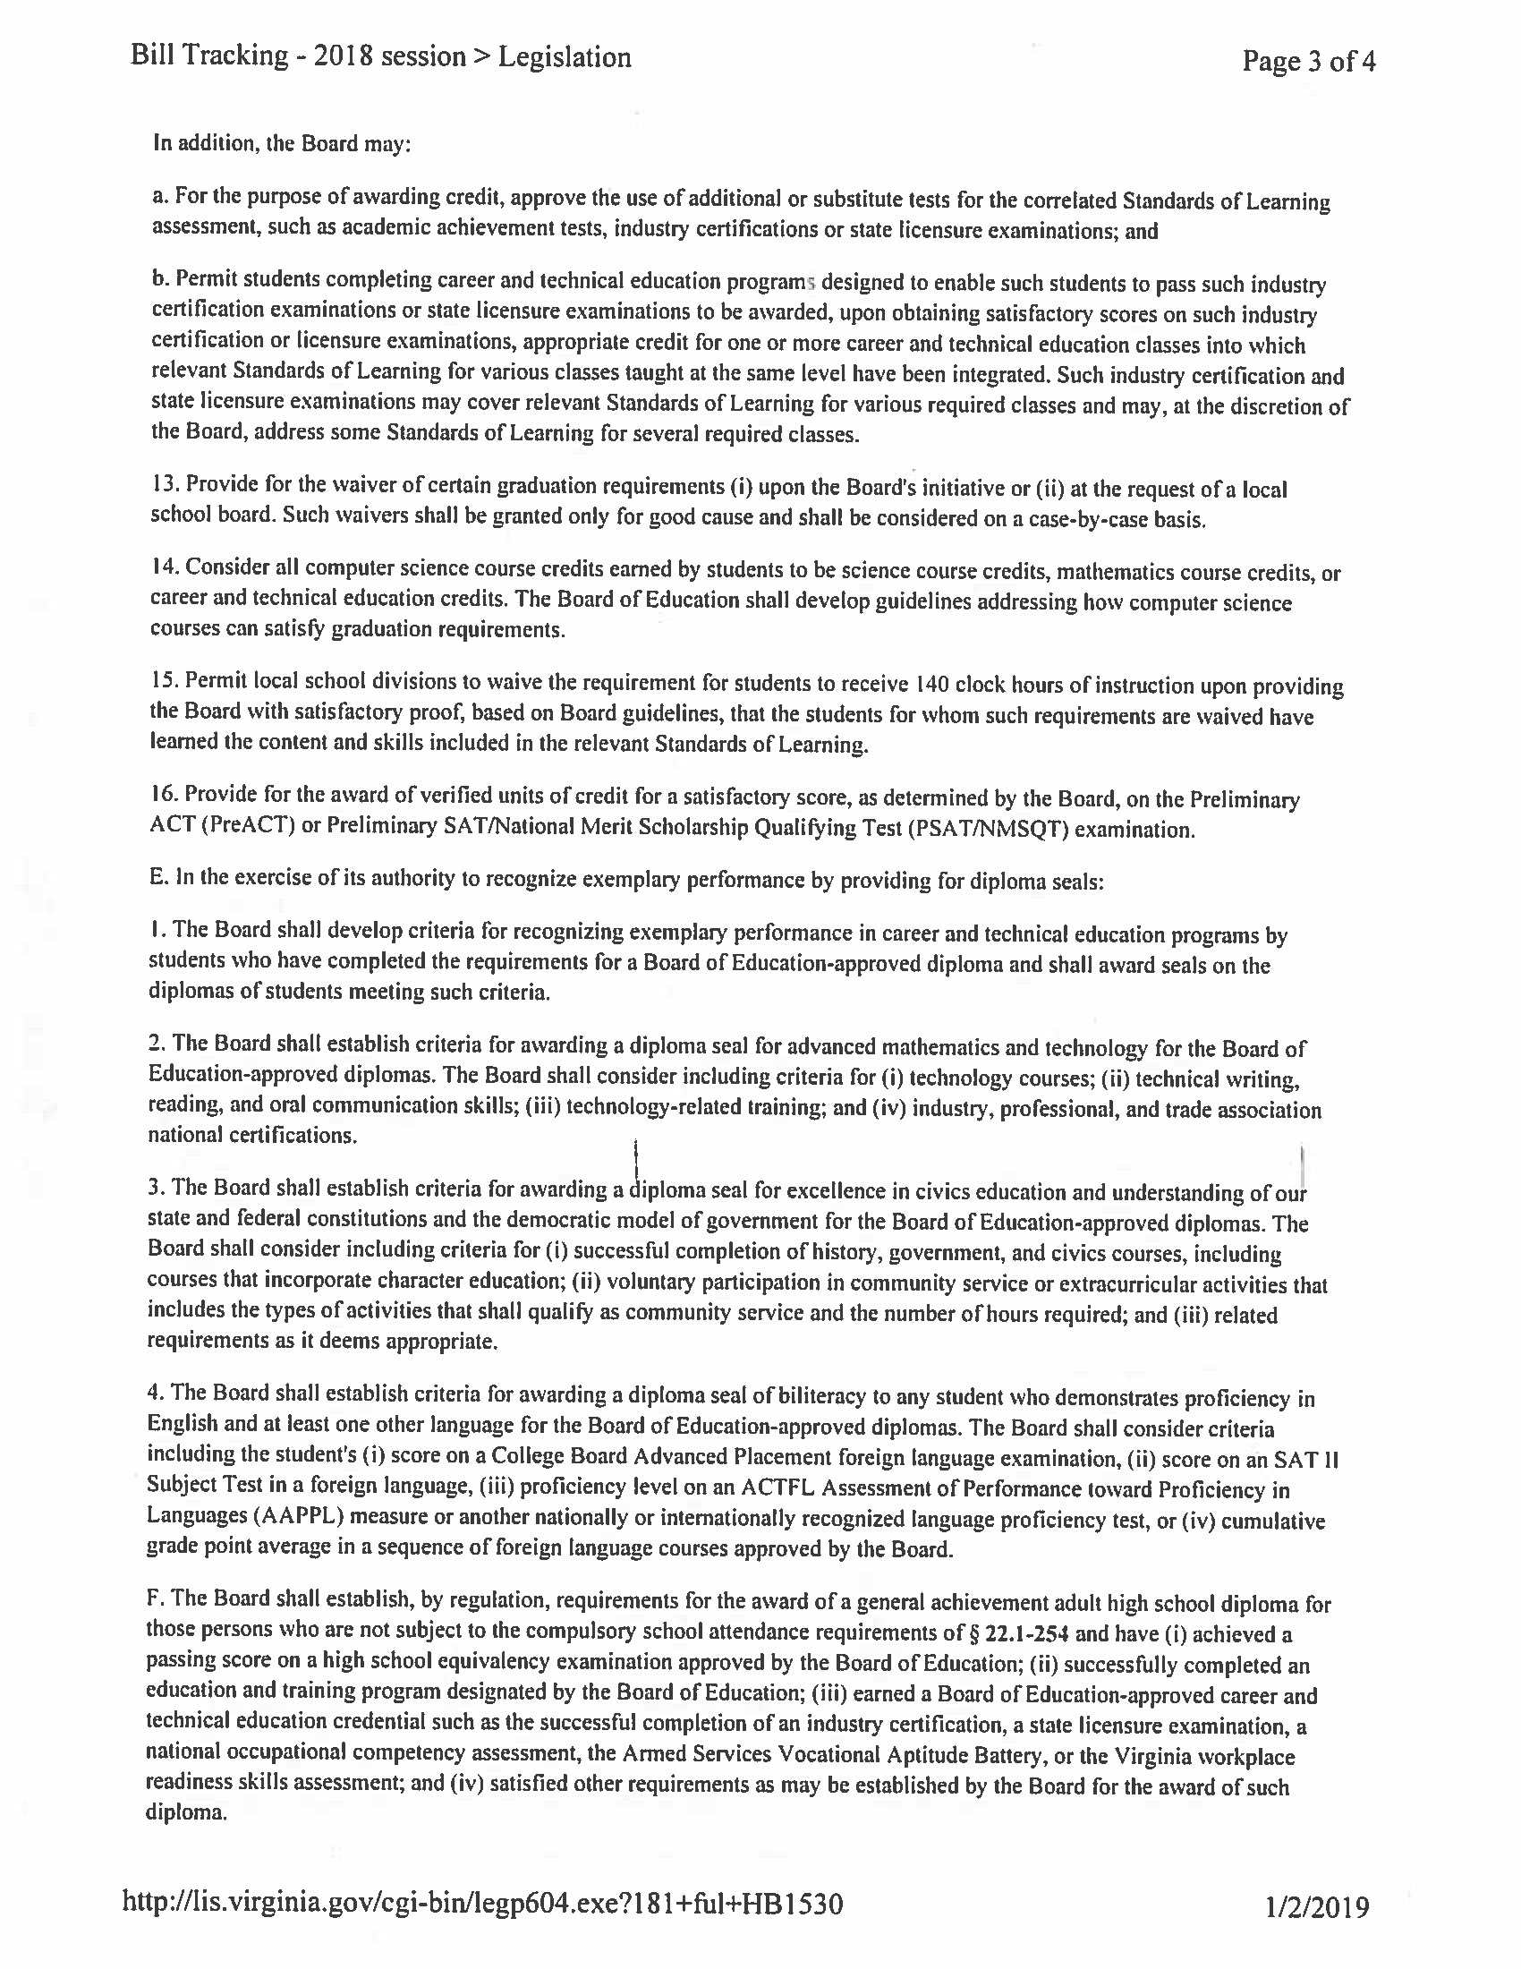

Appendix II: Relevant Sections of the Regulations Establishing Standards for Accrediting Public Schools in Virginia
Relevant Sections of the Regulations Establishing Standards for Accrediting Public Schools in Virginia:
8VAC20-131-50. Requirements for Graduation (Effective for the Students Entering Ninth Grade Prior to the 2018–2019 School Year).
A. The requirements for a student to earn a diploma and graduate from a Virginia high school shall be those in effect when that student enters the ninth grade for the first time. Students shall be awarded a diploma upon graduation from a Virginia high school.
The Advanced Studies Diploma shall be the recommended diploma for students pursuing baccalaureate study. Both the Standard Diploma and the Advanced Studies Diploma shall prepare students for postsecondary education and the career readiness required by the Commonwealth's economy.
When students below the ninth grade successfully complete courses offered for credit in grades 9 through 12, credit shall be counted toward meeting the standard units required for graduation provided the courses are equivalent in content and academic rigor as those courses offered at the secondary level. To earn a verified unit of credit for these courses, students must meet the requirements of 8VAC20-131-110.

The following requirements shall be the only requirements for a diploma, unless a local school board has prescribed additional requirements that have been approved by the board. All additional requirements prescribed by local school boards that have been approved by the board remain in effect until such time as the local school board submits a request to the board to amend or discontinue them.
B. Requirements for a Standard Diploma.
1. Beginning with the ninth-grade class of 2013–2014 and through the ninth-grade class of 2017–2018, students shall earn the required standard and verified units of credit described in subdivision 2 of this subsection.
2. Credits required for graduation with a Standard Diploma.

Discipline Area | Standard Units of Credit Required | Verified Credits Required
English | 4 | 2
Mathematics¹ | 3 | 1
Laboratory Science^{2,6} | 3 | 1
History and Social Sciences^{3,6} | 3 | 1
Health and Physical Education | 2
World Language, Fine Arts or Career and Technical Education⁷ | 2
Economics and Personal Finance | 1
Electives⁴ | 4
Student Selected Test⁵ |  | 1
Career and Technical Education Credential⁸
Total⁹ | 22 | 6

¹Courses completed to satisfy this requirement shall include at least two different course selections from among: Algebra I, Geometry, Algebra, Functions, and Data Analysis, Algebra II, or other mathematics courses above the level of Algebra II. The board shall approve courses to satisfy this requirement. Per the Standards of Quality, a computer science course credit earned by students may be considered a mathematics course credit.
²Courses completed to satisfy this requirement shall include course selections from at least two different science disciplines: earth sciences, biology, chemistry, or physics, or completion of the sequence of science courses required for the International Baccalaureate Diploma. The board shall approve courses to satisfy this requirement. Per the Standards of Quality, a computer science course credit earned by students may be considered a science course credit.
³Courses completed to satisfy this requirement shall include U.S. and Virginia History, U.S. and Virginia Government, and one course in either world history or geography or both. The board shall approve courses to satisfy this requirement.
⁴Courses to satisfy this requirement shall include at least two sequential electives as required by the Standards of Quality.
⁵A student may utilize additional tests for earning verified credit in computer science, technology, career and technical education, economics or other areas as prescribed by the board in 8VAC20-131-110.
⁶Students who complete a career and technical education program sequence and pass an examination or occupational competency assessment in a career and technical education field that confers certification or an occupational competency credential from a recognized industry, or trade or professional association, or acquire a professional license in a career and technical education field from the Commonwealth of Virginia may substitute the certification, competency credential, or license for (i) the student-selected verified credit and (ii) either a science or history and social science verified credit when the certification, license, or credential confers more than one verified credit. The examination or occupational competency assessment must be approved by the board as an additional test to verify student achievement.
⁷Pursuant to § 22.1-253.13:4 of the Code of Virginia, credits earned for this requirement shall include one credit in fine or performing arts or career and technical education. Per the Standards of Quality, a computer science course credit earned by students may be considered a career and technical education course credit.
⁸Students shall earn a career and technical education credential approved by the Board of Education, except when a career and technical education credential in a particular subject area is not readily available or appropriate or does not adequately measure student competency, in which case the student shall receive satisfactory competency-based instruction in the subject area to satisfy the standard diploma requirements. The career and technical education credential, when required, could include the successful completion of an industry certification, a state licensure examination, a national occupational competency assessment, or the Virginia workplace readiness assessment.
⁹Students shall successfully complete one virtual course, which may be a noncredit-bearing course or a required or elective credit-bearing course that is offered online.
Beginning with first-time ninth-grade students in the 2016–2017 school year, students shall be trained in emergency first aid, cardiopulmonary resuscitation, and the use of automated external defibrillators, including hands-on practice of the skills necessary to perform cardiopulmonary resuscitation. Students with an Individualized Education Program (IEP) or 504 Plan that documents that they cannot successfully complete this training shall be granted a waiver from this graduation requirement, as provided in 8VAC20-131-420 B.

3. The board shall establish, through guidelines, credit accommodations to the standard and verified credit requirements for a Standard Diploma. Such credit accommodations for students with disabilities may include:
a. Approval of alternative courses to meet the standard credit requirements;
b. Modifications to the requirements for local school divisions to award locally awarded verified credits;
c. Approval of additional tests to earn a verified credit;
d. Adjusted cut scores required to earn verified credit; and
e. Allowance of work-based learning experiences.
The student's IEP or 504 Plan shall specify any credit accommodations that are applicable.
Students completing the requirements for the Standard Diploma may be eligible to receive an honor deemed appropriate by the local school board as described in subsection H of this section.
C. Requirements for an Advanced Studies Diploma.
1. Beginning with the ninth-grade class of 2013–2014 and through the ninth-grade class of 2017–2018, students shall earn the required standard and verified units of credit described in subdivision 2 of this subsection.
2. Credits required for graduation with an Advanced Studies Diploma.
Discipline Area | Standard Units of Credit Required | Verified Credits Required
English | 4 | 2
Mathematics¹ | 4 | 2
Laboratory Science² | 4 | 2
History and Social Sciences³ | 4 | 2
World Language⁴ | 3
Health and Physical Education | 2
Fine Arts or Career and Technical Education⁵ | 1
Economics and Personal Finance | 1
Electives | 3
Student Selected Test ⁶ |  | 1
Total ⁷ | 26 | 9

¹Courses completed to satisfy this requirement shall include at least three different course selections from among: Algebra I, Geometry, Algebra II, or other mathematics courses above the level of Algebra II. The board shall approve courses to satisfy this requirement. Per the Standards of Quality, a computer science course credit earned by students may be considered a mathematics course credit.
²Courses completed to satisfy this requirement shall include course selections from at least three different science disciplines from among: earth sciences, biology, chemistry, or physics or completion of the sequence of science courses required for the International Baccalaureate Diploma. The board shall approve additional courses to satisfy this requirement. Per the Standards of Quality, a computer science course credit earned by students may be considered a science course credit.
³Courses completed to satisfy this requirement shall include U.S. and Virginia History, U.S. and Virginia Government, and two courses in either world history or geography or both. The board shall approve additional courses to satisfy this requirement.
⁴Courses completed to satisfy this requirement shall include three years of one language or two years of two languages.
⁵Per the Standards of Quality, a computer science course credit earned by students may be considered a career and technical education course credit.
⁶A student may utilize additional tests for earning verified credit in computer science, technology, career or technical education, economics or other areas as prescribed by the board in 8VAC20-131-110.
⁷Students shall successfully complete one virtual course, which may be a noncredit-bearing course, or may be a course required to earn this diploma that is offered online.

Students completing the requirements for the Advanced Studies Diploma may be eligible to receive an honor deemed appropriate by the local school board as described in subsection H of this section.
Beginning with first-time ninth-grade students in the 2016–2017 school year, students shall be trained in emergency first aid, cardiopulmonary resuscitation, and the use of automated external defibrillators, including hands-on practice of the skills necessary to perform cardiopulmonary resuscitation. Students with an IEP or 504 Plan that documents that they cannot successfully complete this training shall be granted a waiver from this graduation requirement, as provided in 8VAC20-131-420 B.

D. In accordance with the requirements of the Standards of Quality, students with disabilities who complete the requirements of their IEP and do not meet the requirements for other diplomas shall be awarded Applied Studies Diplomas.
E. In accordance with the requirements of the Standards of Quality, students who complete prescribed programs of studies defined by the local school board but do not qualify for a Standard Diploma, an Advanced Studies Diploma, or an Applied Studies Diploma shall be awarded Certificates of Program Completion. The requirements for Certificates of Program Completion are developed by local school boards in accordance with the Standards of Quality.
F. In accordance with the provisions of the compulsory attendance law and 8VAC20-30, Regulations Governing Adult High School Programs, students who do not qualify for diplomas may earn a high school equivalency credential.

G. At a student's request, the local school board shall communicate or otherwise make known to institutions of higher education, potential employers, or other applicable third parties, in a manner that the local school board deems appropriate, that a student has attained the state's academic expectations by earning a Virginia diploma and that the value of such a diploma is not affected in any way by the accreditation status of the student's school.
H. Awards for exemplary student performance. Students who demonstrate academic excellence or outstanding achievement may be eligible for one or more of the following awards:
1. The Governor's Seal shall be awarded to students who complete the requirements for an Advanced Studies Diploma with an average grade of "B" or better, and successfully complete college-level coursework that will earn the student at least nine transferable college credits in Advanced Placement (AP), International Baccalaureate (IB), Cambridge, or dual enrollment courses.
2. The Board of Education Seal shall be awarded to students who complete the requirements for a Standard Diploma or an Advanced Studies Diploma with an average grade of "A".
3. The Board of Education's Career and Technical Education Seal shall be awarded to students who earn a Standard Diploma or an Advanced Studies Diploma and complete a prescribed sequence of courses in a career and technical education concentration or specialization that they choose and maintain a "B" or better average in those courses; or (i) pass an examination or an occupational competency assessment in a career and technical education concentration or specialization that confers certification or occupational competency credential from a recognized industry, trade or professional association or (ii) acquire a professional license in that career and technical education field from the Commonwealth of Virginia. The board shall approve all professional licenses and examinations used to satisfy these requirements.
4. The Board of Education's Seal of Advanced Mathematics and Technology shall be awarded to students who earn either a Standard Diploma or an Advanced Studies Diploma and (i) satisfy all of the mathematics requirements for the Advanced Studies Diploma (four units of credit including Algebra II; two verified units of credit) with a "B" average or better; and (ii) either (a) pass an examination in a career and technical education field that confers certification from a recognized industry, trade, or professional association; (b) acquire a professional license in a career and technical education field from the Commonwealth of Virginia; or (c) pass an examination approved by the board that confers college-level credit in a technology or computer science area. The board shall approve all professional licenses and examinations used to satisfy these requirements.
5. The Board of Education's Seal for Excellence in Civics Education shall be awarded to students who earn either a Standard Diploma or an Advanced Studies Diploma and (i) complete Virginia and United States history and Virginia and United States government courses with a grade of "B" or higher; (ii) have good attendance and no disciplinary infractions as determined by local school board policies; and (iii) complete 50 hours of voluntary participation in community service or extracurricular activities. Activities that satisfy the requirements of clause (iii) of this subdivision include: (a) volunteering for a charitable or religious organization that provides services to the poor, sick, or less fortunate; (b) participating in Boy Scouts, Girl Scouts, or similar youth organizations; (c) participating in JROTC; (d) participating in political campaigns or government internships, or Boys State, Girls State, or Model General Assembly; or (e) participating in school-sponsored extracurricular activities that have a civics focus. Any student who enlists in the United States military prior to graduation shall be deemed to have met this community service requirement.
6. The Board of Education's Seal of Biliteracy shall be awarded to students who demonstrate proficiency in English and at least one other language and meet additional criteria established by the board. Such seal shall be awarded to eligible students graduating from public high schools in the Commonwealth beginning in 2016.
7. Students may receive other seals or awards for exceptional academic, career and technical, citizenship, or other exemplary performance in accordance with criteria defined by the local school board.
I. Students completing graduation requirements in a summer school program shall be eligible for a diploma. The last school attended by the student during the regular session shall award the diploma unless otherwise agreed upon by the principals of the two schools.
J. Students who complete Advanced Placement courses, college-level courses, or courses required for an International Baccalaureate Diploma shall be deemed to have completed the requirements for graduation under these standards provided they have earned the standard units of credit and earned verified units of credit in accordance with the requirements for the Standard Diploma and the Advanced Studies Diploma, as specified in subsections B and C of this section.
K. Students shall be counseled annually regarding the opportunities for using additional tests for earning verified credits, as provided in accordance with the provisions of 8VAC20-131-110, and the consequences of failing to fulfill the obligations to complete the requirements for verified units of credit.

8VAC20-131-51.Requirements for Graduation (Effective with the Students Who Enter the Ninth Grade in the 2018–2019 School Year).
A. The requirements for a student to earn a diploma and graduate from a Virginia high school shall be those in effect when that student enters the ninth grade for the first time. Students shall be awarded a diploma upon graduation from a Virginia high school.
Both the Standard Diploma and the Advanced Studies Diploma shall provide multiple paths toward college, career, and citizenship readiness for students to follow in the later years of high school. Each such pathway shall provide meaningful and rigorous opportunities tied to instruction to achieve workplace and citizenship skills through experiences such as internships, externships, credentialing, and blended learning, which may be offered for credit toward high school graduation.
In accordance with the Profile of a Virginia Graduate approved by the board, the instructional program leading to a Standard Diploma or Advanced Studies Diploma shall ensure that students (i) attain the knowledge, skills, competencies, and experiences necessary to be successful in the evolving global economy whether immediately entering the world of work or pursuing a postsecondary education and (ii) acquire and be able to demonstrate foundational skills in critical thinking, creative thinking, collaboration, communication, and citizenship.
When students below the ninth grade successfully complete courses offered for credit in grades 9 through 12, credit shall be counted toward meeting the standard units required for graduation provided the courses are equivalent in content and academic rigor as those courses offered at the secondary level. To earn a verified unit of credit for these courses, students must meet the requirements of 8VAC20-131-110.

The requirements in this section shall be the only requirements for a diploma, unless a local school board has prescribed additional requirements that have been approved by the board. All additional requirements prescribed by local school boards that have been approved by the board remain in effect until such time as the local school board submits a request to the board to amend or discontinue them.
B. Requirements for a Standard Diploma.
1. Beginning with the ninth-grade class of 2018–2019 and beyond, students shall earn the required standard and verified units of credit described in subdivision 2 of this subsection.
2. Credits required for graduation with a Standard Diploma.
A "standard unit of credit" or "standard credit" is a credit awarded for a course in which the student successfully completes 140 clock hours of instruction and the requirements of the course. Local school boards may develop alternatives to the requirement for 140 clock hours of instruction as provided for in 8VAC20-131-110 and in accordance with board guidelines.
A "verified unit of credit" or "verified credit" is a credit awarded for a course in which a student earns a standard unit of credit and (i) achieves a passing score on a corresponding end-of-course SOL test; (ii) achieves a passing score on an additional test, as defined in 8VAC20-131-5 as part of the Virginia Assessment Program; (iii) meets the criteria for the receipt of a locally awarded verified credit conferred in accordance with board criteria and guidelines as provided in 8VAC20-131-110 B 3 when the student has not passed a corresponding SOL test in English, mathematics, laboratory science, or history and social science; (iv) meets the criteria for the receipt of a verified credit for history and social science by demonstrating mastery of the content of the associated course on an authentic performance assessment, as provided in 8VAC20-131-110 B 4; or (v) meets the criteria for the receipt of a verified credit for English (writing) by demonstrating mastery of the content of the associated course on authentic performance assessments as provided in 8VAC20-131-110 B 5.
No more than one locally awarded verified credit may be used to satisfy these requirements, except as provided in subdivision 3 of this subsection for credit accommodations for students with disabilities.
Discipline Area | Standard Units of Credit Required | Verified Credits Required
English (reading and writing) | 4 | 2
Mathematics | 3 | 1
Laboratory Science | 3 | 1
History and Social Science | 3 | 1
Health and Physical Education | 2
World Language, Fine Arts or Career and Technical Education | 2
Economics and Personal Finance | 1
Electives | 4
Total | 22 | 5

Discipline Area | Specifications
Mathematics | Courses completed to satisfy this requirement shall include at least two different course selections from among: algebra I, geometry, algebra functions, and data analysis, algebra II, or other mathematics courses approved by the board to satisfy this requirement. Per the Standards of Quality, a computer science course credit earned by students may be considered a mathematics course credit.
Laboratory Science | Courses completed to satisfy this requirement shall include course selection from at least two different science disciplines: earth sciences, biology, chemistry, or physics, or completion of the sequence of science courses required for the International Baccalaureate Diploma and shall include interdisciplinary courses that incorporate Standards of Learning content from multiple academic areas. The board shall approve courses to satisfy this requirement. Per the Standards of Quality, a computer science course credit earned by students may be considered a science course credit.
History and Social Science | Courses completed to satisfy this requirement shall include Virginia and U.S. history, Virginia and U.S. government, and one course in either world history or geography or both. The board shall approve courses to satisfy this requirement.
Laboratory Science, and History and Social Science | Students who complete a career and technical education program sequence and pass an examination or occupational competency assessment in a career and technical education field that confers certification or an occupational competency credential from a recognized industry, or trade or professional association, or acquires a professional license in a career and technical education field from the Commonwealth of Virginia may substitute the certification, competency credential, or license for either a laboratory science or history and social science verified credit when the certification, license, or credential confers more than one verified credit. The examination or occupational competency assessment must be approved by the board as an additional test to verify student achievement.
World Language, Fine Arts or Career and Technical Education | Per the Standards of Quality, credits earned for this requirement shall include one credit in fine or performing arts or career and technical education. Per the Standards of Quality, a computer science course credit earned by students may be considered a career and technical course credit.
Electives | Courses to satisfy this requirement shall include at least two sequential electives as required by the Standards of Quality.

Additional Requirements for Graduation
Advanced Placement, Honors, or International Baccalaureate Course or Career and Technical Education Credential | In accordance with the Standards of Quality, students shall either (i) complete an Advanced Placement, honors, or International Baccalaureate course, or (ii) earn a career and technical education credential approved by the board, except when a career and technical education credential in a particular subject area is not readily available or appropriate or does not adequately measure student competency, in which case the student shall receive satisfactory competency-based instruction in the subject area to satisfy the standard diploma requirements. The career and technical education credential, when required, could include the successful completion of an industry certification, a state licensure examination, a national occupational competency assessment, or the Virginia workplace readiness assessment.
Virtual Course | Students shall successfully complete one virtual course, which may be a non-credit-bearing course or a required or elective credit-bearing course that is offered online.
Training in emergency first aid, cardiopulmonary resuscitation (CPR), and the use of automated external defibrillators (AED) | Students shall be trained in emergency first aid, CPR, and the use of AED, including hands-on practice of the skills necessary to perform cardiopulmonary resuscitation. Students with an IEP or 504 Plan that documents that they cannot successfully complete this training shall be granted a waiver from this graduation requirement, as provided in 8VAC20-131-420 B.
Demonstration of the five Cs | Students shall acquire and demonstrate foundational skills in critical thinking, creative thinking, collaboration, communication, and citizenship in accordance with the Profile of a Virginia Graduate approved by the board.

3. The board shall establish through guidelines credit accommodations to the standard and verified credit requirements for a Standard Diploma. Such credit accommodations for students with disabilities may include:
a. Approval of alternative courses to meet the standard credit requirements;
b. Modifications to the requirements for local school divisions to award locally awarded verified credits;
c. Approval of additional tests to earn a verified credit;
d. Adjusted cut scores required to earn verified credit; and
e. Allowance of work-based learning experiences.
The student's IEP or 504 Plan shall specify any credit accommodations applicable for the student.
Students completing the requirements for the Standard Diploma may be eligible to receive an honor deemed appropriate by the local school board as described in subsection H of this section.
C. Requirements for an Advanced Studies Diploma.
1. Beginning with the ninth-grade class of 2018–2019 and beyond, students shall earn the required standard and verified units of credit described in subdivision 2 of this subsection.
2. Credits required for graduation with an Advanced Studies Diploma.
A "standard unit of credit" or "standard credit" is a credit awarded for a course in which the student successfully completes 140 clock hours of instruction and the requirements of the course. Local school boards may develop alternatives to the requirement for 140 clock hours of instruction as provided for in 8VAC20-131-110 and in accordance with board guidelines.
A "verified unit of credit" or "verified credit" is a credit awarded for a course in which a student earns a standard unit of credit and (i) achieves a passing score on a corresponding end-of-course SOL test; (ii) achieves a passing score on an additional test, as defined in 8VAC20-131-5, as part of the Virginia Assessment Program; (iii) meets the criteria for the receipt of a locally awarded verified credit conferred in accordance with board criteria and guidelines as provided in 8VAC20-131-110 B 3 when the student has not passed a corresponding SOL test in English, mathematics, laboratory science, or history and social science; (iv) meets the criteria for the receipt of a verified credit for history and social science by demonstrating mastery of the content of the associated course on an authentic performance assessment, as provided in 8VAC20-131-110 B 4; or (v) meets the criteria for the receipt of a verified credit for English (writing) by demonstrating mastery of the content of the associated course on an authentic performance assessment, as provided in 8VAC20-131-110 B 5.
No more than one locally awarded verified credit may be used to satisfy these requirements.
Discipline Area | Standard Units of Credit Required | Verified Credits Required
English (reading and writing) | 4 | 2
Mathematics | 4 | 1
Laboratory Science | 4 | 1
History and Social Science | 4 | 1
World Language | 3
Health and Physical Education | 2
Fine Arts or Career and Technical Education | 1
Economics and Personal Finance | 1
Electives | 3
Total | 26 | 5

Discipline Area | Specifications
Mathematics | Courses completed to satisfy this requirement shall include at least three different course selections from among: algebra I, geometry, algebra II, or other mathematics courses above the level of algebra II. The board shall approve courses to satisfy this requirement. Per the Standards of Quality, a computer science course credit earned by students may be considered a mathematics course credit.
Laboratory Science | Courses completed to satisfy this requirement shall include course selections from at least three different science disciplines from among: earth sciences, biology, chemistry, or physics or completion of the sequence of science courses required for the International Baccalaureate Diploma and shall include interdisciplinary courses that incorporate Standards of Learning content from multiple academic areas. The board shall approve additional courses to satisfy this requirement. Per the Standards of Quality, a computer science course credit earned by students may be considered a science course credit.
History and Social Science | Courses completed to satisfy this requirement shall include Virginia and U.S. history, Virginia and U.S. government, and two courses in either world history or geography or both. The board shall approve additional courses to satisfy this requirement.
World Language | Courses completed to satisfy this requirement shall include three years of one language or two years of two languages.
Fine Arts or Career and Technical Education | Per the Standards of Quality, a computer science course credit earned by students may be considered a career and technical credit.
Electives | Courses to satisfy this requirement shall include at least two sequential electives as required by the Standards of Quality.

Additional Requirements for Graduation
Advanced Placement, Honors, or International Baccalaureate Course or Career and Technical Education Credential | In accordance with the Standards of Quality, students shall either (i) complete an Advanced Placement, honors, or International Baccalaureate course or (ii) earn a career and technical education credential approved by the board, except when a career and technical education credential in a particular subject area is not readily available or appropriate or does not adequately measure student competency, in which case the student shall receive satisfactory competency-based instruction in the subject area to satisfy the advanced studies diploma requirements. The career and technical education credential, when required, could include the successful completion of an industry certification, a state licensure examination, a national occupational competency assessment, or the Virginia workplace readiness assessment.
Virtual Course | Students shall successfully complete one virtual course, which may be a non-credit-bearing course or a required or elective credit-bearing course that is offered online.
Training in emergency first aid, cardiopulmonary resuscitation (CPR), and the use of automated external defibrillators (AED). | Students shall be trained in emergency first aid, CPR, and the use of AED, including hands-on practice of the skills necessary to perform cardiopulmonary resuscitation. Students with an IEP or 504 Plan that documents that they cannot successfully complete this training shall be granted a waiver from this graduation requirement, as provided in 8VAC20-131-420 B.
Demonstration of the five Cs | Students shall acquire and demonstrate foundational skills in critical thinking, creative thinking, collaboration, communication, and citizenship in accordance with the Profile of a Virginia Graduate approved by the board.

D. Requirements for an Applied Studies Diploma. In accordance with the requirements of the Standards of Quality, a student with disabilities who completes the requirements of the student's IEP and does not meet the requirements for other diplomas shall be awarded Applied Studies Diplomas in accordance with state and federal laws and regulations regarding special education.
Students who pursue an Applied Studies Diploma shall be allowed to pursue a Standard Diploma or an Advanced Studies Diploma at any time during high school. Such students shall not be excluded from courses or tests required to earn these diplomas.
E. Requirements for Certificates of Program Completion. In accordance with the requirements of the Standards of Quality, students who complete prescribed programs of studies defined by the local school board but do not qualify for a Standard Diploma, an Advanced Studies Diploma, or an Applied Studies Diploma shall be awarded Certificates of Program Completion. The requirements for Certificates of Program Completion are developed by local school boards in accordance with the Standards of Quality.
F. In accordance with the provisions of the compulsory attendance law and 8VAC20-30, Regulations Governing Adult High School Programs, students who do not qualify for diplomas may earn a high school equivalency credential. The requirements for the General Achievement Adult High School Diploma are provided in 8VAC20-30-20.
G. At a student's request, the local school board shall communicate or otherwise make known to institutions of higher education, potential employers, or other applicable third parties, in a manner that the local school board deems appropriate, that a student has attained the state's academic expectations by earning a Virginia diploma and that the value of such a diploma is not affected in any way by the accreditation status of the student's school.
H. Awards for exemplary student performance. Students who demonstrate academic excellence and outstanding achievement may be eligible for one or more of the following awards:
1. The Governor's Seal shall be awarded to students who complete the requirements for an Advanced Studies Diploma with an average grade of "B" or better and successfully complete college-level coursework that shall earn the student at least nine transferable college credits in Advanced Placement (AP), International Baccalaureate (IB), Cambridge, or dual enrollment courses.
2. The Board of Education Seal shall be awarded to students who complete the requirements for a Standard Diploma or an Advanced Studies Diploma with an average grade of "A."
3. The Board of Education's Career and Technical Education Seal shall be awarded to students who earn a Standard Diploma or an Advanced Studies Diploma and complete a prescribed sequence of courses in a career and technical education concentration or specialization that they choose and maintain a "B" or better average in those courses or (i) pass an examination or an occupational competency assessment in a career and technical education concentration or specialization that confers certification or occupational competency credential from a recognized industry, trade, or professional association or (ii) acquire a professional license in that career and technical education field from the Commonwealth of Virginia. The board shall approve all professional licenses and examinations used to satisfy these requirements.
4. The Board of Education's Seal of Advanced Mathematics and Technology shall be awarded to students who earn either a Standard Diploma or an Advanced Studies Diploma and (i) satisfy all of the mathematics requirements for the Advanced Studies Diploma with a "B" average or better and (ii) pass an examination in a career and technical education field that confers certification from a recognized industry, or trade or professional association; acquire a professional license in a career and technical education field from the Commonwealth of Virginia; or pass an examination approved by the board that confers college-level credit in a technology or computer science area. The board shall approve all professional licenses and examinations used to satisfy these requirements.
5. The Board of Education's Seal for Excellence in Civics Education shall be awarded to students who earn either a Standard Diploma or an Advanced Studies Diploma and (i) complete Virginia and United States history and Virginia and United States government courses with a grade of "B" or higher; (ii) have good attendance and no disciplinary infractions as determined by local school board policies; and (iii) complete 50 hours of voluntary participation in community service or extracurricular activities. Activities that satisfy the requirements of clause (iii) of this subdivision include (a) volunteering for a charitable or religious organization that provides services to the poor, sick, or less fortunate; (b) participating in Boy Scouts, Girl Scouts, or similar youth organizations; (c) participating in JROTC; (d) participating in political campaigns or government internships, or Boys State, Girls State, or Model General Assembly; or (e) participating in school-sponsored extracurricular activities that have a civics focus. Any student who enlists in the United States military prior to graduation shall be deemed to have met this community service requirement.
6. The Board of Education's Seal of Biliteracy shall be awarded to students who demonstrate proficiency in English and at least one other language and meet additional criteria established by the board.
7. The Board of Education's Seal for Excellence in Science and the Environment shall be awarded to students who earn either a Standard Diploma or Advanced Studies Diploma and (i) complete at least three different first-level board-approved laboratory science courses and at least one rigorous advanced-level or postsecondary-level laboratory science course, each with a grade of "B" or higher; (ii) complete laboratory or field-science research and present that research in a formal, juried setting; and (iii) complete at least 50 hours of voluntary participation in community service or extracurricular activities that involve the application of science such as environmental monitoring, protection, management, or restoration.
8. Students may receive other seals or awards for exceptional academic, career and technical, citizenship, or other exemplary performance in accordance with criteria defined by the local school board.
I. Students completing graduation requirements in a summer school program shall be eligible for a diploma. The last school attended by the student during the regular session shall award the diploma unless otherwise agreed upon by the principals of the two schools.
J. Students who complete Advanced Placement courses, college-level courses, or courses required for an International Baccalaureate Diploma shall be deemed to have completed the course requirements for graduation under these standards provided they have earned the total number of standard units of credit and verified units of credit in each discipline area in accordance with the requirements for the Standard Diploma and the Advanced Studies Diploma, as specified in subsections B and C of this section.
K. Students shall be counseled annually regarding the opportunities for using additional tests for earning verified credits, as provided in accordance with the provisions of 8VAC20-131-110, and the consequences of failing to fulfill the obligations to complete the requirements for verified units of credit.

8VAC20-131-110. Standard and Verified Units of Credit.
A. A "standard unit of credit" or "standard credit" is a credit awarded for a course in which the student successfully completes 140 clock hours of instruction and the requirements of the course. A school division may waive the requirement that a student receive 140 clock hours of instruction to earn a standard credit, effective with students enrolled in the 2015-2016 school year, as prescribed in the Standards of Quality and board guidelines. When credit is awarded in less than whole units, the increment awarded must be no greater than the fractional part of the 140 hours of instruction provided. If a school division elects to award credit on a basis other than the 140 clock hours of instruction required for a standard unit of credit defined in this subsection, the local school division shall provide the board with satisfactory proof, based on board guidelines, that the students for whom the 140-clock-hour requirement is waived have learned the content and skills included in the relevant Standards of Learning. In addition, the local school division shall develop a written policy approved by the superintendent and school board that ensures:
1. That the content of the course for which credit is awarded is comparable to 140 clock hours of instruction; and
2. That upon completion, the aims and objectives of the course have been met.
B. A "verified unit of credit" or "verified credit" is a credit awarded for a course in which a student earns a standard unit of credit and completes one of the following:
1. Achieves a passing score on a corresponding end-of-course SOL test. In accordance with the provisions of the Standards of Quality, students may earn a standard and verified unit of credit for any elective course in which the core academic Standards of Learning course content has been integrated and the student passes the related end-of-course SOL test. Such course and test combinations must be approved by the board.
Upon waiver of the 140-clock-hour requirement according to board guidelines, qualified students who have received a standard unit of credit shall be permitted to sit for the relevant SOL test to earn a verified credit without having to meet the 140-clock-hour requirement.
2. Achieves a passing score on an additional test, as defined in 8VAC20-131-5, as a part of the Virginia Assessment Program.

3. Meets the criteria for the receipt of a locally awarded verified credit when the student has not passed a corresponding SOL test.
a. Students who enter the ninth grade for the first time prior to the 2018-2019 school year and do not pass SOL tests in science or history and social science may receive locally awarded verified credits from the local school board in accordance with criteria established in guidelines adopted by the board. Credit accommodations for students with disabilities may be used to confer locally awarded verified credits as provided in 8VAC20-131-50 B 3.
b. Students who enter the ninth grade for the first time in the 2018-2019 school year or thereafter and do not pass SOL tests in English, mathematics, laboratory science, or history and social science may receive locally awarded verified credits from the local school board in accordance with criteria established in guidelines adopted by the board. No more than one locally awarded verified credit may be used to satisfy graduation requirements, except as provided in 8VAC20-131-51 B 3 for students with disabilities seeking a standard diploma.

4. Meets the criteria for the receipt of a verified credit in history and social science by demonstrating mastery of the content of the associated course on an authentic performance assessment that complies with guidelines adopted by the board. Such students shall not also be required to take the corresponding SOL test in history and social science.
5. Meets the criteria for the receipt of a verified credit in English (writing) by demonstrating mastery of the content of the associated course on an authentic performance assessment, that complies with guidelines adopted by the board. Such students shall not also be required to take the corresponding SOL test in English (writing).
C. The board may from time to time approve additional tests for the purpose of awarding verified credit. Such additional tests, which enable students to earn verified units of credit, must, at a minimum, meet the following criteria:
1. The test must be standardized and graded independently of the school or school division in which the test is given;
2. The test must be knowledge based;
3. The test must be administered on a statewide, multistate, or international basis, or administered as part of another state's accountability assessment program; and
4. To be counted in a specific academic area, the test must measure content that incorporates or exceeds the Standards of Learning content in the course for which verified credit is given.
The board shall set the score that must be achieved to earn a verified unit of credit on the additional test options.
D. With such funds as are appropriated by the General Assembly, the board shall provide opportunities for students who meet criteria adopted by the board to have an expedited retake of a SOL test to earn verified credit.

Appendix III: 12.12.18 Workgroup Meeting Participants

Workgroup Meeting Participants
- Brett Vassey, President & CEO Virginia Manufacturing Association
- Paul Nichols, Superintendent Mecklenburg County Public Schools
- Kim MaKay, Deputy Director Virginia Chamber Foundation
- Mac Beaton, CTE Director Henrico County Public Schools
- Dr. Jessica M. Jones, President Virginia Career and Technical Education Association
- Bobbi Comer, Teacher Page County Public Schools
- Kennedy Strickler, National FCCLA President Family, Career and Community Leader of America
- Paula Robinson, Assistant Director College Access State Council of Higher Education for Virginia
- Ben Kiser, Executive Director Virginia Association of School Superintendents
- Carol Flenard, Assistant Superintendent of Instruction Spotsylvania County Public Schools
- Dr. Jim Meyer, Committee Chairman Virginia School Board Association
- Dr. Mikell Brown, Dean, Division of Arts, Virginia Community College System
Humanities & Social Sciences
- Dr. Brenda Long, Executive Director Virginia Career and Technical Education Association
- Courtney Merridew, School Counselor Chesterfield County Public Schools
- Vishon Luck, Director of Recruitment Virginia Commonwealth University
- Karla Allen, School Counselor Hanover County Public Schools
- Randall Stamper, Assistant Vice Chancellor, Virginia Community College System
Career Pathways and Workforce Programs
- Gena Keller, Assistant Superintendent Virginia Department of Education
- Zack Robbins, Director of Policy Virginia Department of Education
- George Willcox, Director, Operations & Accountability Virginia Department of Education

Appendix IV: 12.12.18 Workgroup Meeting PowerPoint

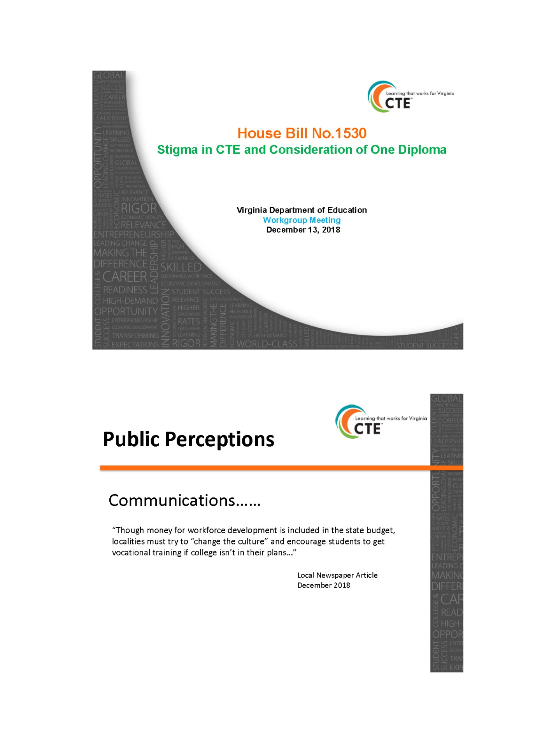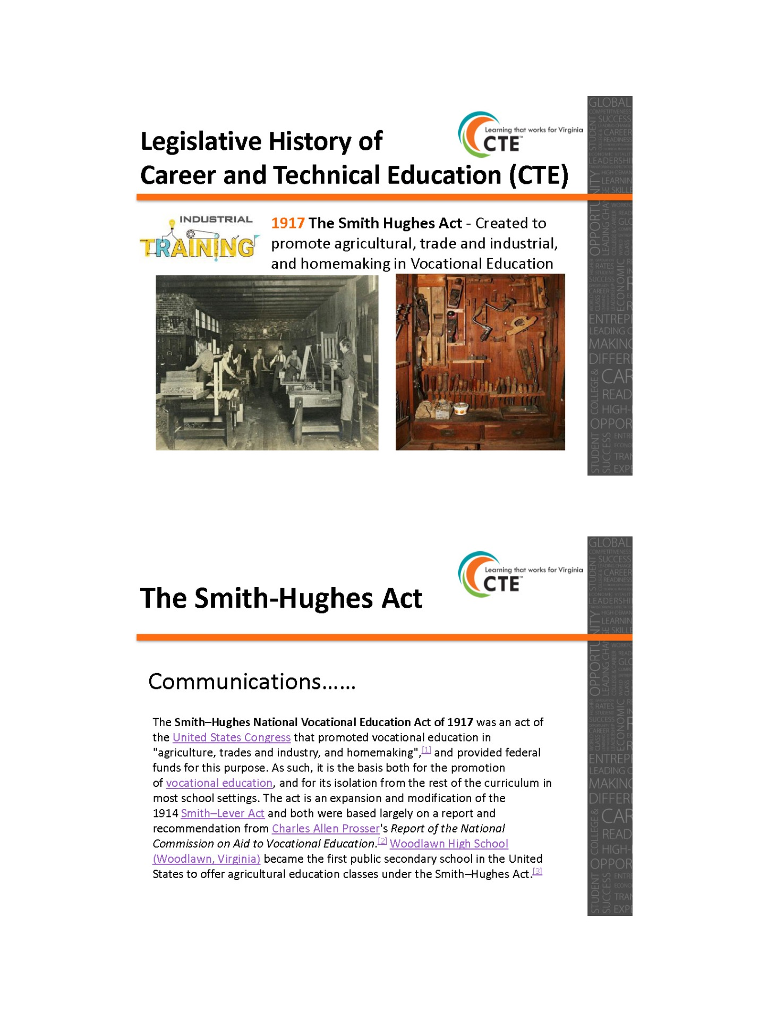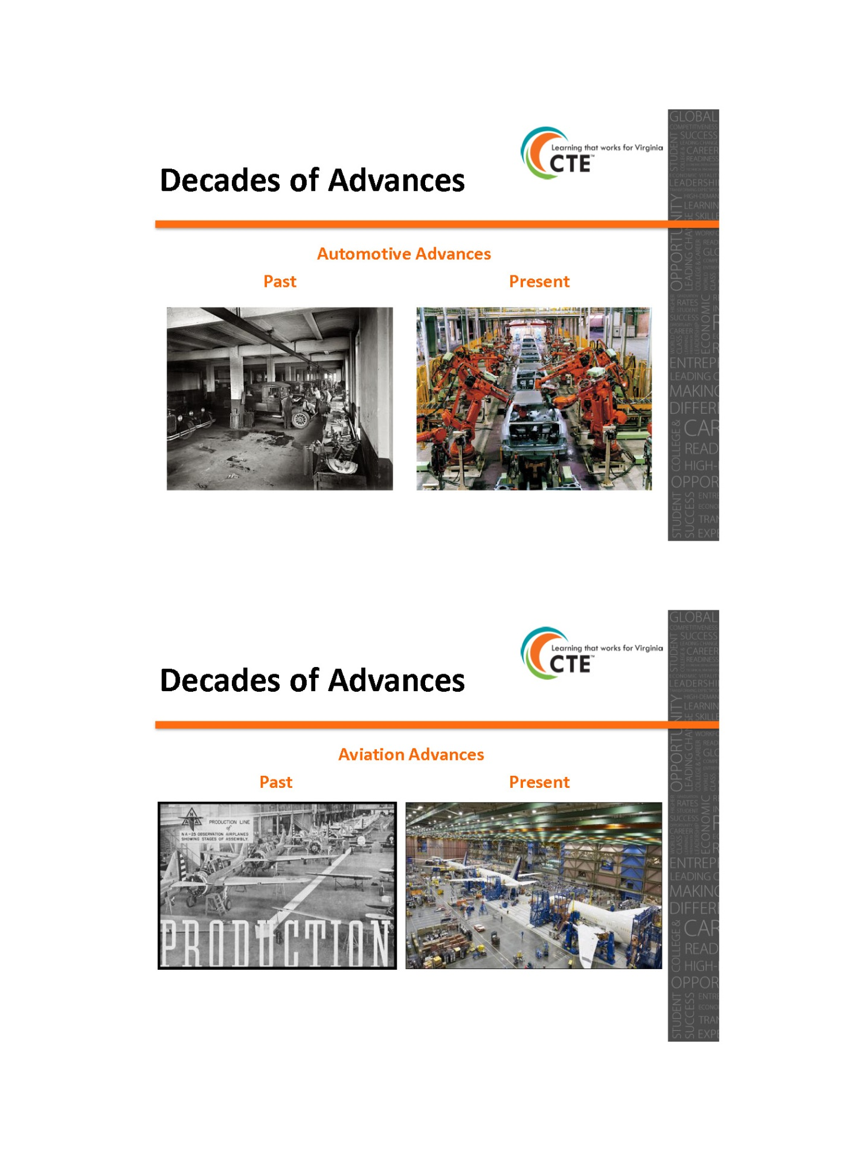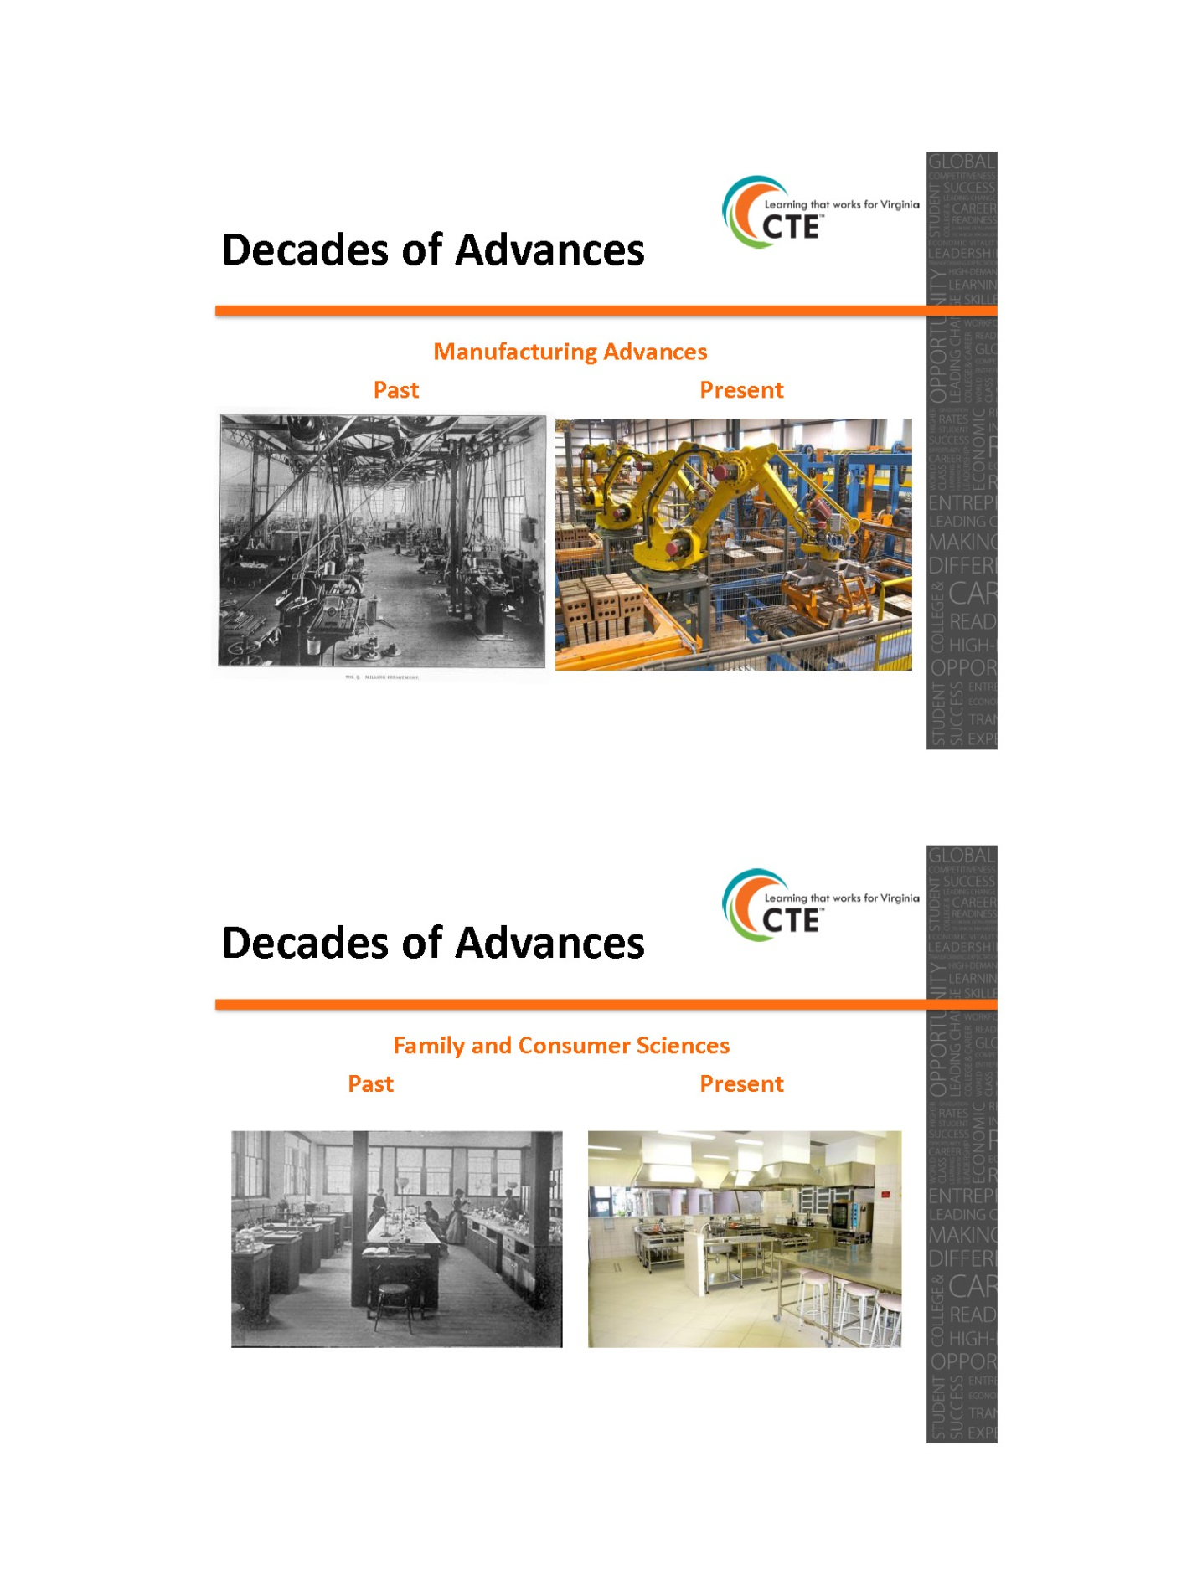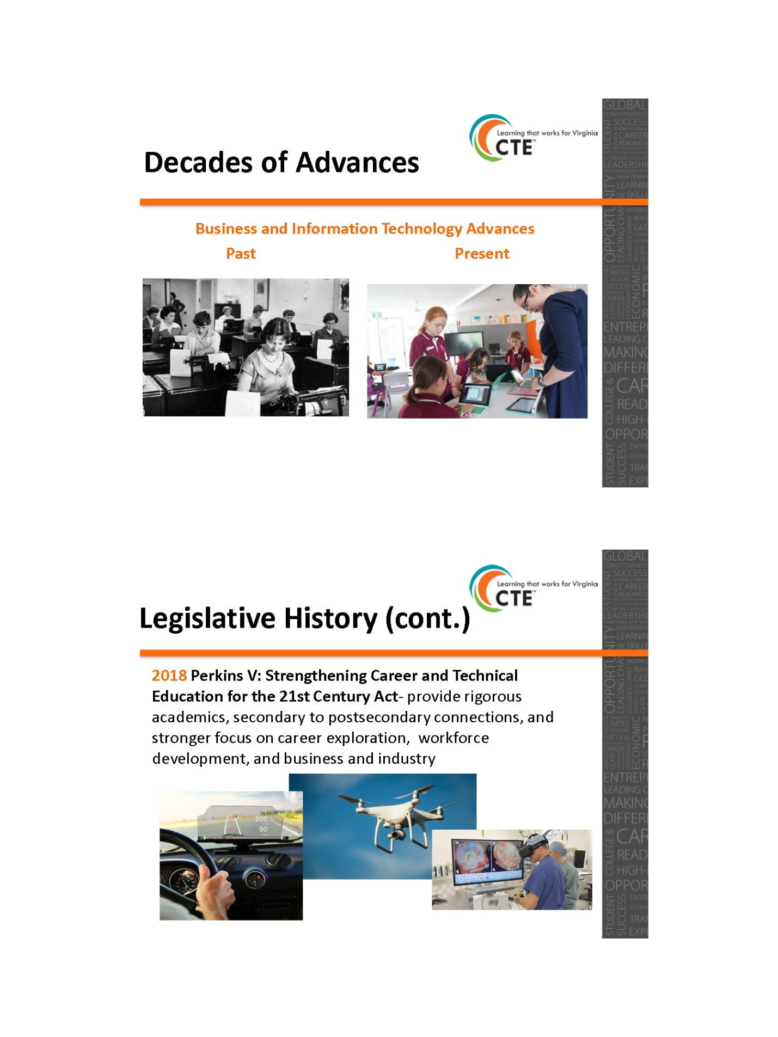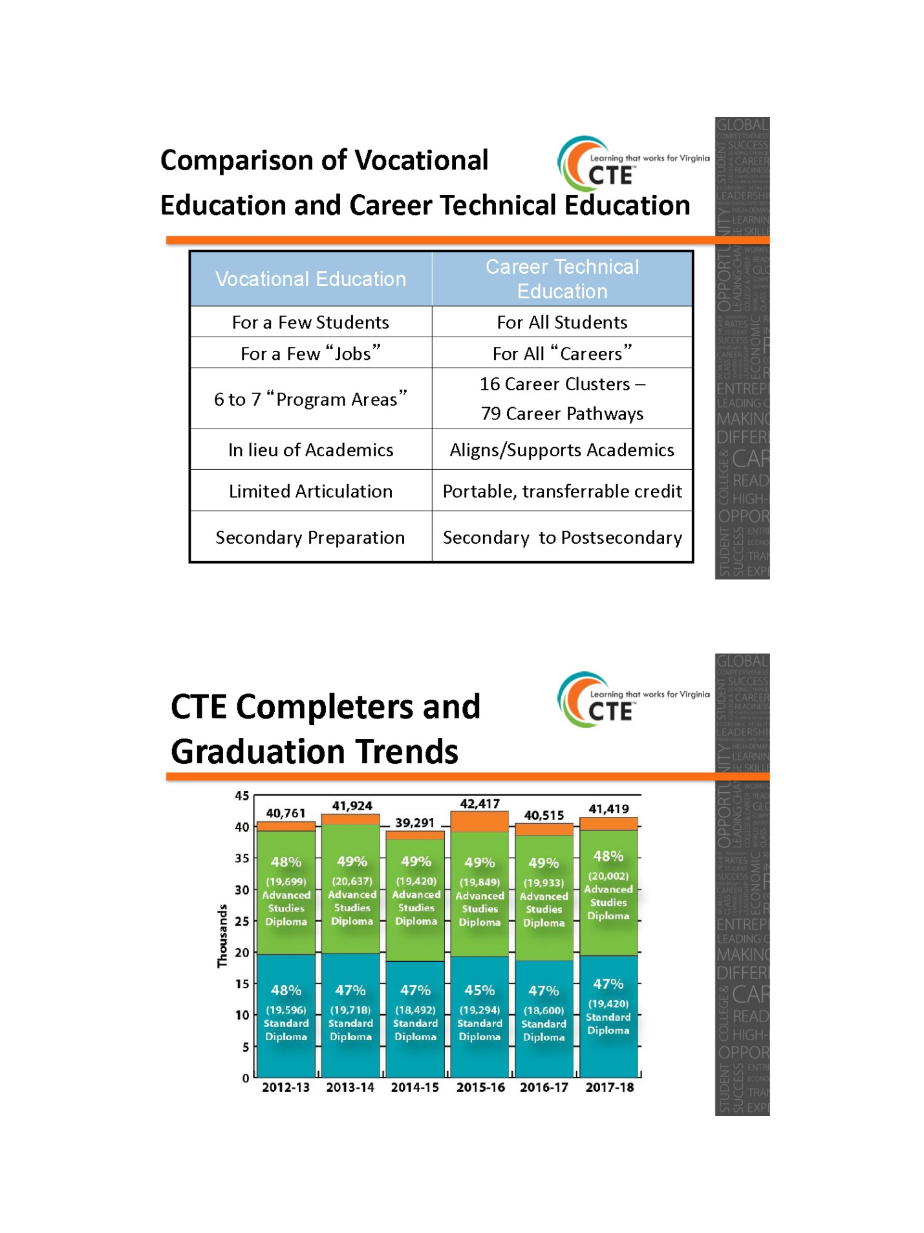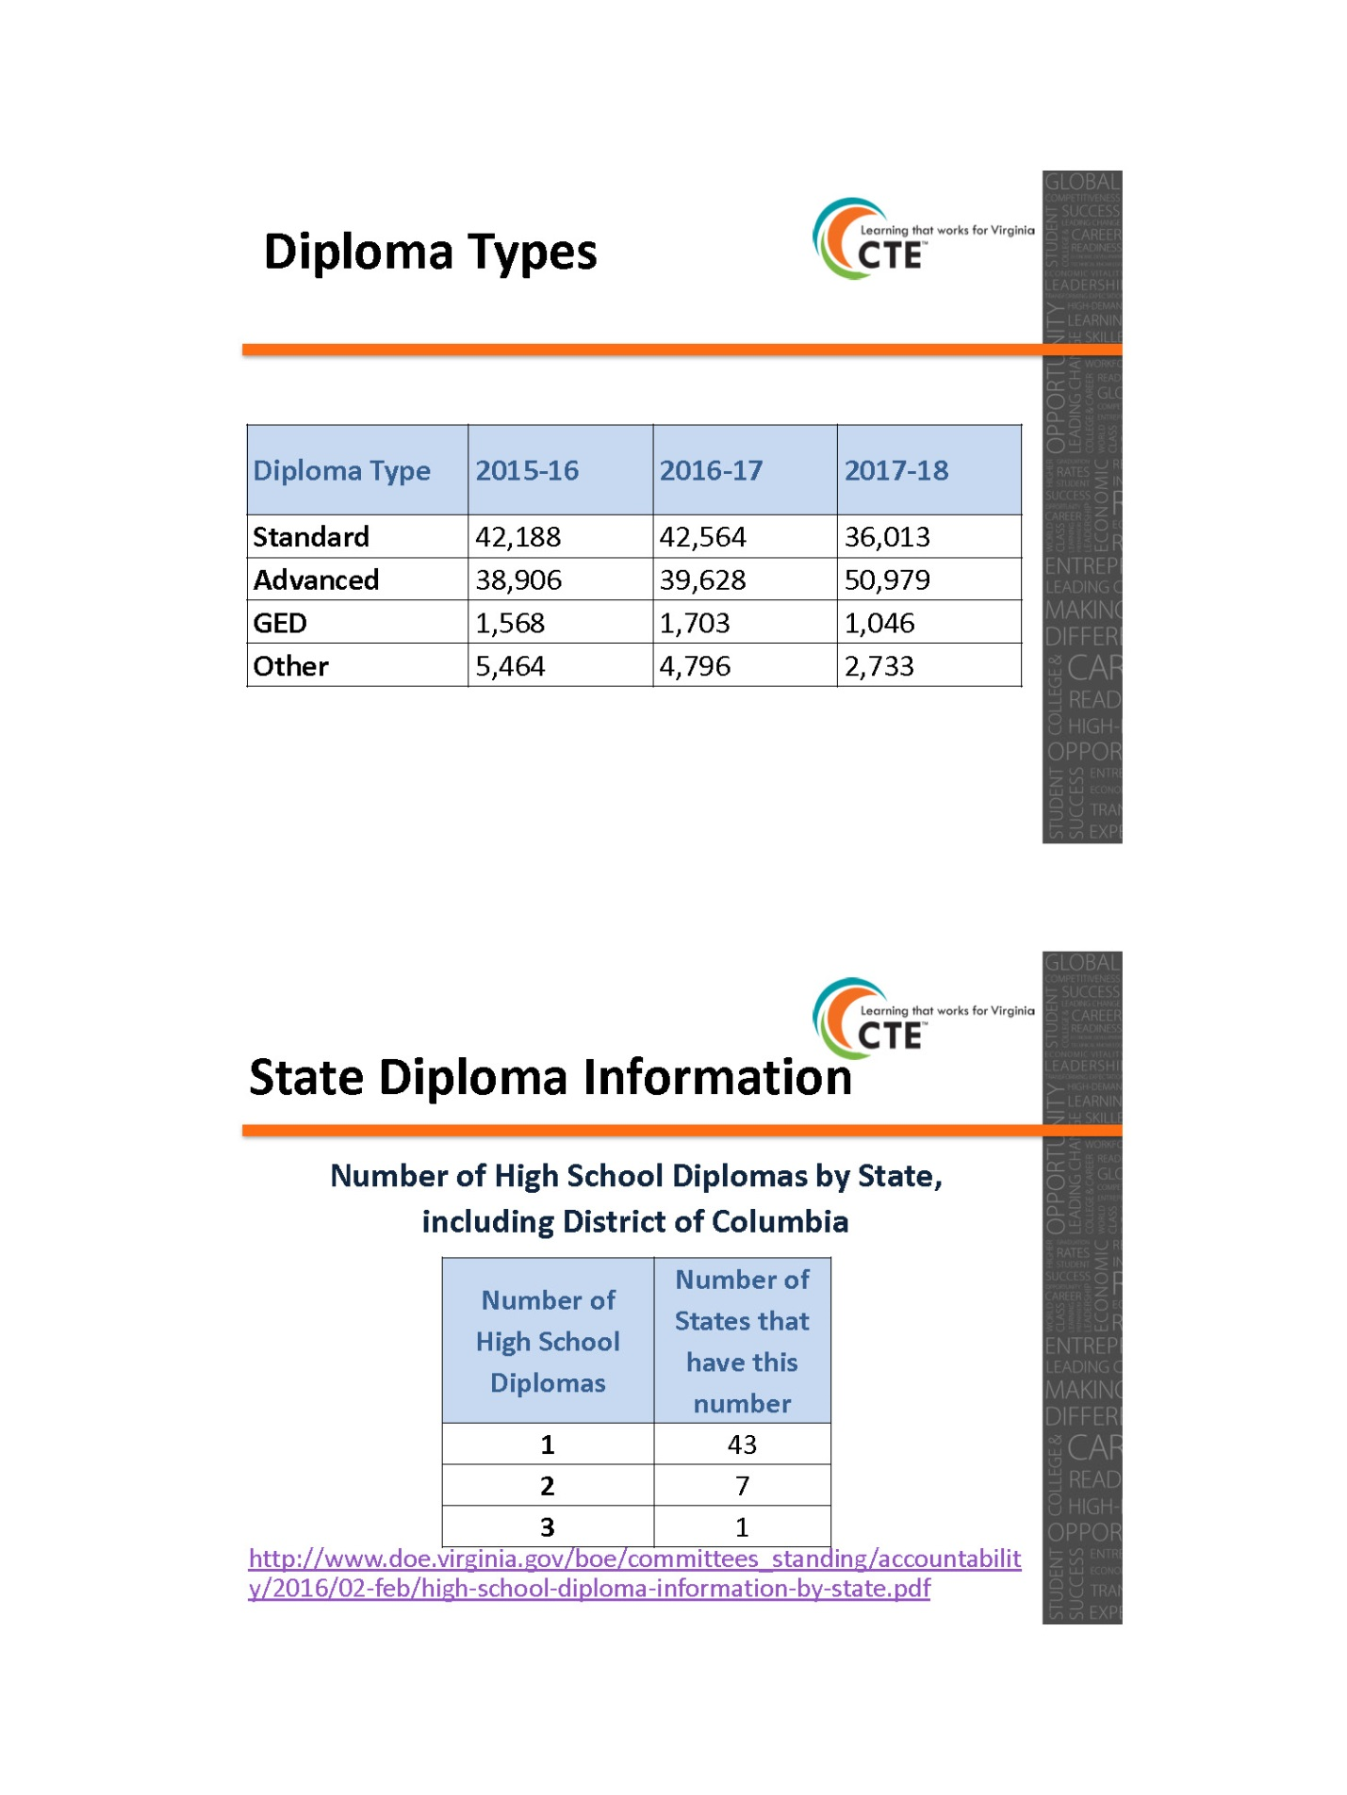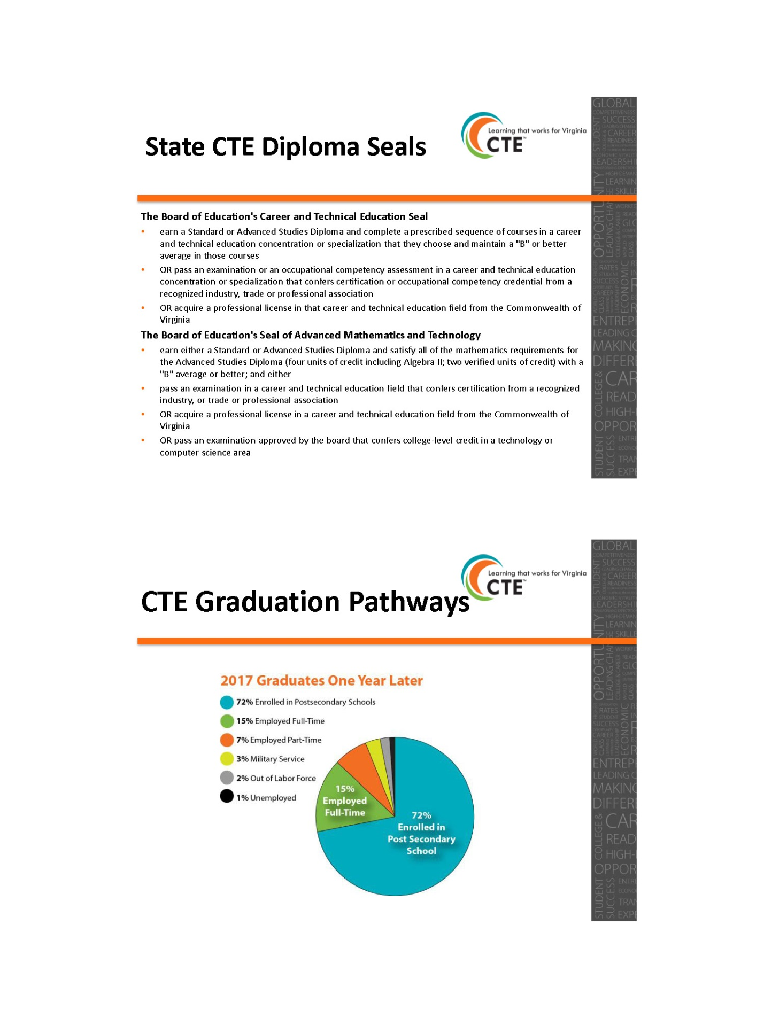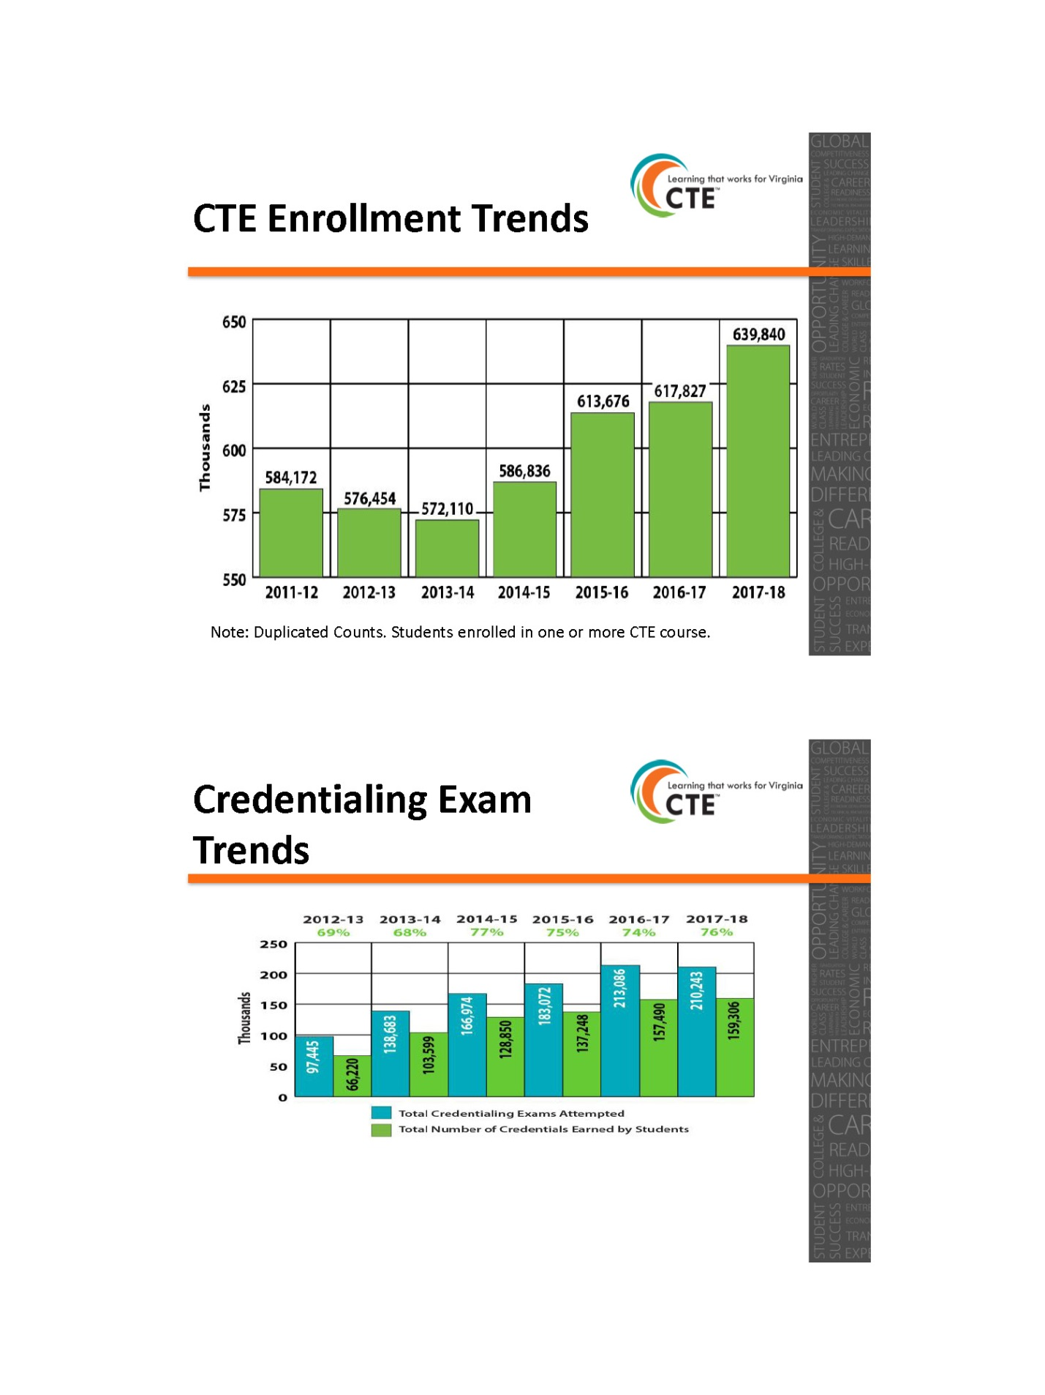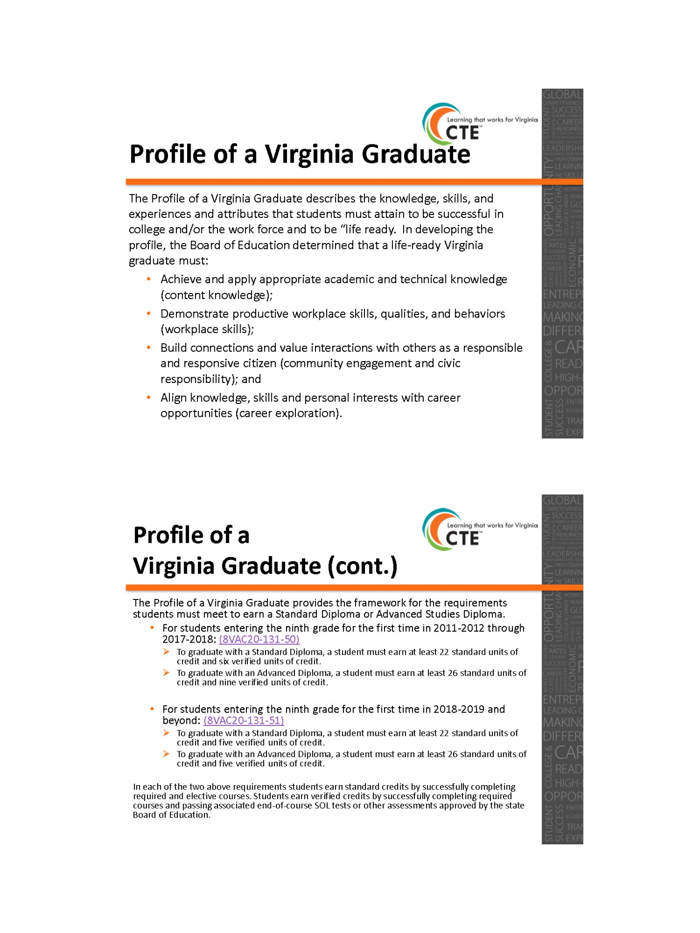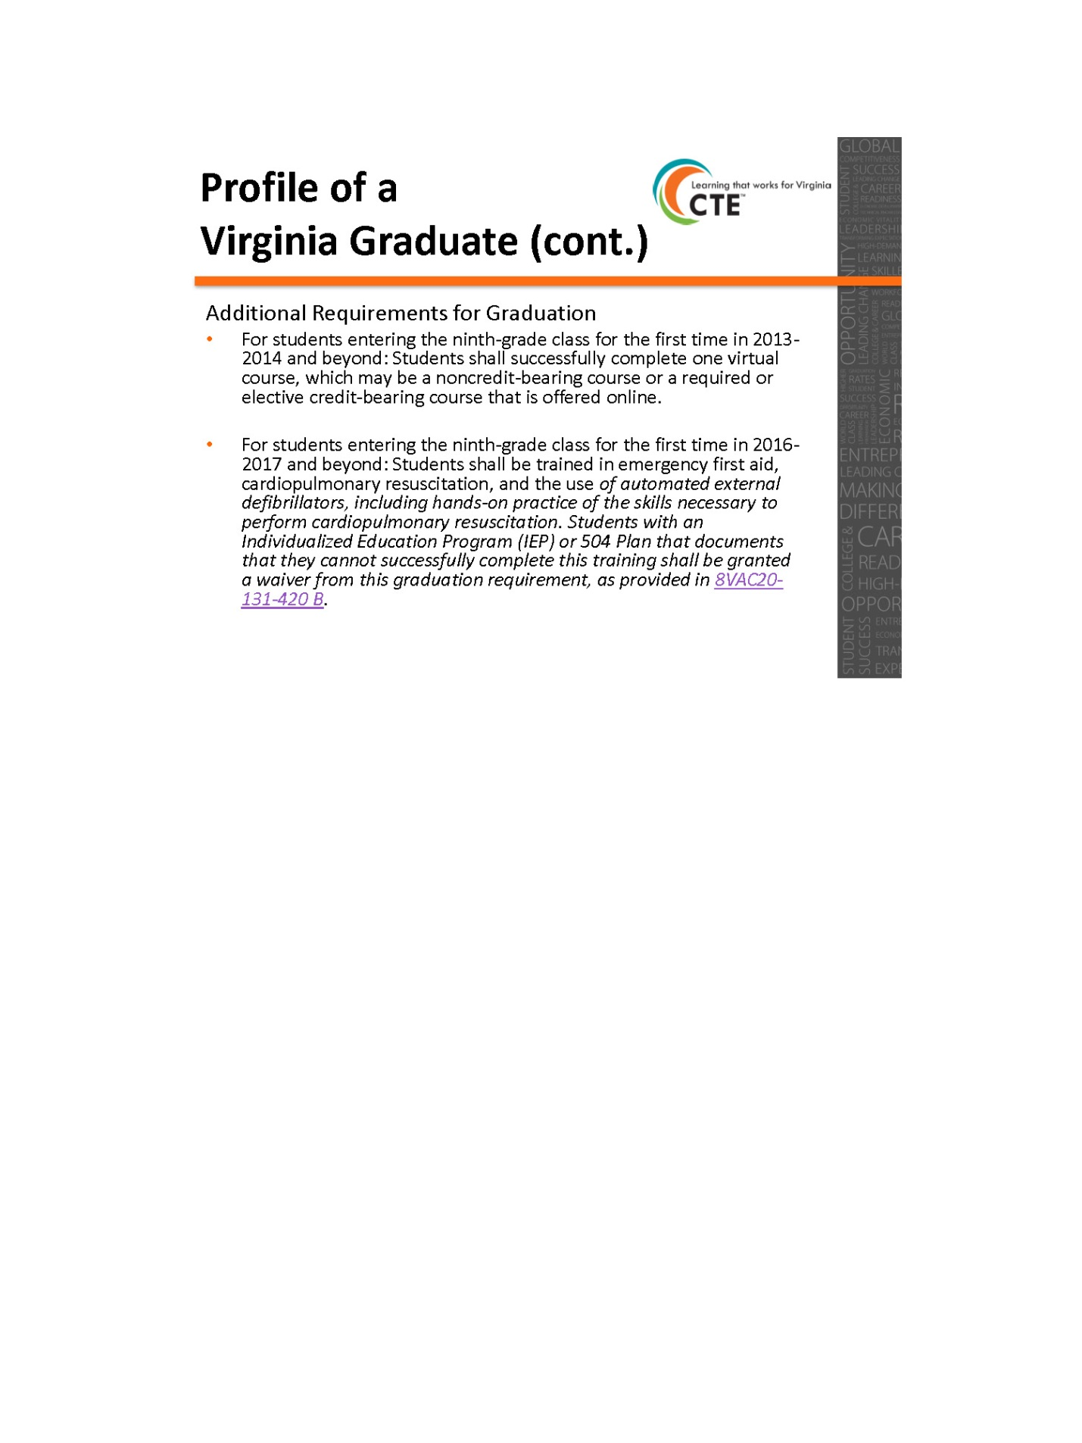

Appendix V: 12.12.18 Workgroup Meeting Handout - Strawman Proposal

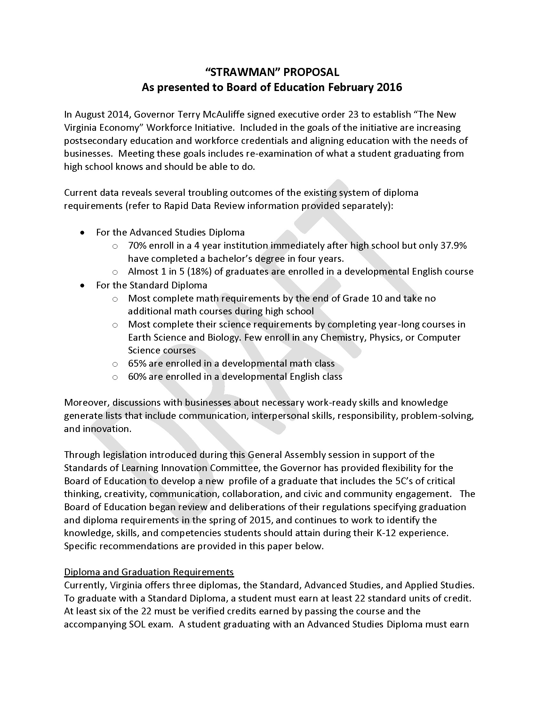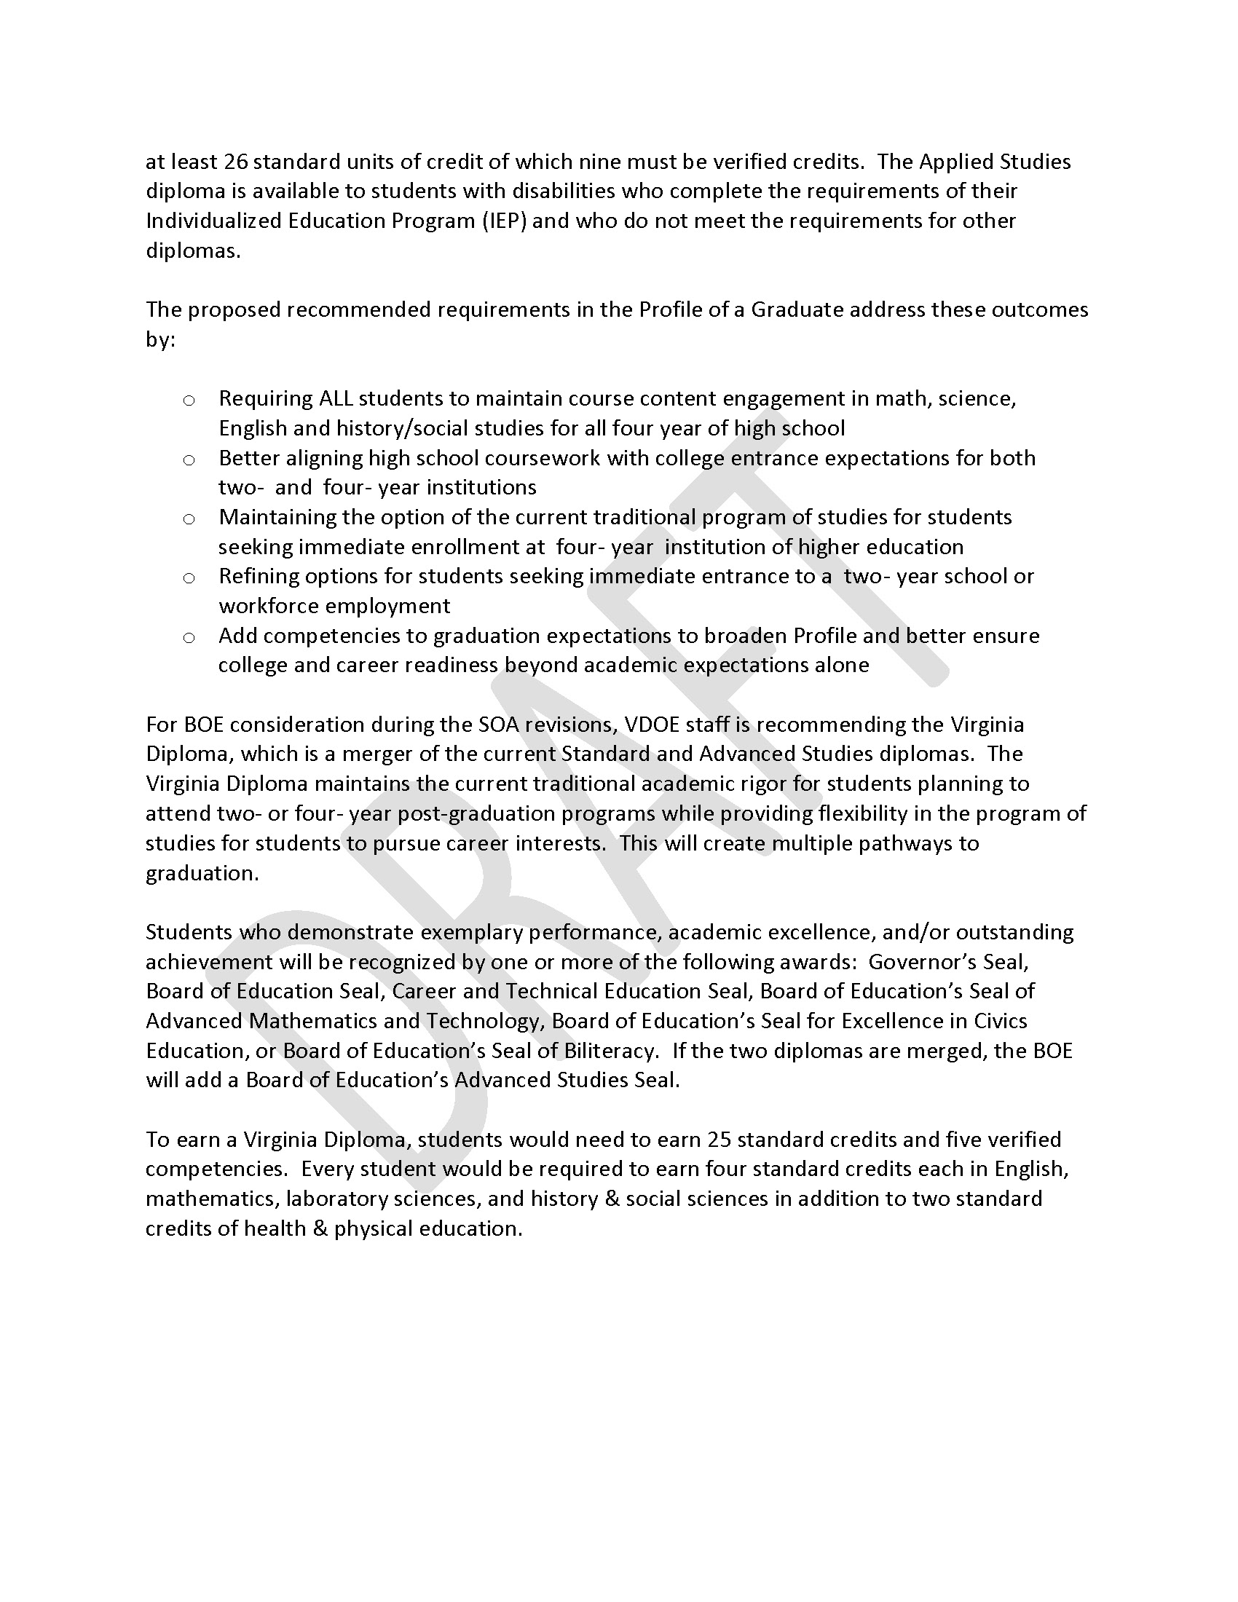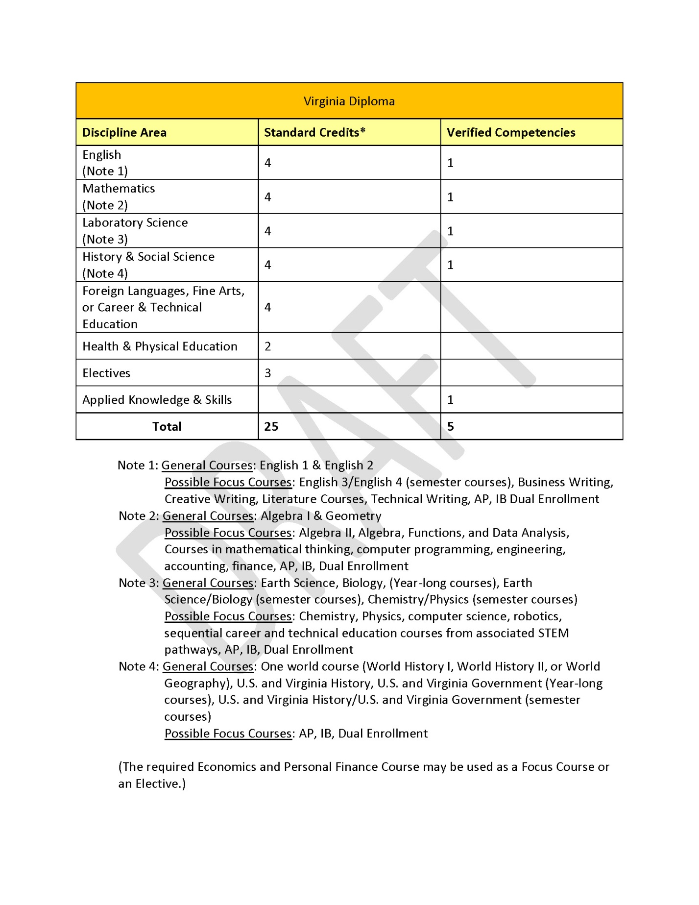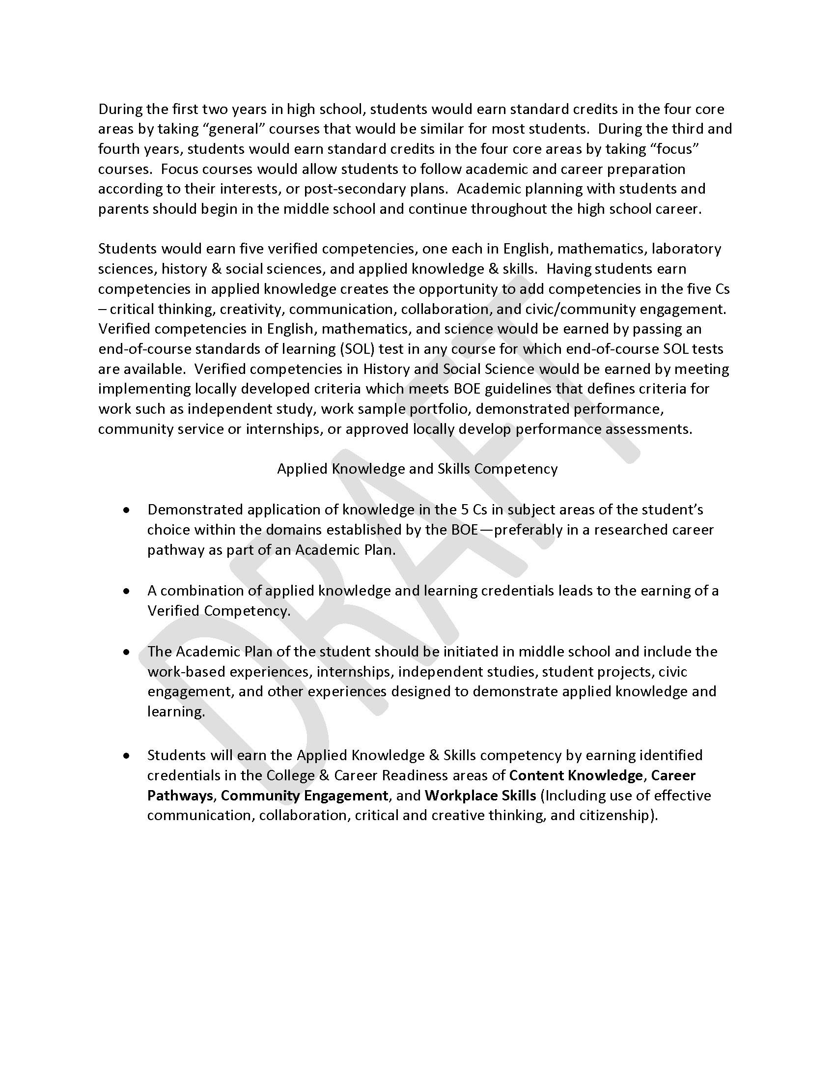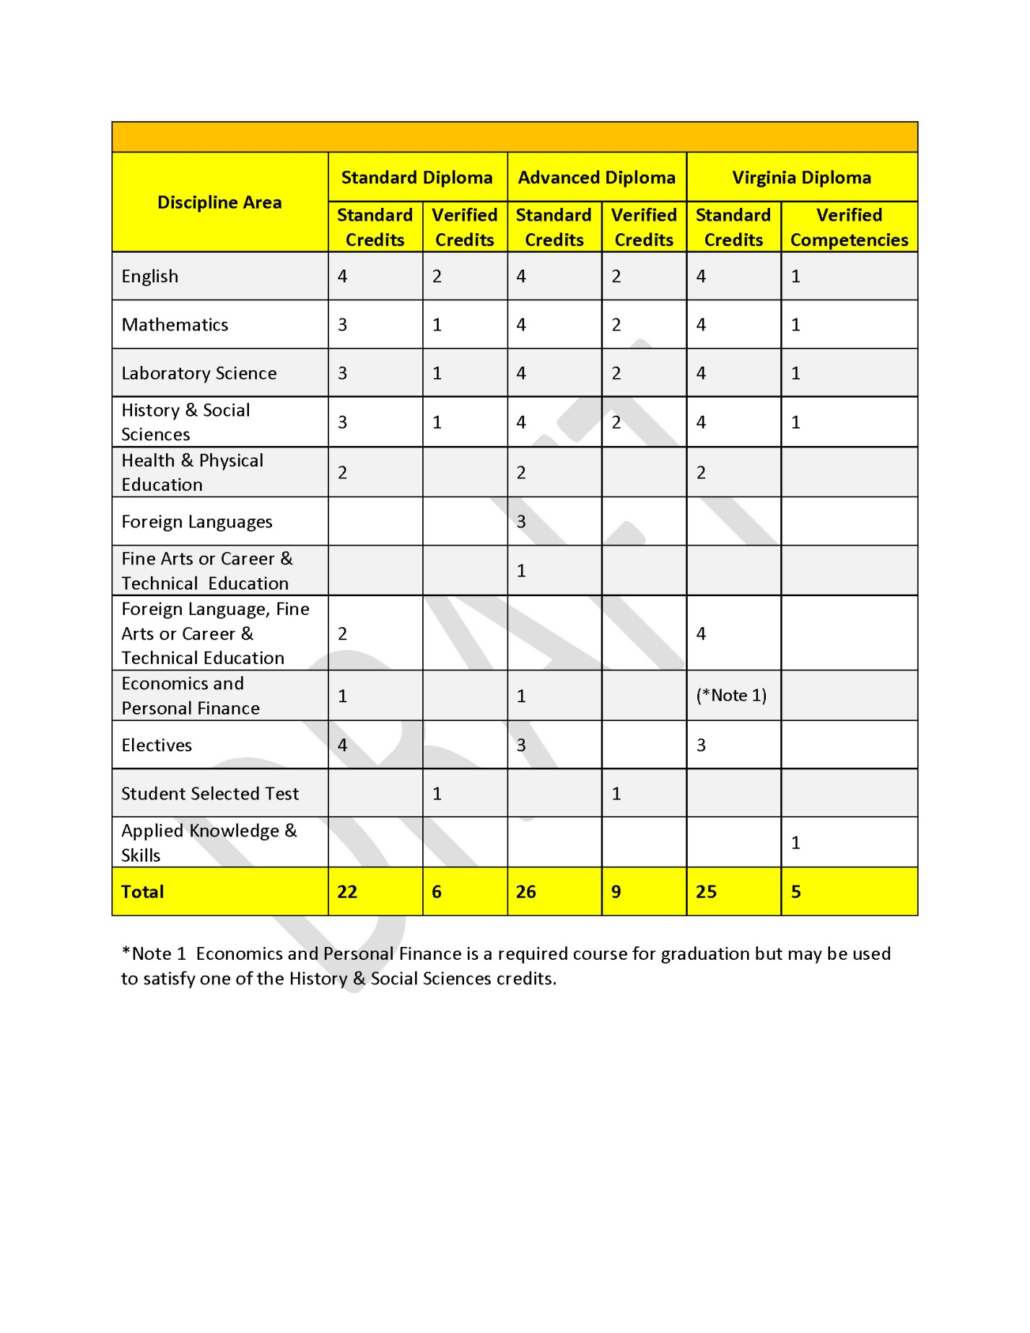

Appendix VI: 12.12.18 Workgroup Meeting Handout - One Diploma vs. Two Diplomas

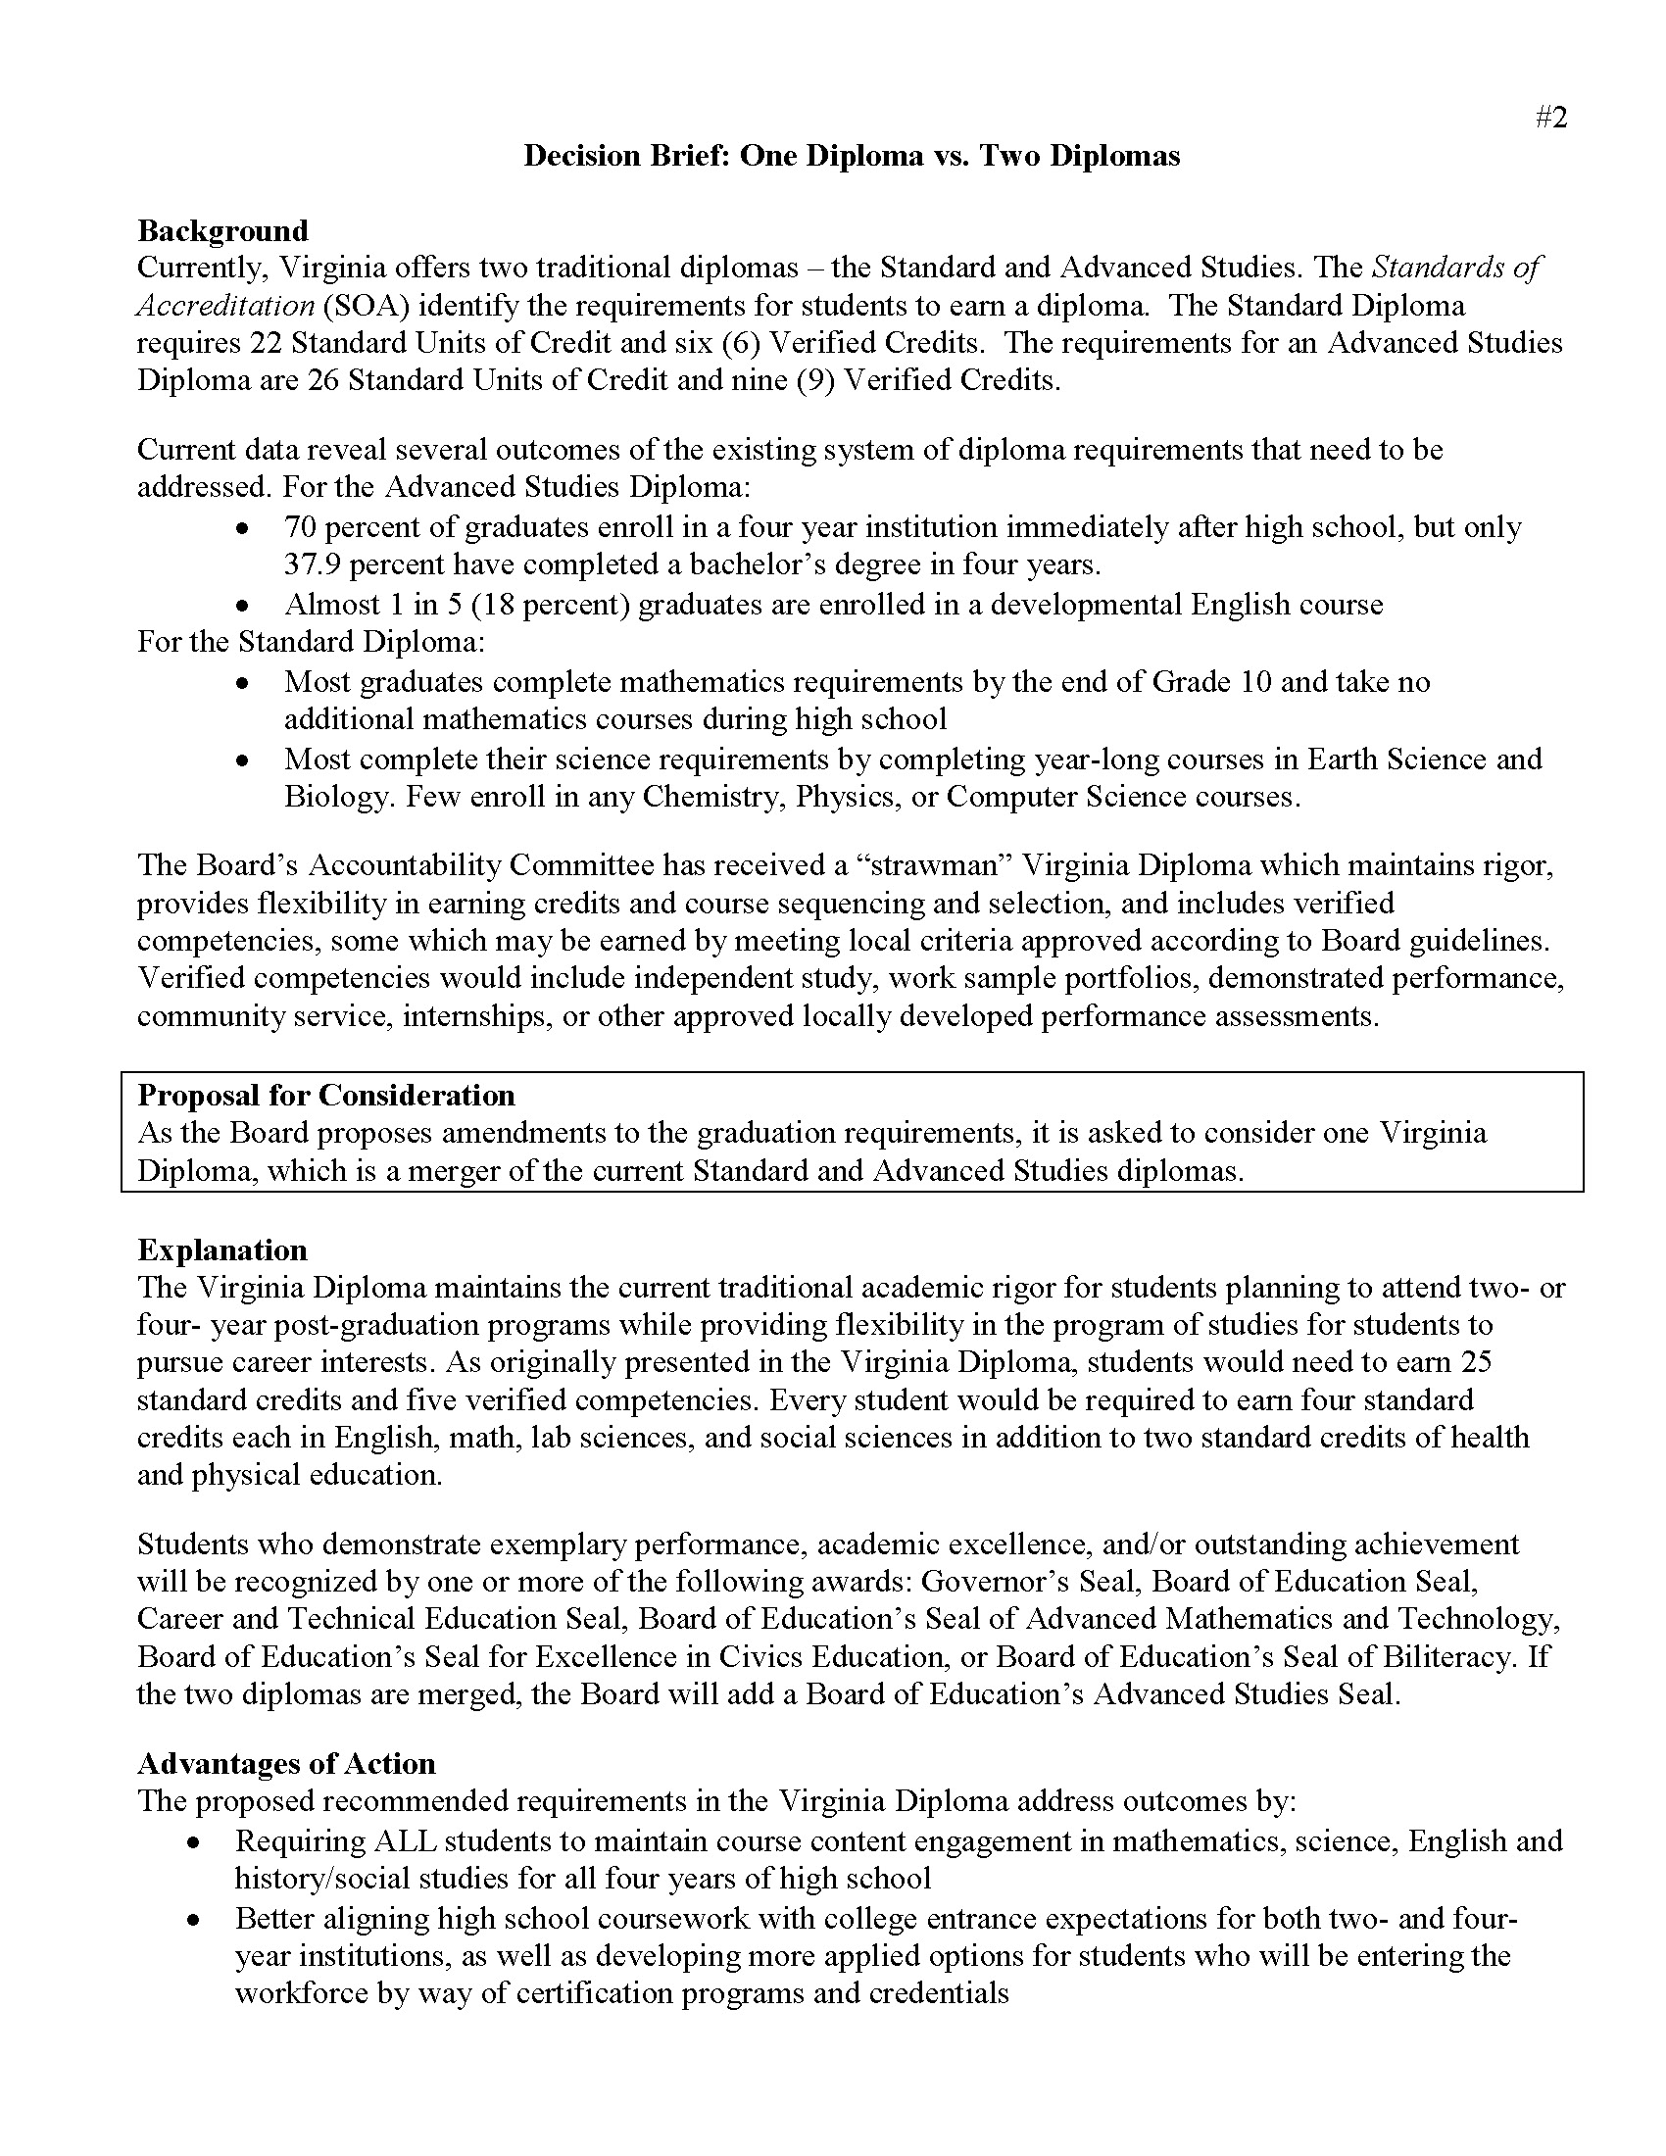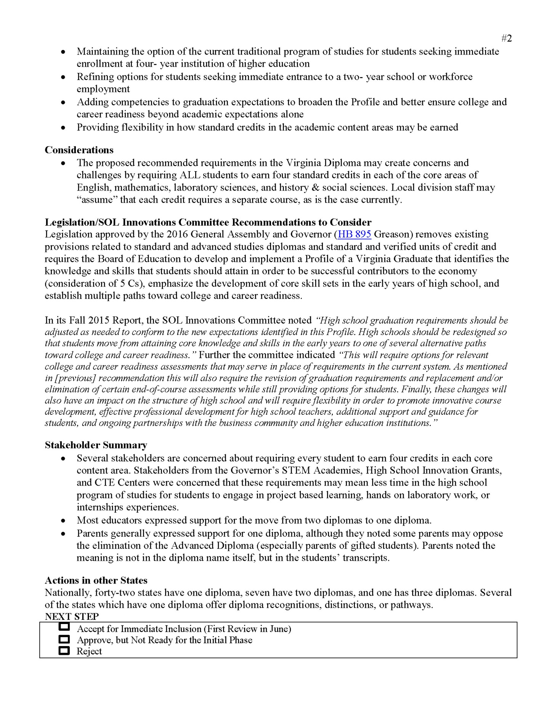

Appendix VII: Resources for Strategic Marketing Plan

Utilize research-based Advance CTE marketing resources:
- Messages:
  - Core Messages for Attracting Students to Career Technical Education: A description of the message triangle - or core motivators - that should be at the center of any communications effort.
  - Summary of Messages to Engage Parents & Students: An analysis of the messages that were tested with parents and students - and what worked and didn't
  - Value and Promise of Career Technical Education messaging card with fast facts.
  - The Value and Promise of Career Technical Education webinar recording
- Tools for using the messages and research:
  - Dos and Don'ts for Engaging Students and Parents around CTE: A simple, easy-to-follow resource on how to put the research into action.
  - The Value and Promise of Career Technical Education PowerPoint and Talking Points (Word, PDF): A set of slides, with talking points, that can be used to explain the research and train others around it.
  - Making a Winning Case for CTE: How State Leaders Can Put This Research to Work: A tool for state leaders on how to begin to build their communications and recruitment strategy.
  - Making a winning Case for CTE: How Local Leaders Can Put This Research to Work: A tool for local leaders on how to begin to build their communications and recruitment strategy.
  - Increasing Student Enrollment in CTE Programs: Parent Engagement Tool: A tool to help state and local leaders develop an effective strategy to engage parents and guardians.
- Advocacy:
  - The Value and Promise of Career Technical Education Fact Sheet: A brief overview of top-line findings to be used as an advocacy tool.
  - CTE Advocacy 101: An overview of how to advocate for CTE issues.
  - Putting Real-World Skills to Work: An Employer Guide for Making the Case for CTE: An overview of how the business community and employers can advocate for CTE.
- Capitalize on Strengths and Benefits of CTE
  - CTE helps students find a career passion, which was rated as the most critical selling point for parents and students, surpassing having a career that pays well in the 2017 Advance CTE survey.
  - CTE students perform at high levels academically (graduating from high school at higher rates than their peers who attend comprehensive academic programs and enrolling in postsecondary education programs at higher rates, too). According to Advance CTE’s 2017 survey, the graduation rate for CTE students is 93 percent, compared with a national average of 82 percent. In Virginia’s CTE programs, 2016-2017 data shows that 49 percent of CTE completers–students who have met the requirements for a CTE concentration and the requirements for graduation–graduate with an Advanced Studies Diploma.
  - Students and parents view college and career success both as important goals. In the 2017 Advance CTE survey, nearly 80 percent of CTE students plan to attend college, including 62 percent who plan to earn at least a bachelor’s degree.
  - CTE offers authentic, WBL experiences, which ensure that programs and courses have value for the students and the workforce.
  - CTE programs prepare students for a career, not just an entry-level job. Courses allow students to explore their interests in careers.
  - CTE offers opportunities for students to take CTE dual-enrollment, International Baccalaureate, and Advanced Placement courses.
  - CTE offers “contextualized learning,” in which students apply knowledge learned in their academic courses, work collaboratively, and solve real-world problems for a richer learning experience.
  - CTE parents are highly satisfied. In the Advance CTE 2017 survey, almost 90% of parents of CTE students were satisfied with their children’s opportunities to explore different careers and learn real-world skills, compared to 48% of parents of non-CTE students.

Endnotes

Aliaga, Oscar A. & Kotamraju, Pradeep & Stone, James R., III. “Understanding Participation in Secondary Career and Technical Education in the 21st Century: Implications for Policy and Practice.” The High School Journal, 97, no. 3 (2014); 128-158. doi:10.1353/hsj.2014.0002
See i above.
Herian, Mitchel, “Examining Public Perceptions of Career and Technical Education in Nebraska.” Publications of the University of Nebraska Public Policy Center. 35 (2010). http://digitalcommons.unl.edu/publicpolicypublications/35
“The Value and Promise of Career and Technical Education.” Silver Spring, MD: Advance CTE. (April 2017) Link: https://careertech.org/resource/value-and-promise-of-cte-results-from-a-national-survey
Etzwiler, David D. “Reframing How We Talk about Career and Technical Education.” Huffington Post (July 10, 2017). https://www.huffingtonpost.com/entry/reframing-how-we-talk-about-career-and-technical-education_us_596397c1e4b0cf3c8e8d5a66
Brand, Betsy, and Andrew Valent and Andrea Browning. “How Career and Technical Education Can Help Students be College and Career Ready: A Primer.” Washington, DC: College & Career Readiness & Success Center at American Institutes for Research. (2013)
See ii above.
"Core Messages for Attracting Students to Career Technical Education." Career Technical Education | Advance CTE. Accessed September 06, 2018. https://cte.careertech.org/sites/default/files/CoreMessages_CTEValue.pdf.
"CTE Month®." ACTE. Accessed September 06, 2018. https://www.acteonline.org/why-cte/cte-awareness/cte-month/.
See ii above.
"Raise the Visibility of CTE." Career Technical Education | Advance CTE. Accessed September 06, 2018. https://careertech.org/recruitmentstrategies.
See ii above.
Schwartz, R. Career and technical education. In M. Hansen & J. Valant (Eds.), “Memos to the President on the Future of U.S. Education Policy.” Washington, DC: Brookings Institution (2016).
See note ii above.
“Virginia Career and Technical Education: Program Highlights 2016-2017.” Richmond, VA: Virginia Department of Education Office of Career, Technical, and Adult Education (March 2018).
See ii above.
“Policy Platform: Career and Technical Education 2018 Edition.” Iowa City, IA: ACT (2018). https://www.act.org/content/dam/act/unsecured/documents/pdfs/Policy-Platform-CTE-2018.pdf
See ii above.

