Virginia Board of Education Agenda Item

Agenda Item: L

Date: September 17, 2020

Title: Written Report on Drive 2025, the Virginia Department of Education’s Strategic Plan

Presenter: John Hendron, Coordinator of Organizational Development and Advancement, Office of the Superintendent

Email: john.hendron@doe.virginia.gov Phone: (804) 225-4387

Purpose of Presentation:
For information only. No action required.

Executive Summary:
Starting in June 2019, leaders within the Virginia Department of Education met to create a strategic plan to set a common agenda for Department activities through 2025. The plan’s development was completed through a number of committee meetings led by a former employee, Ms. Monica Smith-Callahan, the Leadership Team, and final work was completed by the Superintendent’s Cabinet. This work resulted in the formation of a strategic plan that includes an updated vision and mission for the Department, a set of Core Values and Core Skills, and three goals with objectives and strategies. The three priorities of the Board were considered as the team developed the plan.

The plan was officially presented to the Department during an All Agency meeting on January 28, 2020. Due to personnel changes and the arrival of the requirement of a coordinated response to COVID-19, plan activities were put on hold.

Starting in August, the Department has organized professional learning opportunities for staff around the values included in this strategic plan offered during 1-hour lunch and learn sessions through video conference. In addition, the Department is prototyping an objective dashboard to track progress within the plan, and a template for offices to generate tactics in alignment with the strategies within the plan. This new process will help rally every member of the Department around the strategic plan and drive success toward meeting the objectives within the plan.

Both the vision and mission statements used by the Department were modified to be more memorable and clear. The vision for an organization articulates the difference we want to make. The vision selected is: Virginia will maximize the potential of all learners. The mission of an organization articulates what the members of the organization will do to realize the difference stated in the vision, to answer why we exist. The mission of the Department is to advance equitable and innovative learning.

The values of an organization act as a moral compass in how we address leadership decisions. The values of an organization should serve to support the culture of the organization. Beyond selecting four core values for the Department, we chose to integrate the development for all employees through a set of core skills which echo the 5C’s from the Profile of a Virginia Graduate.

Core values:
- Excellence
- Inclusion
- Optimism
- Service

Core Skills:
- Critical Thinking
- Creative Thinking
- Communication
- Collaboration
- Citizenship

The three goals of the Drive 2025 plan are organized around student success, educator success, and the Department’s success. The complete plan is included as Attachment A. Future work on the strategic plan will be to re-form committees to establish which metrics align with the plan’s objectives to monitor progress on an annual basis. In addition, Directors in the Department will be trained on how to use the tactical template to organize efforts around fulfilling the prescribed strategies of the plan.

Action Requested:
No action requested

Superintendent’s Recommendation:

The Superintendent for Public Instruction recommends the Virginia Board of Education receive this written report.

Previous Review or Action:
No previous review or action.

Background Information and Statutory Authority:
This new plan replaces a previous vision and mission for the Department.

The previous vision statement was: The vision of the Virginia Department of Education, in collaboration with the governor, secretary of education, General Assembly, Virginia Board of Education, local school boards, education stakeholders, and parents, is to create an excellent system of public education that prepares every Virginia student for success.

The previous mission statement was: The mission of the Virginia Department of Education is to
lead and facilitate the development and implementation of a quality public education system that meets the needs of students and assists them in becoming educated, productive, responsible, and self-reliant citizens.
Timetable for Further Review/Action:
Yearly report of progress.

Impact on Fiscal and Human Resources:
None.

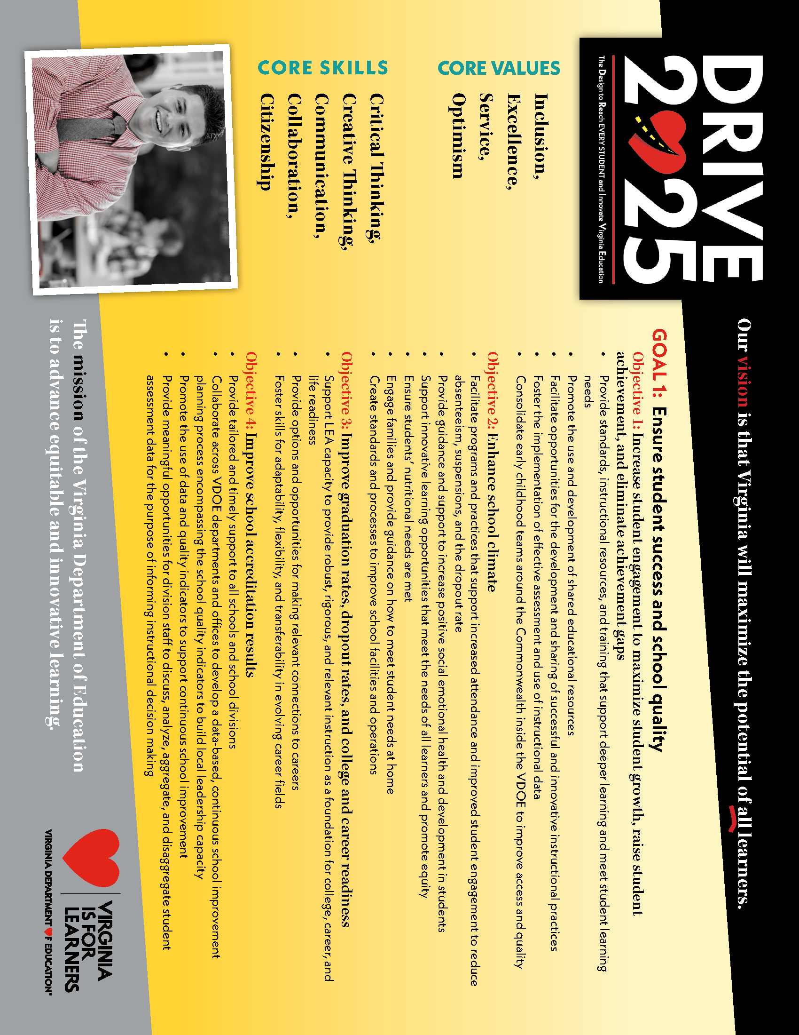
Attachment A
