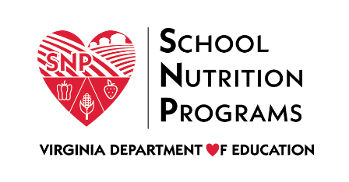

FEDERAL PROGRAM ADMINISTRATIVE REVIEW
SCHOOL NUTRITION PROGRAM SUMMARY
Section 207 of the Healthy Hunger Free Kids Act 2010, amended section 22 of the National School Lunch Act (42 U.S.C. 1769c) requires the Virginia Department of Education, Office of School Nutrition Programs (VDOE SNP), to report the final results of the administrative review to the public in an accessible, easily understood manner in accordance with guidelines promulgated by the Secretary.
Local Educational Agency: Loudoun County Public Schools
Report Publication Date: October 8, 2020
Administrative Review Dates: May 4 – June 4, 2020
Review Month and Year: February 2020
Participating Programs: NSLP, SBP, SFSP, CACFP
Participates in Special Provisions? Provision 2

Findings Identified during the Administrative Review:

Table 1: Program Access and Reimbursement
Category | Findings
Certification and Benefit Issuance | NO FINDINGS
Details:
Verification | FINDINGS IDENTIFIED
Details: | One application selected for verification was not error-prone.
Meal Counting and Claiming | NO FINDINGS
Details:

Table 2: Meal Patterns and Nutritional Quality
Category | Findings
Meal Components and Quantities | FINDINGS IDENTIFIED
Details: | One entrée did not meet the minimum daily meal pattern requirements.  One site did not offer at least two diferent varieties of milk.
Offer versus Serve | FINDINGS IDENTIFIED
Details: | Production records indicated that the fruit and/or vegetable requirement was not met.
Dietary Specifications and Nutrient Analysis | NO FINDINGS
Details:

Table 3: School Nutrition Environment and Civil Rights
Category | Findings
Food Safety |  | NO FINDINGS
Details:
Local School Wellness Policy |  | NO FINDINGS
Details:
Competitive Foods |  | NO FINDINGS
Details:
Civil Rights |  | NO FINDINGS
Details:
USDA is an Equal Opportunity Provider, Employer and Lender.

