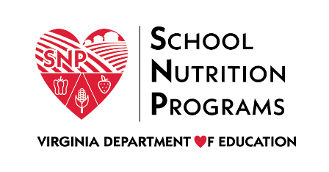

FEDERAL PROGRAM ADMINISTRATIVE REVIEW
SCHOOL NUTRITION PROGRAM SUMMARY
Section 207 of the Healthy Hunger Free Kids Act 2010, amended section 22 of the National School Lunch Act (42 U.S.C. 1769c) requires the Virginia Department of Education, Office of School Nutrition Programs (VDOE SNP), to report the final results of the administrative review to the public in an accessible, easily understood manner in accordance with guidelines promulgated by the Secretary.
Local Educational Agency: Hopewell City Public Schools
Report Publication Date: February 9, 2022
Administrative Review Dates: October 26-29, 2021
Review Month and Year: August 2021
Participating Programs: NSLP, SBP, SSO
Participates in Special Provisions: CEP

Findings Identified during the Administrative Review:

Table 1: Program Access and Reimbursement
Category | Findings
Certification and Benefit Issuance | Not applicable for school year 2021-2022
Details: | N/A
Verification | NO FINDINGS
Details: | N/A
Meal Counting and Claiming | FINDINGS IDENTIFIED
Details: | Meal counts were not taken at the point of service.

Table 2: Meal Patterns and Nutritional Quality
Category | Findings
Meal Components and Quantities | FINDINGS IDENTIFIED
Details: | Two varieties of milk were not offered at breakfast.
Offer versus Serve | FINDINGS IDENTIFIED
Details: | Signage did not meet regulatory requirements.
Dietary Specifications and Nutrient Analysis | NO FINDINGS
Details: | N/A

Table 3: School Nutrition Environment and Civil Rights
Category | Findings
Food Safety |  | FINDINGS IDENTIFIED
Details: |  | The food safety plan was not site specific.
Local School Wellness Policy |  | FINDINGS IDENTIFIED
Details: |  | The local school wellness policy did not meet all regulatory requirements.
Competitive Foods |  | NO FINDINGS
Details: |  | N/A
Civil Rights |  | NO FINDINGS
Details: |  | N/A
USDA is an Equal Opportunity Provider, Employer and Lender.

