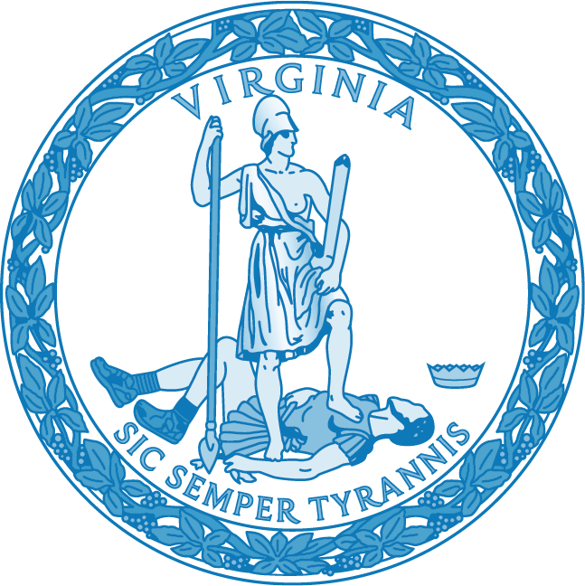

INTERIM GUIDELINES FOR THE
AFRICAN AMERICAN HISTORY REQUIREMENT FOR INDIVIDUALS
SEEKING AN INITIAL LICENSE OR
LICENSE RENEWAL WITH AN ENDORSEMENT IN HISTORY AND
SOCIAL SCIENCES

VIRGINIA BOARD OF EDUCATION

INTERIM GUIDELINES FOR THE AFRICAN AMERICAN HISTORY REQUIREMENT FOR INDIVIDUALS SEEKING AN INITIAL LICENSE OR LICENSE RENEWAL WITH AN ENDORSEMENT IN HISTORY AND SOCIAL SCIENCES

Authorizing Legislation
Senate Bill 1196 (Locke) and House Bill 1904 (Jenkins), both also known as the Culturally Competent Virginia Educators Bill, were passed during the 2021 Session of the General Assembly, signed into law by the Governor, and become effective on July 1, 2021. These bills mandate, in part, the following:

Every person seeking initial licensure or renewal of a license with an endorsement in history and social sciences shall complete instruction in African American history, as prescribed by the Board.

In alignment with the bills’ effective date, this licensure requirement becomes effective on
July 1, 2021. Therefore, the Board of Education is establishing interim guidance to ensure that educators seeking an initial license or license renewal with an endorsement in history and social sciences have options to meet the above component of the statute beginning July 1, 2021.
The interim guidance will be effective following approval from the Board of Education and the public comment process on Town Hall. The Guidelines will remain in effect until revision by the Board of Education.

Background
On August 24, 2019, at Old Point Comfort, the site where the first enslaved Africans arrived on Virginia shores 400 years earlier, Governor Ralph Northam signed Executive Order Thirty Nine and announced the establishment of the Virginia African American History Education Commission. The Governor charged the Commission with thoroughly examining the Commonwealth’s K-12 curricula, professional development practices, and instructional support to make recommendations for improving the way African American history is taught in Virginia schools. Governor Northam appointed a diverse, talented, and vibrant group of individuals to serve on this Commission including educators, historians, museum curators, school board members, faith leaders, school administrators, and citizens across the Commonwealth.

Even though Virginia led the nation in developing high quality content standards more than 25 years ago, the standards presented a master narrative that marginalized or did not recognize the presence of non-Europeans as a part of the American landscape. These historical silences skew our perspective of the past, erasing people of color, and supplanting them with false narratives that ignore the diverse cultural underpinnings in American society. While revised regularly by historians and experts, Virginia’s History and Social Science Standards of Learning continue to be incomplete with regards to incorporating African American history into the larger narrative. Therefore, the Governor's Commission on African American History Education in Virginia was tasked with making recommendations to ensure that the standards are more inclusive of African American history and provide opportunities for students to engage the content deeply, drawing connections to its relevance in our contemporary communities.

Understanding history imbues citizens with a deep and complex knowledge about their community and their nation. An effort to change the way citizens of Virginia are educated about history, with a special emphasis on incorporating African American history into the larger narrative, has never been more important.

In the final report, the Commission offers extensive recommendations to ensure that content in Virginia schools is accurate, inclusive, and relatable, and to equip educators with the skills necessary to teach in a culturally responsive manner. In order to ensure accuracy, inclusivity, and relevance, the 2021 Virginia General Assembly passed legislation that further supports the recommendations of the Commission to enable all Virginia students to develop a comprehensive understanding of the African American voices that contribute to Virginia’s story.

Expectations of Guidance
Many educators employed by the Commonwealth’s school divisions have not taken a course or received professional development on teaching African American history and thus may not have the knowledge necessary to present students with a full and comprehensive representation of African American voices. Additional robust professional development is needed that outlines specific knowledge required to teach African American history.

Effective July 1, 2021, only the Options and Evidence set forth in this Guidance will meet the African American history requirements for individuals seeking an initial license or license renewal with a history and social science endorsement. The Virginia Board of Education authorizes the Virginia Department of Education to approve additional courses or professional development aligned with the Board’s requirements.

Options to Meet the Licensure Requirement in African American History
Educators seeking an initial license or licensure renewal with an endorsement in history and social sciences may meet this statutory requirement by:
- successfully completing the Virginia Department of Education African American History Course for Educators; or
- submitting documentation of the demonstration of evidence in each required objective as set forth in this Guidance.

Demonstration of Evidence
Effective July 1, 2021, educators are required to submit evidence of the completion of one of the following options to meet the African American History requirement for individuals seeking an initial license or license renewal with an endorsement in History and Social Sciences:

- Certificate of Successful Completion of the Virginia Department of Education African American History Course for Educators;
- Verification letter from the Dean of an accredited College or University attesting to an individual serving as an Instructor of Record teaching an African American history course within the most recent 10 years of the licensure request; or
- Official transcript of successful completion of an African American history course (undergraduate/graduate through an accredited college or university) within the most recent 10 years of the licensure request.

High quality African American History Instruction Requirements
Virginia’s objective for high quality instruction in African American history is to equip history educators with the historical content knowledge that is accurate, inclusive, and relevant in Virginia schools. In order to meet this requirement, every person seeking initial licensure or renewal of a license with an endorsement in history and social sciences shall complete instruction in African American history that must be:

- approved and/or sponsored by the Virginia Department of Education;
- appropriate for all educators and delivered by individuals who have demonstrated qualifications and credentials in the discipline of history, specifically African American history.
- available for virtual participation by individuals statewide, with opportunities for live interaction and discussion with participants and course leaders;
- aligned with the content requirements outlined in this Guidance; or
- aligned to meet opportunities for educators to apply culturally responsive and inclusive pedagogy.

I. Content - High quality African American history instruction must include the following topics:
- African origins and the African diaspora
- Power, Oppression and Racism
- Agency, Resistance and Perseverance
- Black Identities
- Black Joy and Contention
Black Historical Consciousness Principles
by Dr. LaGarrett King, University of Missouri

- Understanding African origins, the African diaspora, and developments of the Black experience in North America
The study of African origins and the African diaspora provides an understanding that Black history did not start with the enslavement of Africans, the Trans-Atlantic trade or first contact with Europeans. The study of African societies provides an opportunity to understand the continent of Africa, its people, languages, cultures, and countries. Through the study of the Diaspora, there is a greater understanding of the similarities and differences of Black histories around the world. High quality African American history instruction must begin with ancient African history and connect to Black histories within the United States and around the world.

- How the institution of slavery in the United States established Power, Oppression and Racism
Through the study of power, oppression and racism, there is an understanding of how African Americans have been victimized through institutions, systems, policies, laws, and individuals. Through this examination, educators should be able to connect how the values that established the United States (justice, freedom, equality, equity, rule of law, democracy) have been intentionally ignored throughout Black history. Through the social construct of race, Black histories have been marred with instances of racism, oppression, and paralized efforts for change. High quality African American history instruction must identify and acknowledge systems of oppression in place, contextualize the powerful systems and structures of the past and connect with the relevance to the present.

- Agency, Resistance, and Perseverance: The Black Experience and how African Americans helped shape and have been shaped by American society
Counter to the victimization of African Americans in the United States is the study of agency, resistance, and perseverance. Although there are many examples of victimization, African Americans have also worked within and in spite of oppression and racism to make their own decisions and fought back to advance. Similarly, African American history many times tells a singular narrative of suffering, inferring a passive acceptance of the conditions that are coupled with oppression and racism. Black history is not about developing sympathetic figures; instead, it exposes how their humanity shaped and constructed world ideologies and practices. High quality African American history instruction must include an exploration of Black agency such as the resistance and rebellions to the institution of slavery by enslaved and free Blacks, the maroon experience, or the development of social organizations.

- Black Identities: Differing Perspectives
Through the study of Black identities, there is an opportunity to explore a more complete, diverse, and equitable history of African Americans. Consistently, Black history is presented through and from the perspective of the stories of middle class, heterosexual, Christian black men. High quality African American history instruction must include an exploration of Black identities that include women, the LGBTQA community, the Black poor and working class, radicals and conservatives, a history that identifies diversity in perspectives and experiences and less monolithic.

- Black Contention and Joy: Presenting the whole truth
Addressing history that has been untold, left out and virtually invisible is also about providing truth. Presenting only positive histories and images does not present the complete history. The complete history addresses the humanity of the people, their actions, deficiencies, vulnerabilities, intentions and goals. It recognizes that throughout history, African Americans have been involved in and have complex and human dimensions. On the other side, there is the joy, an extension of agency, resistance, and perseverance. Black joy emphasizes that out of those struggles, the victimization, oppression, there has been the development of a collective identity that speaks to love, collegiality, family, invention, music, dance, and other forms of expression. High quality African American history instruction must include an exploration of Black people’s resolve during oppressive circumstances, fights for freedom while presenting a complete history.

II. Competencies - High quality African American history instruction must include opportunities for educators to apply culturally responsive and inclusive pedagogy. In order to meet the requirements. Culturally responsive educators see the diversity in their classrooms as an asset and use their knowledge on students’ backgrounds to enrich educational experiences. These teachers form a thorough understanding of the specific cultures of the students they teach, how that culture affects student-learning behaviors, and how they can change classroom interactions and instruction to embrace the differences.

Culturally responsive educators:

- Reflect on their own cultural lens;
- Model high expectations for all students;
- Draw on students’ culture to shape curriculum and instruction;
- Promote respect for student differences;
- Recognize and redress bias in the system;
- Bring real-world issues into the classroom;
- Communicate in linguistically and culturally responsive ways; and
- Collaborate with families and the local community.

