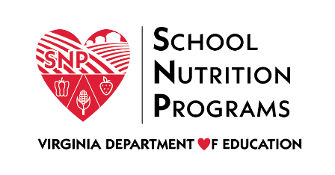

FEDERAL PROGRAM ADMINISTRATIVE REVIEW
SCHOOL NUTRITION PROGRAM SUMMARY
Section 207 of the Healthy Hunger Free Kids Act 2010, amended section 22 of the National School Lunch Act (42 U.S.C. 1769c) requires the Virginia Department of Education, Office of School Nutrition Programs (VDOE SNP), to report the final results of the administrative review to the public in an accessible, easily understood manner in accordance with guidelines promulgated by the Secretary.
Local Educational Agency: Greene County Public Schools
Report Publication Date: January 4, 2021
Administrative Review Dates: April 14-16, 2020
Review Month and Year: February 2020
Participating Programs: NSLP, SBP
Participates in Special Provisions? No

Findings Identified during the Administrative Review:

Table 1: Program Access and Reimbursement
Category | Findings
Certification and Benefit Issuance | NO FINDINGS
Verification | NO FINDINGS
Meal Counting and Claiming | NO FINDINGS

Table 2: Meal Patterns and Nutritional Quality
Category | Findings
Meal Components and Quantities | FINDINGS IDENTIFIED
Details: | Production records and supporting documents were missing required information.
Offer versus Serve | NO FINDINGS
Dietary Specifications and Nutrient Analysis | NO FINDINGS

Table 3: School Nutrition Environment and Civil Rights
Category | Findings
Food Safety |  | NO FINDINGS
Local School Wellness Policy |  | FINDINGS IDENTIFIED
Details: |  | The local school wellness policy did not contain all required information.
Competitive Foods |  | FINDINGS IDENTIFIED
Details: |  | Not all competitive foods sold to students met Smart Snack standards.
Civil Rights |  | NO FINDINGS
USDA is an Equal Opportunity Provider, Employer and Lender.

