DRAFT

2021 Annual Report on the Condition and Needs of Public Schools in Virginia

Presented to the Governor and General Assembly

December 1, 2021

VIRGINIA BOARD OF EDUCATION

MEMBERS OF THE VIRGINIA BOARD OF EDUCATION

Mr. Daniel A. Gecker, President

Chesterfield, VA

Dr. Jamelle Wilson, Vice President

Ashland, VA

Ms. Pamela Davis-Vaught

Bristol, VA

Dr. Francisco Durán

Alexandria, VA

Ms. Anne B. Holton

Richmond, VA

Dr. Tammy Mann

Fairfax, VA

Dr. Keisha Pexton

Hampton, VA

Dr. Stewart Roberson

Richmond, VA

Mr. Anthony Swann

Franklin, VA

Superintendent of Public Instruction

Dr. James F. Lane

Virginia Department of Education

Staff for this Report

Ms. Emily V. Webb, Director of Board Relations

Virginia Department of Education

Table of Contents

Executive Summary
Report
- The Needs of Public Education in Virginia

- The Board’s Work

- Appendices

Appendix A: Constitutional and Statutory Requirements

Appendix B: Standards of Quality (SOQ) prescribed by the Board of Education on October XXX, 2021

Appendix C: Summary of Compliance and Non-Compliance with the Standards of Quality (SOQ) for 2020-2021

Appendix D: School Divisions Reporting Full Compliance with the Standards of Quality for 2020-2021

Appendix E: School Divisions Reporting Noncompliance with One or More Provisions of the Standards of Quality (SOQ) for 2020-2021

Appendix F: Charter School Report and Information on Parent and Student Options

Appendix H: Analysis of School Division Reporting Requirements

Appendix I: Status Report Regarding Multidivision Online Learning

Appendix J: Virtual Virginia Brief
Executive Summary – To Be Added Before Final Review

2021 Annual Report Draft.V1

The Virginia Board of Education is charged with making annual reports to the Governor and the General Assembly concerning the condition and needs of public education in the Commonwealth and to identify any school divisions which have failed to establish and maintain schools meeting the prescribed standards of quality.

The Needs of Public Education in Virginia

As with the Board’s 2020 Annual Report, it is impossible to discuss the condition and needs of public education without acknowledging the situation that we continue to find ourselves in as the COVID-19 pandemic remains. For much of the 2020-2021 school year, many of our children were educated in a fully-remote or hybrid environment. A relatively small number of students across the state were educated fully in-person throughout the school year. The continued disruption to traditional learning resulted in the waiver of annual SOL assessments for the 2019-2020 school year and reduced participation in assessments for the 2020-2021 school year, and an accreditation waiver for the 2019-2020 and 2020-2021 school years. Through collaborations with local health departments and implemented health and safety mitigation strategies, progress was made over the course of the 2020-2021 school year to transition students back to in-person instruction. By May 2021, 58 divisions offered full in-person instruction, 42 divisions offered partial in-person instruction, and 27 divisions offered hybrid instruction.

Operational Modality by Local School Division - September 2020

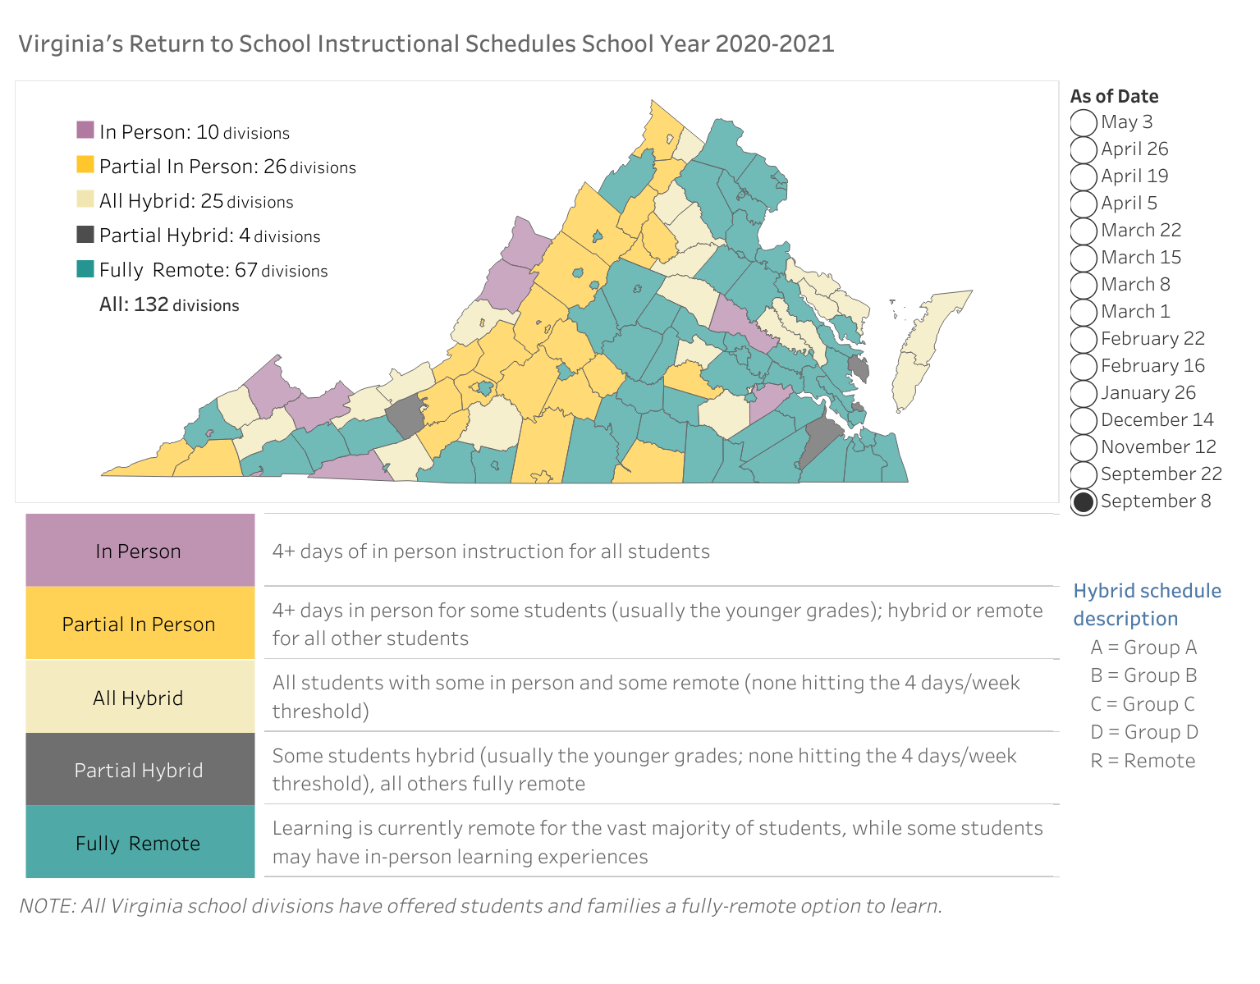

Operational Modality by Local School Division - May 2021

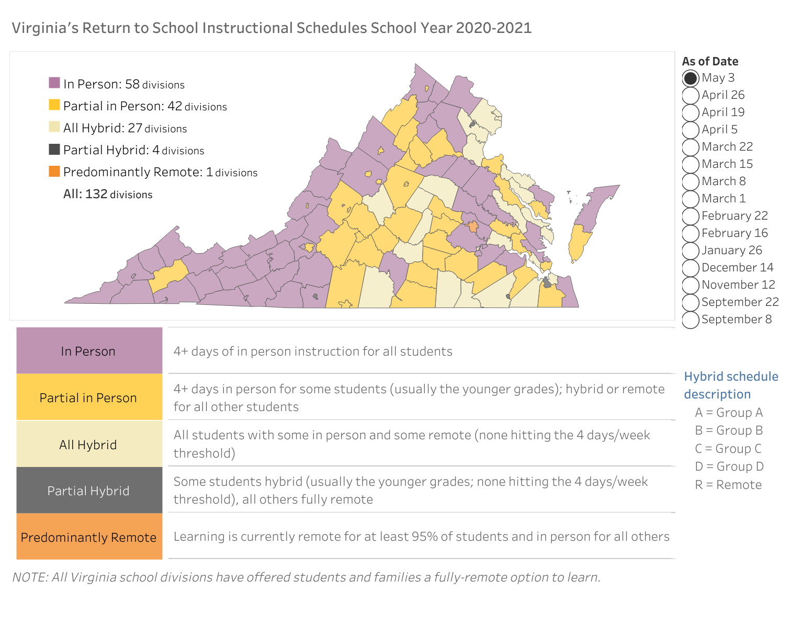
As of September 23, 2021, all Virginia school divisions are open for full in-person instruction, as required by Senate Bill 1303. Local school divisions continue to work diligently to implement recommended mitigation strategies while also navigating quarantine protocols following positive cases among students and staff. It is the desire of the Board that in-person learning continues throughout the 2021-2022 school year and that normalcy of in-person learning remains in place for Virginia’s 1.2 million students.

The Board would like to thank and recognize the tremendous efforts of the Commonwealth’s teachers, school leaders and local school board members over the past 18 months. The pandemic has created unprecedented challenges for education that required creativity, compassion, patience and a steady hand. The Board recognizes the stress that has been placed on you, the reluctance by some to reenter the classroom due to health concerns and a changing virus, and the threats, hostility and unkind words that many have endured. While there is much work to be done to support students in and out of the classroom, Virginia’s educators are poised to tackle these challenges head on. The Board appreciates your remarkable daily efforts to bring back a sense of normalcy for our young people. You are our most valued resource.

Enrollment Impacts for Local School Divisions and Early Childhood Care and Education

While many challenges and uncertainties continue for local school divisions, it is anticipated that those challenges will continue long after the pandemic ends, including budgetary impacts from enrollment loss and potential impacts on state and local funding sources. Since public education funding is largely allocated based on a per-pupil basis, enrollment declines will negatively impact local school division budgets. During the 2020-2021 school year, 38,150 fewer students were enrolled in Virginia public schools. NEW ENROLLMENT NUMBERS AVAILABLE IN NOVEMBER. The long-term impact of the enrollment loss is not yet known. This type of fluctuation in funding, due to enrollment loss, will have a sizable impact on the state budget and local school division budgets. The General Assembly should continue hold local school divisions harmless for enrollment losses due to the COVID-19 pandemic as they did in Fiscal Year ’21 and Fiscal Year ’22. This will provide local divisions consistency for planning and avoid potential staff layoffs due to budget shortfalls.

2020-2021 Enrollment Trends

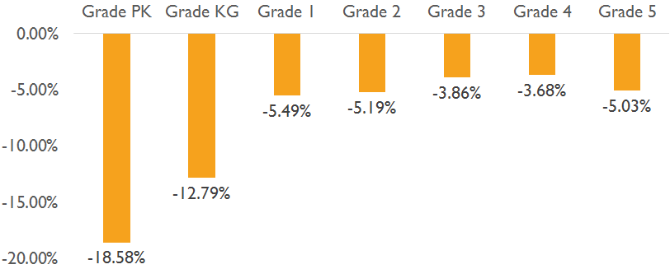

2021-2022 data will be available in November.

The pandemic has also deeply impacted the enrollment of all early childhood care and education programs. Enrollment drops led to challenges for families and will likely impact school readiness in future years. Head Start enrollment was down 30% for the 2020-2021 school year. Enrollment numbers were down six percent for the Virginia Preschool Initiative, despite extending the enrollment period to January 2021. Overall preschool enrollment decreased by 18.58%. Participation in child care subsidy dropped to a low of ~14,500 children in January 2021, a drop of 43% from before COVID 19.

Staffing Challenges

Like much of the nation, Virginia continues to face a shortage of quality educators entering and remaining in Virginia’s public schools. This decline is correlated with low teacher salaries and lack of commitment to tap financial resources to correct this crucial situation. Research has shown that investments in instruction, especially quality teachers, leverage the largest gains in student performance. Up to 25% of the variance in test scores can be attributed to differences in teacher quality. Research indicates that being taught by a teacher in the top quartile of effectiveness for four consecutive years would eliminate achievement gaps between black and white students. This is concerning as black students are nearly two times more likely to be assigned an ineffective teacher, and half as likely to be assigned to the most effective teacher. These inequities are reflected within different schools in single school divisions and across school divisions.

Trends in teacher retention and atrophy during the pandemic are still largely anecdotal but data collection is expanding. Local school divisions are experiencing challenges in other staffing areas such as bus drivers. During the 2020 General Assembly, HB376 expanded vacancy data collection to include licensed and unlicensed personnel. Data is typically collected annually in October and anticipated for release by winter 2021. Expended exit survey data in 2021-2022 will provide insight to individuals leaving divisions and/or the profession. Anecdotally, large numbers of teachers are retiring which will likely lead to more challenges with teacher shortages this year and in the coming years.

The 2021 Special Session II of the General Assembly appropriated $11.5 million to support recruitment efforts for school divisions hiring to fill instructional positions between August 15, 2021 and November 15, 2021. The Recruitment Incentive for Public Education (RIPE) data collection is a snapshot of vacancies reports on August 15, 2021. Seventy-six divisions reported almost 5,000 vacancies. The most significant amount of vacancies reported are in Special Education and Elementary Education, which was anticipated given that those are the top two categories that show up in the critical shortage data collection every year. An eligible teacher will receive a $2,500 incentive aware for filling a non-hard-to-staff position, or an incentive aware of $5,000 for a hard-to-staff position as defined by the critical shortage list.

The 2020-2021 Ten Critical Shortage Teaching Endorsement Areas in Virginia are:
- Special Education
- Elementary Education PreK-6
- Middle Education Grades 6-8
- Mathematics Grades 6-12 (including Algebra 1)
- Career and Technical Education
- Science (Secondary)
- Foreign Language PreK-12
- English (Secondary)
- Library Media PreK-12
- History and Social Science (Secondary)

While the Board does not offer specific recommendations, part of the discussion on staffing challenges, specifically for teachers, must focus on salaries. When compared to similarly educated professions across the country, Virginia teacher wages are less competitive, earning about 30 percent less than their peers in similarly educated professions.

As expected, salary and earning potential play a role in career choice selection. As of 2019-2020, Virginia ranks 26th in average salary for K-12 public school teachers, and 26th in average salary for K-12 public school instructional staff. According to the National Education Association’s Rankings of States 2020 report, the average teacher salary in Virginia is $57,665 while the national average is $64,133.
Unfinished Learning Due to the Pandemic

As anticipated, there is unfinished loss due to the extended school closures and the pandemic. Even our youngest learners are experiencing learning loss. The PALS K-3 screening tool identifies students at-risk in early reading and guides the allocation of EIRI funding to support early intervention. PALS data from spring 2021 shows that significantly more students ended the school year at high risk for reading difficulties as compared to spring 2019. Literacy learning of students who are Black, Hispanic, have low-income backgrounds, and English Learners were disproportionately identified as high-risk for reading difficulties.

PALS Results - Spring 2019 and Spring 2021

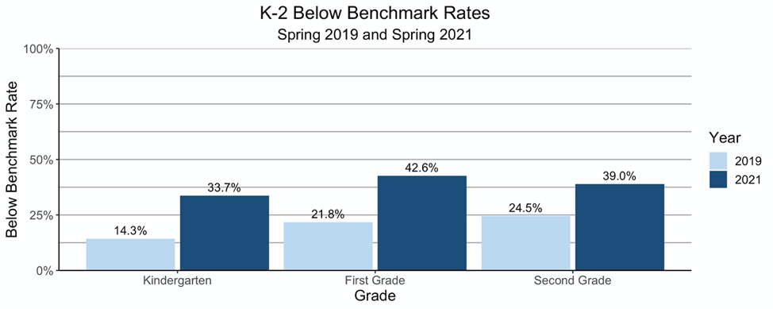

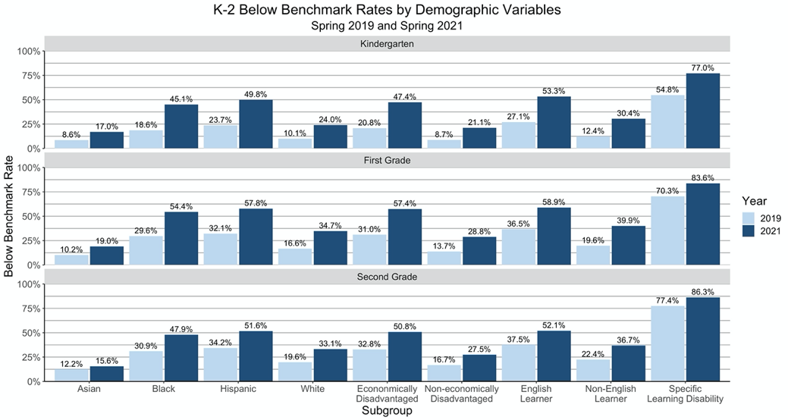

The Virginia Kindergarten Readiness Program (VKRP) was administered statewide to kindergarten students for the first time during the 2020-2021 school year. In the fall, 45% of students fell below the benchmark in one or more foundational areas of learning, this spring that percentage rose to 52%. In reading, mathematics, and self-regulation, there was an increase in the number of students who were tested and the number of students who were rated below the benchmark indicating that many students will need support as they enter into first grade during the 2021-2022 school year.

VKRP Results - Spring 2021
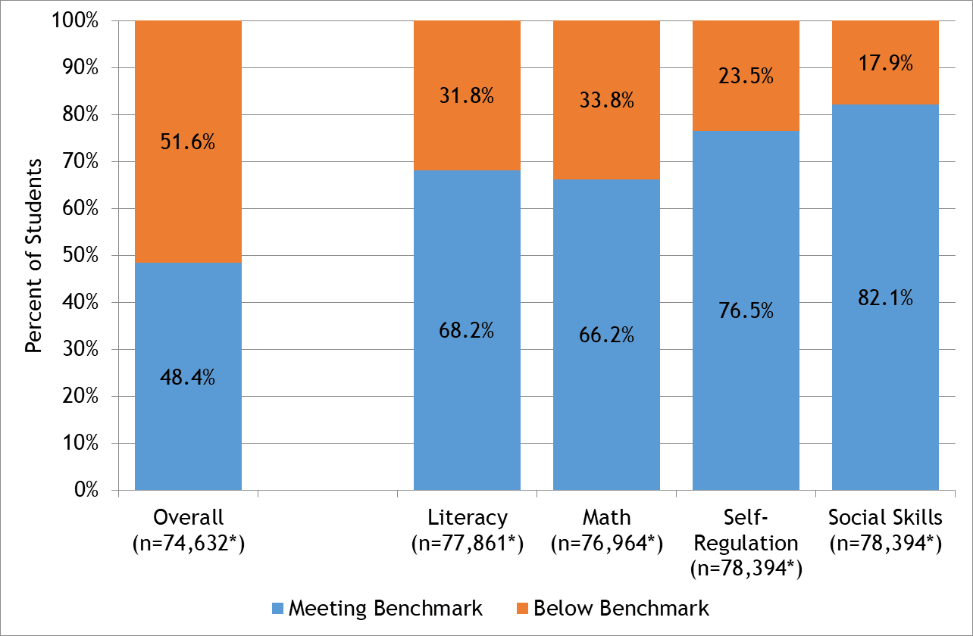

During the spring 2020 school closures, the US Department of Education cancelled testing requirements. While Virginia provided flexibility for non-federally mandated assessments, the USED testing requirements resumed for the 2020-2021 school year, and testing occurred throughout the entire year. During the 2019-2020 and 2020-2021 school year, Virginia offered waivers and flexibilities for testing required for graduation. The Virginia Remote Progress Tests were added in spring 2021 for those students receiving all of their instruction virtually.

At the state level, the 2021 SOL results provide objective and consistent data to inform statewide pandemic recovery initiatives and spending. Additionally, the SOL results in reading and mathematics at the elementary and middle school levels may be used as a baseline for growth calculations for the 2022-2023 accreditation ratings. At the local level, teachers, principals, superintendents and other educators need to know where students are excelling and where they are struggling in order to design instruction and supports that meet their unique academic needs.

From the 2020-2021 school year, significantly fewer students participated in SOL tests in a school building; SOL tests were only administered in-person. There were distinct racial differences in participation rates. Generally speaking, white students participated at the greatest rates, and Black students participated at much lower rates. Overall participation rates by student group varied widely, and ranged from 66% to 91%. Disparities were relatively consistent across different tests, with white students most likely to participate and other minority students participating at lower rates. Black student participation was most striking, at 11% - 17% below white student participation. Economically disadvantaged students were only slightly less likely to participate than their non-disadvantaged peers, with between 3%- 4% lower rates. Typically SOL participation rates are above 95% across all student groups.

Overall SOL Participation Rates
Subject | 2018-2019 | 2020-2021
English: Reading | 99 | 75.46
Math | 99 | 78.68
Science | 99 | 80.16
These participation rates represent approximately 180,000 fewer first test attempts in 2021 in reading, 250,000 fewer in math, and 140,000 fewer in science.

While 2018-2019 SOL test data has been provided as a reference, it should be noted that lower participation rates and remote assessment options for students mean that direct comparison between the data is not appropriate. Additionally, new SOL reading tests were administered for the first time in 2020-2021 and retake opportunities were not provided.

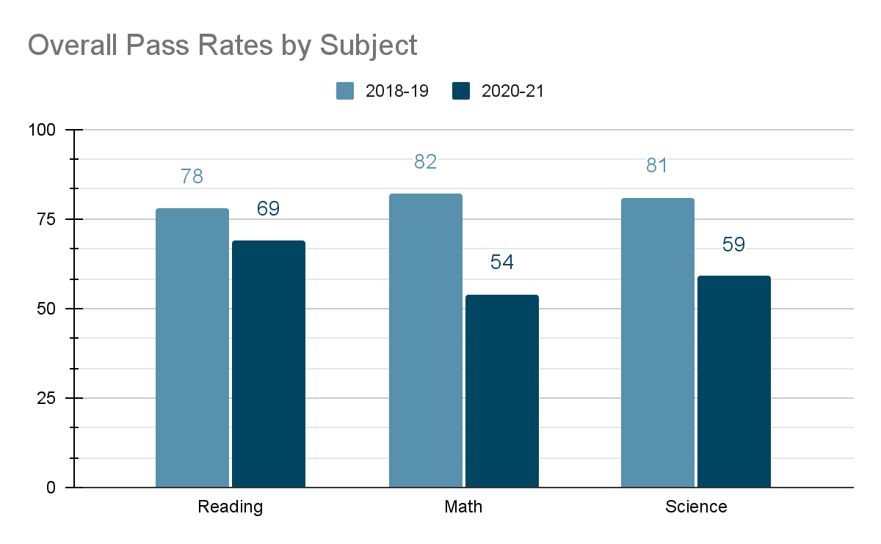

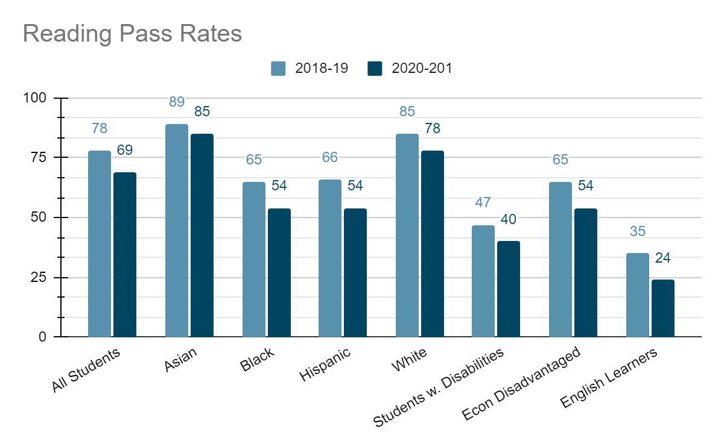
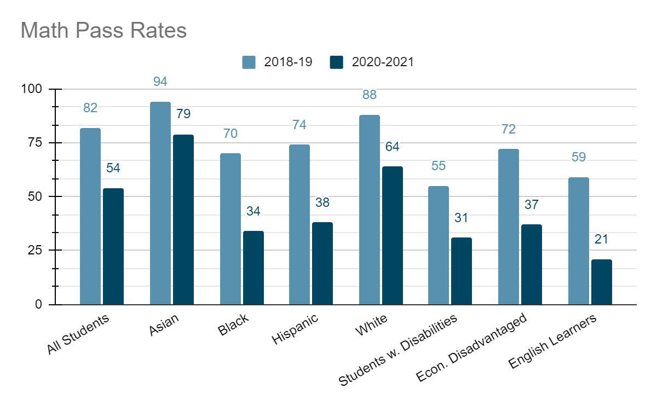
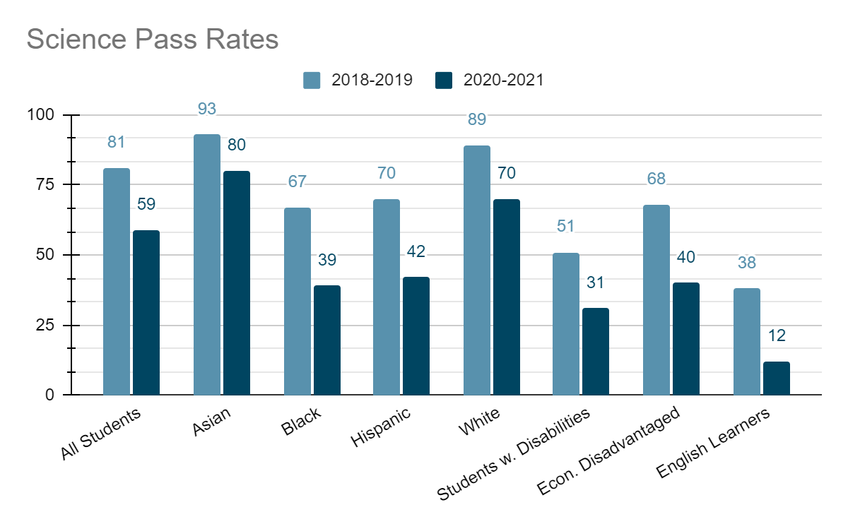

This fall, students in grade 3-8 took new growth assessments to determine baselines for measuring individual academic progress in reading and mathematics during the school year. Legislation passed by the 2021 General Assembly required the administration of fall growth assessments in reading and math, in addition to the end-of-year SOL tests students will take in the spring. The new assessments will provide teachers with baseline data to show exactly where students are as they returned to schools after disruptions in learning caused by the COVID-19 pandemic. Teachers will use the performance data to inform their instruction to meet the individual needs of every student, with the goal of achieving proficiency or significant growth by the end of the school year.
For this year only, the fall growth assessments are based on content from the previous grade level to assist in the identification of unfinished learning from 2020-2021 due to the pandemic. Results from next spring’s grade 3-8 reading and math SOL tests will capture student growth during the year, in addition to providing summative data for use in calculating school accreditation ratings.
Full implementation of the 2021 legislation will occur during the 2022-2023 school year with reading and math growth assessments in grades 3-8 administered three times during the year: in the fall, mid-year, and spring.
Graduation and Dropout Rates

For the class of 2021, 93% earned a Board of Education-approved diploma, compared to 92.3% of the 2020 cohort. The dropout rate for the class of 2021 was 4.3% compared with 5.1% for the previous graduating class.

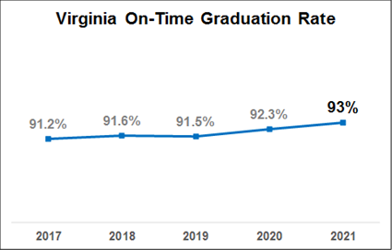
Of the students who entered high school as first-time ninth graders in 2017:
- 52.8% earned an Advanced Studies Diploma.
- 38% earned a Standard Diploma.
- 2.1% earned an Applied Studies or Modified Standard Diploma.
- 0.7% earned a GED.
- 4.3% dropped out.
The graduation rates and dropout rates for the various demographic groups are as follows:
- 98.5% of Asian students graduated; 0.9% dropped out.
- 90.8% of Black students graduated; 4.8% dropped out.
- 89.2% of economically disadvantaged students graduated; 6% dropped out.
- 77.2% of English learners graduated; 21.2% dropped out.
- 85.1% of Hispanic students graduated; 12.2% dropped out.
- 90.7% of students with disabilities graduated; 7.3% dropped out.
- 95.1% of students of multiple races graduated; 2.3% dropped out.
- 95.3% of white students graduated; 2.3% dropped out.
Student Mental Health & Social-Emotional Learning

The COVID-19 pandemic has disrupted the daily life of those around the globe, including young people. The Center for Promise at America’s Promise Alliance conducted a nationally representative survey of young people aged 13-19 to better understand the impacts of the pandemic and mental health. Since the school closures began, young people’s levels of concern about the present and future have increased, and overall health and wellbeing have suffered. Almost 30 percent of students say that they don’t feel connected at all to their teachers, their classmates or their school community. Thirty percent of young people say that they have more often been feeling unhappy or depressed, and nearly as many say that they are more concerned than usual about having their basic needs met. More than 1 in 4 young people reported an increase in losing sleep, feeling unhappy or depressed, feeling constantly under strain, or experiencing a loss of confidence in themselves.

The pandemic has heightened the focus on mental health and the importance of social emotional learning (SEL). Virginia defines social emotional learning as “the process through which all young people and adults acquire and apply the knowledge, skills, and attitudes to develop healthy identities, manage emotions and achieve personal and collective goals, feel and show empathy for others, establish and maintain supportive relationships, and make responsible and caring decisions.” Social emotional learning begins at home and continues through adulthood. Embedding SEL intentionally in school culture advances the work that begins and continues at home. As of July 2, 2021, Virginia Social Emotional Guidance Standards are now available to all Virginia school divisions. While the 2020 General Assembly required the VDOE to develop the guidance standards for SEL, Virginia school divisions are not required to adopt them. Local school boards may choose to adopt all, or portions of, the Virginia SEL Guidance Standards as part of their own local policies, and/or use them as guidance as they implement SEL programming based on the needs of their community.

The Board is appreciative of the General Assembly’s action in 2021 to fund three specialized student support personnel for every 1,000 students as part of the Standards of Quality. These positions, including school social workers, school psychologist, and school nurses, will be able to provide better services and supports to students during this trying time. Additional funding is needed to realize the Board’s SOQ prescription of four to 1,000 students for specialized student support personnel.

Digital Equity and Virtual Education Standards

Despite the incredible efforts of VDOE and local school divisions, the pandemic has highlighted deep inequities as it relates to the digital divide, due to lack of resources, connectivity, and teacher training to educate virtually. Each of these components are essential to developing a meaningful learning environment, especially for virtual and hybrid learning models.

The State Council of Higher Education for Virginia (SCHEV) estimates that 200,000 K-12 students in Virginia lack access to broadband at home. Based on a recent National Education Association report, Digital Equity for Students and Educators, 51 percent of children in under-resourced households lack full digital access in Virginia, including access to broadband and a device. The expansion of virtual learning necessitates professional development for teachers on how to meaningfully use technology and how to teach in a virtual setting. A variety of professional development areas are needed to support teachers through virtual instruction including how to build courses, tech tools to engage students, how to create instructional videos and how to support students social-emotional learning in a virtual environment. While divisions and VDOE have worked diligently to provide this support to teachers, it takes time, experience, and differentiated support to improve instructional efficacy in virtual education.

In addition to the device, broadband and training challenges, there are currently no regulations or standards in place to direct or support virtual education. The Board has begun the regulatory process to develop virtual education regulations. In June 2021, the Board approved the Notice of Intended Regulatory Action to begin revisions to the Standards of Accreditation to include standards for virtual education. Pursuant to 2.2-4016 of the Code of Virginia, the Board approved the withdrawal of the 2013 proposed stage of the Regulations Establishing Standards for Accrediting Public Schools in Virginia to comport with legislative changes from House Bill 1215 (2012 General Assembly) at its April 2021 business meeting. While HB1215 required the Board to promulgate regulations governing “virtual public schools,” the approved NOIRA broadens the scope of the regulations to include all virtual education in Virginia public schools. As the options available to Virginia’s public school students through virtual learning programs continue to expand and evolve, students enrolled in public schools may be provided a variety of options to take coursework virtually. Regulations governing virtual education would expand opportunities to learn by setting forth the expectations for virtual education in Virginia school divisions, for Multidivision Online Providers, and Virtual Virginia. In promulgating these regulations, the Board will establish the policies and standards necessary to ensure accountability of student learning in public virtual education. Finally, the regulations will provide the Board with the opportunity to develop and implement sound policies for student success in a virtual setting, including students in kindergarten through twelfth grade.

Education Funding

According to the Joint Legislative Audit and Review Commission’s report Virginia Compared to the Other States: 2021 Edition, Virginia ranks 27th of 50 for state and local per pupil funding for Pre K-12 education, and 40th of 50 for state per pupil funding. These figures demonstrate the gap between state and local funding of public education. The majority of public school funding in Virginia, 55 percent, is from localities. The state contributes 40 percent of public school funding, with six percent from federal sources. From 2016-17 to 2017-18, per pupil school funding in Virginia increased 2.5 percent. State spending increased $160 per pupil, local spending increased $190 per pupil and federal spending decreased $27 per pupil. Across the country, state per pupil spending increased an average of 3.2 percent between 2016-17 and 2017-18. Despite progress by the legislature, state direct aid per pupil has decreased 5.4 percent, adjusted for inflation. If the Standards of Quality prescriptions were funded, divisions on average would receive over $600 more per student. For Fiscal Year 2020, Virginia localities invested $4.4 billion above the required local effort for SOQ programs. Local governments continue to provide a greater share of funding, which continues to skew funding towards schools in wealthier localities. Because not all localities have the capacity to provide additional investments, this heavy reliance on local funding skews funding totals toward schools in wealthier localities, causing inequitable resources and opportunities for low-income students.

Federal pandemic relief funding has been allocated to school divisions under the following programs:
- The Coronavirus Aid, Relief, and Economic Security (CARES) Act;
- The Coronavirus Response and Relief Supplemental Appropriations (CRRSA) Act; and
- The American Rescue Plan (ARP) Act.

These additional federal funds are intended to address the impact that COVID-19 has had, and continues to have, on elementary and secondary schools in Virginia. Pandemic relief funds have been used to support a wide variety of programs and activities. During the spring and summer of 2020, these dollars were used to purchase device and MiFis for students, expand Virtual Virginia content, provide school nutrition services and support early childhood care and learning. For the 2020-2021 school year and beyond, these funds are being utilized to address unfinished learning through high-quality instructional supports, teacher recruitment and retention efforts, mental health and social-emotional supports, and professional learning activities for teachers and instructional leadership.

The Board’s Work

Section 2, of Article VIII of the Constitution of Virginia provides that standards of quality for the several school divisions shall be determined and prescribed from time to time by the Board of Education, subject to revision only by the General Assembly.

“Standards of quality for the several school divisions shall be determined and prescribed from time to time by the Board of Education, subject to revision only by the General Assembly. The General Assembly shall determine the manner in which funds are to be provided for the cost of maintaining an educational program meeting the prescribed standards of quality, and shall provide for the apportionment of the cost of such program between the Commonwealth and the local units of government comprising such school divisions. Each unit of local government shall provide its portion of such cost by local taxes or from other available funds.”

Between 1972 and 1982, the Board of Education prescribed the Standards of Quality for each biennium, which were subsequently adopted by the General Assembly with revisions. In 1984, the General Assembly established Chapter 13.1 of Title 22.1 of the Code of Virginia, codifying the Standards of Quality, effectively impacting the Board of Education’s ability to fulfill its constitutional duty to prescribe such standards. In 1988, the General Assembly replaced Chapter 13.1 of Title 22.1 of the Code with Chapter 13.2, recodifying the Standards of Quality into their current form. Since the 1988 action, the General Assembly has passed 201 bills amending the Standards of Quality, the overwhelming majority of which were unrelated to the Standards of Quality as prescribed by Board of Education pursuant to its constitutional authority

§ 22.1-18 of the Code requires the Board of Education to indicate in its annual report to the Governor and the General Assembly whether it recommends any change or addition to the Standards of Quality:

“…[T]he Board of Education shall submit to the Governor and the General Assembly a report on the condition and needs of public education in the Commonwealth and shall identify any school divisions and the specific schools therein that have failed to establish and maintain schools meeting the existing prescribed standards of quality. Such standards of quality shall be subject to revision only by the General Assembly, pursuant to Article VIII, Section 2 of the Constitution of Virginia. Such report shall include…[a] complete listing of the current standards of quality for the Commonwealth's public schools, together with a justification for each particular standard, how long each such standard has been in its current form, and whether the Board recommends any change or addition to the standards of quality…”

During the last SOQ review cycle in 2019, the Board developed a comprehensive package of prescriptions which were informed by education data and trends, particularly as it relates to student demographics, equity, staffing, resource allocation, nationally recognized best practices, and current prevailing practice in local school divisions. The Board also received feedback and public comment on the prescriptions and made technical edits to support implementation as part of its review. As a result of this work, the Board prescribed eleven amendments to the SOQ focused on directing funding to those divisions and schools with the highest levels of concentrated poverty, and ensuring the necessary staffing for instruction, remediation, and student supports. Each of these SOQ prescriptions were thoughtfully aligned to the Board’s Comprehensive Plan to promote educational equity (Priority 1) support educator recruitment, development and retention (Priority 2), and support the implementation of the Profile of a Virginia Graduate and the revised school accountability system (Priority 3). These standards were communicated to the Governor and General Assembly, through the Annual Report and other avenues, to review and revise as outlined in the Constitution of Virginia.

During the 2020 and 2021 General Assembly sessions, several pieces of legislation built upon the Board’s SOQ prescriptions. Legislation has improved ratios for school counselors as well as English Learner teachers, established the specialized student support personnel category, removed staffing flexibility, and expanded at-risk add-on funding. With federal funding, there has also been progress in implementing the regional support model for work-based learning coordination. However, none of the Board’s 2019 prescriptions have been fully implemented.

The Board’s Committee on the Standards of Quality began its 2021 review and revision process on June 16, 2021. The Committee also met in July, September, and October to continue its discussion and to provide additional public comment opportunities. The Committee reflected on the need to adjust or amend the existing SOQ prescriptions and progress already made through General Assembly action. With the exception of a few technical changes, the Committee recommended the Board continue to emphasize its commitment to fully-realizing its prescriptions in order to achieve the greatest impact for students enrolled in the Commonwealth’s public schools.

The 2021 prescriptions build upon the Board’s extensive and thorough work during the 2019 review cycle; represent evidence-based and research-driven proposals that help to create a stronger system of support for Virginia’s evolving student population as well as teachers, support personnel, and staff; and are designed to align state resources with need. Virginia ranks as one of the wealthiest states in the country, but is one of eighteen with a “flat” school funding, meaning high-poverty divisions and wealthier divisions receive about the same funding. Through the work of school improvement over the past decade, the Board has seen firsthand that our children in poverty need additional services to be able to benefit from educational opportunity. Our schools in high poverty areas do not have access to the same local funding that schools in low-poverty areas do, and they have greater numbers of students that require access to additional services in order to receive the full benefit of the education being offered. Additionally, over the past 15 years, Virginia’s student enrollment has grown more diverse. The changing makeup of our schools has an impact on resources and supports needed for students. These standards are essential to fulfill the provision of a system of free public elementary and secondary schools for all children of school age, as required in Article VIII of the Constitution. At the XXXXX, meeting, the Board unanimously prescribed the 2021 Standards of Quality.

- Enhanced At-Risk Add-On (estimated cost of $74M in FY22): Consolidates the current At-Risk Add-On as well as the Prevention, Intervention, and Remediation programs into a single, expanded fund.. Also includes language directing school boards to equitably distribute experienced, effective teachers and other personnel among all of its schools, and a prohibition on clustering ineffective teachers in any school or group of schools.
- Teacher Leader and Mentor Programs (estimated cost of $113.9M in FY22): Establishes a new Teacher Leader program and expands Teacher Mentor program.
- Reading Specialists (estimated cost of $37.8M in FY22): Sets a minimum staffing ratio for reading specialists in K-5 determined by the number of students failing third-grade Standards of Learning reading assessments.
- English Learner Teachers (estimated cost of $15M in FY22): Sets a scaled staffing ratio that takes into account the different proficiency level of students and accordingly, the degree of instructional staff required to support these students.
- Principal Mentorship (estimated cost of $1.2M in FY22): Establishes a statewide principal mentorship program.
- Work-Based Learning Coordinators (estimated cost of $7.8M in FY22): Uses a regional coordinator model for supporting work-based learning at the local-level and the implementation of the Profile of a Virginia Graduate.
- Elementary School Principals (estimated cost of $7.8 in FY22): Sets a full-time principal should be provided for every elementary school, regardless of size.
- Assistant Principals (estimated cost of $76.6 in FY22): Sets a ratio of one full-time assistant principal for each 400 students.
- Class Size Reduction and Experienced Teachers for K-3 (no state impact estimated): Moves K-3 class size reduction program from the Appropriation Act to the SOQ.
- Specialized Student Support Personnel (estimated cost of $48.8M in FY22): Establishes a new position category including school nurses, social worker, psychologist, and other licensed health and behavioral positions and sets a 4 specialized student support personnel per 1,000 students.
- School Counselors (estimated cost of $52.4M in FY22): Sets a ratio of 1 school counselor per 250 students.
Comprehensive Review of the Standards of Accreditation
In 2017, the Board completed its comprehensive review of and update to the Regulations Establishing Standards for Accrediting Public Schools in Virginia (also known as the Standards of Accreditation or SOA). Among the substantive revisions approved in 2017 were a revised state accreditation model emphasizing continuous improvement, and the integration of the Profile of a Virginia Graduate. The updated Standards of Accreditation became effective in the 2018-2019 school year.

In June 2020, the Board established a Special Committee for the Review of the Standards of Accreditation tasked with reflecting on the first years of implementation as well as identifying the positive, negative, and unintended consequences of the 2017 SOA revisions. The Special Committee received a number of presentations as part of its work including informational presentations from content experts, panel discussions with a range of education stakeholders, as well as proposals from VDOE staff. VDOE staff presentations drew from the work of an internal SOA Implementation Committee which had been convened following the 2017 revisions to help field questions from divisions, identify outstanding concerns, and propose solutions.

The Special Committee concluded its work in September 2021 making recommendations to the full Board for revisions to improve the impact and efficacy of the SOA. The most notable changes include:

- Refining language related to the award of verified credits and locally-awarded verified credits as well as the use and administration of performance assessments;
- Adding explicit expectations for the delivery of remediation to students, including remediation programs specific to numeracy;
- Adding a requirement for divisions to develop a comprehensive data security plan;
- Adding language about the appeals process for certain indicators when a school’s performance level was determined by Students with Limited and Interrupted Formal Education students;
- Allowing the Board to incorporate an improvement indicator for the College, Career, and Civic Readiness Index into the accreditation model when data is available; and
- Requiring comprehensive, long-range unified plans to draw on student group data to identify opportunity and achievement gaps and identify strategies to improve outcomes for all student groups;

The Board approved the proposed stage of these revisions at the XXXXX meeting for submission pursuant to the Administrative Process Act.

Early Childhood Care & Education
During the 2020 session, the General Assembly passed House Bill 1012 and Senate Bill 578. These bills, and associated funding, both part of Governor Northam’s 2020 Early Childhood Legislative Package, established the Board and VDOE as responsible for the oversight and administration of early care and education out of the home by creating a single point of accountability for school readiness, which became effective July 1, 2021. Additionally, the legislation created an Early Childhood Advisory Committee to the Board, which serves as Virginia’s Early Childhood Advisory Committee (ECAC) as required for federal grants, and advises and vets policies and regulations, making recommendations to the Board on related matters. In March, the Board made appointments to ECAC after a very competitive recruitment and selection process. In April, the Board approved the early childcare regulation transfer from the Board of Social Services, which also became effective July 1, 2021. Over the next few years, the Board will comprehensively review each regulation for necessary changes.
ADDITIONAL INFORMATION FROM JENNA & TEAM IS FORTHCOMING.
While the Board has focused much of its recent efforts on responding to the COVID-19 pandemic, the Special Committee’s review of the Standards of Accreditation, and the Standards of Quality, there are several other noteworthy actions taken over the past year.
- In January, the Board approved the consolidation of Alleghany County and Covington City Schools Divisions to better meet the standards of quality and maximize the ability to better serve the students and best interests of the community.
- In March, the Board approved revisions to the Guidelines for Uniform Performance Standards and Evaluation Criteria for Teachers, considered Phase Two of a more comprehensive overhaul. Most notably, these revisions update research, revised the four-rating levels for summative evaluation and created a new performance standard, Culturally Responsive Teaching and Equitable Practices.
- The Board approved the Guidelines for Practice Year 1 of the Early Childhood Unified Measurement and Improvement System at the June meeting. The document describes the guidelines and protocols for Practice Year 1 (2021-2022) of the Unified Measurement and Improvement System. Virginia’s Unified Measurement and Improvement System supports continuous quality improvement in all publicly-funded early childhood programs, which generally prioritize underserved children, including children in low-income households, children with disabilities, children who are Dual Language Learners and children who face other challenges. Programs that do not receive public funding have the option to participate.
- In July, the Board approved several revisions to the Model Guidance for Positive and Preventative Code of Student Conduct Policy and Alternatives to Suspension to include Standards for Dress and Grooming and the Standards for Reducing Bias in the Enforcement of Student Code of Conduct Policy.
- ADDITIONAL INFORMATION WILL BE ADDED BEFORE FINAL REVIEW.

Conclusion

The Board is committed to creating a more equitable public education system supported by a high-quality, diverse teacher workforce, utilizing its authority provided in the Virginia Constitution and Code of Virginia. Addressing conditions that affect student learning and well-being requires additional investments of resources – financial and human capital. The COVID-19 pandemic has highlighted the deep inequities that exist in our public education system. Addressing these needs require financial resources and partnerships between the Board, General Assembly, the Governor, and local school boards and divisions. The 2021 Standards of Quality are founded in research and best practice. If funded, the Standards would make significant progress toward creating a more equitable public education system for Virginia’s students and help the Commonwealth rebound from the COVID-19 pandemic.

Darling-Hammond (2019) Investing for Student Success: Lessons from State School Finance Reforms. Palo Alto, CA: The Learning Policy Institute. https://learningpolicyinstitute.org/product/investing-student-success-school-finance-reforms-report
Rockoff, J. E. (2004). The impact of individual teachers on student achievement: Evidence from panel data. American Economic Review, 94(2), 247-252Nye, B., Hedges, L. V., & Konstantopoulos, S. (2000). The effects of small classes on academic achievement: The results of the Tennessee Class Size Experiment. American Educational Research Journal, 37(1), 123-151.)
Gordon, R., Kane, T. J., & Staiger, D. O. (2006). Identifying effective teachers using performance on the job. Hamilton project discussion paper. Washington, DC: Brookings Institution
Sanders, W. L., & Rivers, J. C. (1996). Cumulative and residual effects of teachers on future student academic achievement. University of Tennessee Value-Added Research and Assessment Center.
Baker, Farrie, Sciarra. (2018) Is School Funding Fair? A National Report Card (Seventh Edition). Newark, NJ: Education Law Center and Rutgers Graduate School of Education. http://www.edlawcenter.org/assets/files/pdfs/publications/Is_School_Funding_Fair_7th_Editi.pdf
Rankings of the States 2020 and Estimates of School Statistics 2021, National Education Association, April 2021. https://www.nea.org/sites/default/files/2021-04/2019-2020%20Teacher%20Salary%20Benchmark%20Report.pdf.
Margolius, M., Doyle Lynch, A., Pufall Jones, E. & Hynes, M. (2020). The State of Young People during COVID-19: Findings from a nationally representative survey of high school youth. Americas Promise Alliance. file:///C:/Users/neq66846/Downloads/YouthDuringCOVID_FINAL%20(1).pdf
Margolius, M., Doyle Lynch, A., Pufall Jones, E. & Hynes, M. (2020). The State of Young People during COVID-19: Findings from a nationally representative survey of high school youth. Americas Promise Alliance. file:///C:/Users/neq66846/Downloads/YouthDuringCOVID_FINAL%20(1).pdf
Ibid.
Ibid.
Allison, Tom. (2020). Insights: A Closer Look At Virginia’s Digital Divide In Education. State Council of Higher Education for Virginia (SCHEV). https://www.schev.edu/index/reports/insights/insights/2020/09/10/a-closer-look-at-virginia-s-digital-divide-in-education.
Joint Legislative Audit and Review Commission. “Virginia Compared to Other States: 2021 Edition.” Joint Legislative Audit and Review Commission, 2021, jlarc.virginia.gov/pdfs/other/Virginia%20Compared%202021-FULL%20REPORT-FINAL-web.pdf.
Ibid.
Mendes, Kathy & Stewart, Chad. “K-12 Funding Trends At-a-Glance: Data for Statewide and All 132 School Divisions.” The Commonwealth Institute, 2021. https://thecommonwealthinstitute.org/wp-content/uploads/2021/06/Statewide-K-12-Virginia-Public-Schools.pdf
Ibid.
Ibid.

