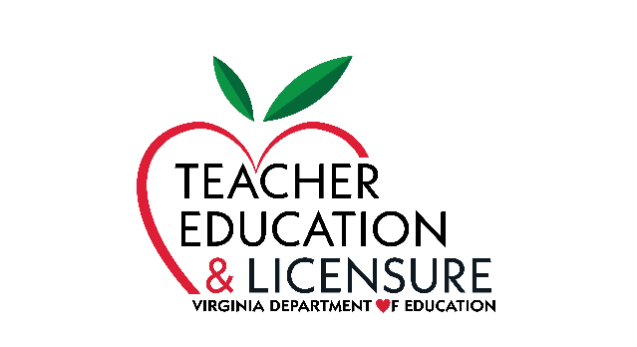
Virginia Department of Education
Department of Teacher Education and Licensure
PO Box 2120
Richmond, Virginia 23218
804-225-2022

Out-of-State Reciprocity

Pursuant to the Licensure Regulations for School Personnel, effective August 23, 2018, degrees must be earned from regionally accredited colleges and universities.

Below is an excerpt from the regulations regarding the “Conditions for licensure for out-of-state candidates by reciprocity.” Please refer to the full section in the Virginia Administrative Code for all conditions for licensure that must be met for individuals seeking an initial license.

8VAC20-23-100. Conditions for licensure for out-of-state candidates by reciprocity.

- An individual coming into Virginia from any state may qualify for a Virginia teaching license with comparable endorsement areas if the individual has completed a state-approved teacher preparation program through a regionally accredited four-year college or university, or if the individual holds a valid out-of-state teaching license (full credential without deficiencies) that must be in force at the time the application for a Virginia license is made. An individual seeking licensure must establish a file in the Virginia Department of Education by submitting a complete application packet, which includes official student transcripts. Unless exempted by the criteria in subsection C of this section, professional teacher's assessment requirements prescribed by the Virginia Board of Education shall be satisfied.

- An individual coming into Virginia will qualify for a Virginia teaching license with comparable endorsement areas if the individual holds an active national certification from the National Board for Professional Teaching Standards (NBPTS) or a nationally recognized certification program approved by the Virginia Board of Education.

Further, the Code of Virginia (§ 22.1-298.1) provides another condition for reciprocity:

K. For individuals who have obtained a valid out-of-state license, with full credentials and without deficiencies, that is in force at the time the application for a Virginia license is received by the Department of Education. Each such individual shall establish a file in the Department of Education by submitting a complete application packet, which shall include official student transcripts. No service requirements or licensing assessments shall be required for any such individual. (*This will be reflected in an upcoming change to the Licensure Regulations for School Personnel, and supersedes section C in 8VAC20-23-100.)

First, the institution must have regional accreditation. Second, you need to check to determine whether the program has been state approved. Each state has its own authority for approving programs for the preparation of school personnel. The Virginia Board of Education approves programs for the preparation of teachers, administrators, and other licensed school personnel at Virginia institutions of higher education. Likewise, other states’ boards approve programs in their respective states.

Please note: even though a college or university may have regional accreditation, the institution may or may not have received approval for programs (endorsement areas) for the purpose of licensure (or certification) in that state. Therefore, it is important to note that an individual who wishes to enroll in a program at a regionally accredited college or university leading to licensure must first check with the Department of Education in the appropriate state to verify that the institution has program approval and then request documentation from the institution that the program in which he or she plans to enroll is an approved program leading to licensure/certification in that state.

Regional Accreditation
Information regarding regional accreditation can be obtained from the various regional accrediting agencies on the Council for High Education Accreditation website. Below are the direct links for each regional accreditation agency:
- Higher Learning Commission (HLC)
- Middle States Commission on Higher Education (MSCHE)
- New England Commission of Higher Education (NECHE)
- Northwest Commission on Colleges and Universities (NWCCU)
- Southern Association of Colleges and Schools Commission on Colleges (SACSCOC)
- WASC Senior College and University Commission (WSCUC)

Application for a Virginia License
Individuals who hold a valid out-of-state license (full credential without deficiencies) with comparable endorsements or who completed an out-of-state approved program may submit an application for a Virginia license. The Virginia application packet and instructions may be on the Virginia Department of Education website.
Updated: August 2020

