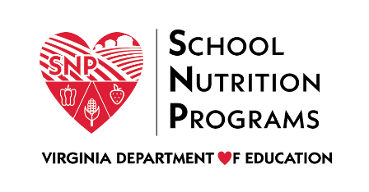

FEDERAL PROGRAM ADMINISTRATIVE REVIEW
SCHOOL NUTRITION PROGRAM SUMMARY
Section 207 of the Healthy Hunger Free Kids Act 2010, amended section 22 of the National School Lunch Act (42 U.S.C. 1769c) requires the Virginia Department of Education, Office of School Nutrition Programs (VDOE SNP), to report the final results of the administrative review to the public in an accessible, easily understood manner in accordance with guidelines promulgated by the Secretary.
Local Educational Agency: The House of Restoration
Report Publication Date: December 16, 2020
Administrative Review Dates: November 12-14, 2019
Review Month and Year: October 2019
Participating Programs: NSLP, SBP, SFSP
Participates in Special Provisions? Yes, CEP

Findings Identified during the Administrative Review:

Table 1: Program Access and Reimbursement
Category | Findings
Certification and Benefit Issuance | NO FINDINGS
Details:
Verification | NO FINDINGS
Details:
Meal Counting and Claiming | NO FINDINGS
Details:

Table 2: Meal Patterns and Nutritional Quality
Category | Findings
Meal Components and Quantities | FINDINGS IDENTIFIED
Details: | Reimbursable meal signage was missing from the meal service area.  No production records were being completed.
Offer versus Serve | FINDINGS IDENTIFIED
Details: | Signage explaining offer versus serve and the elements of a reimbursable meal were missing from the meal service area.
Dietary Specifications and Nutrient Analysis | FINDINGS IDENTIFIED
Details: | Standardized recipes were not used.

Table 3: School Nutrition Environment and Civil Rights
Category | Findings
Food Safety |  | FINDINGS IDENTIFIED
Details: |  | The written food safety plan did not meet all regulatory requirements.  The most recent health inspection was not posted in a publicly visible location.
Local School Wellness Policy |  | FINDINGS IDENTIFIED
Details: |  | The local school wellness policy did not meet all federal and state regulatory requirements.
Competitive Foods |  | NO FINDINGS
Details:
Civil Rights |  | FINDINGS IDENTIFIED
Details: |  | The SFA did not publish a public media release for the current school year.  The SFA did not have a process or procedure for receiving and processing civil rights complaints.
USDA is an Equal Opportunity Provider, Employer and Lender.

