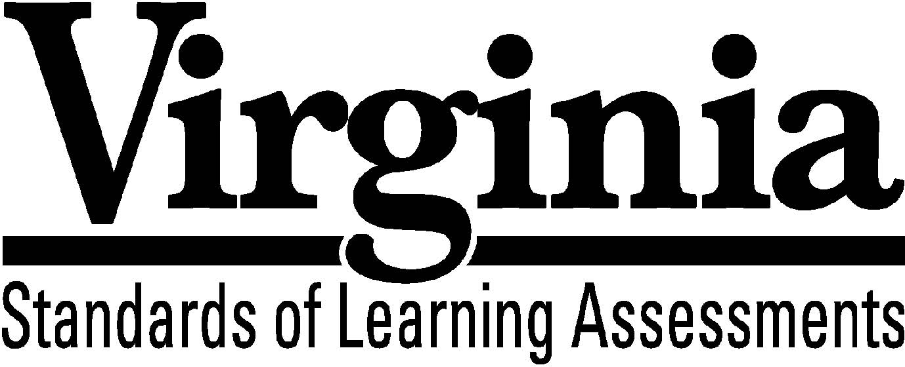
Test Blueprint

World Geography

2008 History and Social Science Standards of Learning

This revised test blueprint will be effective with the administration of the 2010-2011 History and Social Science Standards of Learning (SOL) tests.

Notice to Reader

In accordance with the requirements of the Civil Rights Act and other federal and state laws and regulations, this document has been reviewed to ensure that it does not reflect stereotypes based on race, color, national origin, sex, age, or disability.

The Virginia Department of Education does not discriminate on the basis of race, color, national origin, sex, age, or disability in employment or provisions of service.
©2009 by the Commonwealth of Virginia, Department of Education, P.O. Box 2120, Richmond, Virginia 23218-2120. All rights reserved. Except as permitted by law, this material may not be reproduced or used in any form or by any means, electronic or mechanical, including photocopying or recording, or by any information storage or retrieval system, without written permission from the copyright owner. Commonwealth of Virginia public school educators may reproduce any portion of this test blueprint for noncommercial educational purposes without requesting permission. All others should direct their written requests to the Virginia Department of Education, Division of Student Assessment and School Improvement, at the above address or by e-mail to Student_Assessment@doe.virginia.gov.

World Geography
Standards of Learning

Test Blueprint

TABLE OF CONTENTS

General Test Information 1
Defines common terms

Test Blueprint Summary Table 2
Organizes the SOL and the number of items assessed

Expanded Test Blueprint 3
Full text of each SOL as organized for the test

General Test Information

Test Blueprint
Much like the blueprint for a building, a test blueprint serves as a guide for test construction. The blueprint indicates the content areas that will be addressed by the test and the number of items that will be included by content area and for the test as a whole. There is a blueprint for each test (e.g., grade 3 reading, grade 5 mathematics, grade 8 science, Virginia and United States History).

Reporting Categories
Each test covers a number of Standards of Learning. In the test blueprint, the SOL are grouped into categories that address related content and skills. These categories are labeled as reporting categories. For example, a reporting category for the World Geography Standards of Learning test is Human Geography. Each of the SOL in this reporting category addresses the impact of human activities in a geographic context. When the results of the SOL tests are reported, the scores will be presented for each reporting category and as a total test score.

Assignment of Standards of Learning to Reporting Categories
Different parts of a Standard of Learning may be assigned to different reporting categories. For example, World Geography SOL WG.1d, which covers using maps, is assigned to the reporting category Physical Geography in the World Geography SOL test. However, SOL WG.1e, which involves explaining how different cultures use maps to reflect their own perspective, is assigned to the reporting category Regional Geography.

Standards of Learning Excluded from Testing
In some content areas, there are SOL that do not lend themselves to multiple-choice testing. The SOL not tested are listed as Excluded from Testing at the end of the blueprint for each test. In World Geography there are no SOL that cannot be appropriately assessed in a multiple-choice format.

Coverage of Standards of Learning
Due to the large number of SOL in each grade level content area, every Standard of Learning will not be assessed on every version (form) of an SOL test. By necessity, to keep the length of a test reasonable, each version will sample from the SOL within a reporting category. Every SOL in the blueprint will be tested within a three year period, and all of these SOL are eligible for inclusion on each version of an SOL test.

Use of the Curriculum Framework
The History and Social Science Standards of Learning, amplified by the Curriculum Framework, define the essential understandings, knowledge, and skills that are measured by the Standards of Learning tests. The Curriculum Framework asks essential questions, identifies essential understandings, defines essential content knowledge, and describes essential skills students need to master.

World Geography
Test Blueprint Summary Table

Reporting Category | World Geography  Standards of Learning | Number of Items
Physical Geography | WG.1a-d  WG.2a | 11
Regional Geography | WG.1e  WG.3a-c  WG.4 | 18
Human Geography | WG.2b-c  WG.5  WG.6  WG.12b | 10
Political and Urban Geography | WG.10a-b  WG.11a-c  WG.12a | 9
Economic Geography | WG.7a-b  WG.8  WG.9a-c | 12
Excluded from Testing | None | blank
Number of Operational Items | blank | 60
Number of Field-Test Items* | blank | 10
Total Number of Items on Test | blank | 70

*Field-test items are being tried out with students for potential use on subsequent test and will not be used to compute students’ scores on the test.

World Geography

Expanded Test Blueprint

Reporting Category: Physical Geography
Number of Items: 11
Standards of Learning:

WG.1 The student will use maps, globes, satellite images, photographs, or diagrams to
a) obtain geographical information about the world’s countries, cities, and environments;
b) apply the concepts of location, scale, map projection, or orientation;
c) develop and refine mental maps of world regions;
d) create and compare political, physical, and thematic maps.

WG.2 The student will analyze how selected physical and ecological processes shape the Earth’s surface by
a) identifying regional climatic patterns and weather phenomena and their effects on people and places.

Reporting Category: Regional Geography
Number of Items: 18
Standards of Learning:

WG.1 The student will use maps, globes, satellite images, photographs, or diagrams to
e) analyze and explain how different cultures use maps and other visual images to reflect their own interests and ambitions.

WG.3 The student will apply the concept of a region by
a) explaining how characteristics of regions have led to regional labels;
b) explaining how regional landscapes reflect the physical environment and the cultural characteristics of their inhabitants;
c) analyzing how cultural characteristics, including the world’s major languages, ethnicities, and religions, link or divide regions.

WG.4 The student will locate and analyze physical, economic, and cultural characteristics of world regions: Latin America and the Caribbean, Europe, United States and Canada, North Africa and Southwest Asia, Sub-Saharan Africa, Russia and Central Asia, South Asia, Southeast Asia, East Asia, Australia and the Pacific Islands, and Antarctica.

Reporting Category: Human Geography
Number of Items: 10
Standards of Learning:

WG.2 The student will analyze how selected physical and ecological processes shape the Earth’s surface by
b) describing how humans influence the environment and are influenced by it;
c) explaining how technology affects one’s ability to modify the environment and adapt to it.

WG.5 The student will compare and contrast the distribution, growth rates, and characteristics of human population in terms of settlement patterns and the location of natural and capital resources.

WG.6 The student will analyze past and present trends in human migration and cultural interaction as they are influenced by social, economic, political, and environmental factors.

WG.12 The student will apply geography to interpret the past, understand the present, and plan for the future by
b) relating current events to the physical and human characteristics of places and regions.

Reporting Category: Political and Urban Geography
Number of Items: 9
Standards of Learning:

WG.10 The student will analyze how the forces of conflict and cooperation affect the division and control of the Earth’s surface by
a) explaining and analyzing reasons for the creation of different political divisions;
b) analyzing ways cooperation among political jurisdictions is used to solve problems and settle disputes.

WG.11 The student will analyze the patterns of urban development by
a) applying the concepts of site and situation to major cities in each region;
b) explaining how the functions of towns and cities have changed over time;
c) describing the unique influence of urban areas and some challenges they face.

WG.12 The student will apply geography to interpret the past, understand the present, and plan for the future by
a) using geographic knowledge, skills, and perspectives to analyze problems and make decisions.

Reporting Category: Economic Geography
Number of Items: 12
Standards of Learning:

WG.7 The student will identify types of natural, human, and capital resources and explain their significance by
a) showing their influence on patterns of economic activity and land use;
b) evaluating perspectives and consequences regarding the use of resources.

WG.8 The student will distinguish between developed and developing countries and relate the level of economic development to the standard of living and quality of life.

WG.9 The student will analyze the global patterns and networks of economic interdependence by
a) identifying factors, including comparative advantage, that influence economic activities and trade;
b) describing ways that economic and social interactions have changed over time;
c) mapping, describing, and evaluating the formation of economic unions.

