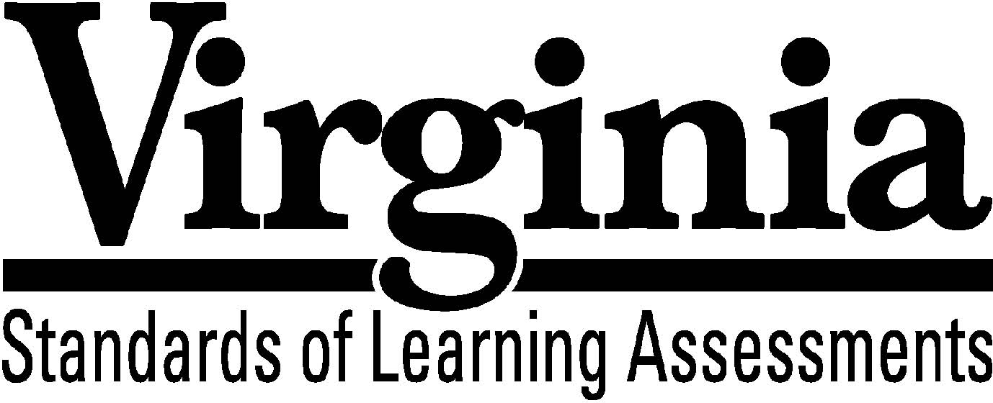
Test Blueprint

Virginia Studies

2008 History and Social Science Standards of Learning

This revised test blueprint will be effective with the administration of the 2010-2011 History and Social Science Standards of Learning (SOL) tests.

Notice to Reader

In accordance with the requirements of the Civil Rights Act and other federal and state laws and regulations, this document has been reviewed to ensure that it does not reflect stereotypes based on race, color, national origin, sex, age, or disability

The Virginia Department of Education does not discriminate on the basis of race, color, national origin, sex, age, or disability in employment or provisions of service

©2009 by the Commonwealth of Virginia, Department of Education, P.O. Box 2120, Richmond, Virginia 23218-2120. All rights reserved. Except as permitted by law, this material may not be reproduced or used in any form or by any means, electronic or mechanical, including photocopying or recording, or by any information storage or retrieval system, without written permission from the copyright owner. Commonwealth of Virginia public school educators may reproduce any portion of this test blueprint for noncommercial educational purposes without requesting permission. All others should direct their written requests to the Virginia Department of Education, Division of Student Assessment and School Improvement, at the above address or by e-mail to Student_Assessment@doe.virginia.gov.

Virginia Studies
Standards of Learning

Test Blueprint

TABLE OF CONTENTS

General Test Information 1
Defines common terms

Test Blueprint Summary Table 2
Organizes the SOL and the number of items assessed

Expanded Test Blueprint 3
Full text of each SOL as organized for the test

General Test Information

Test Blueprint
Much like the blueprint for a building, a test blueprint serves as a guide for test construction. The blueprint indicates the content areas that will be addressed by the test and the number of items that will be included by content area and for the test as a whole. There is a blueprint for each test (e.g., grade 3 reading, grade 5 mathematics, grade 8 science, Virginia and United States History).

Reporting Categories
Each test covers a number of Standards of Learning. In the test blueprint, the SOL are grouped into categories that address related content and skills. These categories are labeled as reporting categories. For example, a reporting category for the Virginia Studies Standards of Learning test is Geography. Each of the SOL in this reporting category addresses the influence geography has had on the history of Virginia. When the results of the SOL tests are reported, the scores will be presented for each reporting category and as a total test score.

Assignment of Standards of Learning assigned to Reporting Categories
Different parts of a Standard of Learning may be assigned to different reporting categories. For example, Virginia Studies SOL VS.3a, which covers the reasons for English colonization in America, is assigned to the reporting category History in the Virginia Studies SOL test. However, SOL VS.3b, which involves describing how geography influenced the decision to settle at Jamestown, is assigned to the reporting category Geography.

Standards of Learning Excluded from Testing
In some content areas, there are SOL that do not lend themselves to multiple-choice testing. The SOL not tested are listed as Excluded from Testing at the end of the blueprint for each test. For example, in Virginia Studies, SOL VS.1h cannot be appropriately assessed in a multiple-choice format.

Coverage of Standards of Learning
Due to the large number of SOL in each grade level content area, every Standard of Learning will not be assessed on every version (form) of an SOL test. By necessity, to keep the length of a test reasonable, each version will sample from the SOL within a reporting category. Every SOL in the blueprint will be tested within a three year period, and all of these SOL are eligible for inclusion on each version of an SOL test.

Use of the Curriculum Framework
The History and Social Science Standards of Learning, amplified by the Curriculum Framework, define the essential understandings, knowledge, and skills that are measured by the Standards of Learning tests. The Curriculum Framework asks essential questions, identifies essential understandings, defines essential content knowledge, and describes essential skills students need to master.

Virginia Studies

Test Blueprint Summary Table
Reporting Category | Virginia Studies  Standards of Learning | Number of Items
Assessed with Other SOL | VS.1a-g, i | blank
History | VS.2f  VS.3a, e-g  VS.4b  VS.5b-c  VS.6a  VS.7a-c  VS.9b, d | 16
Geography | VS.2a-e, g  VS.3b  VS.4c  VS.6c | 10
Civics | VS.3c-d  VS.5a  VS.6b  VS.8b  VS.9c  VS.10a | 7
Economics | VS.4a, d-e  VS.8a, c  VS.9a  VS.10b-c | 7
Excluded from Testing | VS.1h | blank
Number of Operational Items | blank | 40
Number of Field-Test Items* | blank | 10
Total Number of Items on Test | blank | 50

*Field-test items are being tried out with students for potential use on subsequent tests and
will not be used to compute students’ scores on the test.

Virginia Studies

Expanded Test Blueprint

Assessed with Other History and Social Science Standards of Learning
The following skill-based standards will be assessed through the reporting categories by applying them to other Standards of Learning content:

VS.1 The student will demonstrate skills for historical and geographical analysis and
responsible citizenship, including the ability to
a) identify and interpret artifacts and primary and secondary source documents to
understand events in history;
b) determine cause-and-effect relationships;
c) compare and contrast historical events;
d) draw conclusions and make generalizations;
e) make connections between past and present;
f) sequence events in Virginia history;
g) interpret ideas and events from different historical perspectives;
i) analyze and interpret maps to explain relationships among landforms, water
features, climatic characteristics, and historical events.

Reporting Category: History
Number of Items: 16
Standards of Learning:

VS.2 The student will demonstrate knowledge of the physical geography and native peoples, past and present, of Virginia by
f) describing how archeologists have recovered new material evidence at sites including Werowocomoco and Jamestown.

VS.3 The student will demonstrate knowledge of the first permanent English settlement in America by
a) explaining the reasons for English colonization;
e) identifying the importance of the arrival of Africans and English women to the Jamestown settlement;
f) describing the hardships faced by settlers at Jamestown and the changes that took place to ensure survival;
g) describing the interactions between the English settlers and the native peoples, including the contributions of Powhatan to the survival of the settlers.

VS.4 The student will demonstrate knowledge of life in the Virginia colony by
b) describing how the culture of colonial Virginia reflected the origins of European (English, Scots-Irish, German) immigrants, Africans, and American Indians.

VS.5 The student will demonstrate knowledge of the role of Virginia in the American Revolution by
b) identifying the various roles played by whites, enslaved African Americans, free African Americans, and American Indians in the Revolutionary War era, including George Washington, Thomas Jefferson, Patrick Henry, and James Lafayette;
c) identifying the importance of the Battle of Great Bridge, the ride of Jack Jouett, and the American victory at Yorktown.

VS.6 The student will demonstrate knowledge of the role of Virginia in the establishment of the new American nation by
a) explaining why George Washington is called the “Father of our Country” and James Madison is called the “Father of the Constitution.”

VS.7 The student will demonstrate knowledge of the issues that divided our nation and led to the Civil War by
a) identifying the events and differences between northern and southern states that divided Virginians and led to secession, war, and the creation of West Virginia;
b) describing Virginia’s role in the war, including identifying major battles that took place in Virginia;
c) describing the roles played by whites, enslaved African Americans, free African Americans, and American Indians.

VS.9 The student will demonstrate knowledge of twentieth- and twenty-first-century Virginia by
b) identifying the impact of Virginians, such as Woodrow Wilson and George C.
Marshall, on international events;

d) identifying the political, social, and/or economic contributions made by Maggie L. Walker; Harry F. Byrd, Sr.; Oliver W. Hill; Arthur R. Ashe, Jr.; A. Linwood Holton, Jr.; and L. Douglas Wilder.

Reporting Category: Geography
Number of Items: 10
Standards of Learning:

VS.2 The student will demonstrate knowledge of the physical geography and native peoples, past and present, of Virginia by
a) locating Virginia and its bordering states on maps of the United States;
b) locating and describing Virginia’s Coastal Plain (Tidewater), Piedmont, Blue Ridge Mountains, Valley and Ridge, and Appalachian Plateau;
c) locating and identifying water features important to the early history of Virginia (Atlantic Ocean, Chesapeake Bay, James River, York River, Potomac River, Rappahannock River, and Lake Drummond and the Dismal Swamp);
d) locating three American Indian language groups (the Algonquian, the Siouan, and the Iroquoian) on a map of Virginia;
e) describing how American Indians related to the climate and their environment to secure food, clothing, and shelter;
g) identifying and locating the current state-recognized tribes.

VS.3 The student will demonstrate knowledge of the first permanent English settlement in America by
b) describing how geography influenced the decision to settle at Jamestown.

VS.4 The student will demonstrate knowledge of life in the Virginia colony by
c) explaining the reasons for the relocation of Virginia’s capital from
Jamestown to Williamsburg to Richmond.
VS.6 The student will demonstrate knowledge of the role of Virginia in the establishment of the new American nation by
c) explaining the influence of geography on the migration of Virginians into western territories.

Reporting Category: Civics
Number of Items: 7
Standards of Learning:

VS.3 The student will demonstrate knowledge of the first permanent English settlement in America by
c) identifying the importance of the charters of the Virginia Company of London in establishing the Jamestown settlement;
d) identifying the importance of the General Assembly (1619) as the first representative legislative body in English America.

VS.5 The student will demonstrate knowledge of the role of Virginia in the American Revolution by
a) identifying the reasons why the colonies went to war with Great Britain, as expressed in the Declaration of Independence.

VS.6 The student will demonstrate knowledge of the role of Virginia in the establishment of the new American nation by
b) identifying the ideas of George Mason and Thomas Jefferson as expressed in the Virginia Declaration of Rights and the Virginia Statute for Religious Freedom.

VS.8 The student will demonstrate knowledge of the reconstruction of Virginia following the Civil War by
b) identifying the effects of segregation and “Jim Crow” on life in Virginia for whites, African Americans, and American Indians.

VS.9 The student will demonstrate knowledge of twentieth- and twenty-first-century Virginia by
c) identifying the social and political events in Virginia linked to desegregation and Massive Resistance and their relationship to national history.

VS.10 The student will demonstrate knowledge of government, geography, and economics by
a) identifying the three branches of Virginia government and the function of each.

Reporting Category: Economics
Number of Items: 7
Standards of Learning:

VS.4 The student will demonstrate knowledge of life in the Virginia colony by
a) explaining the importance of agriculture and its influence on the institution of slavery;
d) describing how money, barter, and credit were used;
e) describing everyday life in colonial Virginia.

VS.8 The student will demonstrate knowledge of the reconstruction of Virginia following the Civil War by
a) identifying the effects of Reconstruction on life in Virginia;
c) describing the importance of railroads, new industries, and the growth of cities to Virginia’s economic development.

VS.9 The student will demonstrate knowledge of twentieth- and twenty-first-century Virginia by
a) describing the economic and social transition from a rural, agricultural society to a more urban, industrialized society, including the reasons people came to Virginia from other states and countries.

VS.10 The student will demonstrate knowledge of government, geography, and economics by
b) describing the major products and industries of Virginia’s five geographic regions;
c) explaining how advances in transportation, communications, and technology have contributed to Virginia’s prosperity and role in the global economy.

Standards of Learning Excluded from Testing:

VS.1 The student will demonstrate skills for historical and geographical analysis and responsible citizenship, including the ability to
h) evaluate and discuss issues orally and in writing.

