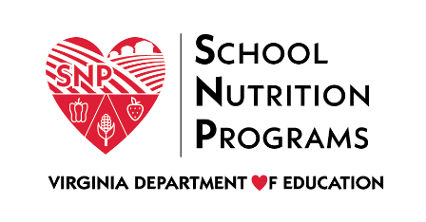

FEDERAL PROGRAM ADMINISTRATIVE REVIEW
SCHOOL NUTRITION PROGRAM SUMMARY
Section 207 of the Healthy Hunger Free Kids Act 2010, amended section 22 of the National School Lunch Act (42 U.S.C. 1769c) requires the Virginia Department of Education, Office of School Nutrition Programs (VDOE SNP), to report the final results of the administrative review to the public in an accessible, easily understood manner in accordance with guidelines promulgated by the Secretary.
Local Educational Agency: Falls Church City Public Schools
Report Publication Date: June 12, 2020
Administrative Review Dates: May 5-13, 2020
Review Month and Year: February 2020
Participating Programs: NSLP, SBP
Participates in Special Provisions? No

Findings Identified during the Administrative Review:

Table 1: Program Access and Reimbursement
Category | Findings
Certification and Benefit Issuance | FINDINGS IDENTIFIED
Details: | Household meal benefit applications were approved for the incorrect benefit status. A media release was not provided to the media.
Verification | FINDINGS IDENTIFIED
Details: | Several requirements for the verification process were not completed or followed.
Meal Counting and Claiming | NO FINDINGS
Details:

Table 2: Meal Patterns and Nutritional Quality
Category | Findings
Meal Components and Quantities | FINDINGS IDENTIFIED
Details: | The menu did not meet the minimum weekly meat/meat alternate and grain requirements. The menu served did not meet the daily vegetable component or the weekly vegetable sugroup requirement.
Offer versus Serve | NO FINDINGS
Details:
Dietary Specifications and Nutrient Analysis | NO FINDINGS
Details:

Table 3: School Nutrition Environment and Civil Rights
Category | Findings
Food Safety |  | NO FINDINGS
Details:
Local School Wellness Policy |  | FINDINGS IDENTIFIED
Details: |  | The LSWP was missing required language and did not include standards for all foods and beverages provided and marketed, but not sold, to students.
Competitive Foods |  | NO FINDINGS
Details:
Civil Rights |  | NO FINDINGS
Details:
USDA is an Equal Opportunity Provider, Employer and Lender.

