English Instructional Plan – Grades 9-12
Task: Performance Assessment for Comparative Analysis
Choice: Comparative Analysis of Two Texts
Choose two texts by different authors written during the same period in history from the same geographic location. What is the social commentary each author is making? Analyze which text makes a stronger social commentary and defend the impact of that commentary and its importance.
Primary Strands: 11.6 Writing and 11.5 Nonfiction
Integrated Strand/s: 11.2 Media
11.7 Editing
11.8 Research
Although this lesson was used with eleventh graders, it could certainly be adjusted to support similar strands in other grades.
Essential Understanding:
- recognize that media messages express viewpoints and contain values to influence the beliefs and behaviors of the intended audience
- understand a variety of persuasive techniques and rhetorical devices
- understand the importance of evaluating the intent of the author, which may include misinformation, bias, and unsupported assertions
Essential Knowledge, Skills, and Processes:
- analyze and critique how media reach the targeted audience for specific purposes
- organize and synthesize information from paired texts while maintaining the intended purpose of each
- analyze how authors use persuasive techniques and rhetorical devices to advance their purpose
- demonstrate comprehension and apply strategies to write about what is read

Primary SOL: 11.6a Apply components of a recursive writing process for multiple purposes to create a focused, organized, and coherent piece of writing to address a specific audience and purpose. 11.6b Produce arguments in writing, developing a thesis that demonstrates knowledgeable judgments, addresses counterclaims, and provides effective conclusions. 11.5f Analyze multiple texts addressing the same topic to determine how authors reach similar or different conclusions.
Reinforced (Related Standard) SOL: 11.2 The student will examine how values and points of view are included or excluded and how media influences beliefs and behaviors. 11.7 The student will self-edit writing for capitalization, punctuation, spelling, sentence structure, paragraphing, and Standard English. 11.8 The student will analyze, evaluate, synthesize, and organize information from a variety of credible resources to produce a research product.

Academic Background/Language:
Before completing this performance assessment, the students will need to have a working knowledge of the Brown v. Board of Education decision. I made sure to contextualize it by connecting it to VA history. Students also will need to understand the purpose and features of “social commentary.” I did this by discussing social commentary within the same sites, readings, and videos used to build background knowledge. I emphasized that social commentary is often written in hopes there can be a change or improvement in society. Here are some possible resources to use to do that:
- http://www.lva.virginia.gov/exhibits/brown/index.htm
- https://www.youtube.com/watch?v=TTGHLdr-iak
- https://www.washingtonpost.com/news/retropolis/wp/2018/03/27/the-determined-black-dad-who-took-linda-brown-by-the-hand-and-stepped-into-history/?noredirect=on&utm_term=.e1ab3ea52c68
- https://www.youtube.com/watch?v=OkuiMr2tLJE
Other academic vocabulary to pre-teach: flashback, parallel structure, imagery, introduction and conclusion, quotation marks in context, connotation, rebuttal and counterargument, transition, evidence, expert opinion, statistics, bias, credibility
Other textual vocabulary that need contextualizing: Article one: dazzling, scripture, doctrine, aftermath, brilliantly, key, unanimous court, justices, primacy, revolutions, epochal; Article two: landmark, watershed, reframing, hinge, mandate, dismantle, drive, disenchantment, veteran, life expectancy, disparities, core mission

Materials
- The two social commentary articles about the same topic as outlined in the task that I used were “Brown v. Board of Education: Few Resolutions Are Ever Truly Complete” by Jon Meacham https://time.com/103002/brown-v-board-of-education-60th-anniversary/ and “How We’re Still Failing, 60 Years After Brown v. Board of Education” by Ronald Brownstein https://www.nationaljournal.com/s/58786 . (Should you want to use another topic and need help finding readings to pair, ask your media specialist librarian.)
- Create a comparison chart, graphic organizer, or other flowchart for students to develop their analysis and guide their decision-making leading up to their essay.

Student/Teacher Actions: What should students be doing? What should teachers be doing?

Days one/two:

Frontload the vocabulary with your students’ needs in mind. Struggling readers, including English learners, can benefit from previewing unfamiliar vocabulary before the reading is done. I have listed some of the words I predict could be unfamiliar in a previous section. Frontloading may look different for different classes, but repetition, clear definitions, visuals, and verbally interacting with the words are critical components for students. One website that lists some strategies is https://www.teachingchannel.org/blog/2017/05/18/top-5-vocab-strategies-ells.

You will also need to announce the culminating essay task so they know that they will be choosing which social commentary they think is strongest. Throughout the rest of the reading, keep reminding them that they should be constantly looking at the pieces through that decision-making lens in order to make informed decisions about which they prefer and why. Remind them that annotations will be critical for supporting their analysis.

After the vocabulary is frontloaded, students should read each article and annotate along the way. The following bullets outline some decisions to make when fleshing out this task for your lesson.

Consider your learners’ reading support needs when deciding how to have them read. Reading can be done in a gradual release, independently, with partners, or as a whole group depending on the needs of your students. After reading and taking notes on the article myself, I chunked the reading and used a gradual release method, modeling the reading, thinking, questioning of the text and annotating on the board at first and then leading them to more independent annotating by the end of the article.

Give the students specifics for how and what to annotate based on previous experience and training. Since we had been working on identifying emotional and dramatic words, transitions, and different types of evidence/support in persuasive writing (ethos, logos, and pathos), I designed a quick marking system for students to mark when they saw these elements. I also have them write question marks in the margins when something confuses them. That is how I check for understanding while they are independently reading and annotating. This way students get quick support before moving on even more confused. When lots of kids have the same questions, that is the first thing we share out as a whole class about that section.

Based on the pacing of your reading plan, choose when your students need to debrief and you need to check for clarity. After each chunk, I asked guided questions for oral response/discussion. These questions required students to share their annotations and summaries of sections. I pointed out specific elements and we talked through inferences particularly about author’s choices and purpose. I talked about some of the common confusions and questions students had and how they might play out in the later portions. I wrote some annotations on the interactive board too. Students were encouraged to add to their notes about anything we discussed or annotated that they thought was interesting or important to the social commentary. We did this for both articles.
- After they have completed the reading, annotating and discussing of the two articles, pass out the graphic organizer. Have them write their definition of social commentary on the top as a reminder; they should share their definitions to make sure they have an accurate working definition. Along the way, encourage students to answer according to their own preferences and annotations. As this is the first time my students have written this type of comparative essay, we talked through the steps of the graphic organizer together even when the question/step required independent thought, opinion, reflection and/or choice. That way they understood what the questions were asking. Many times we shared out whole group. Attached is a picture of the graphic organizer I created. For each question/step in the graphic organizer, I will tell you what I did below in corresponding numbered steps, but you will choose that based on your students’ abilities and needs.
- What is the social commentary/purpose of each article? Hint: It is the same for both. I had them complete this independently; then we shared in partners and whole group.
- Why is this social commentary important? They answered this independently and we did NOT share out.
- What methods of persuasion do each use? With this one, we worked on the lists together based on the annotations of the students on their papers and what they thought was persuasive. See the picture of my notes to see some of the ones we listed. I mainly prompted responses by asking something like which techniques in your annotations did you find the strongest choices, that made the article strong?
- Which proves their social commentary more? Which convinces you more? Only one box marked below. For this they simply chose their favorite article.
- Why? Include methods of persuasion you found persuasive in the one you chose. Only one box used below. For this step, I told them to select the most powerful from the list in #3 that we created together as a class. These are the features that appealed to them the most.
- Create a thesis statement combining your answers to the previous two questions (#4&5). We talked about some possible structures for thesis statements and I reminded them to include what they answered in #5. With student input, I wrote some sentence frames/structures on the board. I have included them in the picture of my copy of the graphic organizer.
- Brainstorm organizational possibilities about how you could organize your essay. Your first step is to go through the state task description and really make sure they understand all parts of the task and how that will translate in the essay. With this step, we discussed as a whole group some possible ways to organize their essays. Many selected structures they typically use when writing persuasively. I did have to explain why they need to also address the other article and how, even though the prompt isn’t focused on them talking about the other one much, they still need to address it to fulfill the greater objective of the exercise. We talked about that being something like a counterargument/rebuttal in persuasive writing.
- Now you are ready to write your essay! If this happens at the end of the period, you will collect everyone’s materials to save and pass out during the next class or have them store the materials in another manner. I encourage you to tell them that the writing of the essay and choices they make during the next two days will be theirs to make independent of you but that they will have these materials. If you follow my lead and do a lot of promprting and guiding up until this point, the essay is their chance to really put it all together and do some independent thinking, but of course that is a decision you have to make depending on your students’ needs. Depending on how long it takes your students to complete the graphic organizer, they will begin writing the paper midway in day two or on day three.

Days two/three and four: For most students, two days for handwriting their rough draft, editing and revising, and typing their final was plenty of time as they had all the prewriting planning, notetaking, etc. already done. Adjust this plan according to your writing practices. Certainly the writing could be done at home or all on the computer if that works for your classes. I am including four student samples from my first run with this task. You will notice that the student who wrote the last sample totally misunderstood the task. So, I would recommend doing check-ins with students as they work to make sure they are on the right track.
Assessment (Diagnostic, Formative, Summative)
- Formative checks: Chunking the text and then debriefing at these check points, circulating and looking at their annotations/notes, and calling on students during whole class discussions allow for immediate feedback. Checking graphic organizers can assess their essay readiness. Much has been discussed about this in previous sections. As I just noted about the last student sample that shows the student didn’t know he/she was supposed to be comparing the texts and instead wrote about the social issue itself, I would advise being more proactive in monitoring the students’ individual understandings particularly at the end of the introduction unless you are handling it as an assessment without feedback and guidance on purpose as I was.
- The summative assessment is obviously the performance assessment, the
comparative analysis essay itself. This will be scored with the state rubric.

Reading Connections: This performance assessment can be connected to any essential question/theme that is linked to a social condition, controversy or historic event. This particular pairing was tied to a unit focused on equality and equity in America.

Extensions and Connections (for all students)
- Cross-curricular: This could be positioned to connect to context linked to the historical unit in the same grade level. For example, positioning this to align with when US History classes are discussing Brown v. Board, would have helped to expand the student background knowledge without extra time in class. Working with US History teachers, there could be common primary or secondary sources used.
- If this same essay type was repeated at a later date, guidance would look different. Perhaps the same sort of graphic organizer could be completed independently or in pairs. Showing student samples from this PA could be used as models for students right before they write their second one.
- Some of the student samples from when I did this PA with my class in 2018 are included in the revised Understanding Scoring aligned to the 2017 framework. You could use those as models before they write their essays especially noting the annotations and scoring as they match up with the rubric.

Strategies for Differentiation
- Sentence frames/starters will help struggling students frame their opinions in more academic forms. Finding some that relate to including evidence, comparing and contrasting, and persuasion could be most beneficial. These can particularly support ELs and SWD. These are easily found through a Google search.

Note: The following pages are intended for classroom use for students as a visual aid to learning.

If you have any questions about this, please feel free to email me at susan.traner@nn.k12.va.us.

[This is a picture of the graphic organizer chart I made that lists the eight steps to planning for this essay with space for students to write notes.]

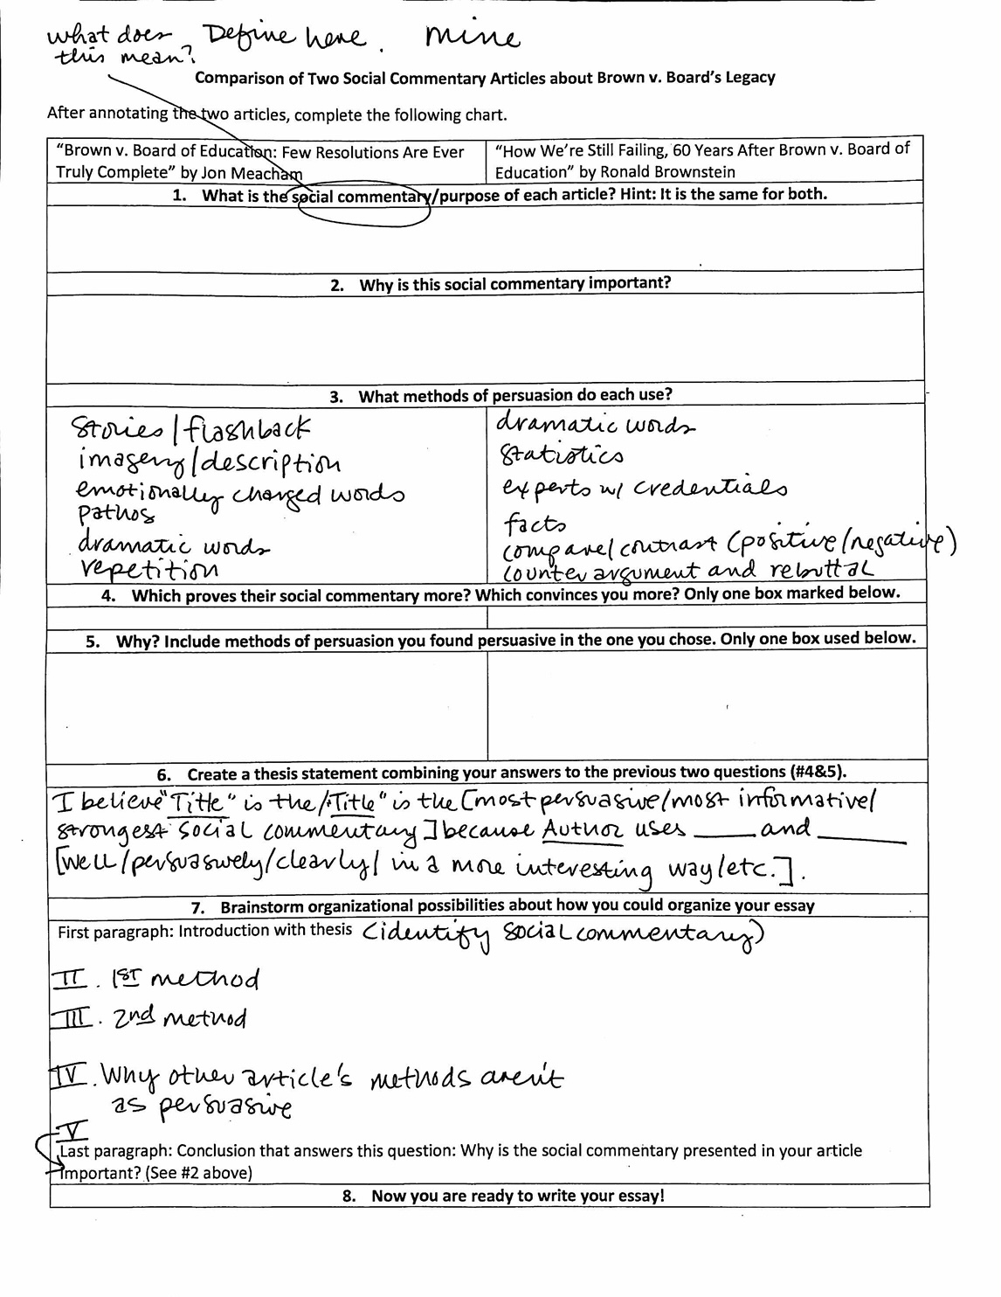

[This is a picture of the same graphic organizer but with my notes in it that include some of the notes we took together while debriefing each step.]

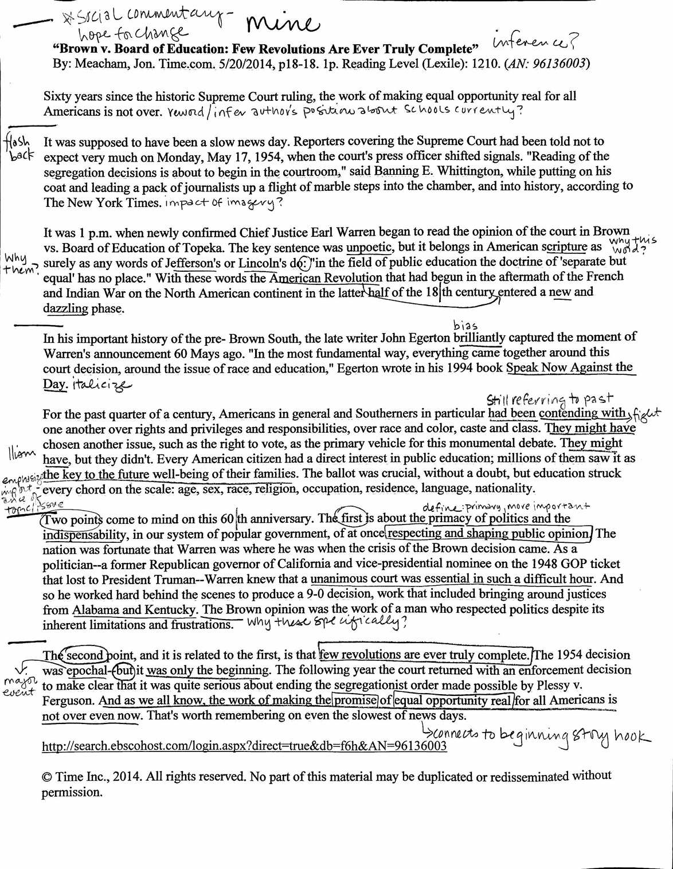
[This is a picture of the first article with my notes on it. The lines in the left column between the paragraphs show my chunking choices.]

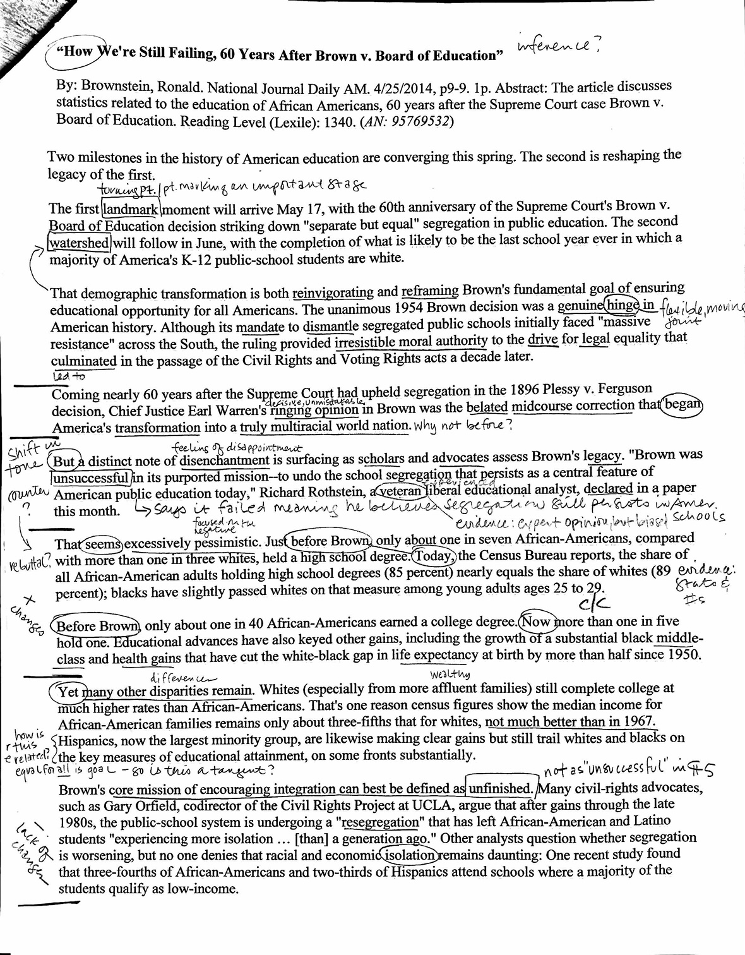

[This is a picture of my notes on page one of the second article.]

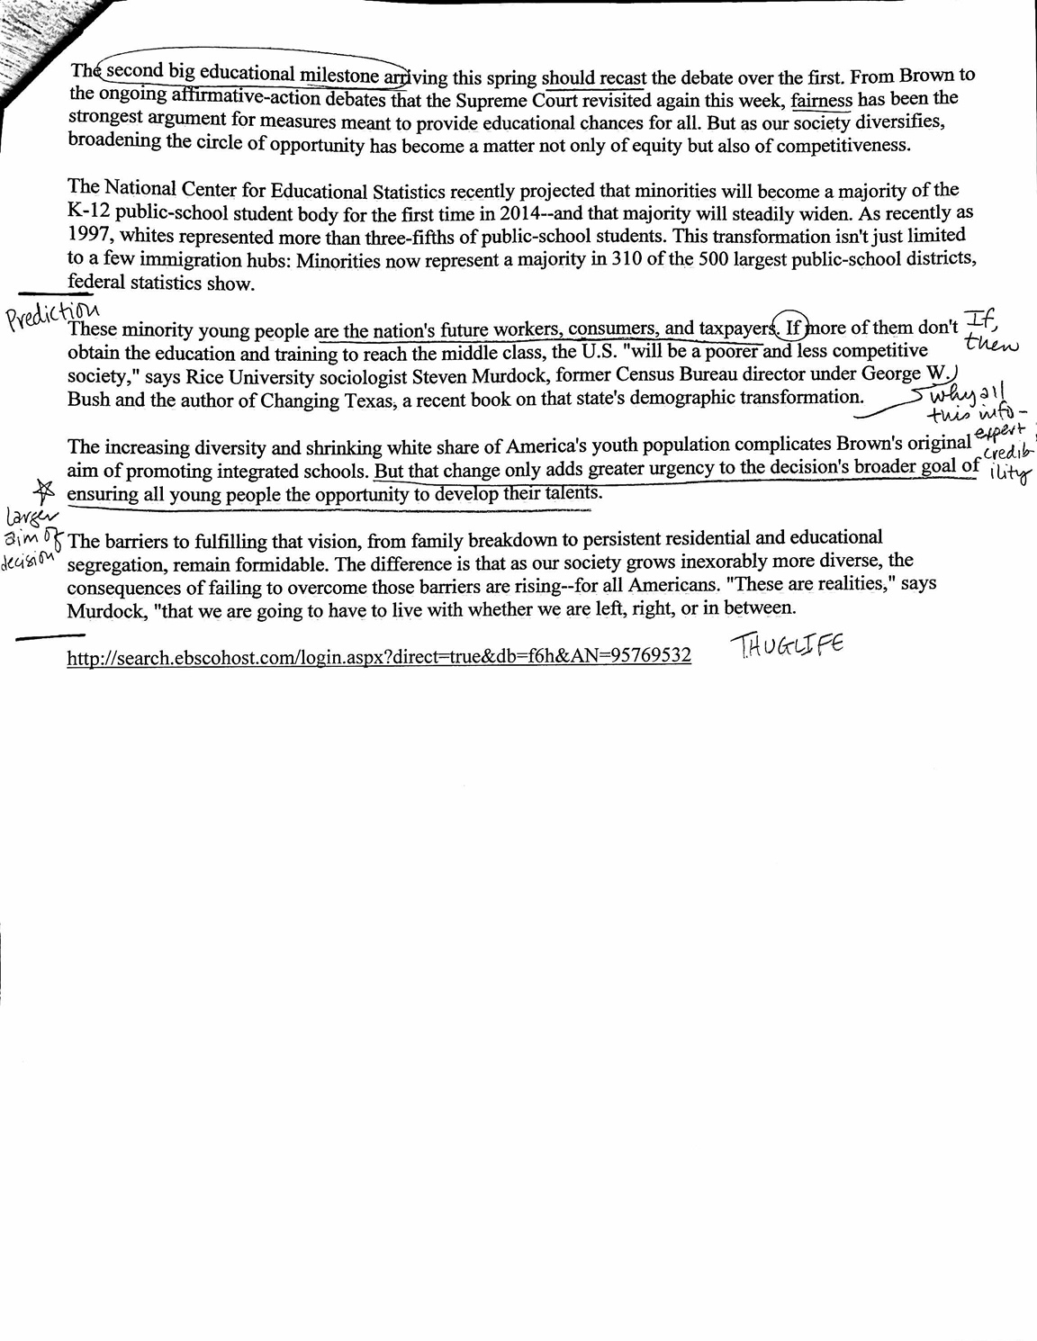
[This is a picture of the second page of the second article with my notes on it.]

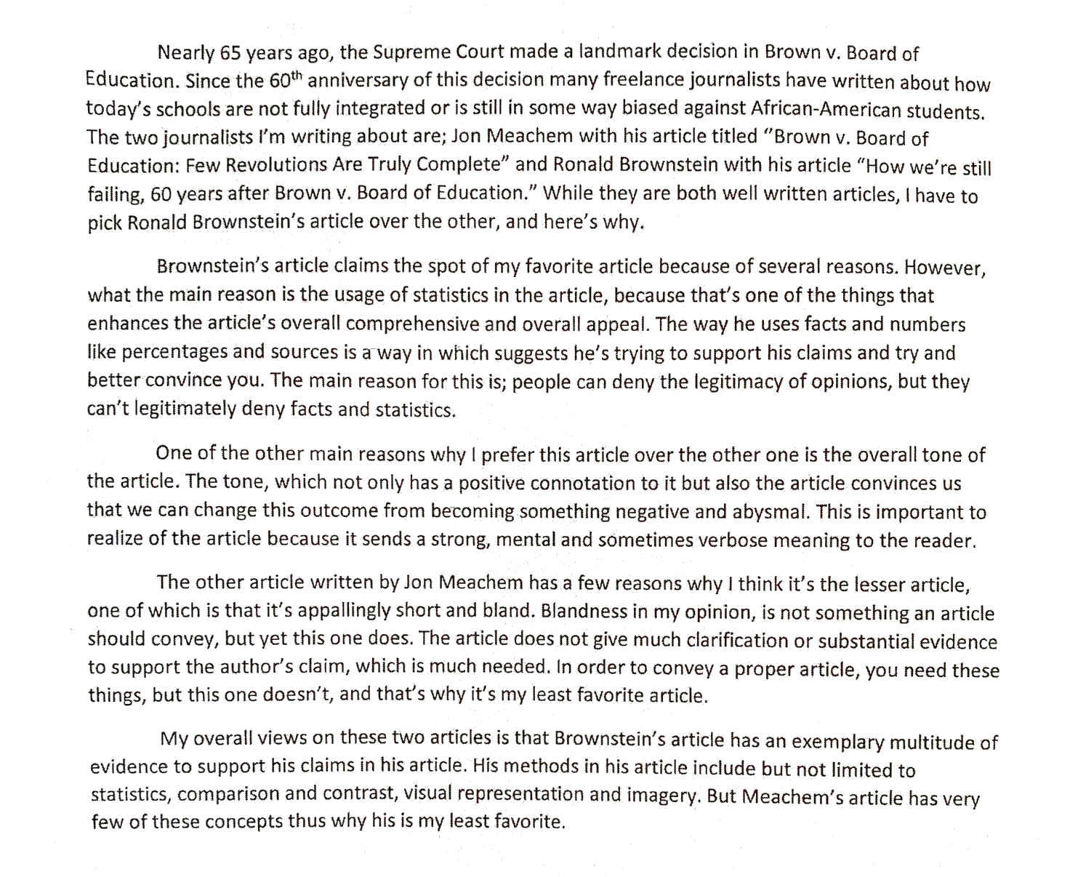

[This is a picture of the first student sample essay.]

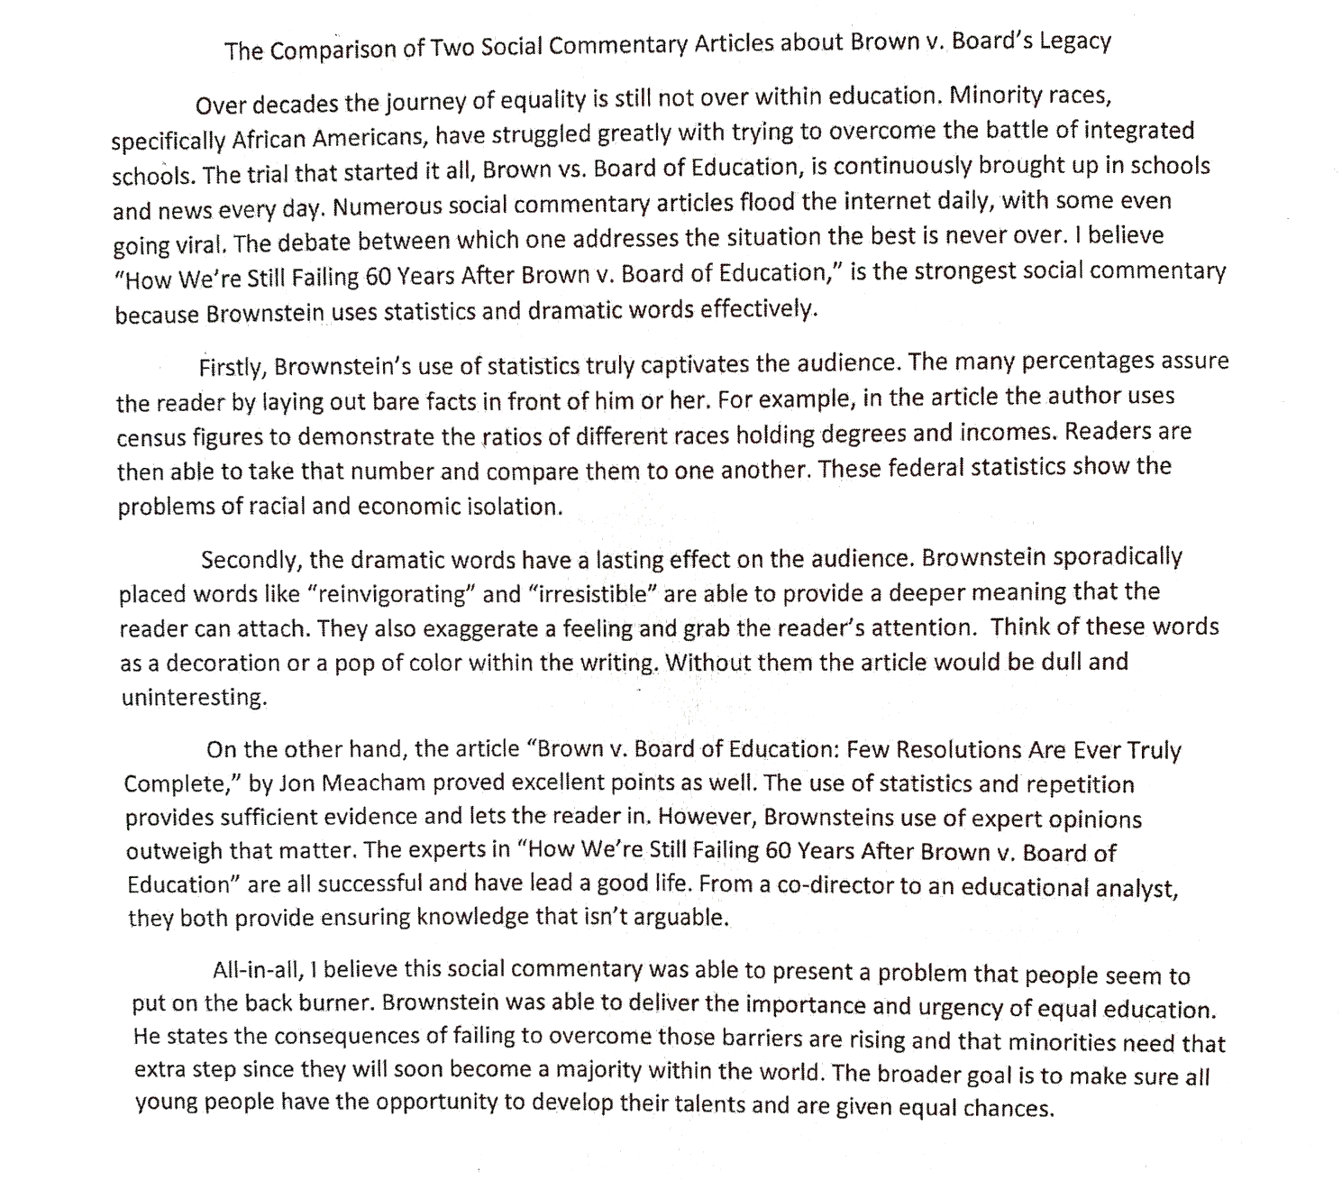

[This is a picture of the second student sample essay.]

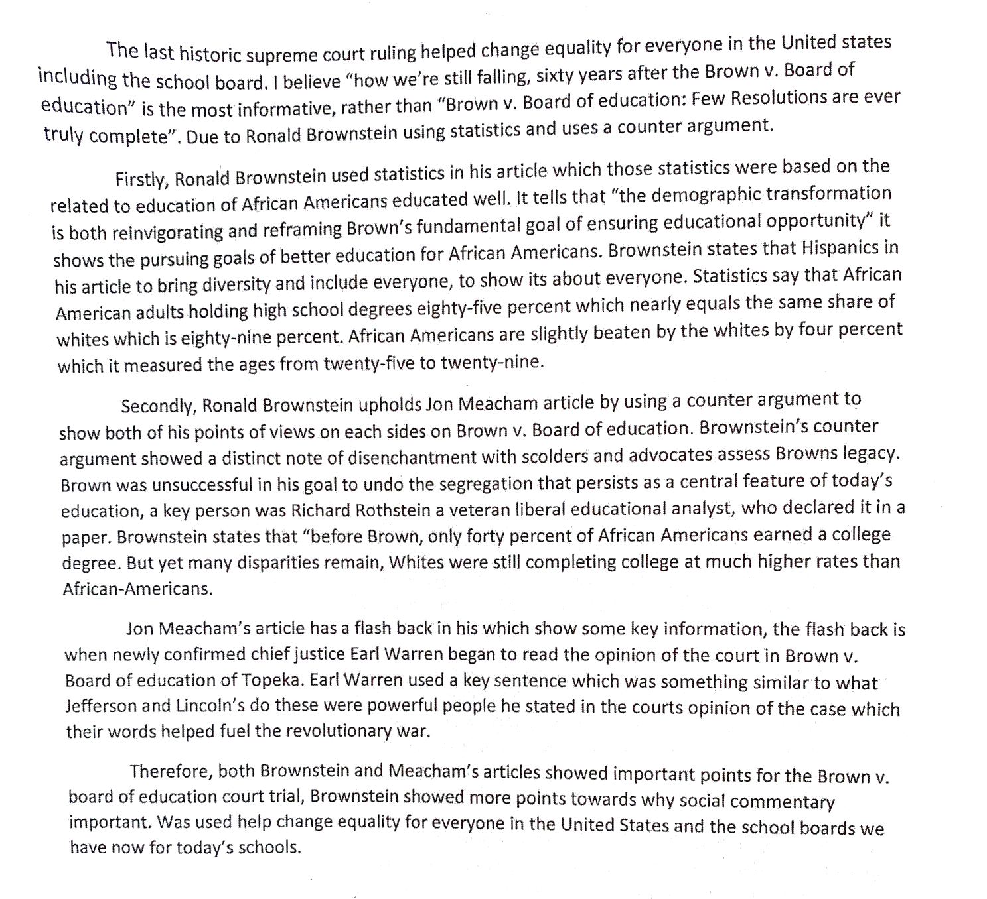

[This is a picture of the third student sample essay.]

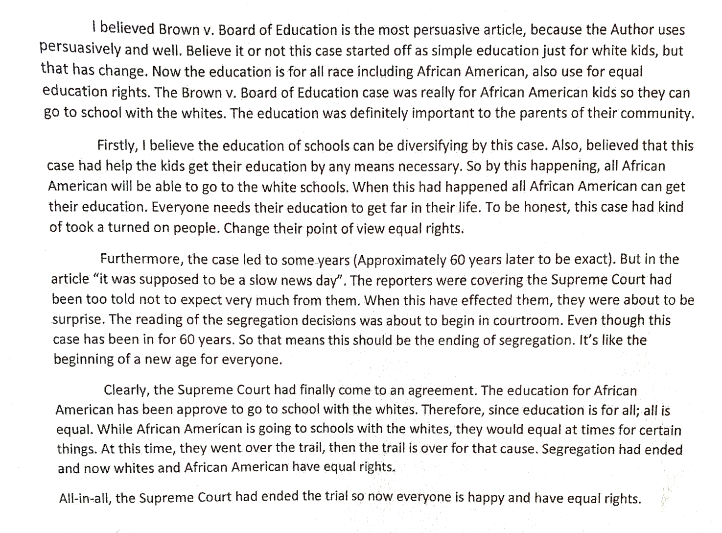

[This is a picture of the fourth student sample essay.]

