English Instructional Plan –
Primary Strand: 9.6 – Writing, 9.4 – Fictional Texts, 9.5 – Nonfiction Texts
Integrated Strand/s:
- 9.1 b, c – Communication
- 9.3 a, b, c – Reading (Vocabulary)
- 9.4 b, c, d, e, h, i, j, k – Reading (Fiction)
- 9.5 a, b, d, e, k – Reading (Nonfiction)
- 9.7 a, c, e – Writing (Editing/Revising)
- 9.8 f c- Research
Essential Understanding:
- understand that writing requires a recursive process that includes planning, drafting, revising, editing, and publishing
- understand that writing should be purposefully crafted, with attention to deliberate word choice, precise information, and vocabulary
- understand that voice and tone must be developed with awareness of audience and purpose
- recognize the importance of maintaining a formal style and objective tone in academic writing
- understand that analysis of a text should be based on text references, not personal opinion
- understand author’s viewpoint refers to his bias or subjectivity toward the subject; a viewpoint can be positive or negative
Essential Knowledge, Skills, and Processes:
- use prewriting strategies and organize writing
- create a thesis statement that focuses the essay, expresses the writer’s position in an argument, or explains the purpose of the essay
- analyze sources and determine the best information to support a position/argument
- compare/contrast and select evidence from multiple texts to strengthen a position/argument
- read paired passages/read across texts to examine author’s word choice, theme development, point of view, etc.
- determine a theme of a text and analyze its development
- compare and contrast two or more texts on the same topic or with similar themes
- use evidence from the text(s) for support when drawing conclusions, making inferences
- identify and infer the main idea from a variety of complex informational text
- make inferences and draw conclusions from complex informational text
Primary SOL:
9.6 g Compare/contrast and select evidence from multiple texts to strengthen a position/argument
9.4 k Compare/contrast details in literary and informational nonfiction texts

Reinforced (Related Standard) SOL:
9.4 i Analyze how the author’s specific word choices and syntax impact the author’s purpose.
9.4 j Make inferences and draw conclusions using references from the text(s) for support.
9.5 b Make inferences and draw conclusions based on explicit and implied information using evidence from text as support.
9.5 d Recognize an author’s intended purpose for writing and identify the main idea.

Academic Background/Language:
- thesis statement
- thematic statement
- speaker
- occasion
- audience
- author’s purpose
- tone
- mood
- diction
- syntax
- point of view
- imagery
- assertion
- evidence
- commentary
- ethos
- pathos
- logos
- main idea
- topic/subject

Materials
- “Fish Cheeks” by Amy Tan (910L) - CommonLit
- “What your most vivid memories say about you” by Susan Krauss Whitbourne (1310L) - CommonLit
- Suggestions for rhetorical passages from famous speeches:
  - Dr. Steven Knapp, Introduction of Tim Cook, George Washington University Commencement Speech, May 07, 2015
  - Barack Obama, Potomac Primary Night Speech, February 12, 2008
  - Walsch, Janet. Failing It's Families, Human Rights Watch, 2011
  - Ronald Reagan "The Boys of Point Du Hoc" Normandy France June 6th 1984
  - Barack Obama Night Before the Election Speech Manassas, Prince William County, Virginia November 3, 2008
  - George Orwell "Marakesh" 1939
  - Brett Arrends Is Apple Becoming a Value Stock? on Marketwatch.com June 21st 2011
  - Al Gore "A Generational Challenge to Repower America" July 17th 2008
  - Stanford Commencement Speech by Steve Jobs. June 12, 2005
  - I Have a Dream by Martin Luther King Jr. August 28th, 1963
  - The Economic Outlook and Monetary Policy by Ben Bernanke. August 27th, 2010
- Persuasive Appeals Commercial Suggestions:
  - “Dr. Todd Appleton – 2017 Sensodyne Commercial”
  - “Taylor Swift: Stay Extraordinary (Diet Coke Ad)”
  - “Little boy lost his mum – quit smoking commercial”
  - “Pedicure – Walgreens TV Commercial”
  - “Verizon Wireless – There’s a map for that commercial”
  - “Carl’s Jr. Commercial – Padma, Extended Version”
  - “Paul Switched Sprint Commercial”
  - “Texting While Driving | Teen Driving Survey | AT&T”
  - “Gatorade emotional great ad Serena Williams best commercial”
  - “Subaru Commercial I’m Sorry”
  - “Old Spice | Mom Song”
  - “Just Like Us | Child Sponsorship | 2007”
  - “Drake Sprite: The Spark Commercial”
  - “Verizon Commercial 2017 Odell Beckham Jr Red Zone”
- SOAPSTone notes – see Figure 1 on page 9
- SOAPSTone graphic organizer – see Figure 2 on page 9
- Index cards
- Suggestions for fiction and informational paired texts – CommonLit:
  - "City of Specters" by Bandi (1060L) paired with “Coming of Age in North Korea” by Tertitskiy (1090L)
  - "Cell One" by Chimamanda Ngozi Adichie (970L) paired with “The Science of Solitary Confinement” by Stromberg (1480L)
  - "The Gift of the Magi" by O. Henry (890L) paired with “Would you Marry a Stranger?” by McBirney (1280L)
  - "The Tell-Tale Heart" by Poe (830L) paired with “The Complexity of Fear” by Mary C. Lamia (1430L)
  - "The Bet" by Anton Chekhov (990L) paired with “Scientists Reveal Three Keys to Happiness” by ABC News (1060L)
  - "The Leap" by Louise Erdrich (1210L) paired with “Help Him Up!: A Witness’s Account of Panic on a Subway Platform” by Wilson (810L)
  - "The Necklace" by Guy de Maupassant (890L) paired with “Klondike Gold Rush” by Anonymous (1080L)
  - "The Lottery" by Shirley Jackson (1030L) paired with “Life isn’t Fair – Deal with it” by Myatt (1100L)
  - "The Man in the Well" by Ira Sher (870L) paired with “The Limits of Empathy” by Brooks (1060L)
  - "The Fly" by Katherine Mansfield (770L) paired with “The Spark that Brought Down Trujillo” by the CommonLit Staff (1140L)
- Comparative Analysis Outline Option 1 – see Figure 3 on page 10
- Comparative Analysis Outline Option 2 – see Figure 4 on page 10
- Student Samples – on pages 11-13

Student/Teacher Actions: What should students be doing? What should teachers be doing?

Part One - Connection to Fictional Texts (This part can either be completed in one class period or over several class periods depending on your students’ needs.)

- The students will read Amy Tan’s “Fish Cheeks.” This can be done in class or for homework.
- The teacher will explain the elements of the narrative/fiction SOAPSTone while the students take notes on their SOAPSTone graphic organizer.
- The teacher and the students, together, will analyze Tan’s “Fish Cheeks” and discuss support from the text for the SOAPSTone elements.
- The teacher will ask the students to recall the components of a thematic (thesis) statement that were taught in the beginning of the year.
- The students will explain that a thematic statement should be a sentence that is universal and that does not simply provide a summary of the text.
- The teacher will then model those components by creating a thematic (thesis) statement that explains the author’s purpose of “Fish Cheeks.” The students will then write their own thematic (thesis) statements that explain what they believe the author’s purpose of “Fish Cheeks” is; they will write these on index cards and turn them in at the end of the lesson.
- The teacher will review the students’ thematic (thesis) statements and provide feedback for each student.
- The teacher will model how to edit and revise a thematic (thesis) statement to include the literary elements that helped the author express his or her purpose of “Fish Cheeks.” Then, the teacher will return the students’ thematic (thesis) statements and the students will edit and revise their statements to include the literary elements that helped the author express his or her purpose of “Fish Cheeks.” During this process, the teacher will monitor students and assist when needed.

Part 2 - Persuasive Appeals (This part can either be completed in one class period or over several class periods depending on your students’ needs.)

- Before the students read and analyze an informational text, it is helpful to introduce or review persuasive appeals so that they can provide different types of textual evidence to support the author’s purpose. To start, the students will watch a series of persuasive commercials and brainstorm a list that answers the following question: What makes this commercial effective?
- After viewing all of the commercials, the teacher and the students will discuss what makes each one effective.
- The teacher will explain the three persuasive appeals (ethos, pathos, and logos) and why/how they are used in writing. During these explanations, the students should take notes on the appeals.
- Each student will receive a passage from a famous speech or document. They will identify if ethos, pathos, and/or logos was used in the passage. Then, each student will explain which persuasive appeal is the most effective and why. Having the students write this type of explanation will reinforce their comprehension of a text, application of persuasive appeals, and construction of a thesis statement. During this process, the teacher will monitor and assist when needed.
- The students will turn in their explanations, the teacher will review them and re-teach and/or remediate if necessary.

Part Three - Connection to Informational Texts (This part can either be completed in one class period or over several class periods depending on your students’ needs.)

- The students will read “What your most vivid memories say about you” by Susan Krauss Whitbourne. This can be done in class or for homework.
- The teacher will explain the elements of the nonfiction/informational text SOAPSTone while the students take notes on their SOAPSTone graphic organizer.
- The students will work with a partner to analyze “What your most vivid memories say about you” and discuss support from the text for the SOAPSTone elements. The teacher will monitor and assist when needed.
- Each student will generate a thematic (thesis) statement, on an index card, that includes the author’s purpose of “What your most vivid memories say about you” and the literary devices he or she used to express that purpose. These will be turned in at the end of the lesson.
- The teacher will review the students’ thematic (thesis) statements and provide feedback for each student.
- The teacher will discuss some strengths and weaknesses that were found while reviewing the thematic (thesis) statements and provide solutions and examples on how to improve them. Then, the teacher will return the students’ thematic (thesis) statements and the students will edit and revise them. During this process the teacher will monitor and assist when needed.

Part 4 - Connection to Comparative Analysis (This part can either be completed in one class period or over several class periods depending on your students’ needs.)

- The teacher will explain the importance of comparing texts and will model how to create a comparative thesis statement that identifies which text is the most effective at expressing the author’s purpose. The students will then compose their own comparative thesis statement on a new index card which will be turned in at the end of the lesson.
- The teacher will review the students’ comparative thesis statements and provide feedback for each student.
- The teacher will discuss some strengths and weaknesses that were found while reviewing the thesis statements and provide solutions and examples on how to improve them. Then, the teacher will return the students’ comparative thesis statements and the students will edit and revise them. During this process the teacher will monitor and assist when needed.
- The teacher will provide students with several options of fictional short stories and the students will indicate their choice.
- The teacher will explain the two choices for the writing outline and the expectations for the essay.
- The teacher will distribute each student’s chosen fictional and corresponding nonfiction texts.
- The students will read and analyze their two texts using the SOAPSTone strategy.
- The students will create an outline that compares the texts’ purpose/main idea by analyzing the literary elements that support the purpose/main idea and explaining which text is the most effective.
- The students will generate, revise, and edit their comparative analysis essays.
- During the writing process the teacher will encourage the students to use their notes, examples, and revised thesis statements to generate essays.

Assessment (Diagnostic, Formative, Summative)
- The teacher can use the persuasive appeals commercials as a diagnostic for the students’ knowledge of ethos, pathos, and logos which can help guide instruction for more or less specific notes, additional practice, or the use of the appeals as textual evidence in their comparative analysis essay.
- The teacher can use the thematic (thesis) statements, explanations for persuasive appeals in the famous speeches, and/or SOAPSTone graphic organizers for “Fish Cheeks” & “What your most vivid memories say about you” as formative assessments to ensure that students can effectively analyze and communicate their ideas.
- The summative assessment can be an edited and revised comparative analysis essay of the students’ chosen fictional and informational pieces.
Writing Connections:
- Teachers should recognize that there is not a required number of paragraphs or prescribed structure. Requiring students to use a prescribed model (i.e.,five paragraphs) often produces formulaic writing and limits student expression.
- Teachers will model the recursive writing process for students, including the use of anchor texts that would be acceptable to both postsecondary education and the workplace.
- Teachers should refer to examples of writing in mentor texts.
- Teachers should integrate grammar with writing instruction throughout the academic year: continue to work with students on incorporating commas, semicolons, and/or colons to improve sentence variety.
- Teachers should provide the opportunity for students to have practice writing on demand, for shorter time frames, and over extended periods of time.
- Teachers should provide opportunities for student choice with topic, audience, and purpose.

Reading Connections:
- Teachers should teach a balance of fiction including poetry and nonfiction throughout the academic year.
- While whole-group instruction can be centered on a shared text, teachers must also provide opportunities for student choice with both fiction and nonfiction texts.
- Teachers should use fictional and informational texts paired on a common theme or topic and have students compare/contrast.
- Teachers should introduce students to longer, more complex texts both on grade level and above.
- Teachers should have students refer to the text(s) for support.
- Although the standard in fiction requires comparing/contrasting details in literary and informational nonfiction texts, teachers should be using paired passages with a variety of texts.

Extensions and Connections (for all students)
- Extension Activity: Students could turn their comparative analysis essays into a persuasive product by either writing a letter or creating a presentation convincing the public that the piece should/should not be removed from the school’s reading list and public library shelves.

Strategies for Differentiation
- After instructing the students on the appropriate and effective use of media literacy, the teacher could allow the students to pick one, or both, of their comparative selections: one fictional piece and one informational piece.
- The teacher could limit the students’ choices of comparative selections or assign one specific fictional piece and one specific informational piece.
- The teacher could provide sentence frames (starters) for thematic (thesis) statements. Some suggestions could include:
  - The author’s use of (literary device/s) shows that (author’s purpose/main idea).
  - (Author’s name) use of (literary device/s) shows (author’s purpose/main idea).
  - In (title of the selection) the use of (literary device/s) shows that (author’s purpose/main idea).
  - The (literary device/s) in the (narrative or informational piece) helps show… (author’s purpose/main idea).
  - Both (author’s name) and (author’s name) address; however, (author’s name)’s use of (literary device/s) have a stronger effect on the reader.

Note: The following pages are intended for classroom use for students as a visual aid to learning.

Figure 1 – SOAPSTone Notes
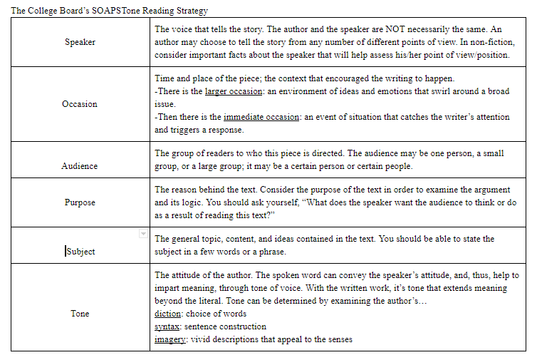

Figure 2 – SOAPSTone Graphic Organizer
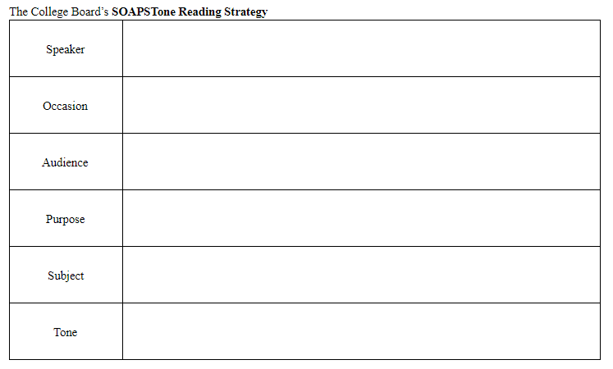

Figure 3 – Comparative Analysis: Outline Option 1

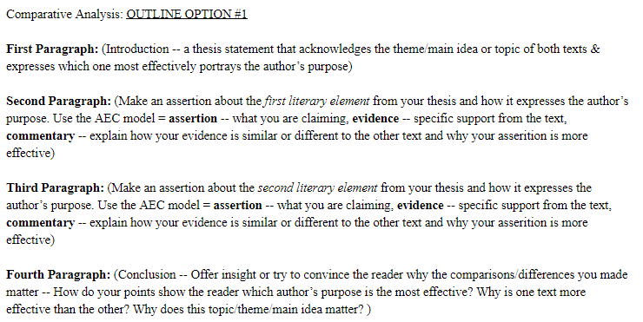

Figure 4 – Comparative Analysis: Outline Option 2

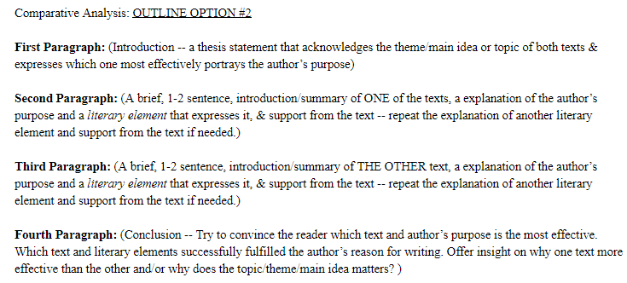

Student Sample # 1

In order to show how a person's life can be better, “The Bet” and “Scientists Reveal Three Keys to Happiness” use the subject of self discovery to show the reader how their life can improve. In “Scientists Reveal Three Keys to Happiness” the author uses second person and positive diction to inform the reader on how to live a happy life. In “The Bet” by Anton Chekhov the author uses a narrator to tell the story of two men who make a bet that change their lives.

In “The Bet” the narrator constantly makes comparisons about age, money, and pride in order to show how your life won’t always be the same and that your ideas will change. In the tenth paragraph the narrator says “The banker, spoilt and frivolous with millions beyond his reckoning, was delighted at the bet.” Then in paragraph twenty-two they say “Fifteen years before his millions had been beyond his reckoning: now he was afraid to ask himself which was greater, his debts or his assets.” This comparison from the time when the banker was younger and “had it all” to now when he isn’t sure he can afford to pay something he had once called a trifle. He had thought he would say rich and that thought that he was right about the bet, he thought he would never have to pay. The banker also says this in paragraph twenty-two, “Why didn’t the man die? He is only forty now. He will take my last penny from me, he will marry, will enjoy life, will gamble on the Exchange; while I shall look at him with envy like a beggar, and hear from him every day the same sentence: ‘I am indebted to you for the happiness of my life, let me help you!’” This shows that the banker’s pride and view on age is still a huge part of him, that he thinks he has done no wrong in taking the man’s freedom and doesn’t want to lose everything he once took for granted. On page three the narrator goes on to explain what the lawyer asked for and learned in his fifteen years of imprisonment, showing the reader where his mind was and what he wanted to read more about. The lawyer goes from reading about fiction stories full of adventures he can’t have while locked up, to reading about the world and how it works, to finally wondering about people and philosophy and an after life. These comparisons throughout the story show how both of the characters lives have changed and how only one of them are taking advantage of these changes. It shows how the lawyer has grown and how though the banker’s life has changed he has not.

In the article “Scientists Reveal Three Keys to Happiness” the author uses examples, research, and quotes to inform the reader on how they can live a happy life. The author starts out by saying “According to decades of research by a husband and wife team of psychologists at the University of Michigan, you need to put yourself in an environment that meets three basic human needs.” This tells the reader that the information being given can be trusted and what the article is about. “In the years since, they have repeated that study dozens of time, all over the world, with the same results. One exception is among teenagers who prefer the urban scenes with the city lights and things to do over scenes of nature, but Kaplan says they grow out of that stage.” The author describes how the study played out to let the reader understand the thought process of others. This helps explains why one of the “keys” to happiness is understanding what is happening around you. The order of the article is presented like a list, showing how to have all of the three keys to happiness individually, why they make your life better, and how they tie in with nature. In paragraph twenty- two the author quotes Kaplan and writes “‘So gradually we came to the realization that what people want to do is participate. The opposite of helplessness is being heard. It’s laying a part. It’s being engaged in the action. Not being ignored.’ Only then will it be possible for your life to make a difference.” Quoting what the scientist said helps the reader understand how the discovered this. Showing all of these things helps the reader understand what is not only making them unhappy, but how it can be fixed.

In “The Bet”, showing the life of the banker and lawyer then and now helps the reader see how much has changed. Furthermore, showing the reader what each key to happiness is helps them see how it can improve their life in “Scientists Reveal Three Keys to Happiness”. However, “The Bet” is more effective in showing the author's purpose. This is because the author writes out the growth of the characters. By showing the banker’s financial situation the reader can see that all the banker cares about still is money. By showing the lawyer’s book choices the reader can see what he is thinking about and how he is growing from it; when the lawyer writes the letter we see how the lawyer’s life has changed him and how the banker’s life hasn't changed him. This matters, because people should know that their life won’t always be a happy one. That your situation may change and your decisions now will affect you in the future. Making sure that you continue to try to improve yourself doesn’t stop at a certain age and you might change your mind on some subjects you thought you once knew so well.

Student Sample # 2

In the passages, “City of Specters, and, “Coming of Age in North Korea,” authors Fyodor Tertitsky and Bandi both address how a heavily flawed society can negatively affect its citizens. However, I believe that by the use of repetition and an extended metaphor, Bandi conveyed this idea better.
The first passage, “City of Specters” was about a family that was banished from North Korea because the mother put up different curtains. She did this in order to help protect her child from seeing portraits outside that scared him. In this passage I believe that the author wanted to show how a society’s corruption instilled fear in its citizens. She achieved this by using a metaphor throughout the entire passage comparing the portraits to the fictional monster “Eobi.” These portraits were of Karl Marx, who heavily influenced North Korea’s ideology, and Kim Il Sung, the leader of North Korea at the time. She puts up these curtains because her child sees them as the terrifying monster and she is trying to protect him. In the passage, it says “Myeong-Shik’s (child’s name) initial terror had come from a face to face encounter with Marx’s portrait, and with his stressed mind and active imagination, the picture loomed larger by the day.” Since these 2 people represented a lot of North Korea’s system of government, I believe the author compared them to the “Eobi” to express his views of the country.
The second passage, “Coming of Age in North Korea,” by Fyodor Tertitsky was an informative text about the experiences of North Koreans in their adult lives. They also heavily discussed the country’s system of government and their strict social hierarchy. I think that the author wanted to show how a government can easily become flawed when it is so influenced by ancestry and strict social classes. The author used his specific, almost satirical, tone and the appeal of logos to help explain how this country is influenced. It used statistics and logical facts to support his claims throughout the passage. For example, while the author is addressing jobs and careers, he says, “Workers are not in a better position since the monthly income of workers is roughly equal to $1-2. Quite an irony, since, the communist movement was initially about bringing up a ‘workers’ and peasants’ state’.”
Fyodor Tertitsky conveyed his ideas well through his use of satire throughout the passage, along with his appeal of logos. He also provided good examples and quality information. But, I believe that Bandi made a more meaningful point about their country with the use of a child seeing the “monsters,” and really providing insight on what day-to-day life was like in the country. I believe the theme of a corrupt government matters because it is such a prevalent issue all over the world today.

Student Sample # 3

Both David Brooks and Ira Sher talk about whether or not our feelings influence our actions; however, David Brooks has a stronger point of view. David Brooks used logos to support his perspective that the feeling of empathy doesn’t determine our actions.
In the article, “The Limits of Empathy,” the author’s purpose was to inform us that empathy doesn’t determine our actions. David Brooks used logos and researches that supported his point of view. One of the researches was from the University of New York and the other was an experiment in the 1970s. Both researches demonstrated that empathy is not a major play when it comes to moral motivation.
In the short fiction story, “The Man in the Well,” the author used negative connotation to show that not everything has an explanation. In the second paragraph it says, “I don’t remember if we told ourselves a reason why we couldn’t help him, but we had decided then.” They didn’t have an explanation as to why they left the man in the well and never told anyone, or asked for help to help get him out of the well. They just decided to not get help and leave him there.
David Brooks purpose was more effective than Ira Sher’s because he used facts. He used logos and researches to support his opinion that the feeling of empathy doesn’t determine our actions. He says, “Empathy makes you more aware of other people’s suffering, but it’s not clear it motivates you to take moral action or prevents you from taking immoral action.” Ira Sher said the opposite from her short fiction story. In the short fiction story, “The Man in the Well,” the kids actions were controlled by their emotions, but there is no actual facts that support that emotions control our actions. That’s why David Brooks purpose was more effective than Ira Sher’s.

