English Instructional Plan – Using and Gathering Information with Text Features Grades 4-5
Primary Strand: Reading 4.6, 5.6
Integrated Strand/s: Communication and Multimodal Literacies, Research 4.9, 5.9
Essential Understanding:
All students should:
- understand that nonfiction texts provide information, explain a process, or persuade
- understand text features serve a purpose
- understand that ideas and topics are presented differently by different authors
Essential Knowledge, Skills, and Processes:
To be successful with this standard, students are expected to:
- Use text features such as type, headings, and graphics, to predict and categorize information.
Primary SOL:
4.6a, 5.6a Use text features such as type, headings, and graphics, to predict and categorize information.
Reinforced (Related Standard) SOL:
4.9b, 5.9b Collect and organize information from multiple resources

Academic Background/Language:
Text features are used to help organize, predict, categorize, and understand nonfiction text. We see text features in various forms of text including but not limited to our Science textbooks, Social Studies textbooks, websites and articles. Some examples of text features are table of contents, headings, pictures, captions, maps, indices, and charts.
Sentence starters:

By previewing the text features, I can predict this text is about ...

(text feature) helps me to better understand what I am reading because ...
- I can learn … by previewing the text features.

Materials
- Text features graphic organizer (example below)
- Text/website with various text features
  - Suggested texts:
    - Water Cycle: www.Nationalgeographic.org
    - Survivors’ Stories: www.Nationalgeographic.org
    - Maggie Walker: www.encyclopediavirginia.org
    - National Geographic Readers
    - Explore and Discover books (Question Time) by Stephen P. Savage
    - DK Eyewitness Books
    - Social Studies or Science textbooks

Student/Teacher Actions: What should students be doing? What should teachers be doing?
- Set a timer for 2 minutes and ask students to write the name of as many text features as they can name from memory. Then give students 2 extra minutes to compare their list with a partner to name as many text features as possible.
- Review text features with students by showing examples and discussing their purpose.
  - a sort (see example below)
  - use actual text with labels (use sticky notes/Post-its and label real texts)
- Choose a website or an informational text that has various text features. Using the text and graphic organizer have students preview the text features, predicting how the text features will help the reader better understand the text.
- Have students read the text and note what they learned.
- Have students report to the class how the features enables the student to better understand the text.
- Go back to the initial review activity in step 1. Have students review their lists and update with an additionally learned text features. Students could then add the purpose of each text feature as an exit ticket.
Assessment (Diagnostic, Formative, Summative)
- Think-pair-share: Have students independently think about how text features help them understand a text. This can be done in writing or orally. Next, pair with a partner to compare thoughts before sharing out to the class. (This can be done before or during the activity). Written ideas can be collected as exit tickets.
- Walk around while students are completing the lesson and listen to their conversations.
- Use students’ posters to assess their application of text features to explain a topic.
Writing Connections:
- Have students research a topic related to Social Studies or Science. Students will create a poster featuring various text features to share their knowledge. Provide students with a rubric detailing what their poster should look like and how many text features should be included.
- Have students select a text feature and write an example of what it looks like and how it is helpful to readers.
Extensions and Connections (for all students)
- Choose a website or text pertaining to one topic. Create a list of questions which can be answered by reading the different features of the text
- Select a nonfiction text: Using sticky notes have students mark the text features located in the text. On the sticky note have them make a prediction about how the text feature will help them or predict what they think they will learn by previewing the text feature. After students have flagged the features, have them read the text features carefully and then reflect on how the text features were helpful to you.
  - Another option: Students can flag text features and write what they learned from the feature and how it was helpful
  - Students can also just tag one text feature.
- In text, review the features (title, headings, bold words, pictures, maps) on a sticky note have them write what they think the passage is mainly about including questions they would like to have answered.
- Using the text have students identify the text structure. They will recognize transitional words and phrases.
  - cause and effect
  - comparison/contrast
  - chronological
  - problem/solution
Strategies for Differentiation
- Have students work in partners
- Provide multiple examples of text with text features
- Model for students before they complete independently
- Use independent level text
- provide students with an outline when completing the poster.
- Audio text
- Use sentence frames: “The author included the (text feature) to help the reader --”
- Provide an anchor chart showing examples of text features and their purposes. This could be created with a small group of students to build vocabulary and/or reteach.
Note: The following pages are intended for classroom use for students as a visual aid to learning.
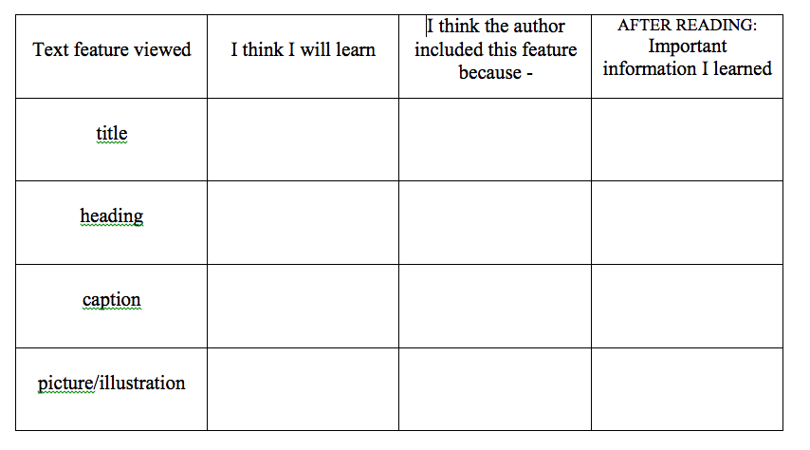
Text feature vocabulary for sorting/matching to pictures
heading | title | caption | photograph
bold print | table of contents | glossary | diagrams
graph | index | map | timeline
italic print | chart | numbering | bullet points

Text Feature Examples for sorting/matching with vocabulary
Matter can be a solid, liquid or a gas. | 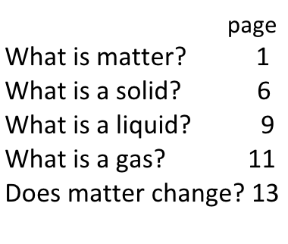 | 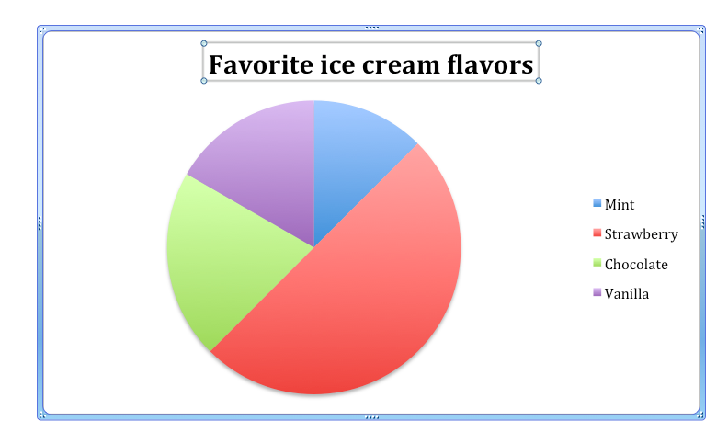 | 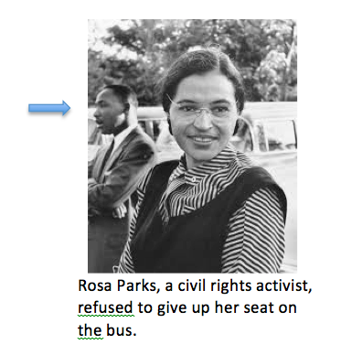
US Presidents  1963-1969 Johnson  1969-1974 Nixon  1974-1977 Ford  1977-1981 Carter  1981-1989 Reagan  1989-1993 Bush | 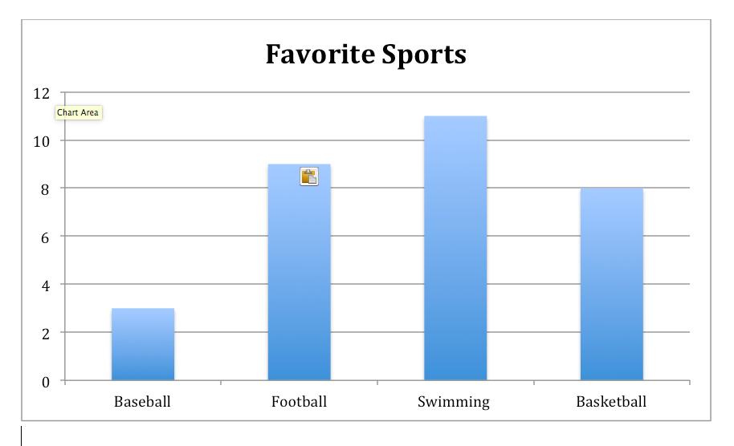 | 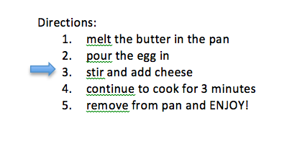 | 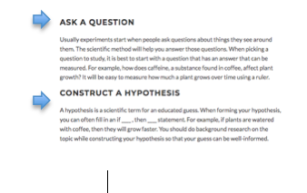  www.commonlit.org
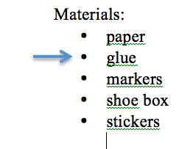 | 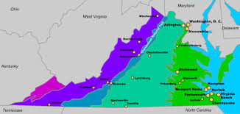  google | 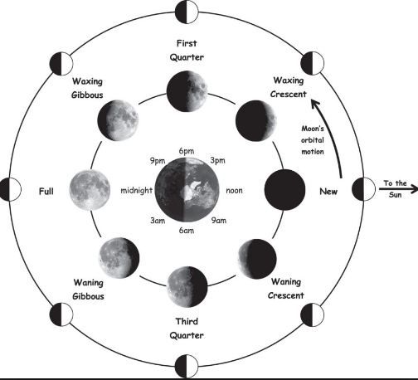  google | The American colonist were unhappy with the British, so they wanted to form their own government.
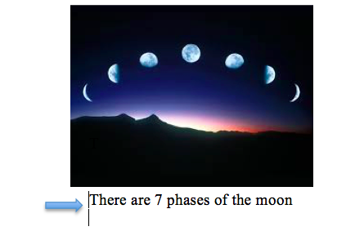  google | absorbs- to take in  pitch- how high or low a sound is  vibrates- to move back and forth quickly  waves-moving energy | 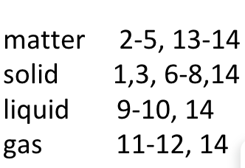 | 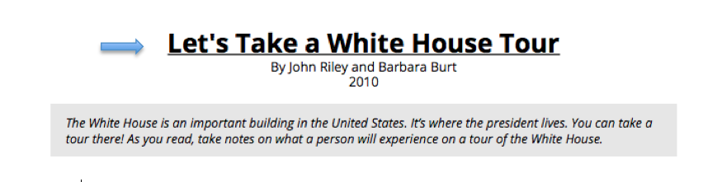www.commonlit.org

