English Instructional Plan – Cause-and-Effect and its Impact on the Plot 6-8
Primary Strand: Reading 6.5, 7.5, 8.5
Integrated Strand/s: Communication and Multimodal Literacies 6.1, 7.1, 8.1
Writing 6.7, 7.7, 8.7
Essential Understanding:
- understand that the author uses images to craft a message and create characters
Essential Knowledge, Skills, and Processes:
- explain plot as the development of the central conflict and resolution
- explain plot as the sequence of events in the story
- explain plot as the writer’s map for what happens, how it happens, to whom it happens, when it happens, why it happens, and where it happens

Primary SOL: 6.5b Describe cause-and-effect relationships and their impact on plot 7.5c Identify cause-and-effect relationships and their impact on plot 8.5b Identify cause-and-effect relationships and their impact on plot

Reinforced (Related Standard) SOL:
- 6.7 The student will write in a variety of forms, to include narrative, expository, persuasive, and reflective, with an emphasis on narrative and reflective writing.
- 7.7 The student will write in a variety of forms to include narrative, expository, persuasive, and reflective, with an emphasis on persuasive and expository.
- 8.7 The student will write in a variety of forms to include narrative, expository, persuasive, and reflective, with an emphasis on persuasive and expository.

Academic Background/Language: Students will need to be familiar with vocabulary related to the elements of plot, including conflict, exposition, initiating event, rising action, climax, falling action, and resolution. Students will need to be familiar with vocabulary related to cause and effect, including common signal words and phrases.

Materials
- Babushka’s Doll, by Patricia Polacco (or another picture book short story with clear plot elements), read previously
- “The Wounded Wolf,” by Jean Craighead George, or another short story with clear cause/effect relationships
- Copies of the attached organizer
- Copies of attached exit activity

Student/Teacher Actions: What should students be doing? What should teachers be doing?
- Teacher ask students to consider Babushka’s Doll, a children’s book they read previously while analyzing plot.
- Teacher will give students a cause from the book (Ex. Natasha was very demanding and refused to help her grandmother) and ask students to consider what the effects were. Students will respond through a think-pair-share discussion.
- Teacher will ask students to consider how the story would have changed if that cause had changed and allow students to respond through a think-pair-share discussion.
- Teacher will point out that cause-and-effect relationships greatly impact the plot of a story and say that today’s focus will be to examine those relationships and determine how they affect the plot. The teacher could sketch the sequence of cause and effect events on an anchor charts to display for students.
- Teacher will introduce a story to the class (“The Wounded Wolf” or a similar story that shows cause and effect relationships) and read a short portion of the text with the students, until a predetermined cause and its effect can be examined.
- Teacher will distribute the attached organizer and model for students how to complete the organizer using the example from the story by listing the cause, the effect, and the impact that relationship has on the plot. Teacher will model pointing out signal words and phrases that help readers find causes and effects in a story if encountered.
- Teacher will continue with examples of cause-and-effect relationships until students can continue independently or in small groups.
- Students will finish reading and complete the graphic organizer in partners or individually. Teacher will circulate, monitor progress, and conference with students as needed.
- Teacher will bring class back together to discuss the graphic organizer, focusing in on the “main” or huge influencing cause/effect relationships have on moving the plot of a story forward.
- Teacher will display attached exit ticket to consider a specific cause/effect relationship and what would happen to the story if that cause had changed.

Teacher Assessment (Diagnostic, Formative, Summative):
- Teacher should confer with students as they read the story and complete the organizer, coaching them if they struggle
- Exit ticket activity will allow teacher to formatively or summatively assess individual understanding of skill (depending on the amount of instruction that has previously been provided).

Writing Connections:
- Have students rewrite the story reflecting changes in the plot if a single cause was changed

Extensions and Connections (for all students)
- Give students different cause/effect organizers or flow charts (see attached example below) with one part filled in and have them work to determine the missing piece(s) (For example, one cause with several effects, a cause-cause/effect-cause/effect chain, or several causes leading to one effect) and have students explain their thinking in writing or to another student/group/the class

Strategies for Differentiation
- Pair readers strategically to provide support for struggling readers
- Cause/effect organizer can be partially filled in as an accommodation
- Provide sentence stems for writing explanations of impact (Examples: The reason _____ happened was that _________., If ____________________ had not happened, then _________________., As a result of _______________________, ________________ happened.)
- Work with a targeted small group while reading and completing the organizer

Note: The following pages are intended for classroom use for students as a visual aid to learning.

Cause/Effect Organizer:
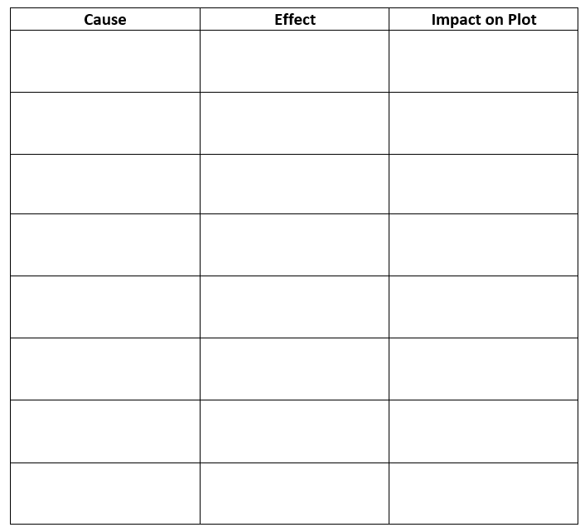

Exit Activity:
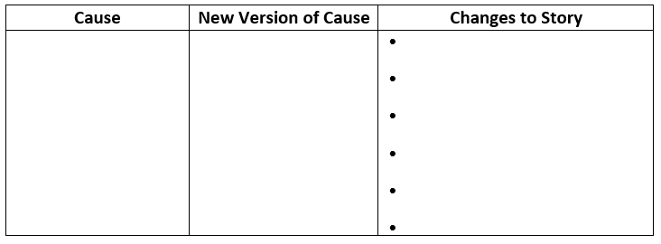

Extension Graphic Organizer/Flow Chart Example
