English Instructional Plan – Analyze the Rhetoric of Persuasive Speech
Primary Strand: 9.5, 10.5, 11.5 - Reading
Integrated Strand/s: 9.4, 10.4, 11.4 - Reading

Essential Understanding:
- understand the relationship between an author’s style and literary effect
- understand that analysis of a text should be based on textual evidence rather than personal opinion
- understand how an author’s intent is achieved by the use of context and language
Essential Knowledge, Skills, and Processes:
- analyze an author’s use of diction and syntax to convey ideas and content.
- compare and contrast two or more texts on the same topic or with similar themes
- use evidence from the text(s) for support when drawing conclusions, making inferences

Primary SOL:9.4i - Analyze how the author’s specific word choices and syntax impact the author’s purpose.
Reinforced (Related Standard) SOL: 9.5d – Recognize an author’s intended purpose for writing and identify the main idea.

Academic Background/Language:
Students should be familiar with elements of rhetoric or persuasion and be able to give examples of the elements (refer to VDOE curriculum framework for grade specific terminology). If not, please review these terms with the students prior to the student/teacher actions in this instructional plan.

Materials
- Copy of two persuasive speeches (Do an Internet search. Consider choosing one from a fiction text)
- Rhetoric Evaluation Chart (handout); butcher block paper
- Venn diagram
- Access to nonfiction materials
- One piece of cardstock per student

Student/Teacher Actions: What should students be doing? What should teachers be doing?
- Each student takes out a sheet of paper and draws a large Tic-Tac-Toe board. The center will be a FREE SPOT. For all of the other empty locations, a student writes an element of rhetoric or persuasion and gives an example. Teacher models completing one square with the class as an example to establish expectations.
- Students walk around and find someone who has the same word written in one of the boxes. Once students find a match, they write the other person’s name and share each other’s example. Incorrect examples, as well as literary devices not belonging to rhetoric or persuasion will not count. Students who achieve three in a row should shout “Tic-Tac-Toe” and sit down. All students must get three in a row.
- Explain that one of the tools necessary for twenty-first century living is to be able to make decisions about the validity of opinions as well as factual information.
- Arrange students in groups of four.
- Distribute the Rhetoric Evaluation Chart. Review the categories with the students. Explain that as students read two speeches, they will evaluate the speeches based on the chart’s categories.
- Distribute copies of the two speeches.
- Students read each speech and collaborate to complete the Rhetoric Evaluation Chart within their groups.
- Groups share their responses from the Rhetoric Evaluation Chart with the class.
- Record accurate responses onto a whole class Rhetoric Evaluation Chart (could be on butcher block paper taped in front of the room).
- Using the completed class Rhetoric Evaluation Chart, discuss how both speeches were meant to be persuasive. Groups collaborate to evaluate each speech by analyzing words, phrases, concepts, sentences, and quotes that demonstrate how the author intentionally crafts the work to achieve its purpose.
- Groups collaborate to compile The ABC’s of Persuasion for each speech. Using their own sheets of paper, students will put a different letter of the alphabet (students should use as many letters of the alphabet as possible) on a separate page. The word, phrase, or concept on each page will begin with a different letter of the alphabet. Each page will be divided in half. One side will analyze the excerpt from one speech and the other half will analyze the other speech. Each page must have the following criteria:
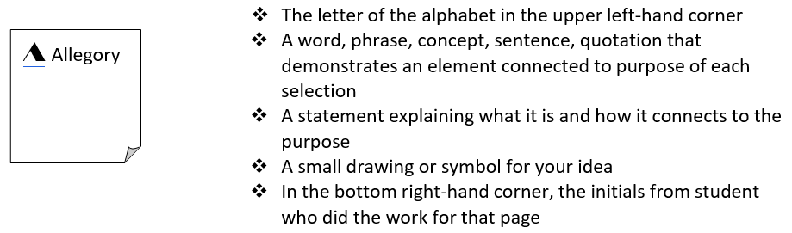
- As students develop the ABC’s of Persuasion, post the following questions to guide their choice of words, phrases, concepts, and quotes: “What are these authors trying to say?” and “What are these authors’ point of views about the topics?”
- After students have completed the ABC’s of Persuasion, require groups to reflect back through their booklets to look for similarities and differences in the ways the authors crafted their persuasive arguments. The students and teacher discuss and create a Venn diagram to record similarities and differences.
- Pose the following question to the students: What makes these forms of persuasion effective? Divide students into four groups using the four corners of the room. The first group thinks that only the first speech was effective. The second group thinks only the second speech was effective. The third group thinks both, and the fourth thinks neither. In each corner, have students make a case for their thinking. They must give evidence directly from the text. Each group member is expected to contribute orally during the presentations.
- As a final exercise, distribute one piece of cardstock to each student. Each student designs a sign that captures the viewpoint of one of the authors. Students must be mindful of their word choice as a persuasive tool when conveying the message.

Assessment (Diagnostic, Formative, Summative)
- Tic Tac Toe board
- Rhetorical Evaluation Chart
- The ABCs of Persuasion terms
- Venn Diagram
- Student sign that captures an author’s viewpoint

Writing Connections:
- Students can write a short response (either individually or as a group) on one of the speeches. Students will analyze how the author uses a rhetorical device (tone, word choice, syntax) to convey his/her purpose.

Extensions and Connections (for all students)
- Students can research the historical context of each text. Students collaborate to create a list of questions related to the historical and cultural context of each text. These questions will drive the students’ research. The whole class can debrief about what they found out and how it relates to the two speeches. Ask the students to think about the following question:
  - Does a historical and cultural perspective clarify or add misconceptions to persuasion?
- Students conduct a day of research using the library and electronic resources to find out about the historical and cultural connections these selections have. The same group that read and wrote the ABC booklets will reconvene and begin their investigation.

Strategies for Differentiation
- In preparation for the lesson, create the Tic-Tac-Toe board with the elements of rhetoric or persuasion already written in the boxes. Provide a list of examples for each rhetorical/persuasive element and have the students match the examples to the elements on the Tic-Tac-Toe board. Students will still walk around the room to share examples.
- Students will be provided with an ABC’s of Persuasion booklet with the word, phrase, or concept already written on each page. Students will then give examples from the texts and draw a symbol for their ideas. The pages will be divided up among the students in the groups.

Note: The following pages are intended for classroom use for students as a visual aid to learning.

Rhetoric Evaluation Chart
Name: Date:
 | SPEECH 1 | SPEECH 2
Analyzing the
Message
Author
Author’s Purpose
Intended Audience
Speaker
Context (historical, cultural)
Viewpoint
Persuasive
techniques
Literary devices
Word choice

