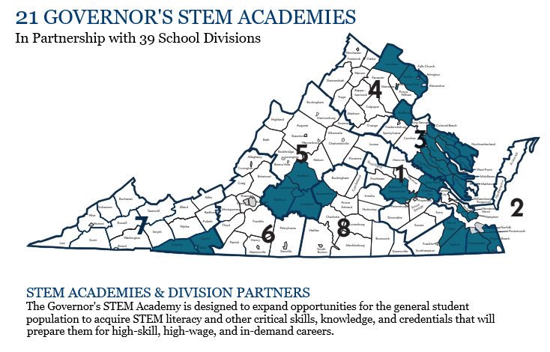
1. GOVERNOR’S STEM ACADEMY AT OSBOURN HIGH SCHOOL, Manassas City Public Schools
2. GOVERNOR’S CAREER AND TECHNICAL ACADEMY IN ARLINGTON, Arlington County Public Schools & Northern Virginia Community College
3. FIRST: FOSTERING INNOVATIONS & RELEVANCE THROUGH STEM AND TRADES, Suffolk City Public Schools
4. STAFFORD ACADEMY FOR TECHNOLOGY, Stafford County Public Schools
5. LOUDOUN GOVERNOR’S CAREER & TECHNICAL ACADEMY, Loudoun County Public Schools
6. CHESTERFIELD GOVERNOR’S CAREER & TECHNICAL ACADEMY FOR ENGINEERING STUDIES, Chesterfield County Public Schools
7. GOVERNOR’S CAREER & TECHNICAL EDUCATION ACADEMY FOR STEM IN RICHMOND, Richmond City Public Schools
8. THE BLUE RIDGE CROSSROADS GOVERNOR’S ACADEMY FOR TECHNICAL EDUCATION, Carroll County Public Schools
9. GOVERNOR’S STEM ACADEMY FOR ENGINEERING, MARKETING & INFORMATION TECHNOLOGY STUDIES, Virginia Beach City Public Schools
10. THE GRASSFIELD HIGH SCHOOL GOVERNOR’S STEM ACADEMY, Chesapeake City Public Schools
11. Governor’s STEM Academy at Chantilly High School, Fairfax County Public Schools
12. GOVERNOR’S STEM ACADEMY AT GEORGE C. MARSHALL HIGH SCHOOL, Fairfax County Public Schools
13. GOVERNOR’S STEM ACADEMY AT THE BURTON CENTER FOR ARTS AND TECHNOLOGY, Roanoke County Public Schools
14. THE BRIDGING COMMUNITIES GOVERNOR’S STEM ACADEMY, New Kent County Public
15. LYNCHBURG REGIONAL GOVERNOR’S STEM ACADEMY, Lynchburg City Public Schools
16. HERITAGE HIGH SCHOOL GOVERNOR’S STEM ACADEMY, Newport News City Public Schools
17. NORTHERN NECK TECHNICAL CENTER GOVERNOR’S STEM ACADEMY FOR AGRICULTURE AND MARITIME STUDIES, Richmond County Public Schools
18. PULASKI COUNTY PUBLIC SCHOOLS GOVERNOR’S STEM ACADEMY, Pulaski County Public Schools
19. GOVERNOR’S STEM ACADEMY AT HARRISONBURG HIGH SCHOOL, Harrisonburg City Public Schools
20. GOVERNOR’S STEM ACADEMY AT CHRISTIANSBURG HIGH SCHOOL, Montgomery County Public Schools
21. GOVERNOR’S STEM ACADEMY OF ARCHITECTURE, ENVIRONMENT, AND ENGINEERING AT KECOUGHTAN HIGH SCHOOL, Hampton City Public Schools

