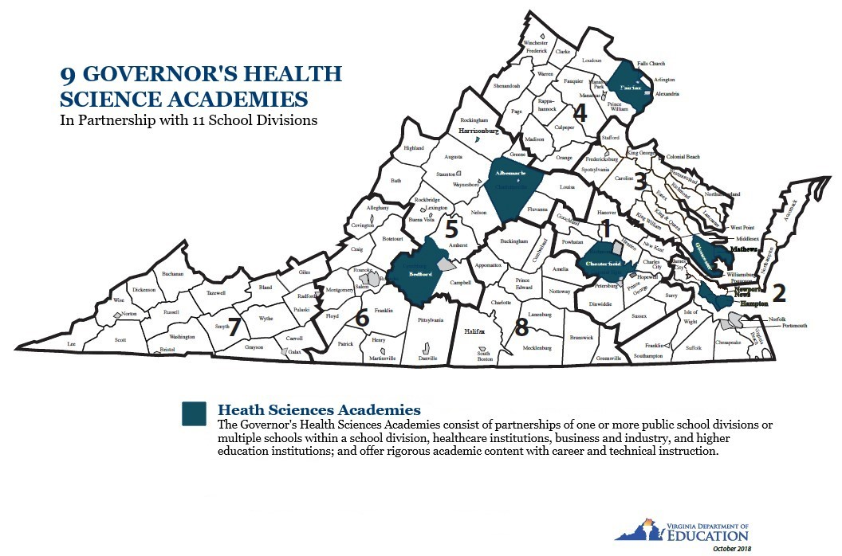
- ALBEMARLE COUNTY PUBLIC SCHOOLS GOVERNOR’S HEALTH SCIENCES ACADEMY, Albemarle County

- CHESTERFIELD COUNTY PUBLIC SCHOOLS GOVERNOR’S HEALTH SCIENCES ACADEMY, Chesterfield County

- FALLS CHURCH GOVERNOR’S HEALTH SCIENCES ACADEMY, Fairfax County

- CLIFFORD S. HARDISON GOVERNOR’S HEALTH SCIENCES ACADEMY, Fairfax County

- GLOUCESTER COUNTY PUBLIC SCHOOLS AND MATHEWS COUNTY PUBLIC SCHOOLS GOVERNOR’S HEALTH SCIENCES ACADEMY, Gloucester County and Mathews County

- HAMPTON CITY PUBLIC SCHOOLS GOVERNOR’S HEALTH SCIENCES ACADEMY, Hampton City

- NEWPORT NEWS PUBLIC SCHOOLS AND YORK COUNTY PUBLIC SCHOOLS GOVERNOR’S HEALTH SCIENCES ACADEMY, Newport News and York County

- BEDFORD COUNTY PUBLIC SCHOOLS GOVERNOR’S HEALTH SCIENCES ACADEMY, Bedford County

- GOVERNOR’S HEALTH SCIENCES ACADEMY AT ALEXANDRIA HIGH SCHOOL, Alexandria City

