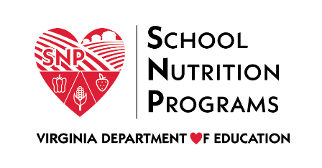

FEDERAL PROGRAM ADMINISTRATIVE REVIEW
SCHOOL NUTRITION PROGRAM SUMMARY
Section 207 of the Healthy Hunger Free Kids Act 2010, amended section 22 of the National School Lunch Act (42 U.S.C. 1769c) requires the Virginia Department of Education, Office of School Nutrition Programs (VDOE SNP), to report the final results of the administrative review to the public in an accessible, easily understood manner in accordance with guidelines promulgated by the Secretary.
Local Educational Agency: Chesapeake City Public Schools
Report Publication Date: July 25, 2022
Administrative Review Dates: February 15-18, 2022
Review Month and Year: January 2022
Participating Programs: NSLP, SBP, ASP, FFVP, SSO
Participates in Special Provisions? CEP

Findings Identified during the Administrative Review:

Table 1: Program Access and Reimbursement
Category | Findings
Certification and Benefit Issuance | Not applicable for school year 2021-2022
Verification | NO FINDINGS
Details: | N/A
Meal Counting and Claiming | NO FINDINGS
Details: | N/A

Table 2: Meal Patterns and Nutritional Quality
Category | Findings
Meal Components and Quantities | NO FINDINGS
Details: | N/A
Offer versus Serve | NO FINDINGS
Details: | N/A
Dietary Specifications and Nutrient Analysis | NO FINDINGS
Details: | N/A

Table 3: School Nutrition Environment and Civil Rights
Category | Findings
Food Safety |  | NO FINDINGS
Details: |  | N/A
Local School Wellness Policy |  | NO FINDINGS
Details: |  | N/A
Competitive Foods |  | NO FINDINGS
Details: |  | N/A
Civil Rights |  | NO FINDINGS
Details: |  | N/A
USDA is an Equal Opportunity Provider, Employer and Lender.

