National External Diploma Program in Virginia
Guidelines
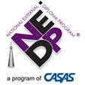

Commonwealth of Virginia
Department of Education
P.O. Box 2120
Richmond, Virginia 23218-2120
January 2023

TABLE OF CONTENTS
OVERVIEW 3
Components of the NEDP® 3
Characteristics of Successful NEDP Clients 4
Eligible NEDP Providers 5
State Support 5
Program Ownership 5
NEDP Implementation 5
Implementation Policies and Procedures 6

BECOMING AN NEDP PROVIDER: AGENCY REQUIREMENTS AND GUIDELINES 6
Preliminary Phase 6
Implementation Training Phase 6
NEDP Agency and Training Fees 7
Staff Requirements 8
Facilities 9

PREREQUISITIES FOR CLIENT ENROLLMENT INTO NEDP 9
Diagnostic Phase 10
Generalized Assessment Phase 11
Portfolio Review 12
Portfolio Reviewer Qualifications 12
Portfolio Review Procedures 12
Portfolio Review for New Staff at New Agencies 13
Portfolio Review for New Staff at Existing Agencies 13
Portfolio Review for Experienced Staff at Existing Agencies 13
Mediation and Consensus 13
Program Completion 14
Accommodations 14
Records Retention 15

ADVISOR/ASSESSOR ROLES, RESPONSIBILITIES, AND CERTIFICATION REQUIREMENTS 15
Advisor/Assessor Certification 15
Maintaining Active Status as an Advisor/Assessor 16
Responsibilities of NEDP Staff Members 16
Responsibilities of NEDP Advisors, Assessors and Agency Coordinators 17

DATA MAINTENANCE AND SUBMISSION 18

REMAINING AN ACTIVE AGENCY 18

Appendices 20
Appendix A: Diploma-Granting Documentation 21
Appendix B: Sustainability Plan 22
Appendix C: Virginia NEDP Assessment Guidelines 24
Appendix D: Sample NEDP Transcript 25
Appendix E: Sample Adult High School Diploma 27

The National External Diploma Program® – Overview

The National External Diploma Program (NEDP®) is an approved adult secondary option in Virginia, which leads to an adult high school diploma. NEDP is a program of Comprehensive Adult Student Assessment Systems (CASAS), the policy-making and administrative body for the program. The Virginia Department of Education’s (VDOE) Office of Career, Technical, and Adult Education works in collaboration with CASAS and the Virginia Adult Learning Resource Center (VALRC) to provide technical assistance and training support to organizations that operate NEDP programs throughout the state.

NEDP is a remote program, which enables adults who have acquired high school-level skills through life experiences to demonstrate their abilities in a series of simulations that parallel job and life situations. All NEDP clients undergo evaluations against a criterion of excellence instead of through comparison to others, take responsibility for acquiring instruction by using existing community resources, and achieve mastery of all the competencies required as well as an occupational or specialized skill.

This guide is designed to serve as a resource for programs supported by Adult Education and Family Literacy Act (AEFLA) funding, including continuing NEDP programs, programs considering starting an NEDP program, and programs that are in the initial stages of NEDP training and implementation. This guide will be revised as necessary to reflect program updates and upgrades as delineated by CASAS policy and procedures. Authorized NEDP personnel may also access the latest administrative notices, program support materials, and training resources on the CASAS NEDP Professionals webpage.

Components of the NEDP

Component | Description
Diagnostic Phase | Clients demonstrate that they possess high school-level skills through standardized assessments in writing, reading, and math. They also self-assess their familiarity with the skills measured in the Generalized Assessment portion of the program and their ability to use technology, identify a college and career competency (skill that shows their readiness to transition to employment, training, or higher education after graduation), and complete the Occupational Information Network (O*NET) Interest Profiler.
Generalized Assessment | Participants demonstrate their high school-level abilities by applying them in simulated, academic, workplace, and life contexts. They must demonstrate mastery of over 70 competencies in three foundational content areas and eight functional life skill content areas, all of which are crosswalked with the College and Career Readiness Standards.
Individualized Competency - College and Career Competency (CCC) | Clients have several options for demonstrating a college- or career-ready competency, such as verification of employment, possession of an occupational license, proof of recent career training, etc.
Portfolio Review | When a competency area has been found to fully demonstrate mastery by the Assessor, that area is reviewed by another certified NEDP staff member who verifies successful demonstration.

Characteristics of Successful NEDP Clients:

- Are at least 18 years old and not enrolled in public school.
- Possess strong non-academic skills such as self-direction, time management, and resourcefulness.
- Can demonstrate high school-level academic skills.
- Prefer showing what they know and can do through performance rather than by testing.
- Prefer remote learning and flexibility in scheduling in-office meetings.
- Tend to perform better when activities are not timed.
- Have experience with internet use and basic understanding of word processing, spreadsheets, and presentation software.
- May be high school equivalency completers (adults who have earned a GED® or High School Equivalency Test [HiSET] credential).
- Want to earn an adult high school diploma through NEDP.

Throughout the NEDP, adults are assessed in academic, work readiness, and life skills. The NEDP Competencies encompass the following areas:
Foundational Competencies
- Communication and Media Literacy
- Applied Math/Numeracy
- Information and Communication Technology

Content-Specific Competencies
- Culture Literacy
- Health Literacy
- Civic Literacy and Community Participation
- Consumer Awareness
- Twenty-First Century Workplace
- Financial Literacy
- Geography and History
- Science

Eligible NEDP Providers

Adult education providers, including local adult education programs, community-based organizations, American Job Centers, workforce centers, libraries, and community colleges, may establish an NEDP Agency, providing that a local school division formally agrees to issue an adult high school diploma to those successfully completing the requirements of the NEDP.

Prospective agencies must complete the steps outlined in the “Becoming an NEDP Provider” section.

State Support

Section 8VAC20-30-20 (Minimum Requirements for Adult High School Programs) of the Virginia Administrative Code states that “An adult high school diploma shall be awarded to an adult student who demonstrates through applied performance assessment full mastery of the National External Diploma Program Competencies, version 5.0, January 2013, a CASAS program, as promulgated by the American Council on Education and validated and endorsed by the U.S. Department of Education.”

Program Ownership

The NEDP is a program of CASAS that is the policy-making and administrative body for the NEDP. The federally registered service mark, NEDP, is owned by CASAS and may not be used except by those certified to provide NEDP. CASAS is the sole owner of all copyrights and other intellectual property embodied in the National External Diploma Program and NEDP materials.

NEDP Implementation

Local School Division Approval - Diploma Granting Authority

New NEDP sites can be established by a variety of providers statewide, including local adult education programs, community-based organizations, American Job Centers, workforce centers, libraries, and community colleges.

New NEDP agencies must establish a formal partnership with an accredited Virginia diploma-granting school division that agrees to award an adult high school diploma to NEDP graduates according to the following:

- A local diploma-granting agency (usually a local school board) must commit to grant an adult high school diploma to NEDP graduates who demonstrate all NEDP competencies with one hundred percent mastery. A Letter of Agreement between the agency and the local diploma-granting agency must be sent to CASAS prior to attending New Agency Training (see Appendix A).
- An adult high school diploma will be awarded to graduates of the NEDP. This diploma is a Virginia accredited diploma.
- For all NEDP graduates, the accredited diploma-granting school division must follow the records retention procedures specified by the state and/or local guidelines. Accredited Virginia high school diploma-granting agencies must store copies of transcripts in accordance with state and/or local guidelines.

Implementation Policies and Procedures

The NEDP is a remote, competency-based assessment program that must be implemented in its entirety to ensure its validity. No alterations, additions, or deletions to the program are allowed by CASAS. Each agency within Virginia must use the NEDP in its entirety.

The NEDP is administered in accordance with CASAS guidelines, the national standards outlined in the NEDP New Staff Training Manuals, as well as in the official NEDP Policy Manual, NEDP Program Manuals, NEDP Policy Memoranda, and other CASAS written directives posted on the CASAS NEDP Professionals page. Advisors, Assessors, and Agency Administrators are required to implement the program according to the guidelines established in these documents. In addition, NEDP agencies within Virginia are required to follow local and state policy and regulatory requirements relating to safety; security; documentation maintenance; and protection of private, sensitive, and personally identifiable information.

Becoming an NEDP Provider: Agency Requirements and Guidelines

Preliminary Phase:

- Research NEDP through presentations, Virginia NEDP Guidelines, and the NEDP Web agency (www.casas.org/nedp).
- Contact the VDOE or VALRC NEDP Specialist to schedule a preliminary consultation meeting. To prepare for this meeting.
  - Begin discussions with diploma-issuing school division(s).
  - Gather program data to prepare for a conversation about sustainability plan (see Appendix B).
- The superintendent or designee of the school division agreeing to issue the adult diploma to NEDP completers will formalize this agreement in writing (see sample agreement in Appendix A). This agreement must be sent to CASAS.
- Ascertain that CASAS’s agency requirements have been met and submit the required new NEDP agency documents and agency license fees to CASAS.
- Upon final approval from CASAS, the prospective agency may proceed with planning for implementation training.

Implementation Training Phase

- Request new agency implementation training.
- While awaiting training, complete the following online CASAS training modules at www.casas.org to certify to administer CASAS tests. There is no cost for these modules.
  - Module 1: CASAS Implementation Basics, AND
  - Module 2: CASAS eTest Implementation OR
  - Module 3: CASAS Paper Test Implementation
- All NEDP trainees complete the following training modules, face-to-face or via webinar, scheduled on an “as needed” basis.

Training | Training Objectives
Module One - Introduction to NEDP | - Review the history and philosophy of NEDP  - Appropriately use NEDP terminology  - Become familiar with the NEDP program model  - Distinguish roles of NEDP staff and certification requirements  - Log in to the NEDP online assessment system and set up agencies and staff and enroll clients  - Conduct client intake activities, including the NEDP Information Session
Module Two - NEDP Diagnostics | - Locate and use NEDP implementation materials used in diagnostic phase  - Articulate the intent of the NEDP College and Career Competency  - Use NEDP software to document completion of diagnostic scores
Modules Three and Four - Generalized Assessment and T Trainer | - Define Performance Assessment  - Use NEDP software to administer Generalized Assessment  - Use NEDP software to document Individualized Assessment  - Build skills in consensus moderation  - Practice T Trainer Competency evaluation  - Prepare for In-Office appointment  - Use NEDP software to administer Generalized Assessment  - Continue practice of T Trainer Competency evaluation  - Continue to build skills in consensus moderation
Module Five - Post-Task Assessment and Portfolio Review | - Continue to build skills in consensus moderation  - Conduct Post-Task Assessment  - Prepare for Portfolio Review  - Review Advisor/Assessor roles  - Complete Advisor/Assessor certification requirements

NEDP Agency and Training Fees

Fees for establishment and management of the NEDP program agencies are the responsibility of the program providing the NEDP. Those agencies eligible for federal and state funding may use funds (including AEFLA and GAE) and program income in accordance with policy, regulations, and guidelines. Refer to the Adult Education Program Manager Responsibilities Manual.

All NEDP agencies are required to pay an annual agency fee established by CASAS. Agency fees provide for national CASAS program oversight. All NEDP agencies must sign an official NEDP Agency Agreement each program year and pay the annual agency fee to remain active. Contact CASAS at (858) 292-2900, or email nedp@casas.org, for current fees.

Designated NEDP state trainers will provide training for new staff in existing programs each year. For this training, the VALRC will cover the cost of the trainers and the training agency. It will be each program’s responsibility to cover costs associated with individual staff members, including purchase of training manuals, travel, meals, overnight stays, and compensation for staff members.

The first portfolio review for each newly trained Assessor must be conducted by a certified state trainer. The agency is responsible for the cost of this review.

Staff Requirements

The CASAS requires the following to become and remain an active NEDP provider:

- A minimum of two Advisor/Assessors are required to be trained and certified for each new agency; however, five Advisors/Assessors are recommended so that possible staff turnover will not necessitate an additional training within the first year.
- One Advisor/Assessor will be designated as the NEDP coordinator and lead Assessor. Often it is desirable, but not required, that this person be a full-time employee in order to meet the responsibilities and demands of the program. Other staff may be part-time employees, depending on the projected client enrollment.
- Each NEDP provider in Virginia is required to designate a primary and secondary contact for communication with CASAS. All policy and procedure notices and requests for information will be submitted to the primary and secondary contacts. The primary and secondary contacts have the responsibility to share all information provided by CASAS with other NEDP staff, especially those items pertaining to changes or clarification of policies and procedures.
- All Advisors/Assessors must hold at least a baccalaureate degree and be able to evaluate writing and critical thinking demonstrations.
Note: Because NEDP is an assessment program, Advisors/Assessors may not instruct any candidate assigned to them in the Diagnostic or Generalized Assessment Phases of the program.
- Staff hiring must be done in accordance with all Virginia and local requirements.
In the event that two trained Advisor/Assessors are not on staff, CASAS should be notified and an agreement should be reached on how to continue. Possible remedies may include:
- Operate temporarily with fewer than two trained staff until a new staff member(s) can be trained. The client portfolios can be reviewed by staff from another agency or, in some cases, the staff may serve as both Advisor and Portfolio Reviewer to the same client; however, prior approval from CASAS/NEDP is required.
- Form a partnership with another NEDP Agency to help provide support to satisfy all the requirements of the program.
- Purchase a portfolio review from CASAS.

To become a certified Advisor/Assessor, an NEDP Assessor-in-training must:

- Completely evaluate a portfolio on which the Assessor-in-training served as Assessor and have this portfolio successfully reviewed by a State Trainer, and
- Receive recommendation from the State Trainer that the Assessor-in-training be certified. In some cases, a review of a second portfolio will be required before certification is recommended.

Facilities

The NEDP diagnostic tools and assessments must be administered in accordance with prescribed testing procedures and under the most favorable conditions possible. The NEDP Agency requires suitable facilities to ensure confidentiality and privacy during in-person and/or remote meetings with Advisors and Assessors and during the administration of various NEDP instruments.

Suitable facilities include, but are not limited to, the following features:

- Office space with private areas for meetings and testing.
- Office entrances and meeting spaces that allow for client confidentiality.
- Office space that is structured so that Assessors/Advisors can meet with and monitor the assessment of at least three clients simultaneously.
- Office space that is quiet and has good lighting and ventilation.
- Offices that have secure storage space for NEDP materials, client portfolios, and other files, equipment, and instruments.
- Appropriate technology for conducting remote meetings.

Prerequisites for Client Enrollment into NEDP

An Information Session, conducted by intake staff or an NEDP Advisor, outlining the requirements of the program prior to beginning the NEDP is required of all participants in the program.

The CASAS and VDOE strongly encourage agencies to administer a CASAS appraisal or locator to ensure that the level C and D tests given in the Diagnostic Phase are appropriate for the client. Clients who score lower than the C or D level on the locator or appraisal in both Math and Reading are not eligible to enter NEDP. These clients should be pre-tested at the appropriate level and referred to a skill-building Adult Basic Education (ABE) program until they are performing at the C or D level in both Math and Reading.

Clients whose appraisal scores are at the C or D level in Reading and Math may be entered into NEDP to begin the Diagnostic Phase of the program.

Note that CASAS states that appraisal tests are not appropriate substitutes for NEDP Diagnostic instruments measuring basic skills in Math, Reading, and Writing. Agencies must use the approved appraisal/placement assessments required within the state.

The appraisal may be waived for clients who transfer from another instructional program (i.e., High School Equivalency or ABE) and have valid, current test scores of 6th grade or higher in both Reading and Math in another state-approved testing system.

Diagnostic Phase

The Diagnostic Phase of the NEDP introduces the client to the skills needed for assessment and allows clients to evaluate personal strengths and weaknesses with a prescriptive analysis of the skills needing improvement. In keeping with the open information philosophy of the program, the Diagnostic Phase informs the applicant of all competencies and skills measured in Generalized Assessment along with the level of preparation necessary for success. In addition, the client’s occupational and specialized skills are explored so that an appropriate recommendation for training or other individualized skill demonstration can be made.

During the Diagnostic Phase, the client is assigned to an NEDP Advisor who administers all diagnostic instruments as outlined in the NEDP Training Materials, the NEDP Policies and Procedures Manual, and specifically in the NEDP Test Administration Manual. Diagnostic instruments may be administered in any order chosen by the Advisor and client. The client is required to complete all open and closed instruments in the Diagnostic Phase prior to beginning Generalized Assessment. These include:

- The NEDP Registration Agreement, along with the state, regional, or local intake or enrollment form
- A math score indicating readiness for Generalized Assessment; either
  - Score of 230 or higher on CASAS Life Skills Math form 35C, 36C, 37D, or 38D, or
  - Score of 226 or higher on CASAS GOALS Math form 917 or 918
- Score of 236 or higher on CASAS Reading GOALS form 905, 906, 907, or 908
- Writing diagnostic with a score of three or higher
- Self-Assessment of Competencies (SAC)
- Self-Assessment of Technology Skills instrument
- College and Career Competency - client and Advisor should determine the client’s college and career competency
- The Occupational Information Network (O*NET) Interest Profiler (IP) and paperwork

Even clients who perform at the C or D level on the appraisal may not earn the necessary cut scores on the first attempt at a diagnostic test; however, a high appraisal score makes it likely that the client will need only minor remediation to achieve the cut score. If basic skills are found to be deficient, a competency form is generated to identify areas of weakness, and a referral to an appropriate learning resource can be made at this time.

The recommended time interval before retesting is dependent upon a number of factors, including the client’s overall test performance, the amount of time the client has to devote to remediation activities, and other factors. To increase the chances for success, the client should learn the identified skills before retesting. After a second unsuccessful attempt at a diagnostic test, CASAS recommends that the client wait for three months from the date of the first test administration to be retested. This will allow time for more intensive remediation. The Advisor should alternate test forms so that the candidate is not retesting with the same test form.

Clients who have been inactive for one year or longer may require redemonstration on the diagnostic assessments. Refer to the CASAS NEDP Policy and Procedure Manual for cases in which retesting is required.

Transitioning from Diagnostic Phase to Generalized Assessment Phase – Data Guidelines

NEDP clients must be reported in SSWS in accordance with adult education data entry policies and procedures. Clients who transition from the Diagnostic Phase to the Generalized Assessment phase will be recognized for making a Measurable Skill Gain (MSG) in SSWS (in the program year in which the transition occurred). Further, clients will be recognized for making a second MSG upon completion of the NEDP.

To ensure that an NEDP client’s transition from Diagnostic to Generalized Assessment is properly captured in SSWS, it is important for programs to be sure that they have selected “Enrolled in NEDP Assessment Phase” under the “National External Diploma (NEDP)” program type under “Diploma Program Enrollment”. Programs must remember that NEDP in SSWS is part of a progression, so SSWS will not allow programs to enter “Enrolled in NEDP Assessment Phase” without first making sure that the client is 1) “active” (i.e. equivalent to being registered in NEDP and 2) enrolled in the NEDP Diagnostic Phase.

To verify that SSWS has recognized a client’s transition from the Diagnostic to Generalized Assessment Phase, programs can access the “Student Performance Dashboard” and click “Secondary Credentials and EFL Gains”.

Generalized Assessment Phase

During the Generalized Assessment Phase, clients are required to demonstrate 100 percent mastery of over 70 high school-level competencies aligned with CASAS competencies and crosswalked with the College and Career Readiness Standards. These competencies are demonstrated by a series of computer-delivered assignments, completed independently and verified through in-person or remote in-office evaluation meetings with an NEDP-trained Assessor. The client must also demonstrate an occupational or advanced academic skill (college and career competency).

An NEDP Assessor activates the Web-based competency areas for the client, meets with the client for In-Office Checks, evaluates the competencies, and gives feedback to the client during the Generalized Assessment Phase. The NEDP Assessor may not concurrently serve as an instructor or tutor to a client. Each Assessor must administer and evaluate the Assessments according to the established national criteria found in the Generalized Assessment Manual and the assessment guidance pop-ups in the Web-based program.

The Generalized Assessment and College and Career Competency assessment criteria are detailed in in the NEDP Training Materials, the NEDP Policies and Procedures Manual, and specifically in the NEDP Test Administration and College and Career Competency.

If the client does not demonstrate all competencies on his or her first attempt, additional opportunities to demonstrate the competencies are provided during Post-Task Assessment (PTA). The Assessor follows the guidelines specified in the NEDP Program Manuals to ensure that the client achieves 100 percent mastery of all of the competencies in any competency area before submitting that competency area for portfolio review.

Portfolio Review

Portfolio review is an integral part of NEDP reliability. The purpose of the portfolio review is to provide an independent validation that all competencies are demonstrated according to the criteria established in the NEDP Test Administration Manual. The portfolio review also ensures that the entire portfolio is complete, including documentation of all diagnostic instruments and the College and Career Competency.

Portfolio Reviewer Qualifications

The portfolio reviewer must be able to complete a “cold” portfolio review, evaluating each answer as though it has not already been assessed as demonstrating mastery. Therefore, the reviewer:

- May not be the Assessor who completed the Generalized Assessment Phase with the client portfolio;
- may not be the Advisor who completed the Diagnostic Phase of the client portfolio unless approved by CASAS;
- should not be a person who has served as an instructor or tutor for the client; and
- must be a certified Assessor for whom at least one completed portfolio has been verified by a state NEDP trainer.

It is not recommended that programs designate a person whose only responsibility is to conduct portfolio reviews. If the primary role of a staff member is portfolio review, CASAS recommends that this staff member also serve in the roles of Advisor and Assessor for a minimum of one client per year. This effort is intended to assist in keeping skill levels and a thorough understanding of the program in its entirety current and effective.

Portfolio Review Procedures

Portfolio review for each competency area may be conducted when all of the activities and In-Office Checks in that area have been assessed as demonstrating mastery. Additionally, demonstration of the college and career competency and completion of all diagnostic instruments must be verified before the entire portfolio is deemed complete and the client is eligible for graduation.

Portfolio Review for New Staff at New Agencies

The first portfolio review for each Assessor-in-training must be conducted by an NEDP-certified State Trainer. After the first portfolio has been successfully completed, the newly-trained Assessor will become certified and may conduct portfolio reviews for other Assessors and may have eligible Portfolio Reviewers validate subsequent portfolios.

Portfolio Review for New Staff at Existing Agencies
The first portfolio completed by a new Assessor-in-training must be reviewed by an NEDP-certified State Trainer, but it may be reviewed first by an experienced, certified staff member prior to sending it out for the external review. When an internal NEDP staff has conducted a preliminary review, given feedback, and found that all items demonstrate mastery, the portfolio of the new Assessor-in-training is then sent to an NEDP-certified State Trainer who is external to that agency. This process provides feedback to both the new staff member completing Generalized Assessment and to the agency regarding portfolio review procedures. After the first portfolio has been successfully completed, the newly-trained Assessor will become certified and may conduct portfolio reviews for other Assessors and may have eligible Portfolio Reviewers validate subsequent portfolios.

Portfolio Review for Experienced Staff at Existing Agencies

The portfolio is submitted for review by competency area to another certified Assessor.

Any items found by the Reviewer to be deficient in demonstrating mastery will be marked as ND (not demonstrated) and returned to the Assessor, who will provide feedback to the client and instructions to reattempt any required items. The Assessor will then re-evaluate the work and, if it is now found to demonstrate mastery, submit back to the Reviewer for final review. This process continues until every item has been found to demonstrate mastery by the Portfolio Reviewer.

Mediation and Consensus
When a client response requires further discussion between the Assessor and Reviewer, the Reviewer marks “mediation needed” instead of assessing the item as D or ND. The Assessor and Reviewer then discuss whether the client’s response fulfills the requirements of the NEDP guidelines to demonstrate mastery, and a demonstration status is jointly determined.

If the Assessor and Reviewer disagree on whether a client’s response demonstrates mastery after an attempt at mediation, the NEDP staff should review the item and reach group consensus as to whether the item does or does not demonstrate mastery. If the group cannot reach consensus, the NEDP staff at CASAS should be contacted.

Once the entire portfolio is determined to be complete (including the diagnostic instruments and college and career competency), the Portfolio Reviewer signs and dates the Portfolio Review Form. The client provides documentation of how his or her name should appear on the diploma, and the agency Administrator is informed that the client is eligible for graduation.

Program Completion
After all requirements for the program are met, it is the Agency Coordinator’s responsibility to ensure that the portfolio is complete and that all the following required items are stored as part of the NEDP graduate’s permanent record:

- ID verification – The person receiving the diploma is the person who completed the program.
- Transcript – An official, signed copy of the Virginia NEDP transcript should be printed and stored with the client’s record. The Virginia NEDP transcript, modified to include agency and diploma-issuing agency information, is provided by CASAS.
- Diploma – An official, signed copy of the diploma should be printed and stored with the client’s record.
- Outcome Data – The client is marked as graduated in the NEDP Web-based system, with the graduation date and any follow-up goals (employment, training, etc.) that the client has achieved.
- SSWS – The client’s program completion and attainment of an adult high school diploma must also be documented in SSWS.

See “Record Retention Requirements” for additional information on retaining client graduation records.

Accommodations

When administering NEDP assessments, NEDP Agencies are required to follow the NEDP Assessment Accommodations Policy as documented. The complete NEDP Accommodations Policy is published under separate cover on the CASAS website.

Assessment accommodations provide an opportunity for all test takers to demonstrate skills and abilities by altering test administration procedures without changing what the test measures. The policy guidelines address methods for administering NEDP assessments using accommodations for clients with documented disabilities.

The NEDP Assessment Accommodations Policy provides NEDP applicants and candidates with guidelines for using assessment accommodations in compliance with the Americans with Disabilities Act of 1990 (ADAA), as amended by the ADA Amendments Act of 2008. In no way do the guidelines diminish the high standards set for the NEDP but are intended to improve access to adult programs and achieve employment outcomes for learners with disabilities. Other legislation addresses provisions related to assessment accommodations for learners with disabilities, including the accountability standards outlined in the 1998 Workforce Investment Act (WIA) that incorporate the Rehabilitation Act Amendments of 1998. Section 504 in the Rehabilitation Act of 1973, the No Child Left Behind Act of 2001, and the Individuals with Disabilities Education Act reauthorized in 2004 all ensure equal access for all learners in education programs, including learners with disabilities.

Records Retention

Each NEDP provider must follow these guidelines for record retention:

- Retention of records must meet the requirements of state and local laws, policies, and procedures.
- Client records must be kept confidential.
- Graduates’ permanent records, as defined in the NEDP Program Manuals, must be maintained at the agency permanently after graduation according to NEDP national policy. Agencies must also abide by any records retention procedures specified by local, state, and/or federal guidelines.
- If a client exits NEDP before earning a diploma, the client will be marked as “exited” in the NEDP Web-based system, inactivating the client’s login credentials, but retaining all work completed by the client so that the program may be reentered at a later date.
- Although NEDP providers may decide when to disable a client’s log-in to the Web-based system and when to exit a client from the system, it is recommended that after 90 days of inactivity, the client will be marked as “exited” and made unable to access the system before meeting with the Assessor for a reexamination of programmatic expectations and client goals.

Advisor/Assessor Roles, Responsibilities, and Certification Requirements

Advisor/Assessor Certification

To become a certified Advisor/Assessor for the NEDP, the following requirements must be met:

- Possess a baccalaureate degree or higher.
- Complete all modules of the NEDP Implementation Training.
- Complete any additional training sessions designated by CASAS (e.g., CASAS assessment proctor certification).
- Have one client portfolio (assessed as completely demonstrated) verified by CASAS-certified State Trainer.
- Serve in the role of Advisor with a minimum of one client and complete the Diagnostic Phase.
- Serve in the role of Assessor with a minimum of one client and complete the Generalized Assessment Phase, including all follow-up after the portfolio review.
- Satisfy any additional requirements of Advisors/Assessors specified by the state or local school divisions.
- Fulfill all the responsibilities of Advisors/Assessors outlined in the NEDP training manuals.

To be recognized as a certified Advisor/Assessor with CASAS, a certified CASAS State Trainer must complete and sign a form verifying that the Assessor-in-training has met all of the above requirements. After this form is complete, CASAS will provide a certificate recognizing the staff member’s Advisor/Assessor status and provide availability for the staff to be selected as a Portfolio Reviewer on the client Update tab.

CASAS also recommends that Advisors/Assessors be proficient with the skills delineated in the Technology Skills Self-Assessment Checklist. This document lists all of the technical skills clients should be able to demonstrate in the course of the NEDP program.

Maintaining Active Status as an Advisor/Assessor

To remain an active Advisor/Assessor, individuals are required to:

- Attend all required refresher training sessions required by CASAS.
- Continue to demonstrate all responsibilities of an Advisor/Assessor.
- Work as an Advisor with a minimum of one client each fiscal year.
- Work as an Assessor with a minimum of one client each fiscal year.

If the above requirements are not satisfied, the Advisor/Assessor may have to complete additional training to renew active Advisor/Assessor status.

Responsibilities of NEDP Staff Members

All NEDP Staff Members must:

- Agree to follow the official NEDP Policies and Procedures as stated in the NEDP Policies and Procedures Manual, NEDP Program Manuals, NEDP Policy Memoranda, the NEDP Agency Agreement, and other CASAS written directives. These documents set out the policies and procedures governing the implementation of NEDP and must be followed to protect the consistency and validity of the NEDP.
- Administer assessment instruments in accordance with prescribed testing procedures and under the most favorable conditions possible.
- Ensure that agency facilities permit the participation of adults with disabilities and adhere to NEDP accommodations policies.
- Conduct all In-Office Checks in accordance with CASAS policy.
- Protect the privacy of all applicants and candidates consistent with the Freedom of Information Act (FOIA) as amended. The agency's confidentiality policy must require that applicant and candidate files are stored in locked file drawers or cabinets. Access to an individual applicant or candidate’s files should be restricted to staff members with legitimate reasons for requesting access to an individual's records.
- Treat contents of all activities and In-Office Checks as confidential and not disclose these activities to anyone outside of the NEDP.
- Provide no instruction of any kind to NEDP clients assigned to them and refrain from making direct references to specific NEDP tasks or In-Office Checks during outside instruction.

Responsibilities of NEDP Advisors, Assessors, and Agency Administrators

The roles and responsibilities of NEDP Advisors and Assessors are described in detail in the NEDP training manuals. In general, these roles and responsibilities are as follows:

Advisor Responsibilities:

- Introduce program processes to prospective applicants, the public, and others through information sessions.
- Obtain demographic data on all applicants through the NEDP registration agreement form.
- Administer open diagnostic instruments.
- Administer and/or review the CASAS Reading and Math Diagnostic Instruments, complete remediation forms as required, and provide learning recommendations.
- Interpret writing diagnostic test results and provide learning recommendations according to NEDP Policies and Procedures.
- Identify possible learning resources.
- Assist the client in identifying the College and Career Competency.
- Facilitate clients’ entry into the Generalized Assessment Phase.
- Ensure that all diagnostic documentation is orderly and complete before client enters Generalized Assessment.

Assessor Responsibilities:
- Provide procedural information to assist client in navigating the Web-based assessment system.
- Activate competency areas.
- Conduct In-Office Checks after Generalized Assessment activities have been submitted.
- Evaluate activities and In-Office Checks completed by clients using evaluation criteria.
- Provide evaluation results to the client along with instructions on how the Post-Task Assessment will be conducted.
- Conduct and evaluate Post-Task Assessment.
- Organize and implement the College and Career Competency process, culminating in documented demonstration of the College and Career Competency.
- Review and approve portfolios completed by other Assessors, following portfolio review procedures and guidelines.

Agency Coordinator Responsibilities:
  - Share appropriate communication (e.g., NEDP Newsletter and Policy Memos) from CASAS, VALRC, and VDOE with NEDP staff.
  - Ensure that all components of program completion have been conducted for NEDP graduates.
  - Ensure that primary contacts attend the biannual NEDP state meetings. Encourage secondary contacts to attend the meetings as well.
  - Report in-office contact hours accrued in the Web-based system (found in “Agency Hours” report) to local data specialist for National Reporting System (NRS) reporting.
  - Maintain an adequate amount of program materials and Web Enrollment Units.
  - Enter staff members and clients into the NEDP Web-based system.
  - Conduct and document regular in-house NEDP staff meetings.
  - Conduct periodic desk reviews to ensure that client work is assessed, reviewed, and released in accordance with NEDP policies.
  - Verify and deliver the yearly statistical report on the status of program participants to CASAS upon request.
  - Maintain program administrative files.
  - Maintain client records.

Data Maintenance and Submission

NEDP agencies using state or federal funding must report data elements in accordance with current Adult Education Data Entry Guidance posted on the Data, Monitoring, and Evaluation webpage. The NEDP is an approved distance education curriculum in Virginia. Hours accrued performing in-home activities may be counted as distance learning hours, provided that these hours are not also being counted as contact hours. In-Office Checks are reported as contact hours, not proxy hours, and should be designated as contact time in SSWS.

Remaining an Active Agency
Each NEDP Agency must sign an official NEDP Agency Agreement each year, pay the annual agency maintenance fee, and maintain the minimum staff requirements as listed above to remain active. The agency must continue to follow all implementation procedures and ensure the reliability and validity of the NEDP. CASAS will notify VDOE annually of state NEDP Agency status.

- CASAS will disseminate all communication to the NEDP agencies through the primary and secondary contacts, including policy and procedure notices and requests for information. Each agency’s primary contact is required to communicate this information to all NEDP staff members.
- Each NEDP Agency must conduct regular meetings with staff to ensure that the program is being consistently implemented in a standardized manner according to the NEDP Policies and Procedures.
- It is the responsibility of each NEDP Agency to conduct outreach and promote NEDP as a viable adult high school completion option. Regularly offering NEDP information sessions virtually and/or in-person for prospective participants in accessible locations is a local NEDP Agency responsibility.
- Each NEDP Agency must agree to maintain communication with CASAS and VDOE. The NEDP Agency must keep all agency-specific and personnel contact information up to date with CASAS and submit the Yearly Statistical Report, client data, and other information as required. In addition, operational agencies must provide data to VDOE as requested.
- Each NEDP Agency must continue to conduct the program in accordance with established Virginia and NEDP policies and procedures. The VDOE and/or CASAS staff may conduct NEDP Agency-Monitoring Desk Audits or visits.
- Each NEDP Agency must have at least three active staff members to remain an active agency. Agencies may operate temporarily in a partnership with another agency to maintain the requirement of three staff members if given special permission by CASAS.
- To remain an active staff member, Advisors/Assessors must serve at least one client in Diagnostics and one client in Generalized Assessment each year.

Appendices

Appendix A: Diploma-Granting Documentation

Prior to sending staff members to the New Agency Training, the prospective agency must provide to CASAS a letter of confirmation that the local school division awarding the adult high school diploma will be issued to all NEDP graduates. This letter (see below sample) must be on the applicable school division letterhead from the local school division. A copy of the diploma-granting documentation should be attached. See sample diploma in Appendix E.

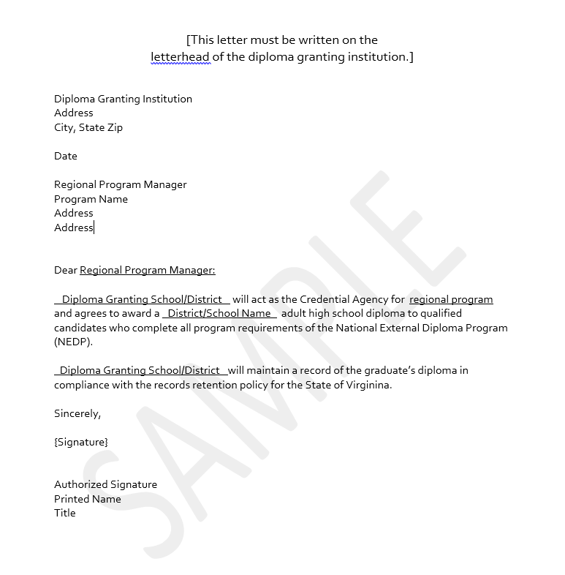

Appendix B: Sustainability Plan

It is highly recommended that programs create a sustainability plans that address the following questions:

- Who will be the program’s NEDP staff and how will the roles of Advisor/Assessor/Portfolio Reviewer be distributed?
- How will NEDP staff members be compensated for their responsibilities?
- How will NEDP staff members manage their time as Advisors and Assessors?
- Who will collect NEDP-related data?
- What is the program’s plan for training additional and replacement staff?
- How will the program’s NEDP be funded?
Initial startup cost considerations should include:
- Staffing
- Facility rental costs, including utilities, if appropriate
- Training and follow-up certification costs including New Agency Training, Portfolio Reviews, Agency Visits, and Evaluation Workshops
- New agency package for training materials
- Additional assessment costs for the first year
- CASAS annual agency fee (There are no state fees or licenses associated with the establishment of an NEDP Agency other than those required by county and local laws and regulations.)
- How will the program leverage regional resources?
- What grant funding can be used?
- How much will clients be charged for participation?
- Is this charge for a limited time?
- How will the program create/provide instructional opportunities for NEDP clients?
- Will classroom instruction be aligned with NEDP competencies? If so, how?
- Will distance education be available to NEDP clients? If so, how? Will the distance education curriculum used be approved by the state for submission of hours to the NRS?
- Whom will the program serve?
- How many localities will the NEDP serve?
- Will the school division be willing to issue diplomas to adults residing outside of the locality? If the school division will award diplomas to adults outside of the jurisdiction, will it be limited to the adult education region?
- How will new clients be identified?
- What outreach strategies will the program use to inform the public about the program?
- How many clients will be in the initial cohort?
- How many clients does the program hope to serve in the first year?
- What is the plan for the program’s NEDP growth?
- How will the staff stay in touch with clients who are in the program?
- Does the program have sufficient technology to support NEDP?
- How will the NEDP impact local and regional partnerships?
- Who will sign the transcript for graduates? (The NEDP transcript has space for two signatures; generally one signature is the school leader and the second is the signature of the director of the NEDP agency.)
- How will the program communicate with local employers about NEDP?
- How will the program communicate with core WIOA partners about NEDP?

Appendix C: Virginia NEDP Assessment Guidelines

- All clients enrolled in NEDP must be pre-tested within the first six hours of instruction. Any CASAS level C or D test may be used to determine that the NEDP client has achieved the required “cut score” to move into Generalized Assessment. Refer to Assessment and Distance Education Policy for Adult Education and Literacy Programs for the current CASAS forms approved for testing.

- Newly enrolled clients must complete the CASAS Appraisal and the CASAS Math and Reading tests within the first six hours of instruction.
  - Newly enrolled clients must complete the CASAS appraisal in Reading and Math to indicate readiness for a C- or D-level CASAS diagnostic test.
  - Clients whose appraisal scores are below a C level are not to be given the C- or D-level CASAS pre-test. These learners should be referred to an ABE class and given the appropriate pre-test for entry into that class.
  - Clients should not be entered in the “Diploma Course Enrollment” tab until they show readiness for the C- or D-level CASAS tests.

- Clients transferring to NEDP from another adult education program (ESL/ABE/GED) may already have a valid test score from an approved assessment. In this case, the CASAS appraisal may be substituted by the valid test score to indicate readiness for the C- or D-level CASAS pre-test. The following scores indicate readiness to take the CASAS C- or D-level tests.

Test | Total Math | Reading
TABE | SS 508 (Grade Equivalent 6.0) | SS 519 (Grade Equivalent 6.0)

A score of 230 on the CASAS Life Skills Math or 226 on CASAS Math GOALS, a score of 236 on CASAS Reading GOALS, and a Written Prompt response score of 3, along with satisfactory completion of the other diagnostic requirements, will enable the learner to move from the Diagnostic to Generalized Assessment Phase of NEDP. No other test may be substituted for the CASAS test to show readiness to begin Generalized Assessment.

NEDP clients who transition from the Diagnostic Phase to the Generalized Assessment phase will be recognized for making a Measurable Skill Gain in SSWS, and they will make a second MSG upon completing the NEDP (see page 11).

Appendix D: Sample NEDP Transcript
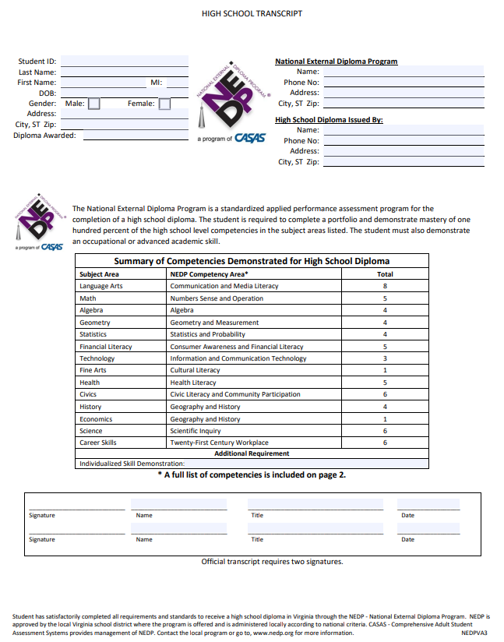

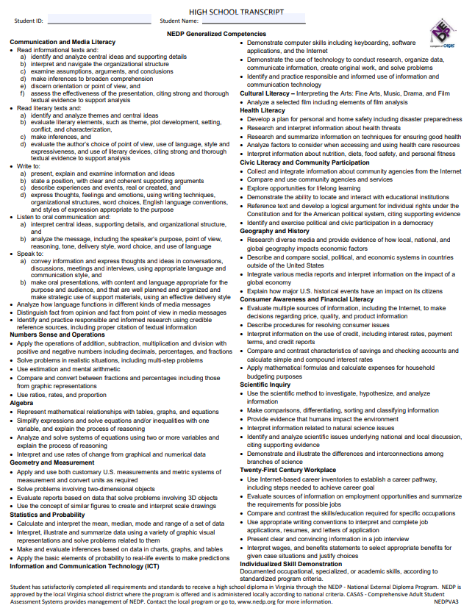

Appendix E: Sample Adult High School Diploma

