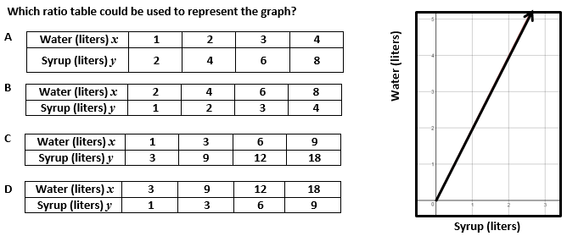 | 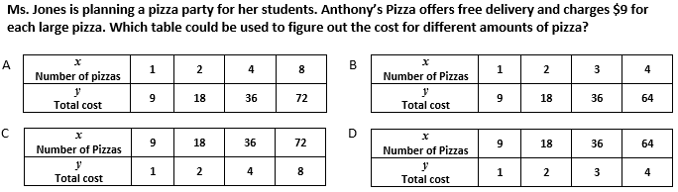
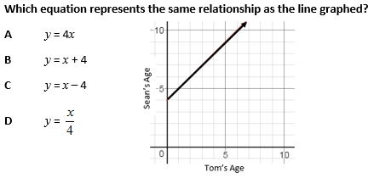 | 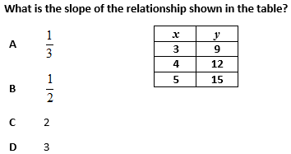
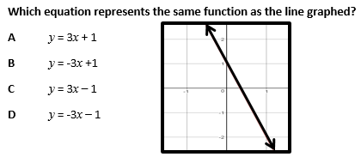 | 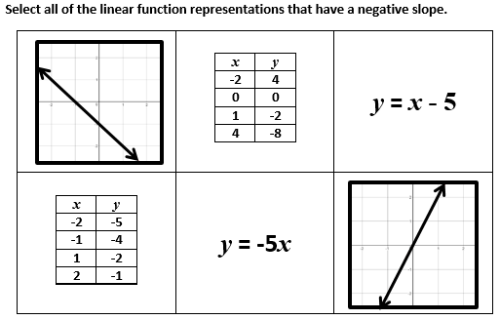
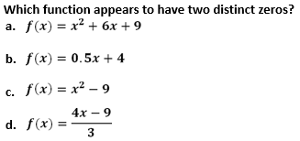 | 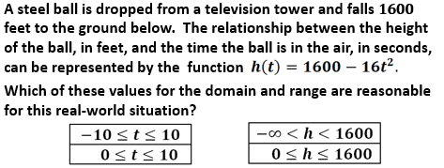
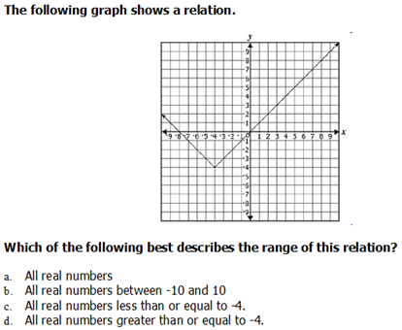 | Find the coordinates of a point that lies on a line which passes through point P and is perpendicular to line c.  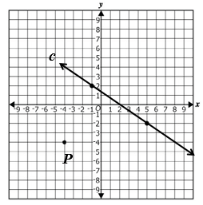
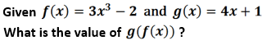 | 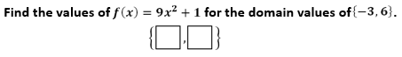
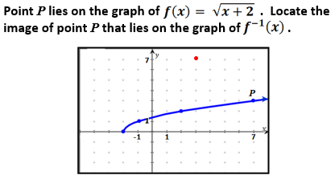 | Create two different equations that correspond to the graph shown:  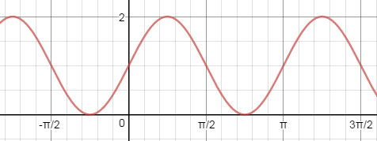
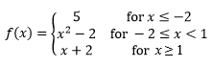 | 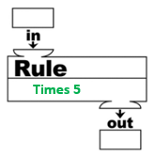

Multiple Representations of Functions Assessment Sort Answer Key

Grade 3 – 3.16
Solve problems that involve the application of input and output rules limited to addition and subtraction of whole numbers.

Grade 6 – 6.12d
Make connections between and among representations of a proportional relationship between two quantities using verbal descriptions, ratio tables, and graphs.

Grade 7 – 7.10e
Make connections between and among representations of a proportional or additive relationship between two quantities using verbal descriptions, tables, equations, and graphs.
Grade 8 – 8.16e
Make connections between and among representations of a linear function using verbal descriptions, tables, equations, and graphs.

Algebra 1 – A.7f
Represent relations and functions using verbal descriptions, tables, equations, and graph. Given one representation, represent the relation in another form.
Investigate and analyze characteristics and multiple representations of functions with a graphing utility.
Performance Analysis 2014 | Performance Analysis 2014

Geometry - G.3a
The student will solve problems involving symmetry and transformation. This will include investigating and using formulas for determining distance, midpoint, and slope;
Find the coordinates of a point that lies on a line which passes through point P and is perpendicular to line c.
Performance Analysis 2013
Algebra 2 – AII.7g
Make connections between and among multiple representations of functions using verbal descriptions, tables, equations, and graphs
Represent relations and functions using verbal descriptions, tables, equations, and graph. Given one representation, represent the relation in another form.
Performance Analysis 2014 | Performance Analysis 2014
Performance Analysis 2014
Trigonometry | Math Analysis
Create two different equations that correspond to the graph shown:

