The Mean Rectangle
For this task, you’re going to make, investigate, and attempt to prove/disprove a conjecture about rectangles. In order to do that, follow the steps below:
- Plot and label four points (A, B, C, and D) on your coordinate plane that will be the vertices of a rectangle. If you don’t like fractions, make all of the coordinates be even numbers. For an added challenge, create a rectangle with sides that are not vertical or horizontal.
- Connect the points to form rectangle ABCD.
- Mark and label the midpoints (E, F, G, and H) of each side of your rectangle.
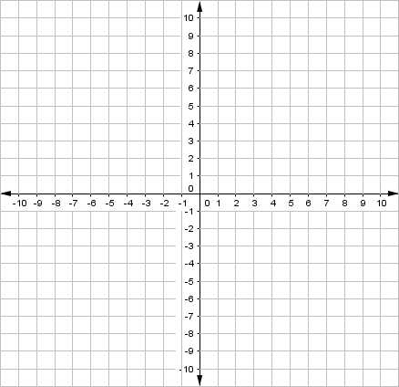
- Connect these midpoints to find quadrilateral EFGH.
$$x$$

$$y$$

1: How do you know quadrilateral ABCD is a rectangle?

2: What do you think is true about quadrilateral EFGH?

3: Justify that what you think about quadrilateral EFGH is actually true.
Now, look at quadrilateral EFGH from others’ papers. Did they start with the same points as you? Did they come up with the same conjecture?

Do you think this will always happen? Why/why not?

Can you prove it or find a case when it is not true?

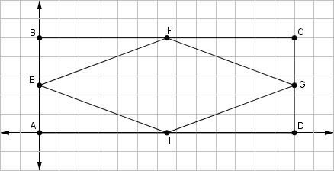
The Mean Rectangle: Coordinate Proof
$$x$$

$$y$$

Label the coordinates as follows: $A\left(0, 0\right) B\left(0, a\right) C\left(b, a\right) D\left(b, 0\right)$
The midpoints then have the following coordinates: $E\left(0,\frac{a}{2}\right) F\left(\frac{b}{2},a\right) G\left(b,\frac{a}{2}\right) H\left(\frac{b}{2},0\right)$
Now, determine the lengths of the sides of quadrilateral $EFGH$.
The length of $\overline{EF}$ is: $d=\sqrt{{\left(\frac{b}{2}-0\right)}^{2}+{\left(a-\frac{a}{2}\right)}^{2}}=\sqrt{{\left(\frac{b}{2}\right)}^{2}+{\left(\frac{a}{2}\right)}^{2}}=\sqrt{\frac{b^{2}}{4}+\frac{a^{2}}{4}}$
The length of $\overline{FG}$ is: $d=\sqrt{{\left(b-\frac{b}{2}\right)}^{2}+{\left(\frac{a}{2}-a\right)}^{2}}=\sqrt{{\left(\frac{b}{2}\right)}^{2}+{\left(-\frac{a}{2}\right)}^{2}}=\sqrt{\frac{b^{2}}{4}+\frac{a^{2}}{4}}$
The length of $\overline{GH}$ is: $d=\sqrt{{\left(\frac{b}{2}-b\right)}^{2}+{\left(0-\frac{a}{2}\right)}^{2}}=\sqrt{{\left(-\frac{b}{2}\right)}^{2}+{\left(-\frac{a}{2}\right)}^{2}}=\sqrt{\frac{b^{2}}{4}+\frac{a^{2}}{4}}$
The length of $\overline{EH}$ is: $d=\sqrt{{\left(0-\frac{b}{2}\right)}^{2}+{\left(\frac{a}{2}-0\right)}^{2}}=\sqrt{{\left(-\frac{b}{2}\right)}^{2}+{\left(\frac{a}{2}\right)}^{2}}=\sqrt{\frac{b^{2}}{4}+\frac{a^{2}}{4}}$

Since all sides of quadrilateral $EFGH$ are the same, they are congruent. Therefore, quadrilateral $EFGH$ is a rhombus.

The Mean Rectangle: Paragraph Proof
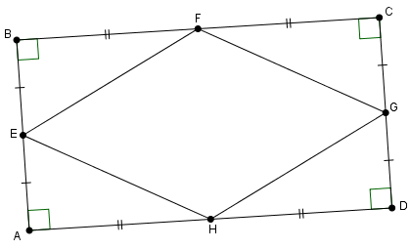

$ABCD$ is a rectangle. Therefore opposite sides are congruent ($\overline{AB}≅\overline{CD}$ and $\overline{BC}≅\overline{DA}$) and all four angles are right angles.
$E$ is the midpoint of $\overline{AB}$, so $\overline{AE}≅\overline{EB}$. $G$ is the midpoint of $\overline{CD}$, so $\overline{CG}≅\overline{GD}.$ Since $\overline{AB}≅\overline{CD}$:
$$\overline{AE}≅\overline{EB}≅\overline{CG}≅\overline{GD}$$
$F$ is the midpoint of $\overline{BC}$, so $\overline{BF}≅\overline{FC}$. $H$ is the midpoint of $\overline{DA}$, so $\overline{DH}≅\overline{HA}.$ Since $\overline{BC}≅\overline{DA}$:
$$\overline{BF}≅\overline{FC}≅\overline{DH}≅\overline{HA}$$
These relationships form four triangles that can be proved congruent by Side-Angle-Side:
$$∆HAE≅FBE≅∆FCG≅∆HDG$$
Since these are all congruent right triangles, the hypotenuse of each triangle must be congruent:
$$\overline{EF}≅\overline{FG}≅\overline{GH}≅\overline{HE}$$
Therefore, quadrilateral $EFGH$ must be a rhombus.

