Multiple Representations of Functions Task

x | f(x) |  | x | g(x)
-3 | 7 |  | -2 | 12
-2 | 5 |  | 0 | -2
0 | 1 |  | 1 | -3
1 | -1 |  | 2 | 0
4 | -7 |  | 4 | 18

f(x) g(x)
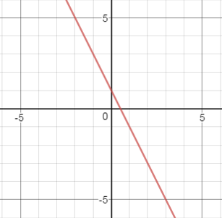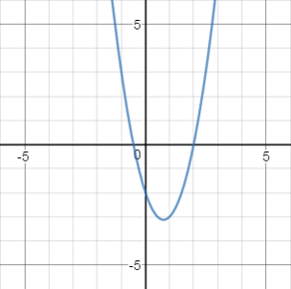

- Find f(1) and f(g(1)).

a. f(1) = _________
b. f(g(1)) = _________
c. How did you solve each and why did you choose your approach?

- Find f(-1) and f(g(-1)).

a. f(-1) = _________
b. f(g(-1)) = _________
c. How did you solve each and why did you choose your approach?

- Using the same functions above, how would you find $f(\frac{2}{3})$ and $f(g\left(\frac{2}{3}\right))$?

Multiple Representations of Functions Task - KEY

x | f(x) |  | x | g(x)
-3 | 7 |  | -2 | 12
-2 | 5 |  | 0 | -2
0 | 1 |  | 1 | -3
1 | -1 |  | 2 | 0
4 | -7 |  | 4 | 18

f(x) g(x)

- Find f(1) and f(g(1)).

a. f(1) = -1
b. f(g(1)) = 7
c. How did you solve each and why did you choose your approach?
Students may explain using tables or graphs.

- Find f(-1) and f(g(-1)).

a. f(-1) = 3
b. f(g(-1)) = -5
c. How did you solve each and why did you choose your approach?

Students should explain by using a graph.
- Using the same functions above, how would you find $f(\frac{2}{3})$ and $f(g\left(\frac{2}{3}\right))$?
Answers may vary. Students may find the equation of the line or use estimation

