SOL 8.16 Task 1
* Recognize negative slopes * Identify slope and y-intercept * Identify dependent/independent variables *Write the equation y = mx+b*

- Carlos is draining water out of his pool at a constant rate. The line on the graph represents the volume of the water in the pool as water is being drained. Use the line on the graph to complete the table.
y
time (minutes) | water volume (gallons)
0
1
2
3
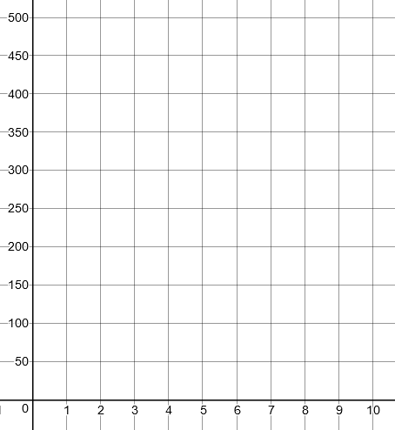

Volume (gallons)

x

Time (minutes)

- What is the initial volume of water in the pool when Carlos began draining it?

- How many gallons of water per minute are being drained from the pool?

- Write an equation of the line to represent volume of water (y) after (x) minutes.

- Using your equation, determine how long it will take for the pool to drain completely. Identify the point representing this on the graph.

- What is the dependent variable?

- What is the independent variable?

- The point (4, 200) is located on the line. Write a sentence about what this point represents.

- The point (6, 100) is located on the line. Write a
sentence about what this point represents.

- If water was draining from the pool at a constant rate of 25 gallons per minute, how would a line representing this situation differ from the line in the given graph? Draw this new line on the graph above. How long will it take the pool to drain completely?

- If the beginning water level was 300 gallons and water was being added to the pool at a constant rate, what would the line look in comparison to the graph above? Explain why.

SOL 8.16 Task 2
*zero slope* equation of a line* contextual problem*

Sam works downtown and lives outside the city. He is driving at a constant rate of speed from his home to work.

1. Which of the following graphs could best represent his trip, if x represents the total time he has been driving and y represents the distance he has travelled?
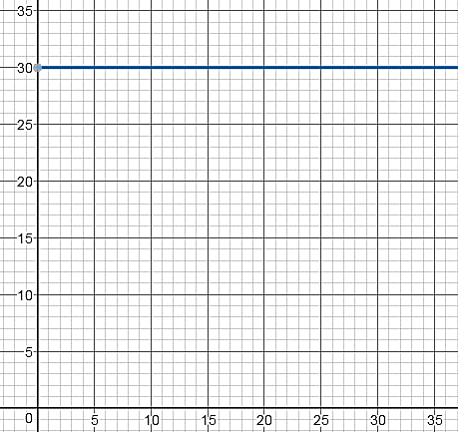
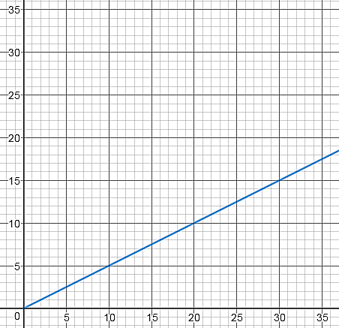
Graph B
Time (minutes)
y
x
Graph A
Distance (miles)
Time (minutes)
y
x

Distance (miles)

2. Complete Table A using information from Graph A. Complete Table B using information from Graph B.

Table A Table B
Time (min) | Distance (miles)
2
4
8
10
30
Time (min) | Distance (miles)
2
4
8
10
30

3. Using Table A, determine the constant rate of speed (mph).

4. Using two points from Graph A, determine the slope of the line.
Explain what this slope means in relation to distance and time for Sam’s trip.

5. What is the equation of the line for Graph A?

6. Using two points from Graph B, determine the slope of the line.
Explain what this slope means in relation to distance and time for Sam’s trip.

7. Will the slope of a horizontal line always be zero? Explain your reasoning.

8. Did you select the correct graph in question #1 that showed Sam’s constant rate of speed?

9. Describe the difference between the graph of a line that represents constant rate of movement and
the graph of a line with a zero slope.

10. If the origin of the both graphs is the location of Sam’s house, what could the y-intercept represent in graph B?

