SOL 8.16 Task 1
* Recognize negative slopes * Identify slope and y-intercept * Identify dependent/independent variables *Write the equation y = mx+b*

- Carlos is draining water out of his pool at a constant rate. The line on the graph represents the volume of the water in the pool as water is being drained. Use the line on the graph to complete the table.
y
time (minutes) | water volume (gallons)
0 | 400
1 | 350
2 | 300
3 | 250
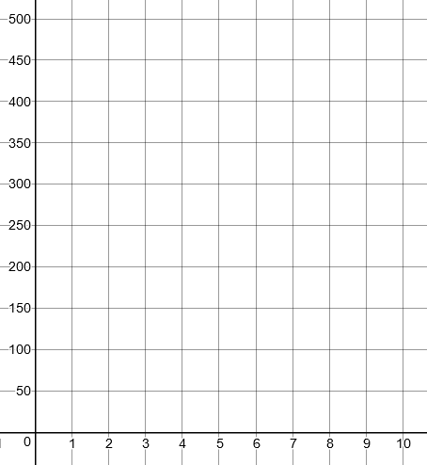

Volume (gallons)

x

Time (minutes)

- What is the initial volume of water in the pool when Carlos began draining it?
Guide students to note the labels of the y and x-axis and what each axis represents.
400 gallons
- How many gallons of water per minute are being drained from the pool?
50 gallons
How does the graph show this? Using slope triangles between any 2 consecutive points, students should notice a decrease in 50 gallons going down the y-axis for every 1 minute to the right on the x-axis.
- Write an equation of the line to represent volume of water (y) after (x) minutes.
$$y=-50x+400 or y=400-50x$$

How are these equations equivalent?
NOTE: students may feel y=400-50x matches the scenario better for the water starting at a level and draining from the pool.

What property is used to show equivalency? – asking this question will allow students to see that both equations are equivalent by the commutative property of addition.

- Using your equation, determine how long it will take for the pool to drain completely. Identify the point representing this on the graph.
Ask students how the equation would be written to show that the pool was completely drained 0 = -50x + 400
Solution, x = 8 which refers to the point (8,0)
Students may notice on the graph that water is completely gone when time reaches 8 minutes. Have students prove this answer using the equation.
- What is the dependent variable?
Gallons of water in pool.
The amount of water left in the pool is
dependent on the time
- What is the independent variable?
Time in minutes
- The point (4, 200) is located on the line. Write a sentence about what this point represents.
At 4 minutes, 200 gallons of water are left in the pool.
Note the misconception students may have: 200 gallons drained from the pool. Next question will address this misconception.

- The point (6, 100) is located on the line. Write a
sentence about what this point represents.
At 6 minutes 100 gallons of water are left in the pool. This point does NOT represent that 100 gallons drained from the pool.

- If water was draining from the pool at a constant rate of 25 gallons per minute, how would a line representing this situation differ from the line in the given graph? Draw this new line on the graph above. How long will it take the pool to drain completely?
The line will be less steep (more horizontal). Over
time less water drains thus more water left in pool.
The pool will be empty at 16 minutes. It takes
twice the time if half the original amount is
draining

- If the beginning water level was 300 gallons and water was being added to the pool at a constant rate, what would the line look in comparison to the graph above? Explain why.
The y-intercept will be at 300 gallons with line of positive slope since the volume will be increasing.

SOL 8.16 Task 2
*zero slope* equation of a line* contextual problem*

Sam works downtown and lives outside the city. He is driving at a constant rate of speed from his home to work.

1. Which of the following graphs could best represent his trip, if x represents the total time he has been driving and y represents the distance he has travelled? Accept all answers for discussion as the focus of this task is an exploration and will guide them to an understanding of zero-slope.
Graph A is correct. Many will say graph B because it looks constant speed but it is a constant distance.
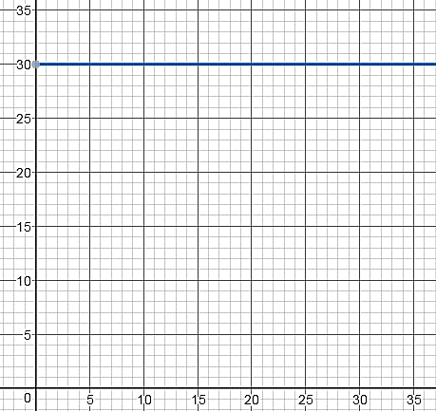
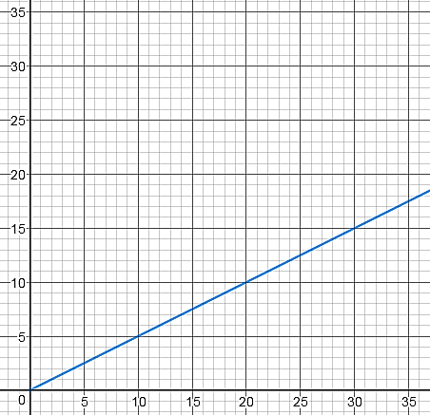
Graph B
Time (minutes)
y
x
Graph A
Distance (miles)
Time (minutes)
y
x

Distance (miles)

2. Complete Table A using information from Graph A. Complete Table B using information from Graph B.

Table A Table B
Time (min) | Distance (miles)
2 | 1
4 | 2
8 | 4
10 | 5
30 | 15
Time (min) | Distance (miles)
2 | 30
4 | 30
8 | 30
10 | 30
30 | 30

NOTE: Students may have difficulty reading the graph and completing the table. Have students refer to the graph and ask, what two points are easy to read from the graph? (10, 5) and (30, 15)
What is the relationship between the time and distance of these two points? - Distance is half the time
How then could you determine the rest of the table? - All distances are half of the time.
3. Using Table A, determine the constant rate of speed (mph)?
Ask students if we know how far Sam will travel in 1 hour? – Since our time is in minutes, how many minutes are in 1 hour?
With the ratio of 15 miles traveled in 30 minutes, ask students if they know how far Sam will travel in 60 minutes?
How could we extend the table to find the distance for 60 minutes? - Doubling the 30 minutes to 60 minutes, and then doubling the 15 miles to 30 miles.
Students should then arrive at the ratio of $\frac{30 miles}{1 hour}=\frac{30 miles}{60 minutes}$

4. Using two points from Graph A, determine the slope of the line.
Explain what this slope means in relation to distance and time for Sam’s trip.
Pick any two points and use slope triangles to find the rate of change m = $\frac{1}{2}$

For every 2 minutes Sam travels 1 mile.

How does the $\frac{1}{2}$ relate to 30 mph? $\frac{30 miles}{1 hour}=\frac{30 miles}{60 minutes}= \frac{1 mile}{2 minutes}$

5. What is the equation of the line for Graph A?
How does the constant rate of speed relate to the slope? $\frac{30 miles}{60 minutes}= \frac{1}{2}$

$y=\frac{1}{2}x$

6. Using two points from Graph B, determine the slope of the line.
Explain what this slope means in relation to distance and time for Sam’s trip.
Pick any two points and use slope triangles to determine rate of change.
No change in distance (y) therefore $\frac{0}{any number}$ = 0

Sam is at the same distance as time increases. Sam is not moving

7. Will the slope of a horizontal line always be zero? Explain your reasoning.
Yes. There will never be a change in y on a horizontal line which gives a slope of 0.

8. Did you select the correct graph in question #1 that showed Sam’s constant rate of speed?

As an exploratory task, this question is to direct the student back to his original thinking and give time to reflect on the correct answer.

9. Describe the difference between the graph of a line that represents constant rate of movement and
the graph of a line with a zero slope.
Constant rate of speed (implying the car is moving) will have a distance that is increasing over time.
The graph of the line with 0 slope will be horizontal showing no change in the distance over time so the car is not moving…..constant distance of 0 over time

10. If the origin of the both graphs is the location of Sam’s house, what could the y-intercept represent in graph B?
The graph only shows that Sam was 30 miles from his home.
The contextual scenarios students could imply are: Sam is at work, he is stuck in traffic, he stopped for breakfast at a place 30 miles from his home….

