SOL 7.10 Task 1
*Determine slope as a rate of change * Write the proportional relationship as y = mx *
* Graph a line of a proportional relationship*

David walks at a rate of 10 yards in 4 seconds.

- Use the double number line below to show how far Dave can walk in 14 seconds.
0 yds.
10 yds.

0 sec
4 sec

- Use your thinking from the number line to complete the table below.

TIME  (seconds) | DISTANCE (yards)
1
 | 5
4
8
 | 30
14

- Does this table represent a proportional or a non-proportional relationship? Explain your reasoning.

- Determine the unit rate using your number line or the table.

- How could this unit rate be used to find the yards walked in 14 seconds?

- Write a rule to express how many yards (y) can be walked for any number of seconds (x).

- Graph the points from your table on the coordinate grid below and connect them with a line.
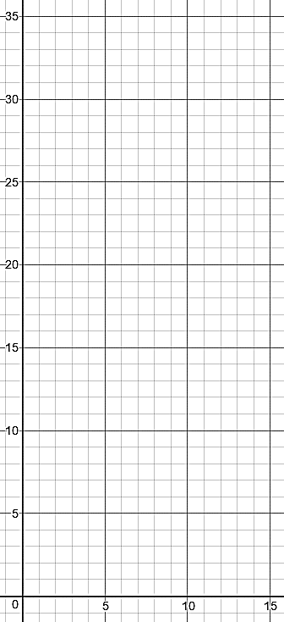
Y

Distance (yards)

X
Time (seconds)

- Should your line include the origin? Why?

- What does this line represent?

- What do the points (2, 5) to (4, 10) represent? Describe how the y-value changes as the x-value changes.

- Draw a triangle that shows this change on your graph.
- Continue drawing these triangles to show the rate of change along the line.

- These rate of change triangles are also known as ____________________ m, of the line.

- How is this ratio related to the unit rate?

- Write the equation of the line in the form y=mx.

- Draw a line on the graph above that represents Dave walking at a slower pace. What could be a value for slope to represent Dave walking at a slower pace? Explain your reasoning.

- Given that a line includes the point (2, 6) and has a slope of m = 3, graph the line using slope triangles.

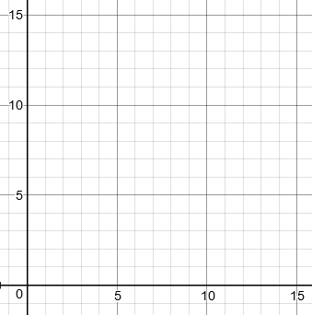
x
y

- What is the equation of this line?

- Graph $y= \frac{1}{3}x$ on the grid below.
Y
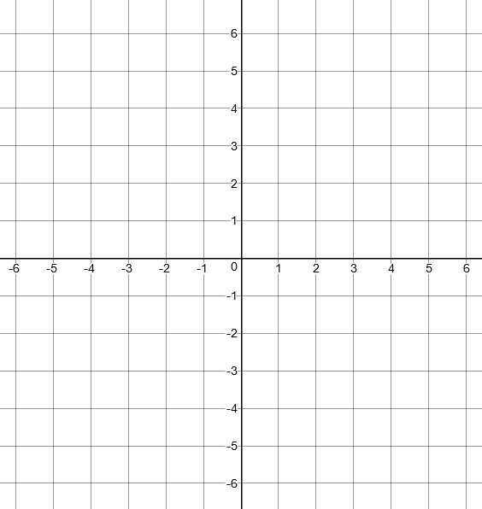

X

SOL 7.10 Task 2
* Determine y-intercept * Write the additive relationship as y = x + b * Graph a line of an additive relationship *

An iPad game will cost $3 to download. In order to increase levels within the game, you will be charged $1 per level to advance.

- Complete the table below.

Number of Levels Purchased (x) | Total Cost (y)
1
2
3
4
5

- Does this table show a proportional or a non-proportional relationship? Explain your reasoning.

- Using the ordered pairs from the table, graph them below.
y
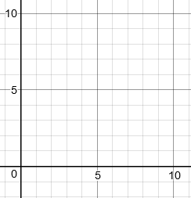

Total Cost ($)

- Should the points in the graph be connected?

x

Number of Levels Purchased

- Write an equation to represent the total cost (y) for number of levels purchased (x) for this game.

- What is the total cost if 0 levels are purchased?

- Graph this point and discuss what it represents in the problem.

- The point at which the graph intersects the y-axis is known as the _______________________________

- How would the graph change if there were no fee to purchase the game?

What would be the y-intercept?
- Graph the equation $y=x-4.$

- What is the y-intercept?
y

x

