SOL 7.10 Task 1
*Determine slope as a rate of change * Write the proportional relationship as y = mx *
* Graph a line of a proportional relationship*

David walks at a rate of 10 yards in 4 seconds.
NOTE: To highlight the importance and use of a double number line and to prevent students from using the ratio table to arrive at the answer, tell students to cover the table in question #2 to ensure they only use the number line for question #1. Using the table in question #2 promotes a guided strategy and does not allow for the creative reasoning about ratios that the double number line in question #1 intends.

- Use the double number line below to show how far Dave can walk in 14 seconds.
0 yds.
10 yds.

0 sec
4 sec

Students should use ideas of doubling ($\frac{10}{4} = \frac{20}{8} )$, halving ($\frac{10}{4}=\frac{5}{2} )$ or unit rate to find the answer of 35 yards. This number line emphasizes reasoning about ratios as a composed unit. Allow students to reason through and share the many strategies that can be used to arrive at the answer.

- Use your thinking from the number line to complete the table below.

TIME  (seconds) | DISTANCE (yards)
1 | 2.5
2 | 5
4 | 10
8 | 20
12 | 30
14 | 35

- Does this table represent a proportional or a non-proportional relationship? Explain your reasoning.
Ask students if the ratios are equivalent? - Proportional - All ratios are equivalent.

Ask students to determine the distance David would walk for 0 seconds? - The idea of 0 yards walked for 0 seconds shows a proportional relationship exists within this context. The problem situation starts at (0,0)

- Determine the unit rate using your number line or the table.
Focus students on the order of the ratio, Distance per Time.
As a reminder from 6th grade, unit rate for this situation is yards per 1 second (distance per time).

2.5 yards per second

- How could this unit rate be used to find the yards walked in 14 seconds?
Multiply the unit rate of 2.5 by 14 seconds = 35 yards

- Write a rule to express how many yards (y) can be walked for any number of seconds (x).

Have students generalize in words how they would have solved for question #5:
The total distance traveled is equal to the unit rate times the time traveled.
$y=2.5x$

- Graph the points from your table on the coordinate grid below and connect them with a line.
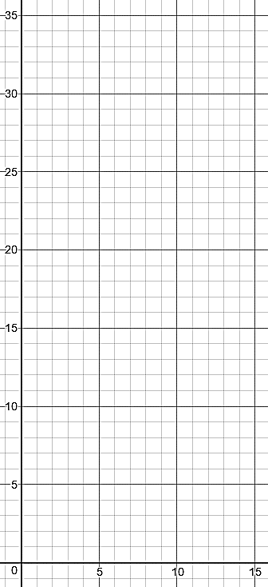
Y

Distance (yards)

X
Time (seconds)

- Should your line include the origin? Why?
Refer back to discussion in question #3
Yes - At 0 seconds David has not traveled any distance
- What does this line represent?
The distance Dave walked is dependent upon
the time.
- What do the points (2, 5) to (4, 10) represent? Describe how the y-value changes as the x-value changes.
Note: It is not the intention to use the slope
formula but have students reason using the
graph. The goal is to have students in the habit of looking first at how the y-value changes and then note the change in the corresponding x-values. This sets them up to understand that linear functions compare the change in y dependent upon the change in x.

Have students start with the y-value of 5 and count the spaces traveled to reach the y-value of 10 (up 5 units).

Repeat this process with the x-value of 2 to the x-value of 4 (the travel is 2 units to the right).
- Draw a triangle that shows this change on your graph.
- Continue drawing these triangles to show the rate of change along the line.
- These rate of change triangles are also known as SLOPE m, of the line.
- How is this ratio related to the unit rate?
Referring back to question #6 (the unit rate of 2.5 yards/second) ask students how 2.5 is related to 5/2? - Students must understand that 5 yards traveled for every 2 seconds is double the rate of 2.5 yards per 1 second. The purpose is to link the idea that unit rate and slope are the same quantity.
They are equivalent.
$2.5 = \frac{5}{2}$
NOTE: for graphing purposes, using the rate of 5/2 allows students to use slope triangles to travel 5 units up for each y-value and 2 units to the right for each x-value for each point.
- Write the equation of the line in the form y=mx.
$y=\frac{5}{2}x$ or y=2.5x
- Draw a line on the graph above that represents Dave walking at a slower pace. What could be a value for slope to represent Dave walking at a slower pace? Explain your reasoning.
Any value less than 5/2 will be flatter showing less distance as time increases. Example: $\frac{5}{4}$ (5 yards in 4 seconds)

- Given that a line includes the point (2, 6) and has a slope of m = 3, graph the line using slope triangles.
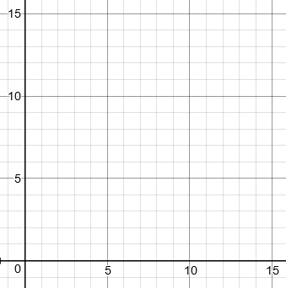
X
Y
How could we think of a slope of 3
as a ratio? $\frac{3}{1}$

Start at point (2,6), go up 3 and right 1
Continue in that pattern.

To draw the line toward the origin ask:
How can I use the same ratio and
determine y when x = 1, when x = 0?
Go down 3 and to left 1 $\frac{-3}{-1}$ = $\frac{3}{1}$

- What is the equation of this line?$y=3x$

- Graph $y= \frac{1}{3}x$ on the grid below.
How does the steepness of the line in question #17 (m=3) compare to this graph (m=1/3)?
- Less steep

Using slope triangles for both question #17 and #19, have students discuss the difference with graphing a slope of 3:1 as compared to 1:3.?
- 3:1, rise up 3 for every 1 unit to the right
- 1:3, rise up 1 for every 3 units to the right

Ask students to generalize the difference between slopes that are a proper fraction versus a whole number or improper fraction?
- Proper fractions will have a shorter rise as compared to the run
- Whole number or improper fractions will have a greater increase in rise as compared to the run
y
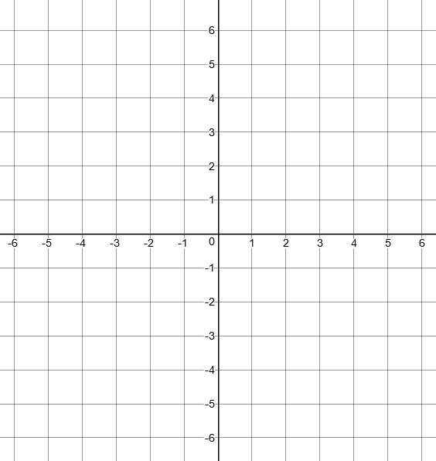

X

SOL 7.10 Task 2
* Determine y-intercept * Write the additive relationship as y = x+b * Graph a line of an additive relationship *

An iPad game will cost $3 to download. In order to increase levels within the game, you will be charged $1 per level to advance.

- Complete the table below.

Number of Levels Purchased (x) | Total Cost (y)
1 | 4
2 | 5
3 | 6
4 | 7
5 | 8

- Does this table show a proportional or a non-proportional relationship? Explain your reasoning.
NON-Proportional. There are no equivalent ratios within the table. There is not a constant number that can be multiplied to the x-value to arrive at the y-value. Because there is an initial cost, the situation represents an ADDITIVE relationship.
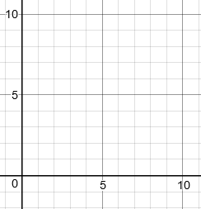
- Using the ordered pairs from the table, graph them below.
Y
X

Total Cost ($)

Number of Levels Purchased

- Should the points in the graph be connected?
No. This context does not allow for purchasing half a game.
- Write an equation to represent the total cost (y) for number of levels purchased (x) for this game. $y=x+3$
- What is the total cost if 0 levels are purchased? $3
- Graph this point and discuss what it represents in the problem.
For 0 levels purchased, the total cost will still include the initial cost of the app.
- The point at which the graph intersects the y-axis is known as the y-intercept.
- How would the graph change if there were no fee to purchase the game?
The graph would represent a PROPORTIONAL relationship (all ratios of cost per level purchased to number of levels would be equivalent) and start at the origin (0, 0).
What would be the y-intercept? (0, 0)

- Graph the equation $y=x-4.$
NOTE: Students may create a ratio table of ordered pairs, or some students may recognize the y-intercept (see answer to #11) and use slope triangles (from Task 1) to graph the line.

- What is the y-intercept? (0, -4)
NOTE: Students may have created a table of values that included x=0 and y=4.
Suggest that students rewrite the equation using the Inverse Property of Addition $y=x+(-4)$ .
This will allow students to recognize the value for the y-intercept, $b,$ is -4.
Y

X

