SOL 6.12 Task 1
*Determining proportional relationships and unit rates*
Sarah is going to an amusement arcade to play games with her friends. Sarah’s arcade charges $3 per game and no entrance fee to the arcade. Kayla is going to a different arcade that charges an entrance fee of $4 plus $1 per game. The tables below represent the cost per number of games played for Sarah and Kayla.
Sarah Kayla
# of games | Cost $
1 | $3
2 | $6
3 | $9
4 | $12
# of games | Cost $
1 | $5
2 | $6
3 | $7
4 | $8

- What is a ratio?

- Given that both girls will pay $6 for two games, do the tables represent the same relationship?

- Use the linking cubes to model the ratio of cost to number of games played for Sarah.
What do you notice with Sarah’s growing pattern?

- What is the cost for 1 game in Sarah’s table?

- Build Sarah’s unit rate with linking cubes. Show how the unit rate model is repeated within all the other ratio models that you’ve built for Sarah’s table.

- The ratio of $\frac{cost}{1 game}$ is known as _______________

- Using any two of the $\frac{cost}{number of games}$ ratios within Sarah’s table, determine if they are equivalent.

- Use the linking cubes to model the ratio of cost to number of games played for Kayla.
What do you notice with Kayla’s growing pattern?

- Using any two of the $\frac{total cost}{number of games}$ ratios within Kayla’s table, determine if they are equivalent.

- Which table represents a proportional relationship and which table represents a non-proportional relationship? Explain your thinking.

SOL 6.12 Task 2
*Comparing proportional versus non-proportional relationships*

Jerome wants to start saving money. He has no money in his bank account. He will save $2 per week. Tori has saved $4 in her bank account. She will also save $2 per week. The graphs below represent the amount of money each will save per week.
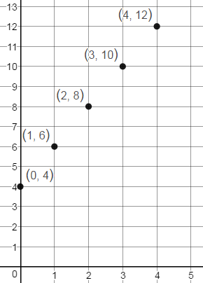
Jerome’s Earning Tori’s Earnings
y
y
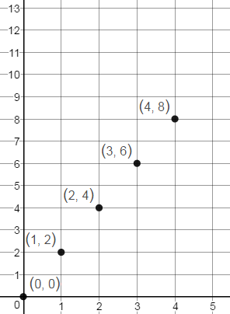

Money Saved
Money Saved

x
x
Weeks
Weeks

- Use the points on the graph to fill in the tables.
Jerome Tori
Week | Money Saved
Week | Money Saved

- Use the linking cubes to show the ratio pairs (money saved per week) for both Jerome and Tori.

- Explain the relationship between money saved and number of weeks on week 0 for Jerome and Tori.

- Select two of the non-zero $\frac{Money Saved}{Week}$ ratios within Jerome’s table and within Tori’s table to determine which situation is proportional.

- What makes a table or graph appear to be proportional or non-proportional? Explain your reasoning.

Which graph shows a proportional relationship? Explain your thinking.

What is the unit rate of the proportion? How does your linking cubes model show this?
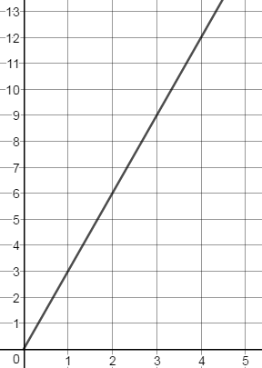
Graph A Graph B
Y
Y
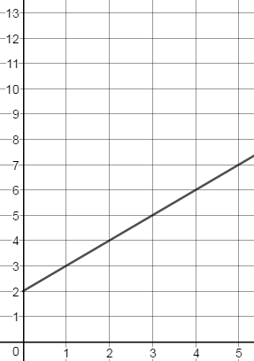

X
X

- Which graph above represents a proportional? How is it similar to either Jerome or Tori’s graph?

- Which graph above represents a non-proportional? How is it similar to either Jerome or Tori’s graph?

- Explain how you would determine whether a graph represents a proportional or non-proportional relationship.

SOL 6.12 Task 3
*Creating a table of ratios * Determining if a proportional relationship exists*

Sam would like to buy a video game that costs $27. Because Sam has not saved any money, his parents are willing to pay him for chores completed around the house. They agree to pay Sam $3 for every 2 chores he completes but will also pay him for completing single chores.

Complete the table below to show how many chores Sam would have to do in order to save enough money to buy the game.
X chores | 1 | 2 | 4 |  | 9
Y money earned |  | $3 |  | $12 |  | $27

- Does the situation above represent a proportional relationship? Explain your thinking.

- What is the unit rate of cost per chore for Sam’s situation?

- Use ratios from the table to prove that a proportional relationship exists.

- How could you change Sam’s situation to represent a non-proportional relationship between money earned and chores completed?

