SOL 6.12 Task 1
*Determining proportional relationships and unit rates*
Sarah is going to an amusement arcade to play games with her friends. Sarah’s arcade charges $3 per game and no entrance fee to the arcade. Kayla is going to a different arcade that charges an entrance fee of $4 plus $1 per game. The tables below represent the cost per number of games played for Sarah and Kayla.
Sarah Kayla
# of games | Cost $
1 | $3
2 | $6
3 | $9
4 | $12
# of games | Cost $
1 | $5
2 | $6
3 | $7
4 | $8

- What is a ratio?
A ratio is a comparison of 2 quantities.
- Given that both girls will pay $6 for two games, do the tables represent the same relationship?
No. Have students look at other ratios within both tables to notice the different cost for # of games played.
- Use the linking cubes to model the ratio of cost to number of games played for Sarah.
What do you notice with Sarah’s growing pattern?
Allow students to show and tell their models.
Guide students to explain how the cost for 1 game can be shown as a composed unit, repeatedly throughout the other ratios (i.e. 1:3 can visually be shown with linking cubes three times in the ratio of 3:9)
- What is the cost for 1 game in Sarah’s table?
$3 for one game
- Build Sarah’s unit rate with linking cubes. Show how the unit rate model is repeated within all the other ratio models that you’ve built for Sarah’s table.
There is a repeated pattern of the modeled 3:1 unit throughout all modeled ratios. For example, the 3:1 ratio model can be seen twice for the cost of 2 games, three times for the cost of 3 games…
- The ratio of $\frac{cost}{1 game}$ is known as Unit Rate.

- Using any two of the $\frac{cost}{number of games}$ ratios within Sarah’s table, determine if they are equivalent.
$$\frac{\$3}{1 game}= \frac{\$12}{4 games}$$
- Use the linking cubes to model the ratio of cost to number of games played for Kayla. What do you notice with Kayla’s growing pattern?
There is a pattern BUT NOT a repeated pattern of the unit cost for 1 game. For example, the cube model of 1 game to $5 cannot be shown as a composed unit, twice within the 2 games to $5 ratio (refer to question #5).

- Using any two of the $\frac{total cost}{number of games}$ ratios within Kayla’s table, determine if they are equivalent.
$$\frac{\$6}{2 games} ≠ \frac{\$8}{4 games}$$

- Which table represents a proportional relationship and which table represents a non-proportional relationship? Explain your thinking.
Sarah –
- PROPORTIONAL relationship
- Multiplying by the same number (times 3) for each game, will result in the total cost. This is a MULTIPLICATIVE relationship that is evident in all proportional situations.
- Any two ratios are equivalent.

Kayla –
- NON-PROPORTIONAL relationship
- Adding the same number (plus 4) for each game will result in the total cost. This is an ADDITIVE relationship.
- Any two ratios are NOT equivalent.
SOL 6.12 Task 2
*Comparing proportional versus non-proportional relationships*

Jerome wants to start saving money. He has no money in his bank account. He will save $2 per week. Tori has saved $4 in her bank account. She will also save $2 per week. The graphs below represent the amount of money each will save per week.
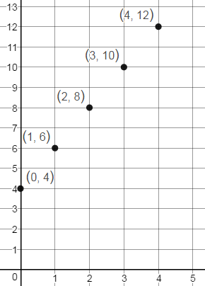
Jerome’s Earning Tori’s Earnings
y
y
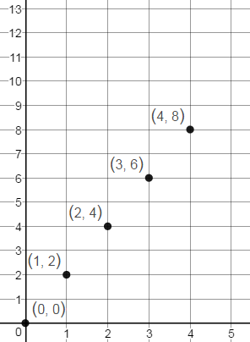

Money Saved
Money Saved

x
x
Weeks
Weeks

- Use the points on the graph to fill in the tables.
Jerome Tori
Week | Money Saved
0 | 0
1 | 2
2 | 4
3 | 6
4 | 8
Week | Money Saved
0 | 4
1 | 6
2 | 8
3 | 10
4 | 12

- Use the linking cubes to show the ratio pairs (money saved per week) for both Jerome and Tori.
Similar to Task 1, students should notice the PROPORTIONAL repeated unit rate model of 1:2 within all of Jerome’s ratio models.
Students will NOT be able to see Tori’s model of 1:6 doubled, tripled, etc… within any of her ratio models.

- Explain the relationship between money saved and number of weeks on week 0 for Jerome and Tori.
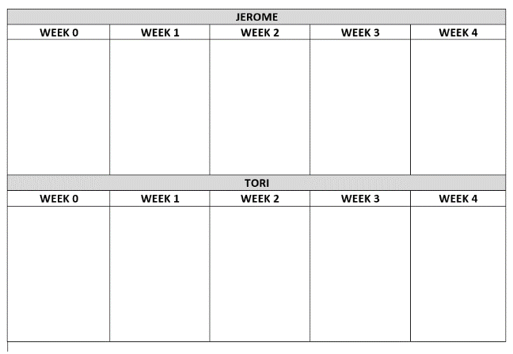
Students may find it helpful to use blank paper labeled with columns Week 0 to Week 4 (one for Jerome and one paper for Tori). They can then lay their cube models for Jerome and for Tori within the appropriate labeled week (SEE PICTURE )
Ask students to look at the linking cube ratios they have created for Week 0 for both Jerome and Tori. Students can now look at Week 0 for both and notice Jerome started with no money and Tori started with $4. When a context or graph does not include the origin (0,0) it is not proportional because each ratio will have an additive component.

- Select two of the non-zero $\frac{Money Saved}{Week}$ ratios within Jerome’s table and within Tori’s table to determine which situation is proportional.

Jerome $\frac{\$2}{week 1}= \frac{\$8}{week 4}$ ratios equivalent therefore PROPORTIONAL.

Tori $\frac{\$6}{week 1} ≠ \frac{\$12}{week 4}$ ratios are not equivalent therefore NON-PROPORTIONAL.

- What makes a table or graph appear to be proportional or non-proportional? Explain your reasoning.
Proportional TABLE will have equivalent, non-zero ratios
Proportional GRAPHS will include the origin (0, 0)

NON-Proportional TABLE will not have equivalent ratios.
NON-Proportional GRAPHS will not go through the origin.

Which graph shows a proportional relationship? Explain your thinking.

What is the unit rate of the proportion? How does your linking cubes model show this?
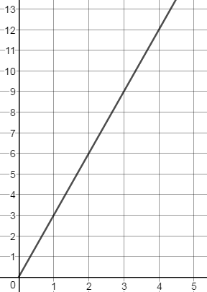
Graph A Graph B
Y
Y
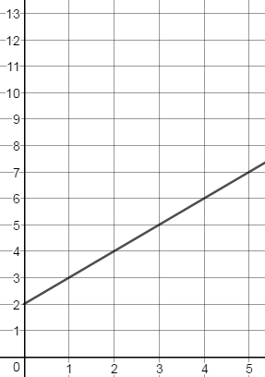

X
X

- Which graph above represents a proportional? How is it similar to either Jerome or Tori’s graph?
Graph A. It is similar to Jerome’s graph and goes through the origin. All points on the graph are equivalent.

- Which graph above represents a non-proportional? How is it similar to either Jerome or Tori’s graph?
Graph B. It is similar to Tori’s graph and does NOT go through the origin. Points on the graph are not equivalent.

- Explain how you would determine whether a graph represents a proportional or non-proportional relationship.
Proportional GRAPHS will include the origin (0, 0).
NON-Proportional GRAPHS will not go through the origin.

SOL 6.12 Task 3
*Creating a table of ratios * Determining if a proportional relationship exists*

- Sam would like to buy a video game that costs $27. Because Sam has not saved any money, his parents are willing to pay him for chores completed around the house. They agree to pay Sam $3 for every 2 chores he completes but will also pay him for completing single chores. Complete the table below to show how many chores Sam would have to do in order to save enough money to buy the game.

X chores | 1 | 2 | 4 | 8 | 9 | 18
Y money earned | $1.50 | $3 | $6 | $12 | $13.50 | $27
NOTE: Allow students to discuss the various ways they can reason through completing this table by
doubling ($\frac{2 chores}{\$3}= \frac{4 chores}{\$6}$ ), halving ($\frac{2 chores}{\$3}= \frac{1 chore}{\$1.50})$, and adding composed units (8 + 1 = 9 chores, therefore $12 + $1.50 = $13.50).
Some questions to ask students to get to these points:
How did you find the money earned for 4 chores? - doubling 2 chores leads to doubling $3
How did you find the number of chores completed for $12? - doubling the $6 leads to doubling 4 chores to arrive at 8 chores
How do you find the money earned for 9 chores?
- determine the cost for 1 chore by halving and use that unit rate of 1 chores for $1.50.
- Adding 1 more chore to 8 chores, adds $1.50 to the total money earned of $12 for 8 chores.
- NOTE: this idea of adding the unit rate is not reflective of an Additive relationship. An additive relationship in this problem would require that Sam had money already saved before he began doing chores.
- The composed unit of any of these rates can be added in its entirety to show a multiplicative relationship.
- Repeated addition is the same as multiplication
- Does the situation above represent a proportional relationship? Explain your thinking.
Yes. Sam did not start with any money, therefore for 0 chores completed, he earned $0.
All ratios within the table are equivalent.
- What is the unit rate of cost per chore for Sam’s situation?
$$\frac{\$1.50}{1 chore}$$
- Use ratios from the table to prove that a proportional relationship exists.
Any two ratios will show equivalency
$$\frac{2 chores}{\$3}= \frac{4 chores}{\$6}$$
- How could you change Sam’s situation to represent a non-proportional relationship between money earned and chores completed?
If Sam had started with money already saved, then this amount would have been added to the subsequent money he will earn for chores completed. This situation will then represent an ADDITIVE relationship.

