The purpose of the 2017 Mathematics SOL Institutes is to provide teachers with professional development focused on the instruction that supports implementation of the 2016 Mathematics Standards of Learning.
2016 Mathematics Standards of Learning Resources
- 2016 Standards of Learning
- 2016 Curriculum Frameworks
- Crosswalks (Summary of Revisions 2009-2016)
- Summary of Revisions (Narrated PPT 2009-2016)
Professional Development Instructions
A product of the 2017 Mathematics Institutes is a set of online professional development modules designed to be used by a group of teachers of a specific grade level or course, facilitated by a member of the team. Modifications could be made to adapt the professional development for more than one grade level/course or for large groups. Facilitators should review the PowerPoint, the Facilitator Guide, and the resources prior to facilitating this professional development.

Approximate Time | Facilitator Instructions | Links to Materials
30 minutes total | Module 1: New 2016 Standards of Learning (Slides 1-21)  Essential Question: What are the new 2016 Standards of Learning and how might the VDOE documents support understanding of these standards? | - Grade Band 3-5 Session PowerPoint  - 2009 to 2016 Crosswalks (Summary of Revisions)  - Grade 3  - Grade 4  - Grade 5  - Scavenger Hunt  - Scavenger Hunt Key
1) Introduce the Process Goals-5 minutes  2) Scavenger Hunt- 20 minutes  3) Closing-1 minute | Agenda provided for entire Grade Band 3-5 Session (Slides 1-2)  Revisions to Standards and Purpose: (Slide 3)  - Introduce the Process Goals and High Leverage Mathematics Teaching Practices (Slides 4-9)  - It’s important to note that with the 2016 standards revision the mathematical process goals are still driving the mathematical understanding. Students will learn the math content through the process goals of problem solving, connections, communication, representations, and reasoning. (Slide 4)  - We will be looking at the Principles to Actions: Ensuring Mathematical Success for All by NCTM. Consider how these principles are connected to one another and the importance of these for high leverage mathematics teaching practices. Time will be spent throughout the presentation making connections to this work. (Slide 5)  - When looking at the 2016 Mathematics Standards of Learning, there appears to be a reduction of standards. The reduction in the number of standards does not necessarily result in less content but that some standards were combined. For example, in 5th grade classifying triangles and measuring angles are taught together because these skills are used together.  - There are format changes in the 2016 Frameworks. (See slides 6 and 7.) This is one of the standards that changed in grade 4. Now there are two columns. On the left are teacher notes to assist with better understanding of the content. On the right is more information about each essential standards, knowledge and skills. New this year is that each bullet is tied directly to the standards, knowledge and skills listed. If there is an asterisk, like here at A, B and C, that means that items measuring this objective are assessed without the use of a calculator on the state assessment. Because D does not have an asterisk, it would be tested in the calculator section of the state assessment.  - Overview of Crosswalk Documents highlights the changes between 2009 and the 2016 Standards. It focuses on additions, deletions, parameter changes/clarifications, and the moves within the grade level. In a moment you will be exploring these documents in greater detail. (Slides 8 and 9)  - Here’s an example of what they look like. What questions might you have about the organization of the crosswalk document? (Slide 9)  - Scavenger Hunt (Slides 10-21)  - The crosswalk addresses what has been added, deleted, parameter changes, and if standards have been moved that is also indicated. In addition, the following pages of the crosswalk provide a side-by-side comparison of the 2009 standards alongside the 2016 standards. This provides an overview of the changes and does not necessarily highlight every revision. It is important that teachers spend time exploring the 2016 Curriculum Frameworks.  - To gain a better understanding of the revisions to the standards, you will have an opportunity to read through the crosswalks and complete a scavenger hunt. The scavenger hunt is not grade level specific, so you will need to look through all three grade levels to determine if the statements are true or false. There is also a notes section so that you can add your own notes about why statements are true or false.  - Review the answers to the scavenger hunt and highlight the notes about the changes that are listed.  - Closing (Slide 21)  - You may have noticed themes in the changes. The content emphasis for this session will highlight these bigger changes in the areas of number and number sense of fractions, computation and estimation with problem types and computational fluency.

Approximate Time |  | Facilitator Instructions | Links to Materials
Module 2: Emphasis on Specific Content (Slides 22-56)
Essential Question:
- What standards are new and may be most challenging for students to learn and/or teachers to teach?
- What instructional implications do these changes present?
- What instructional strategies and activities will assist in teaching and learning this content?
- What assessment implications do these changes present?
 | 120 minutes total | Part 2a: Number and Number Sense of Fractions (Slides 23-39)  Essential Question: What instructional strategies will promote students’ understanding of benchmark fractions? | - Number Sense (Fraction) Progression Document  - Unpacking Template  - Benchmarking Video-Johnson Elementary School  - More or Less Than Half Activity  - Benchmark Fractions Lesson  - Fractions on a Number Line Activity  - SOL3.2 CF Pages  - Cuisenaire rods (1 set per pair)
 | - Vertical alignment highlighting-10 minutes  - Unpack-5 minutes  - Video-10 minutes  - More or Less-45 minutes  - Benchmark Fractions-30 minutes  - Fractions on a Number Line-15 minutes  - Principles to Action-5 minutes | - Vertical Alignment for 3.2, 4.2, 5.2 (Models, benchmarks, compare/order) (Slides 24-25)  - In looking at the progression of fractions we will highlight key ideas on a Number and Number Sense Progression as they relate to 3.2, 4.2, and 5.2.  - Use your Vertical Progression for Number and Number Sense, highlight the models listed in yellow, highlight the benchmarks blue and highlight comparing and ordering in pink. As you finish consider these guiding questions (slide 25).  - What do students need to know?  - How do these standards connect?  - How does the progression of the standards build number sense?  - In small groups, share what you noticed based on the guiding questions. Share ideas whole group. (Ideas shared might include, but are not limited to the following – progression from concrete, representation, abstract within each grade; solving of contextual problems; length and measurement model connection, etc.)  - Unpack SOL 3.2 (Slide 26)  - Unpacking standards is an important process to help teachers understand what each standard is asking the students to know and be able to do, what guidelines or parameters they will do it with, what model or representations are to be used, any new vocabulary, and possible students’ misconception. This process is critical with any adoption of new standards. It is recommended you utilize the unpacking template provided by your district if one is available. A generic unpacking template has been provided for your convenience.  - Participants have an opportunity to use the unpacking template to unpack standard 3.2. Debrief whole group: What are some of the things that have bubbled up for you? (Ideas that might be shared include: misconceptions, new vocabulary, etc.) Now that we have looked closely at SOL 3.2, we will take a look at the instructional implications and how this might look in the classroom.  - Benchmarking Video - Fractions on a Number line (Slides 27- 31)  - Thinking about the standard you just unpacked, we will take a look at a video that highlights one way this might be taught. It takes place in a Virginia school that is Title 1. As you watch, consider these questions:  - What understandings do students demonstrate?  - What types of experiences lead to this type of discussion?  - Let’s watch as the teacher introduces benchmarking to ½ to the class.  - Stop video at 4:20 and invite participants to turn and talk with a partner about these two questions. Whole group: share responses to the two questions.  - Refer to the High Leverage Mathematics Teaching Practices chart. Point out that some of these practices were noticed in the video.  - As we continue to explore fractions, pay special attention to how we incorporate these three practices.  - Use and connect mathematical representations.  - Facilitate meaningful mathematical discourse.  - Pose purposeful questions.  - More or Less than Half (Adapted from McNamara, J and Shaughnessy, M. (2010) Beyond Pizzas & Pies; 10 Essential Strategies for Supporting Fraction Sense, Scholastic.) (Slides 32-33)  - Working with a partner use one paper, find the top number line. Using your Cuisenaire rods. Find ½. How do you know it’s one half? How can you prove it? Teacher shares different ways students made ½. Did anybody do anything different? On the next number line, find thirds? How many thirds are there? Remember you should be able to write down four fractions (i.e., 0/3, 1/3, 2/3, 3/3).  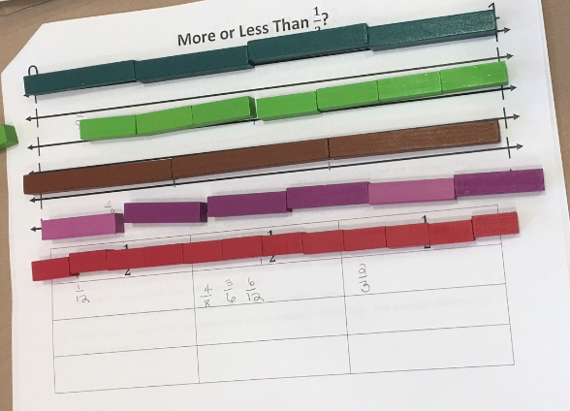  - Continue finding other fractions as mentioned on your directions sheet (fourths, sixth, and eights these will transition in on the PowerPoint).  - With the group, discuss what’s less than a half, equal to or greater than one half. What do you notice about the fractions that are less than one half? What do you notice about the fractions that are greater than one half? What do you notice about the fractions that are equal to one half? How might this activity benefit students?  - Turn and Talk then Whole Group Share: Why complete this activity with Cuisenaire Rods instead of labeled fraction bars? What are some reasons students might struggle with this activity?  - Benchmark Fractions Lesson – Close to 0, 1/2, 1 (slides 34-35)  - Using the fraction cards (from page 2 of Lesson) on your table, describe what you see.  - With a partner, sort the cards into three different categories -- by what is closer to 0, closer to ½ and closer to 1? Share the strategies you used with your partner.  - Label each card with a sticky note of the fraction it represents.  - With your table group, organize your fractions from your post-it notes that are close to 1, close to 1/2 and close to 1. Consider these questions: What do you notice about the fractions close to zero? Close to 1/2? Close to 1?  - Check for understanding by asking: Where would 11/12 go? How do you know? Where would 2/8 go? How do you know?  - Invite participants to share how these representations scaffold the concrete models. (These activities bridge the concrete to the representation to the symbolic.)  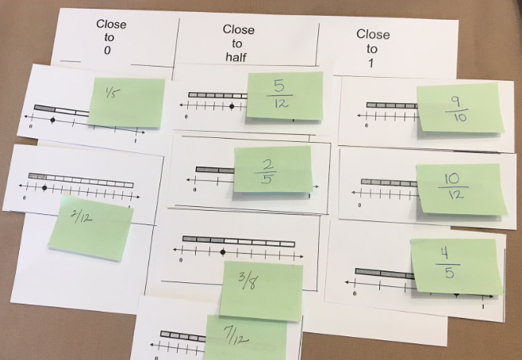  - Fractions on a Number Line (Slides 36-37)  - Using a long rope, have two volunteers hold the rope at each end. Use other volunteers to determine where zero goes and place with clothes pin; then one, then two (0-1-2 should be equidistant apart).  - Looking at the number line, where would you place 1/12? Be sure to highlight the importance of an endpoint and how the beginning and endpoints impact the placement of the fraction. Tell us about your reasoning. How did you know to place it there? How many pieces are in twelfths? Where might 1/8 go? Before someone comes up – have participants turn to a partner and tell where they think it will go and how they know? Who could say that in their own words? What fraction could come between 1/8 and 1/12? Ask for reasoning? Where would 1/2 go? Turn to you partner and share some fractions that you know could go between 1/8 and 1/2? After discussion, ask where would you place 0.25? How do you know? Discuss how 0.25 has the same value as one-fourth (students do not always recognize this). How far away is 0.25 from 1.2, how far away from one whole? If time allows, have participants discuss the same questions as it relates to the other fractions placed.  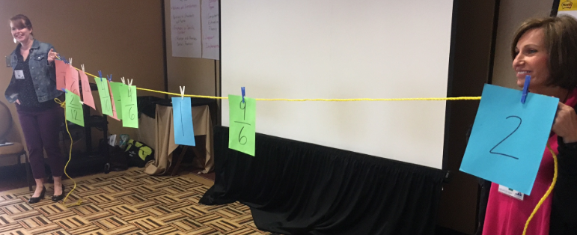  - Model placing numbers on a number line. Be sure to use fractions greater than 1 and have participants explain how they know. (See the handout for additional ideas.) Share “Developing Fraction Sense Using Benchmark Fractions” handout with participants.  - Prompts to Move Students Deeper in Thinking (Slide 38)  - Discuss the different prompts and how they support students’ understanding around the relationships found in fractions.  - What prompts stood out to you and that made you think more deeply?  - Principles to Actions (Slide 39)  - Revisit the Principles to Actions Mathematics Teaching Practices. How were the mathematics teaching practices (highlighted on the slide - #s 3, 4, 5) made explicit throughout the activities in which you just participated?  Closure: Take a moment with a partner at your table and write down three questions that you plan to ask when you implement these activities with students.
 | 55 minutes total | Module 2b: Problem Types (Slides 40-52)  Essential Question: What instructional strategies will promote students’ understanding of problem solving using various problem types? | - Computation and Estimation Progression  - Modeling Problem Types Add/Sub  - Problem Sorting Chart  - Mult/Div Problem Type Sorting Cards  - Mult/Div Problem Type Key
 | - Create problems-2 minutes  - Principles to Actions-2 minutes  - Vertical Alignment-10 minutes  - Explore Problem Types-20 minutes  - Match Multiplica-tion and Division-10 minutes  - Video-10 minutes | - Create an addition word problem and a subtraction word problem. Record on separate sticky notes. (Slide 41)  - Give a few minutes for participants to write two word problems, one on each sticky note.  - Once finished, participants should set the sticky notes to the side and we will come back to them.  - Principles to Actions (Slide 42-43)  - In the next activity we will be highlighting the following practices 2, 7, 8. While you might see other practices being used, it is these practices that are the focus.  - Vertical alignment SOL 3.3, 3.4, 4.4, 5.4 (Slide 44)  - Revisiting the Principles to Action, we invite you to connect with these 3 high leverage instructional practices throughout the afternoon.  - While we are not taking time to unpack these standards, these might be guiding questions you use during unpacking with your teachers. Within the vertical progression for computation and estimation, look for these key ideas and share with a partner.  - What do students need to know?  - How do these standards connect?  - How does the progression of these standards support problem solving?  - As you debrief these questions, highlight the importance of where fluency and the use of a calculator are noted in the progression if it does not come up in the discussion.  - Explore the Problem Types Chart for Addition/Subtraction (Slide 45- 47)  - Now that we have a clearer understanding of what students are expected to learn in these grade levels, let’s spend some time looking more closely at the different problem types.  - Use the Grade 1 modeling addition/subtraction handout. Have participants act out the different problem types and discuss the difference in what each of these looks like. Record an equation for each problem type. This will help in determining the differences between different problems.  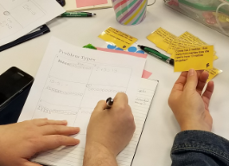  - Ask participants to think about the following questions and share in small group: How can these problem structures be adapted to your grade level? What models would best be used to represent problems appropriate for your grade level? Share some ideas whole group.  - Discuss which problem types students might struggle with the most and why.  - Revisit the addition/subtraction problem sticky notes previously written by participants. Have them turn and talk to a partner about what type of story structure their problem represents. Then have participants sort their problems onto the appropriate charts on the wall. After all the sticky notes are placed ask: What do you notice? (More than likely, most of the problems will fall into the ‘result unknown’ column. Talk about how when we are asked to come up with problems we tend to create problems that have a certain structure. Teachers need to be strategic in providing students with a variety of problem structures. What questions do we tend to ask our students? Which problems are students most comfortable with and which ones are more challenging?  - Now let’s take a look at the different problem structures for multiplication and division.  - Match the multiplication/division problem types to the chart (essentially creating the table of problem types) (Slides 48-49)  - Provide participants with the blank multiplication and division problem type chart and cards with problems (need to be cut out ahead of time). Invite participants to match the problems with the descriptions on the chart.  - Review the matches and clarify any questions or misconceptions. Record an equation for each problem type. This will help in determining the differences between different problems.  - Invite participants to reflect on the connection between addition and subtraction and/or connections to models by discussing and then sharing out whole group:  - How does the work that you do with addition and subtraction problem types support learning in multiplication and division?  - What models would best be used to represent problems appropriate for your level?  - What squares with your thinking and what is still circling around in your head regarding problem structures?  - Now we are going to watch a brief video that speaks to the importance of having students explore all the types of story structures.  - Problem Solving - Problem Types (Slides 50-51)  - View the video of Dr. Sybilla Beckmann discussing problem types. (Note: Link is included in PowerPoint. Once at the website, click on number 4, show more, to bring up the 5 minute video.) Discuss at your table any take-away from the video. Whole group: What resonated with you or your group as you reflected on this video?  - Show the VDOE quote regarding problem solving and the use of key words from the 2016 Curriculum Frameworks. Ask participants to turn to a shoulder partner and reflect on quote.  - Revisit the addition and subtraction problems that were written on the sticky notes and placed on the charts on the wall. Ask - if a teacher were to focus solely on a keyword approach, what word might they include in a problem where they would like the students to add? Point out examples of problems written on the sticky notes that use the words “altogether” or “in all”. Ask - what word might teachers include in a problem where they would like the students to subtract if they are focusing on a keyword approach? Point out examples of problems written on sticky notes that use the word “left.” Discuss where these problems fall in the problem types chart.  - (Slide 52) Revisiting these high leverage teaching practices, what connections did you make to practice #s 2, 7, and 8 through our work this afternoon? Thinking about the word problem type activity, what connections can you make with the teaching practices?
 | 30 minutes | Part 2c: Computational Fluency (Slides 53-56)  Essential Question: What instructional strategies will promote students’ flexibility with numbers and computational fluency?
- Number Talks are a quick way to promote computational fluency as well as reinforce basic fact strategies, place value, and the application of properties. When we use the term “Number Talks” we are referring to the work of Sherry Parish in her book titled “Number Talks”. Ask how many of are familiar with her book? So you might have Number Sense routines that you refer to as a number talk, like a number of the day activity or a count around. We’re going to be very specific and intentional about how we are differentiating what a number talk is based on the work of Sherry Parish.
So what is a Number Talk? It’s a 5-15 minute routine using naked number problems that are purposefully crafted to support students in developing computational fluency while reinforcing their understanding of number sense, place value, and the properties. When you are facilitating a Number Talk there are five necessary key components.
- The first key component of a number talk is to build a community of learners. This is designing a safe space for students to explore math without being critical of each other. All answers are honored and explored, even the incorrect ones, because we are learning together and from each other.
- All of this happens through discourse. Discourse is the opportunity for students to talk to each other and explore each other’s ideas. It’s important for us to teach our students how to engage with each other in appropriate ways. One way you might do this is using sentence frames and providing students frames like “I agree with you because___” or “I disagree with you because___” to help them communicate respectfully.
- Because this communication occurs through discourse, the teacher’s role is not the “sage on the stage”; the teacher is the “guide on the side”. You are the facilitator of the conversation asking probing questions, clarifying understanding, and encouraging students to talk to each other rather than to you. You also serve as the recorder of the mathematics. As students are describing their strategies, you are making the connection to the symbolic form and modeling how their strategy can be written with numbers and symbols.
- Because all of the work during a number talk is mental math students do not have paper and pencil. Students are using what they know to solve problems in their head. Sometimes students get confused or lost as they think about a strategy and try to transcribe their method to show their thinking. We are attempting to lift off that layer for them so they can focus on what they know about the numbers and then the teacher is attempting to show what that looks like in writing. In order for this to be successful and accessible for all students, teachers need to be purposeful in their choice of numbers.
- Purposeful computation is our final component. All of the number strings that we chose for students need to be intentionally chosen for your class so that all students have access and a way to solve the problem. We also want to pick problems that are naturally going to move students forward their thinking around computation and fluency by understanding patterns in numbers and properties. Because fluency doesn’t mean fast. Fluency is using what you know to solve a problem in an efficient way that makes sense to you. As you think about purposeful computation and how you use number strings to promote these ideas, it may be helpful to have an example. So if I wanted my students to start thinking about making 10s, I might start with having students solve 9+1, share answers and explore strategies. Then we could solve 9+1+4, share answers and explore strategies. Then we might solve 9+5 and make connections through our work. From the student answers, we would hope to uncover that 9+5 can be solved by breaking apart the 5 into 4+1 and I can combine the 1 and 9 to make 10 and then add on 4 more. As students start to notice this pattern, I might start asking them if this strategy would always work? How do we know? And in the upper grades we can start exploring more about the properties they’re learning like the distributive property and the associate property. Because these are student’s strategies, we can pull out what students are doing mentally in an authentic way, show how this is written and connect it to the property they are using. We are not teaching the properties in isolation; we are teaching them in a way that makes sense to kids. So how does that really work? We’re going to find out by doing a Number Talk together.
Silently and in your head, remember this is mental math, solve this problem 12x15 (Slide 55). (Write the problem at the top of a piece of chart paper.) I’ll know that you have an answer when you hold a thumb up in front of your chest. When you hold up another finger, I’ll know you have two strategies. Adding another finger means three strategies and so on. Solve this problem.
(Observe participants solving the problem and wait until everyone has at least one strategy for solving.) Here are a few examples of strategies that might be used to solve 12 x 15 mentally:

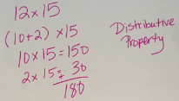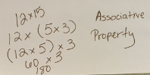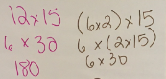

- So who has an answer to share? (Write the answer on the chart paper.) Who has another answer? (Write down all answers shared.)
  - Who would like to defend their answer? (Document teacher strategies for solving by prompting teachers or answering questions. For example, tell me more; how do you know; why can we do that; which property lets us do that; will this strategy always work. As more strategies are shared, encourage teachers to make connections between them.)
  - (After the number talk, reflect on the process.)
- Now let’s talk about what took place. Where did you see the distributive property? Where did you see extensions of basic fact strategies? Place value? How does it support the vertical progression of computational fluency? How does the notation that the teacher uses allow properties or specific strategies to become explicit for students? Discuss the similarities and differences between the strategies shared.
  - How is thinking about the problem as (10 x 12) + (5 x 12) similar to (10 x 15) + (2 x 15)?
  - How is thinking about the problem as 3 x 4 x 15 different from (10 x 15) + (2 x 15)?
- Whole group. Connecting Back to 3.4, 4.4, 5.4 (Slide 56) Have participants discuss the following questions as a small group:
- Where do you see examples of the properties?
- Where do you see extensions of basic fact strategies?
- How does this support the Vertical Progression for Computation and Estimation?
 | 30 minutes total | Module 3: Support for Implementation (Slides 57-63)  Essential Questions: In what ways can I support my colleagues in implementation of the 2016 Standards of Learning? What resources are available from VDOE to assist with implementation? | - 2016 Mathematics Standards of Learning Documents  - Narrated Crosswalk Presentations  - Grade 3  - Grade 4  - Grade 5
- 2016 Standards of Learning Support documents (Slide 58)
Use link on slide 58 to go to VDOE webpage.
- Share the VDOE mathematics website listing the new standards, the new curriculum framework, and the Crosswalk documents
- Share the location of the Narrated Crosswalk Presentations. Play the VDOE Narrated Crosswalk presentation sample slides 59-61. Note: Narrated Crosswalk PPTs are available for each grade level K-8, Algebra I, Geometry, and Algebra II.
- Implementation Support (Slide 58)
- Review the various roles as the new standards are being implemented
- What has VDOE provided?
- What will individual divisions provide?
- Implementation timeline (Slide 63)
- What does curriculum development mean for the rest of the 2016-2017 school year?
- What does the Crossover Year mean for the 2017-2018 school year?
- What does Full-Implementation year mean for the 2018-2019 school year?
Closure: What are your next steps in preparing to implement the 2016 Standards of Learning?

