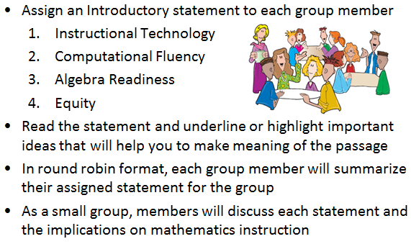
Introductory Statements
Jigsaw Activity

Instructional Technology
The use of appropriate technology and the interpretation of the results from applying technology tools must be an integral part of teaching, learning, and assessment. However, facility in the use of technology shall not be regarded as a substitute for a student’s understanding of quantitative and algebraic concepts and relationships or for proficiency in basic computations. Students must learn to use a variety of methods and tools to compute, including paper and pencil, mental arithmetic, estimation, and calculators. In addition, graphing utilities, spreadsheets, calculators, dynamic applications, and other technological tools are now standard for mathematical problem solving and application in science, engineering, business and industry, government, and practical affairs.
1
Calculators and graphing utilities should be used by students for exploring and visualizing number patterns and mathematical relationships, facilitating reasoning and problem solving, and verifying solutions. However, according to the National Council of Teachers of Mathematics, “… the use of calculators does not supplant the need for students to develop proficiency with efficient, accurate methods of mental and pencil-and-paper calculation and in making reasonable estimations.” State and local assessments may restrict the use of calculators in measuring specific student objectives that focus on number sense and computation.
Computational Fluency
Mathematics instruction must develop students’ conceptual understanding, computational fluency, and problem-solving skills. The development of related conceptual understanding and computational skills should be balanced and intertwined, each supporting the other and reinforcing learning.
Computational fluency refers to having flexible, efficient and accurate methods for computing. Students exhibit computational fluency when they demonstrate strategic thinking and flexibility in the computational methods they choose, understand and can explain, and produce accurate answers efficiently.
2
The computational methods used by a student should be based on the mathematical ideas that the student understands, including the structure of the base-ten number system, number relationships, meaning of operations, and properties. Computational fluency with whole numbers is a goal of mathematics instruction in the elementary grades. Students should be fluent with the basic number combinations for addition and subtraction to 20 by the end of grade two and those for multiplication and division by the end of grade four. Students should be encouraged to use computational methods and tools that are appropriate for the context and purpose.
Algebra Readiness
The successful mastery of Algebra I is widely considered to be the gatekeeper to success in the study of upper-level mathematics. “Algebra readiness” describes the mastery of, and the ability to apply, the Mathematics Standards of Learning, including the Mathematical Process Goals for Students, for kindergarten through grade eight. The study of algebraic thinking begins in kindergarten and is progressively formalized prior to the study of the algebraic content found in the Algebra I Standards of Learning. Included in the progression of algebraic content is patterning, generalization of arithmetic concepts, proportional reasoning, and representing mathematical relationships using tables, symbols, and graphs. The K-8 Mathematics Standards of Learning form a progression of content knowledge and develop the reasoning necessary to be well-prepared for mathematics courses beyond Algebra I, including Geometry and Statistics.
3
Equity
“Addressing equity and access includes both ensuring that all students attain mathematics proficiency and increasing the numbers of students from all racial, ethnic, linguistic, gender, and socioeconomic groups who attain the highest levels of mathematics achievement.”
– National Council of Teachers of Mathematics
Mathematics programs should have an expectation of equity by providing all students access to quality mathematics instruction and offerings that are responsive to and respectful of students’ prior experiences, talents, interests, and cultural perspectives. Successful mathematics programs challenge students to maximize their academic potential and provide consistent monitoring, support, and encouragement to ensure success for all. Individual students should be encouraged to choose mathematical programs of study that challenge, enhance, and extend their mathematical knowledge and future opportunities.
4
Student engagement is an essential component of equity in mathematics teaching and learning. Mathematics instructional strategies that require students to think critically, to reason, to develop problem-solving strategies, to communicate mathematically, and to use multiple representations engages students both mentally and physically. Student engagement increases with mathematical tasks that employ the use of relevant, applied contexts and provide an appropriate level of cognitive challenge. All students, including students with disabilities, gifted learners, and English language learners deserve high-quality mathematics instruction that addresses individual learning needs, maximizing the opportunity to learn.

Additional Individual Reflection Questions:
- How is instructional technology used in the classroom, school, and division? How might it be used to further deepen student understanding?
- What classroom activities support the development of computational fluency? How might these activities be designed to address various readiness levels?
- What resources exist in the classroom, school, and division to support Algebra Readiness? How are learning gaps identified and remediated?
- How is equity ensured in my classroom, school, and division? What specific steps might be needed to ensure that all students are engaged in high-quality mathematics instruction?

