_{TASK}
The City Planning Commission is considering building a new playground. They would like the playground to be equidistant from the two elementary schools, represented by points A and B in the coordinate grid that is shown.
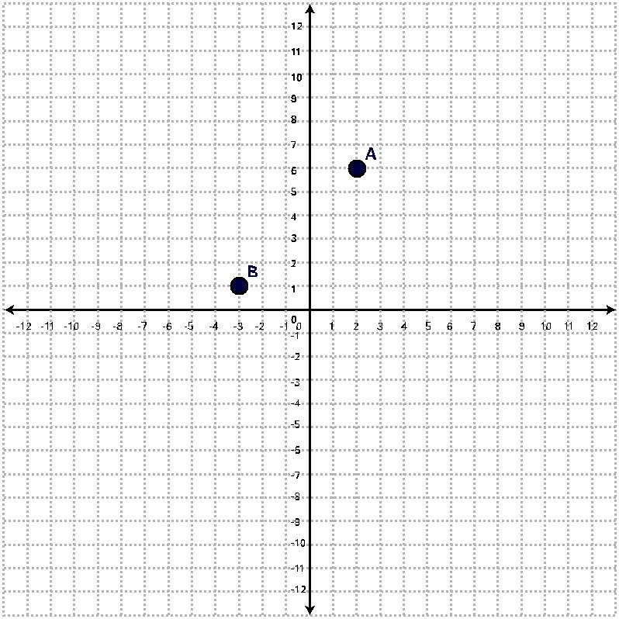

PART A

- Determine at least three possible locations for the park that are equidistant from points A and B. Explain how you know that all three possible locations are equidistant from the elementary schools.

- Make a conjecture about the location of all points that are equidistant from A and B. Prove this conjecture.

PART B

- The City Planning Commission is planning to build a third elementary school located at (8, -6) on the coordinate grid. Determine a location for the park that is equidistant from all three schools. Explain how you know that all three schools are equidistant from the park.

- Describe a strategy for determining a point equidistant from any three points.

