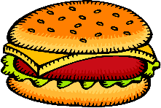
Burger Task

You are very hungry, so you go to a fast food restaurant. You have exactly $15.02. You love Big Burgers and cheeseburgers. Based on past experience, you know that you can eat only 7 sandwiches. Big Burgers cost $3.70, while cheeseburgers cost $.98. How many Big Burgers and how many cheeseburgers can you buy? (Disregard the issue of sales tax in this problem.)

Monitoring Planning Tool -- Burger Task

Anticipated  Solutions | Instructional Support - Assessing Questions | Instructional Support - Advancing Questions

