STUDENT RESPONSE: Michael Atiyah
#3
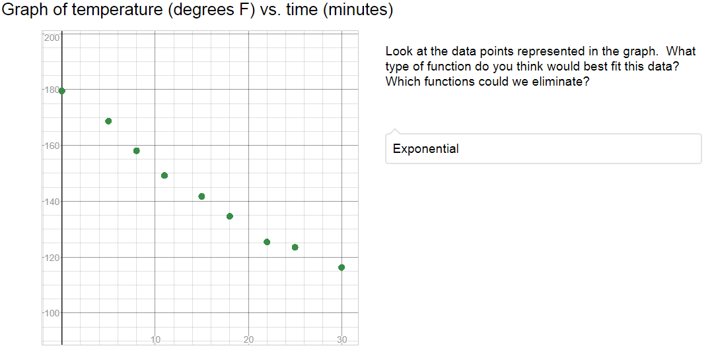

#4 & #5
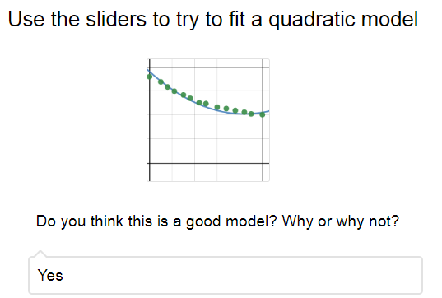

STUDENT RESPONSE: Michael Atiyah
#6 & # 7
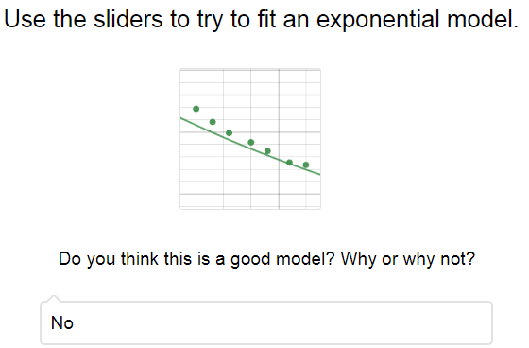

#9 & #10
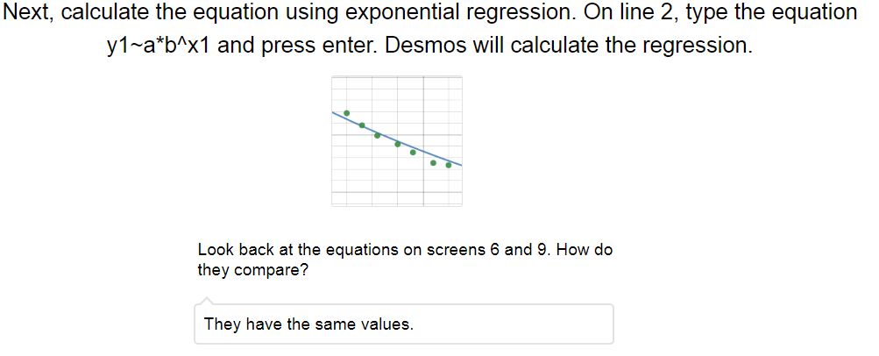

STUDENT RESPONSE: Manjul Bhargava
#3
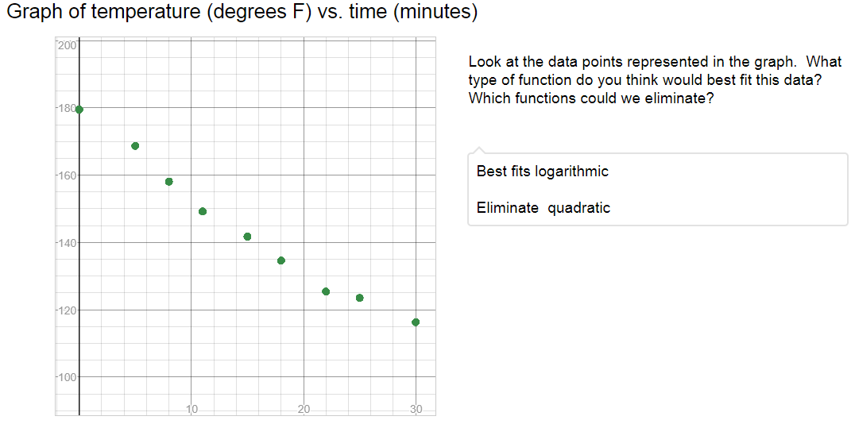

#4 & #5
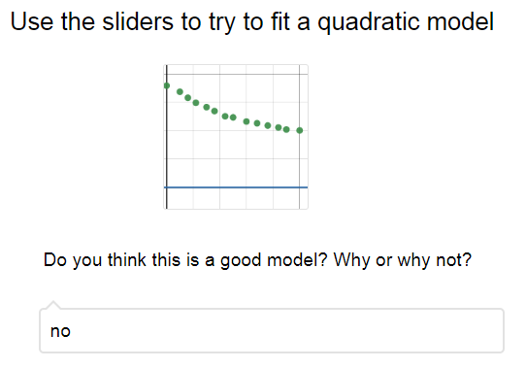

STUDENT RESPONSE: Manjul Bhargava
#6 & # 7
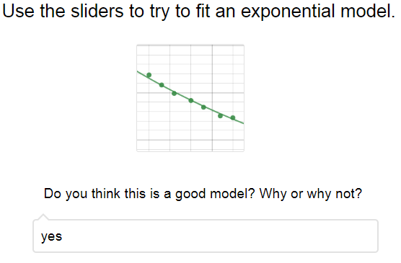

#9 & #10
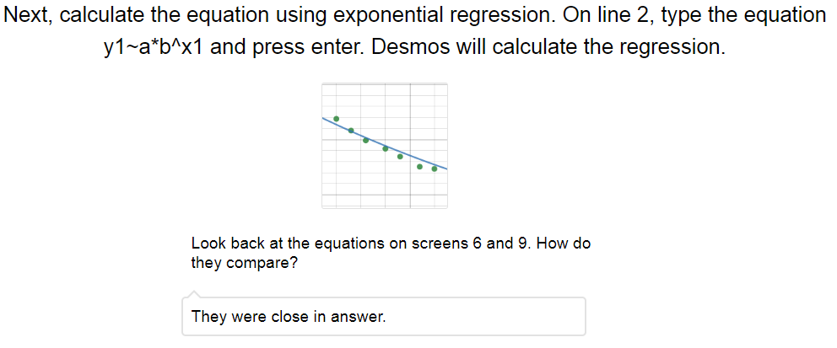

STUDENT RESPONSE: Shiing Shen Chern
#3
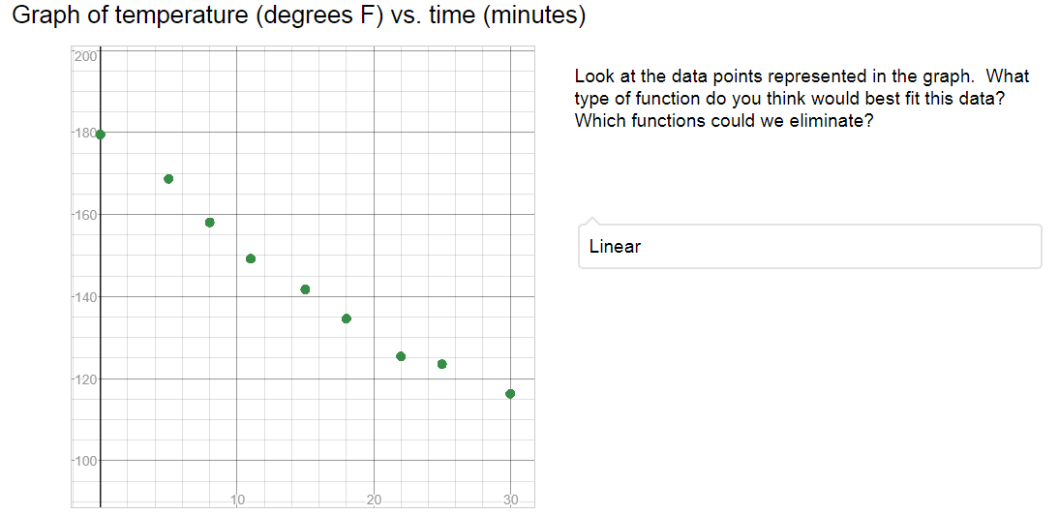

#4 & #5
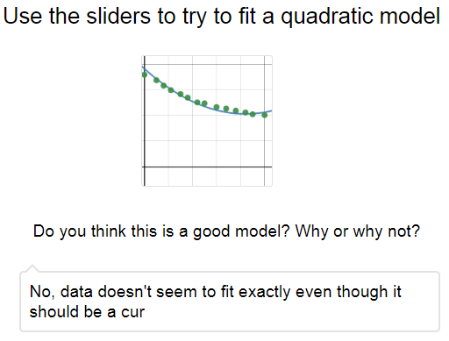

STUDENT RESPONSE: Shiing Shen Chern
#6 & # 7
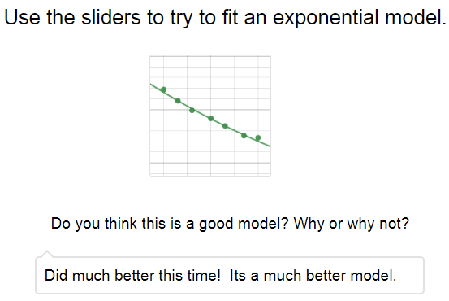

#9 & #10
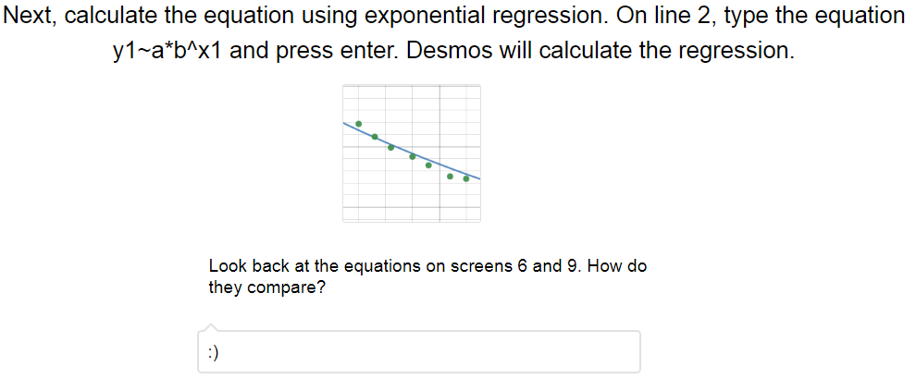

STUDENT RESPONSE: Marjorie Rice
#3
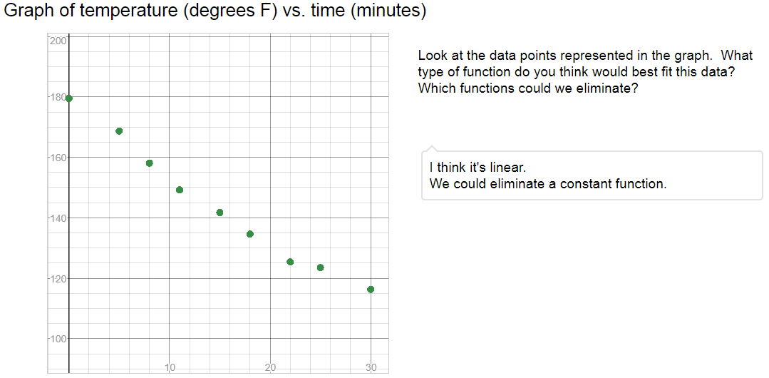

#4 & #5
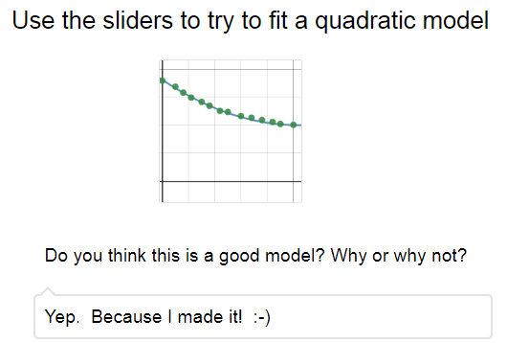

STUDENT RESPONSE: Marjorie Rice
#6 & # 7
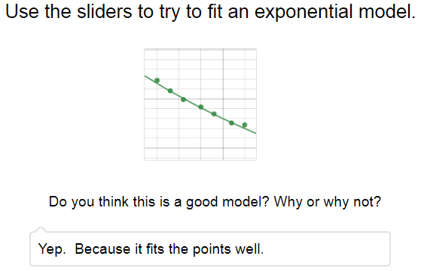

#9 & #10
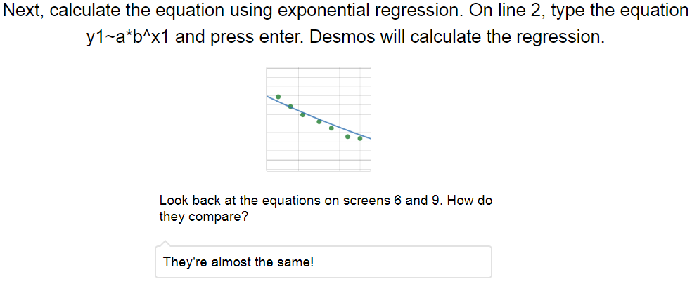

STUDENT RESPONSE: Herman Grass
#3
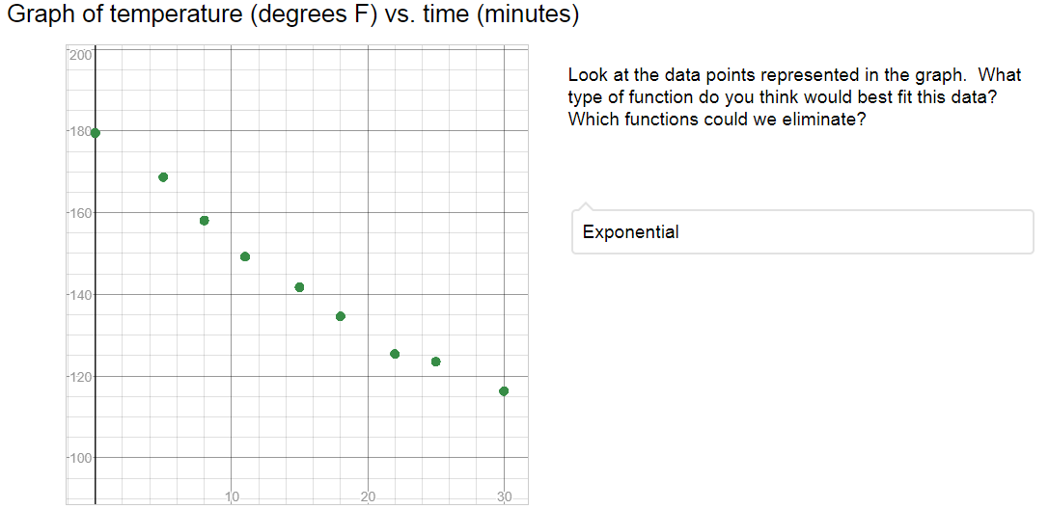

#4 & #5
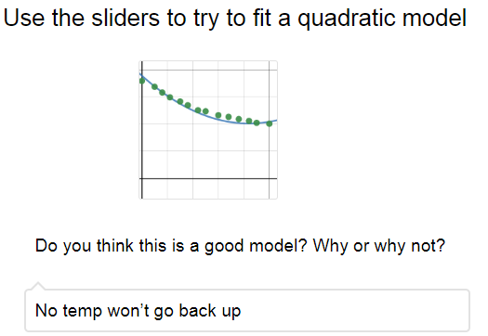

STUDENT RESPONSE: Herman Grass
#6 & # 7
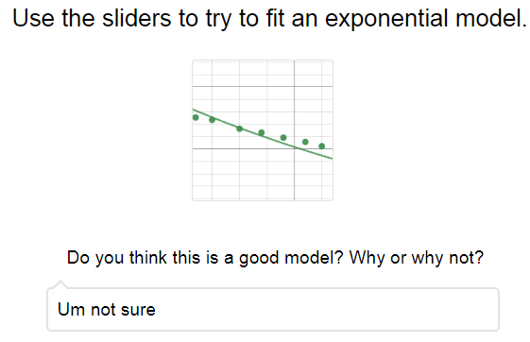

#9 & #10
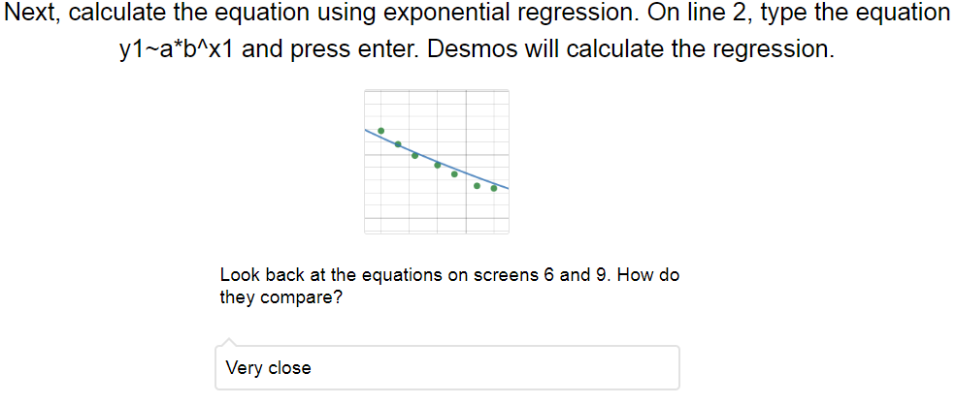

STUDENT RESPONSE: Rene Descartes
#3
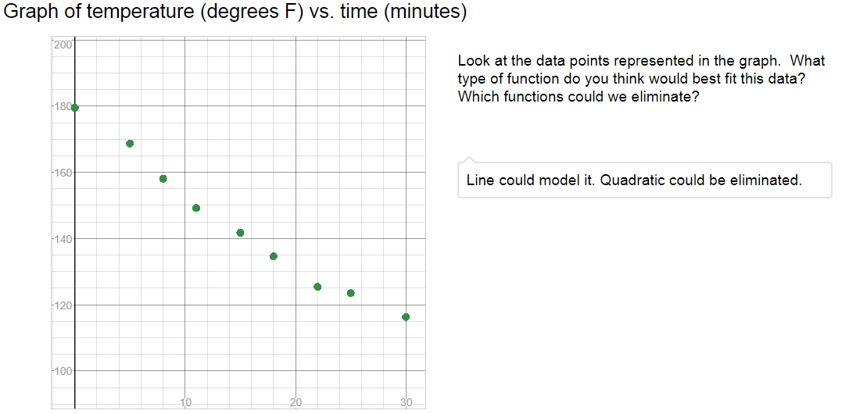

#4 & #5
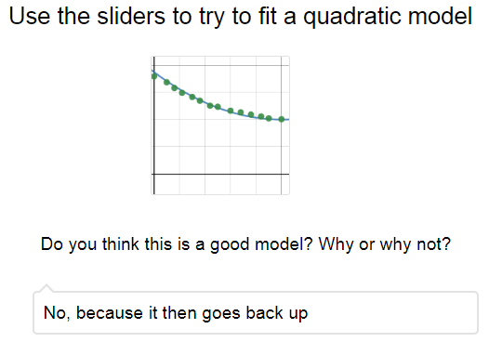

STUDENT RESPONSE: Rene Descartes
#6 & # 7
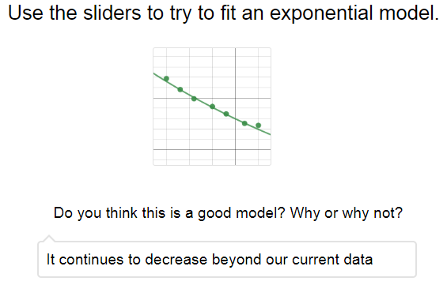

#9 & #10
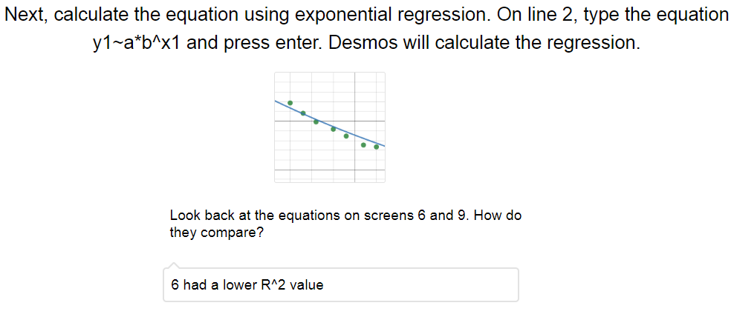

STUDENT RESPONSE: Carl Gauss
#3
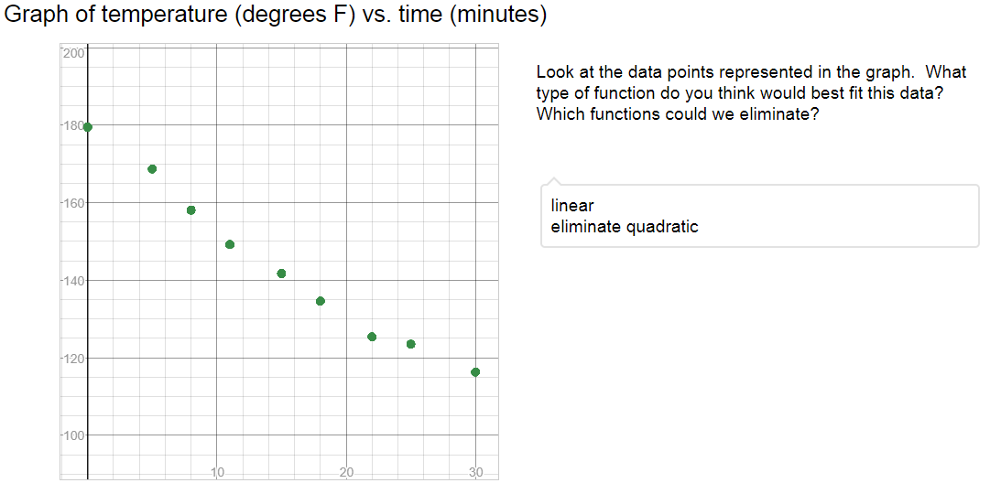
#4 & #5
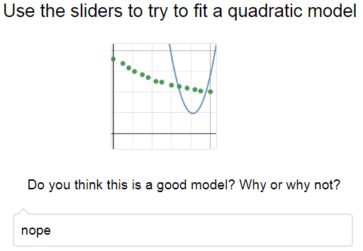

STUDENT RESPONSE: Carl Gauss
#6 & # 7
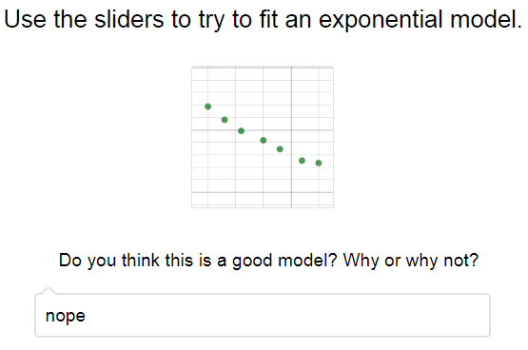

#9 & #10
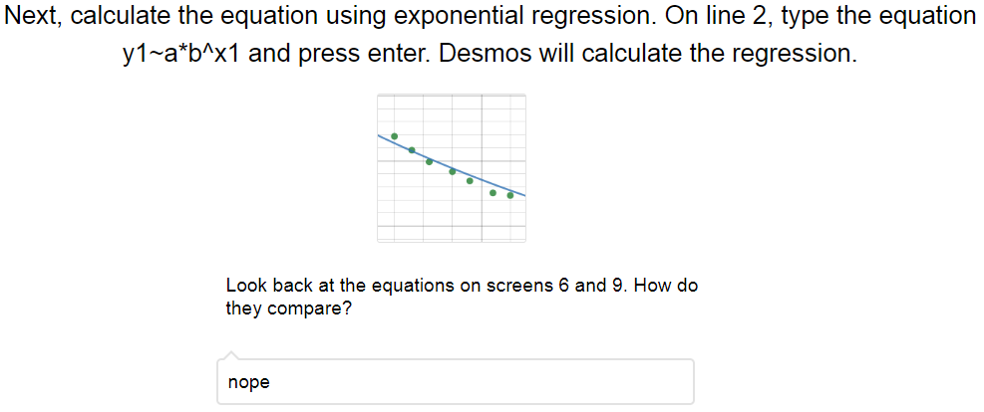

STUDENT RESPONSE: Anna Pell Wheeler
#3
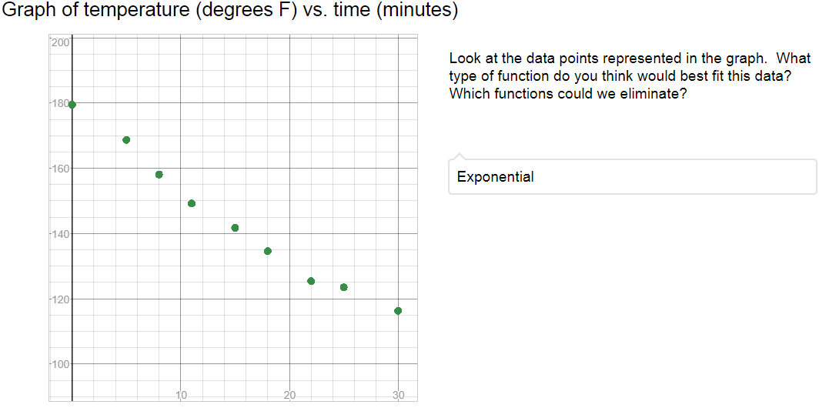

#4 & #5
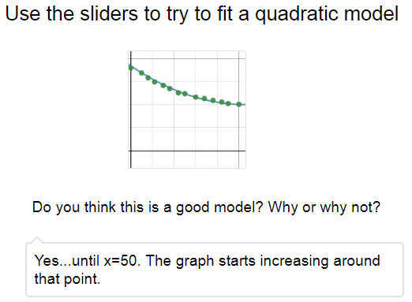

STUDENT RESPONSE: Anna Pell Wheeler
#6 & # 7
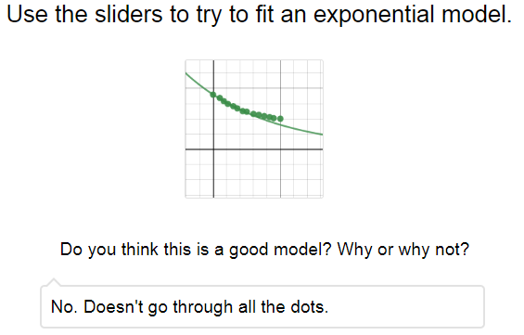

#9 & #10
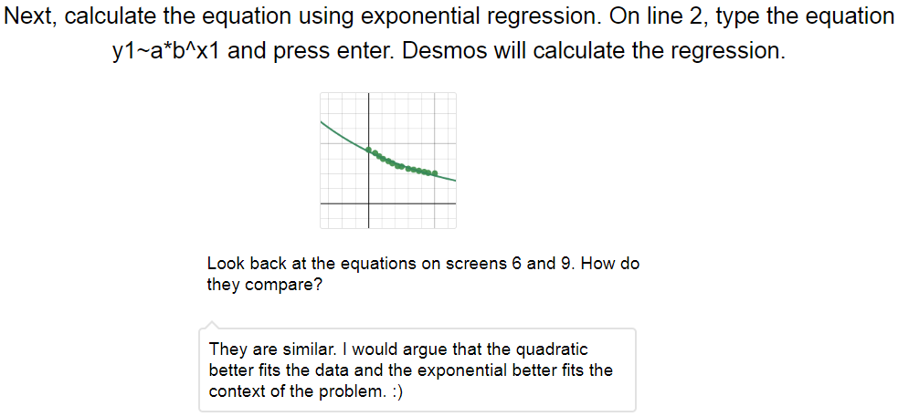

STUDENT RESPONSE: Felix Klein
#3
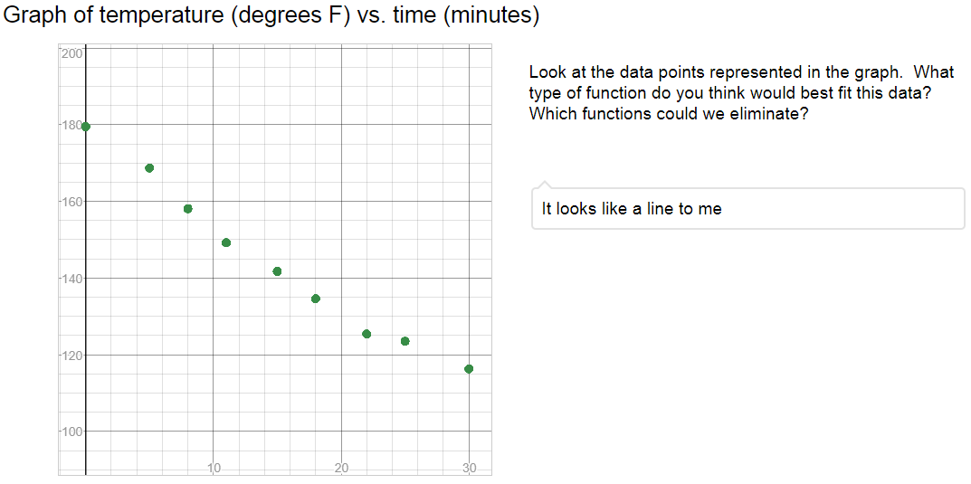

#4 & #5
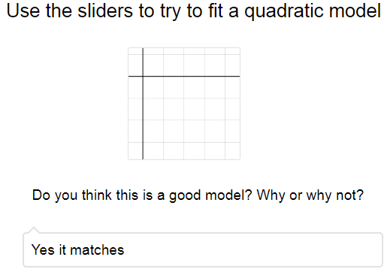

STUDENT RESPONSE: Felix Klein
#6 & # 7
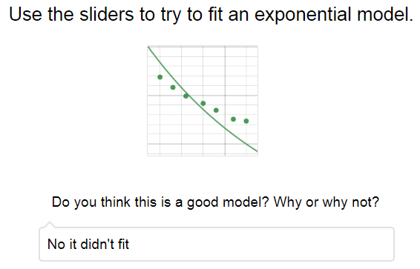

#9 & #10
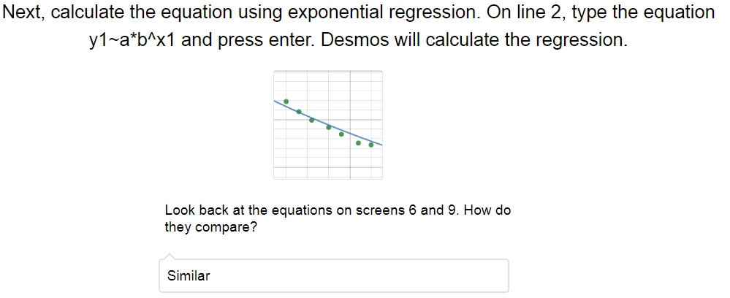

STUDENT RESPONSE: Heisuke Hironaka
#3
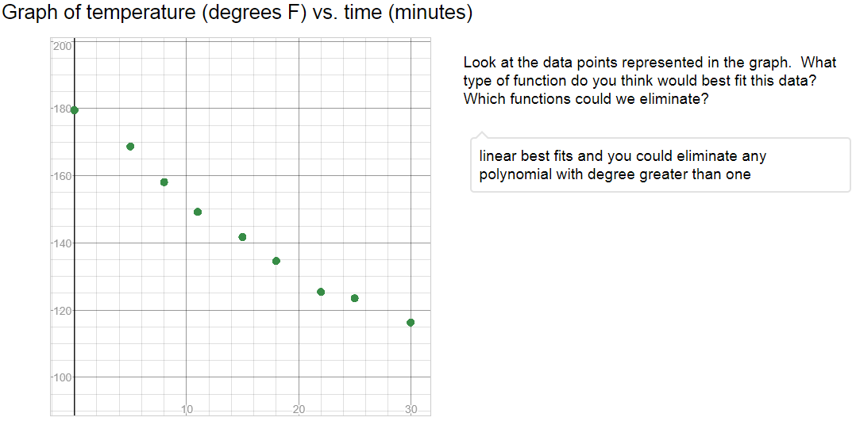

#4 & #5
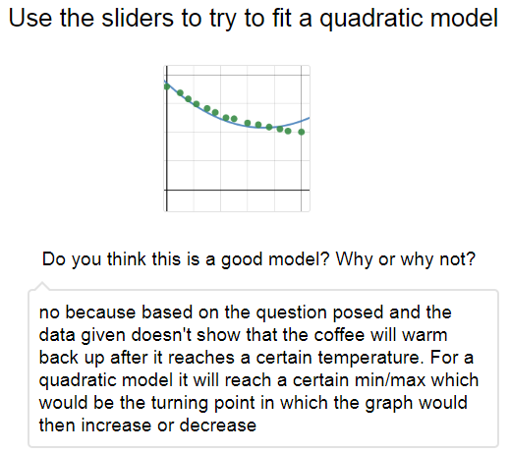

STUDENT RESPONSE: Heisuke Hironaka
#6 & # 7
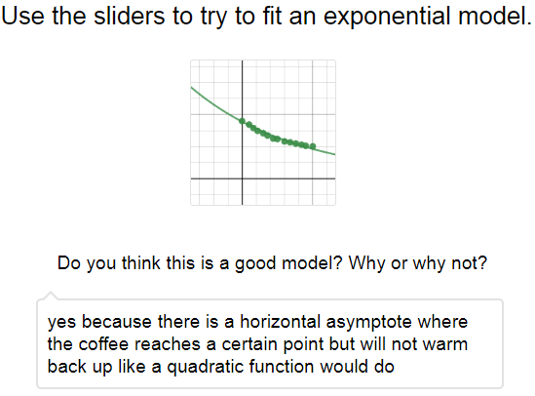

#9 & #10
