*Mathematics Instructional Plan – Algebra I*

# Graphing Systems of Linear Inequalities in Two Variables

**Strand:**  Equations and Inequalities

**Topic:**  Graphing systems of linear inequalities in two variables

**Primary SOL:** A.5d The student will

d)represent the solution to a system of inequalities graphically.

**Related SOL:** A.4d, A.5abc

## Materials

* What Can I Buy? Activity sheet (attached)
* Graphing Systems of Inequalities Activity sheet (attached)
* Teacher Notes for Graphing Systems of Inequalities (attached)
* Graphing calculators
* Graph paper (or individual dry-erase boards with the coordinate plane)
* Colored pencils or markers in different colors
* Highlighter

## Vocabulary

inequality, solution set, system of inequalities

## Student/Teacher Actions

1. Introduce systems of inequalities by first reviewing systems of equations. Then, distribute the What Can I Buy? Activity sheet, and have students complete it, using graphing calculators.
2. Distribute the Graphing Systems of Inequalities Activity sheet, sheets of graph paper (or individual dry-erase boards with the coordinate plane), colored pencils or markers in different colors, and highlighters. As students work on each of the examples, model the graphing for all to see.
3. Students can use the [Desmos graphing calculator](https://www.desmos.com/calculator/) to graph linear inequalities in one variable. Teachers and students can learn more about graphing inequalities using Desmos at <http://learn.desmos.com/inequalities>. Teachers may also wish to have students graph ordered pairs using Desmos to ascertain which fall within the solution set (shaded region).

## Assessment

### Questions

* + - How would you write a system of linear inequalities where (2, 4) is a solution and (−3, 2) is not a solution? Justify your answer with a graph.
    - How would you graph this system of linear inequalities?

$$\left\{\begin{matrix}y≥0 \\ 2x+3y<12\end{matrix}\right.$$

Is (3, 2) a solution to the system? Is (0, 0) a solution to the system? How can you justify the difference in your answers to these questions?

### Journal/Writing Prompts

* + - Describe a situation when a system of two inequalities would have no solution. Give an example to support your reasoning.
    - Describe a situation where the solution set for a system of inequalities would look like a horizontal strip on the graph. Give an example to support your reasoning.

### Other

* + - Have students write the system of linear inequalities that defines the solution shown below.

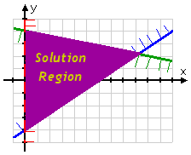

## Extensions and Connections (for all students)

* Have students write a system of inequalities that shows the various numbers of hours they could work at each job in the following scenario: “You can work a total of no more than 20 hours per week at your two jobs. Baby-sitting pays $8 per hour, and your job as a cashier pays $10 per hour. You need to earn $120 per week to cover your expenses.” Then, have students graph the system of linear inequalities and give two possible ways they could divide their hours between the two jobs to achieve their goal.

## Strategies for Differentiation

* Have students use grid paper or individual dry-erase boards with the coordinate plane to help them create more accurate graphs.
* Put painters tape on the classroom tile floor to represent the *x*-axis and *y*-axis of a large coordinate plane. Have students graph on the floor, using different-colored string or yarn for each inequality. Use large sheets of colored paper for the shading. This method is best used with small cooperative learning groups.
* Have students graph a system of two inequalities by graphing each inequality on a separate transparency and then placing one graph on top of the other to see the solution.
* Assign students a partner to work with in graphing and shading solutions of systems of inequalities. For each problem, have student A graph one linear inequality and student B shade the region of that inequality. Then student B will graph the second inequality and student A will shade the region of the solution to that inequality.
* Give students one inequality already graphed for a few problems so that the student is only responsible for graphing one other linear inequality and finding the region of solutions.

**Note: The following pages are intended for classroom use for students as a visual aid to learning.**

Virginia Department of Education © 2018

**MC900264260[1]MC900264260[1]MC900264260[1]MC900264260[1]What Can I Buy?**

|  |  |
| --- | --- |
| **Big Burgers** | **Cheese-**  **burgers** |
| 0 | 1 |
| 0 | 2 |
| 0 |  |
| 0 |  |
| 0 |  |
| 0 |  |
| 0 |  |
| 1 |  |
| 1 |  |
| 1 |  |
| 1 |  |
| 1 |  |
| 1 |  |
| 1 |  |
| 2 |  |
| 2 |  |
| 2 |  |
| 2 |  |
| 2 |  |
| 2 |  |
| 3 |  |
| 3 |  |
| 3 |  |
| 3 |  |
| 4 |  |

**Name Date**

You are hungry, so you go to a fast-food restaurant. You have exactly $15.02. You love Big Burgers and Cheeseburgers. Based on past experience, you know that you can eat only seven sandwiches. Big Burgers cost $3.70, while Cheeseburgers cost $.98. How many Big Burgers and how many Cheeseburgers can you buy? (Disregard the issue of sales tax in this problem.)

1. Write a system of equations for this problem. Let B represent the number of Big Burgers and C represent the number of Cheeseburgers you can buy.

2. Graph this system of equations. It is recommended that you use a graphing calculator to do this.

3. You can buy _____ Big Burgers and _____ Cheeseburgers.

4. Now, suppose you decide that you don’t want to spend all of your money. Also, you realize that it would be fine to eat fewer than seven sandwiches. Write a system of inequalities for this new problem.

5. Graph this system of inequalities.

6. How many different sandwich combinations can you buy to fulfill your new criteria? Complete the chart at right, showing all of the possible combinations.

7. Notice that systems of inequalities have *many* solutions.

**Graphing Systems of Inequalities**

**Name Date**

Using sheets of graph paper (or a dry-erase board with the coordinate plane) and colored pencils or markers in different colors, complete each of the following systems of inequalities. Show your work.

**Example 1**

1. Isolate the variable, *y*, in each inequality.

2. Graph each inequality on the same coordinate plane, using a different color for each.

3. Identify the solution set by highlighting the region on the graph.

4. Pick a point from the solution set, and test it in the system.

**Example 2**

1. Isolate the variable, *y*, in each inequality.

2. Graph each inequality on the same coordinate plane, using a different color for each.

3. Identify the solution set by highlighting the region on the graph.

4. Check.

**Example 3**

1. Graph each inequality on the same coordinate plane, using a different color for each.

2. Identify the solution set by highlighting the region on the graph.

**Teacher Notes for Graphing Systems of Inequalities**

Using sheets of graph paper (or a dry-erase board with the coordinate plane) and colored pencils or markers in three different colors, complete each of the following systems of inequalities. Note that possible solutions are highlighted.

**Example 1 $\left\{\begin{matrix}2x-y>-3 \\ 4x+y≥5\end{matrix}\right.$**

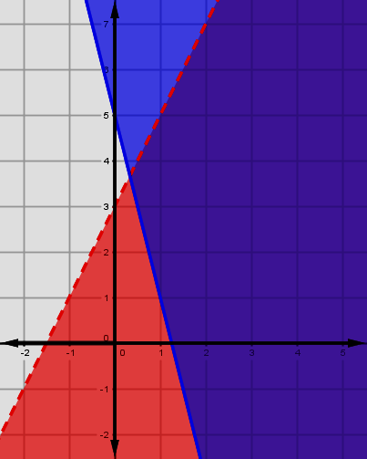1. Isolate the variable, *y*, in each inequality.

2. Graph each inequality on the same coordinate plane, using a different color for each.

3. Identify the solution set by highlighting the region on the graph.

The solution to this system of inequalities is the region where the colors of shading overlap. This is the area that both inequalities have in common. This solution is “unbounded” and continues indefinitely to the right.

4. Pick a point from the solution set, and test it in the system.

**Example 2**

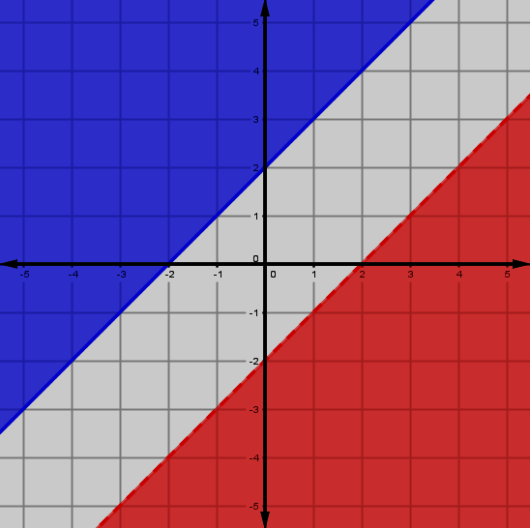1. Isolate the variable, *y*, in each inequality.

2. Graph each inequality on the same coordinate plane, using a different color for each.

3. Identify the solution set by highlighting the region on the graph.

This system of inequalities has no solution. There is no place where the colors of shading overlap.

4. Check.

**Example 3**

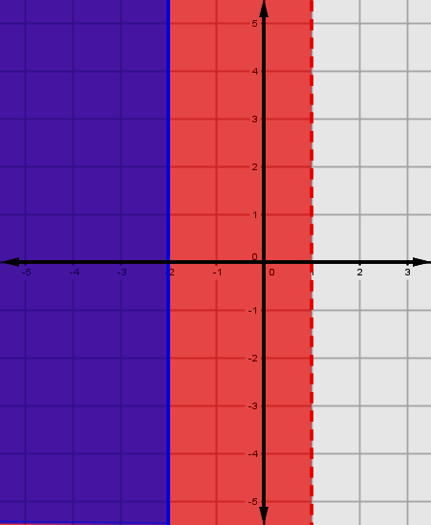1. Graph each inequality on the same coordinate plane, using a different color for each.

2. Identify the solution set by highlighting the region on the graph

The solution to this system of inequalities is the region where the colors of shading overlap.