Telling the Tale
Grade 6 (SOL 6.12)
Structure 0 | Structure 1 | Structure 2 | Structure 3

What do you notice? | What do you wonder?
Create a story that might have produced the series of structures presented above.

Jack Prism works in a warehouse at Amazon Composite. His job is to prepare boxes for transport. When he arrives at work, there are no boxes ready to transport. As the day progresses, he arranges the boxes as shown.
Consider the number of boxes in each structure.
Structure 0 | Structure 1 | Structure 2 | Structure 3
Complete the table below:  Structure # (x) Number of Boxes (y)  0  1  2  3 | Create a graph to represent the relationship between the structure number (x) and number of boxes (y):  y  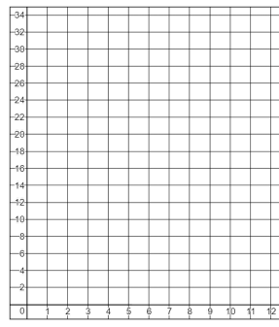  x
If this pattern were to continue, determine the number of boxes in:  Structure 4: ______ boxes  Structure 6: ______ boxes  Structure 12: ______ boxes | If this pattern were to continue, determine the structure number of the number of boxes is:  20 boxes: Structure ______  32 boxes: Structure ______  100 boxes: Structure ______
In this relationship, how much does the number of boxes change each time the structure number increases by 1? | Is the relationship between the number of boxes and the structure number a proportional relationship? Justify your answer.
Create a double number line to represent this relationship.

