Telling the Tale
Grade 8 (SOL 8.16)
Part I:
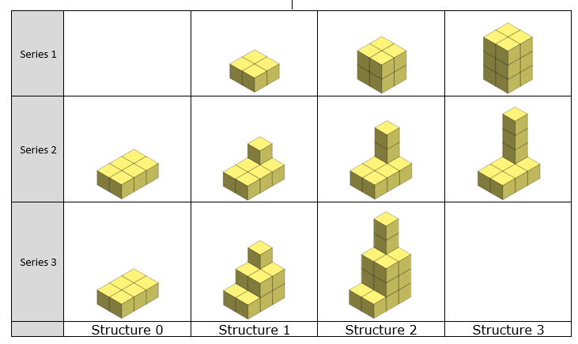

What do you notice? | What do you wonder?
Complete Structure 3 for Series 3. You may use linking cubes, create a drawing in the space provided, or use an online drawing tool, such as this NCTM Drawing Tool.

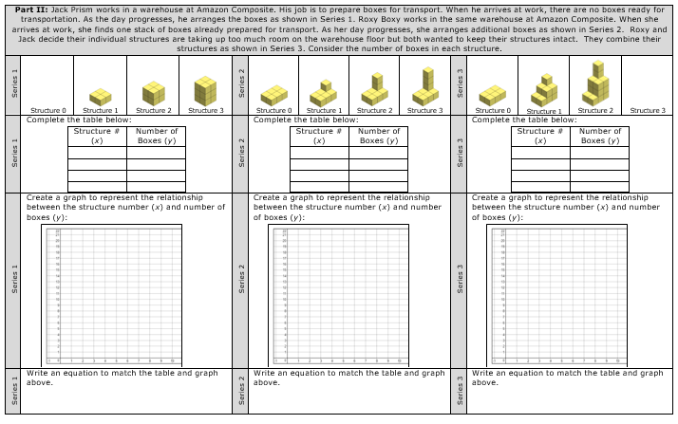

How is the equation that represents Series 3 related to the equations representing Series 1 and Series 2?
What is the rate of change, or slope, of the equation that represents Series 3? How does it relate to the story?
Assuming that the pattern for Roxy Boxy continued as she prepared boxes for transport, how would the equations representing Series 2 and Series 3 change if she had arrived to work to find the number of boxes shown below ?

Describe the set of Structures that Jack Prism might have built if his work could be represented by the equation y = 5x. How would this affect the equation for Series 3?

Part III:

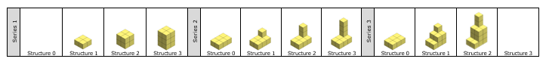
How is the equation that represents Series 3 related to the equations representing Series 1 and Series 2?
What is the rate of change, or slope, of the equation that represents Series 3? How does it relate to the story?
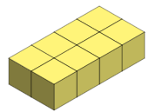
Assuming that the pattern for Roxy Boxy continued as she prepared boxes for transport, how would the equations representing Series 2 and Series 3 change if she had arrived to work to find the number of boxes shown below ?

Describe the set of Structures that Jack Prism might have built if his work could be represented by the equation y = 5x. How would this affect the equation for Series 3?

Part III:

