Telling the Tale
Grade 7 (SOL 7.10)
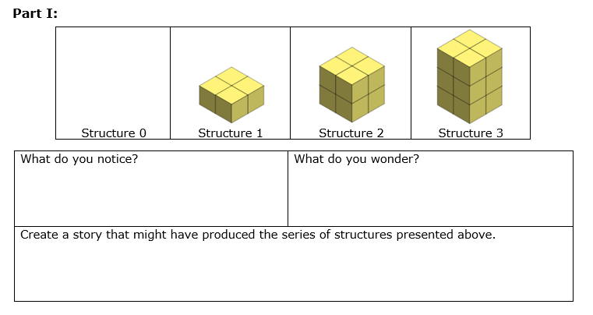

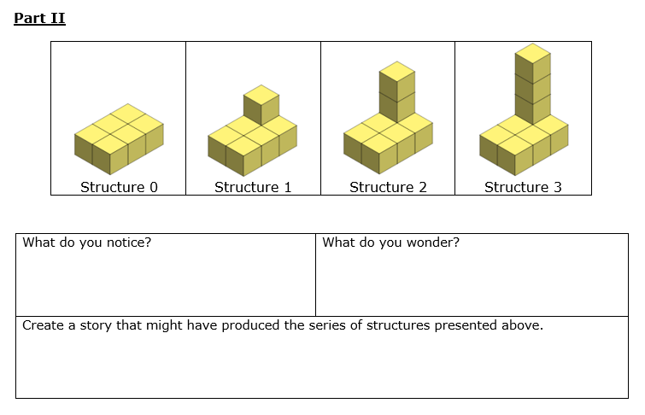

Jack Prism works in a warehouse at Amazon Composite. His job is to prepare boxes for transport. When he arrives at work, there are no boxes ready to transport. As the day progresses, he arranges the boxes as shown.
Consider the number of boxes in each structure.
Structure 0 | Structure 1 | Structure 2 | Structure 3
Complete the table below:  Structure # (x) Number of Boxes (y)  0  1  2  3 | Create a graph to represent the relationship between the structure number (x) and number of boxes (y):  y  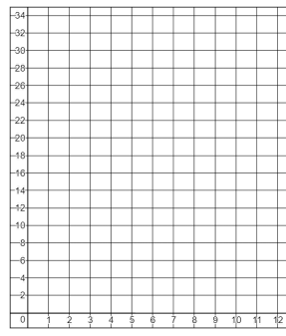  x
If this pattern were to continue, determine the number of boxes in:  Structure 4: ______ boxes  Structure 6: ______ boxes  Structure 12: ______ boxes | If this pattern were to continue, determine the structure number if the number of boxes is:  20 boxes: Structure ______  32 boxes: Structure ______  100 boxes: Structure ______
In this relationship, what is the rate of change (slope) between the number of boxes and the structure number? | Write an equation that represents the relationship between the structure number (x) and the number of boxes (y).
Is the relationship between the structure number and the number of boxes a proportional relationship or an additive relationship? Justify your answer.

 |  |  |  | Roxy Boxy works in the same warehouse at Amazon Composite. Her job is also to prepare boxes for shipment. When she arrives at work, she finds one stack of boxes already prepared for transport. As her day progresses, she arranges additional boxes as shown. Consider the number of boxes in each structure
Structure 0 | Structure 1 | Structure 2 | Structure 3
Complete the table below:  Structure # (x) Number of Boxes (y)  0  1  2  3 | Create a graph to represent the relationship between the structure number (x) and number of boxes (y):  y  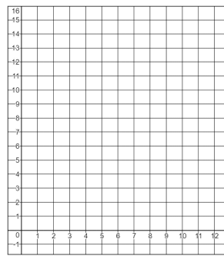  x
If this pattern were to continue, determine the number of boxes in:  Structure 4: ______ boxes  Structure 6: ______ boxes  Structure 12: ______ boxes | If this pattern were to continue, determine the structure number if the number of boxes is:  11 boxes: Structure ______  15 boxes: Structure ______  100 boxes: Structure ______
In this relationship, Structure 0 was already prepared when Roxy Boxy arrived. What term can be used to describe the ordered pair, (0, 6)? | Write an equation that represents the relationship between the structure number (x) and the number of boxes (y).
Is the relationship between the structure number and the number of boxes a proportional relationship or an additive relationship? Justify your answer.

