Using Desmos to Make Connections
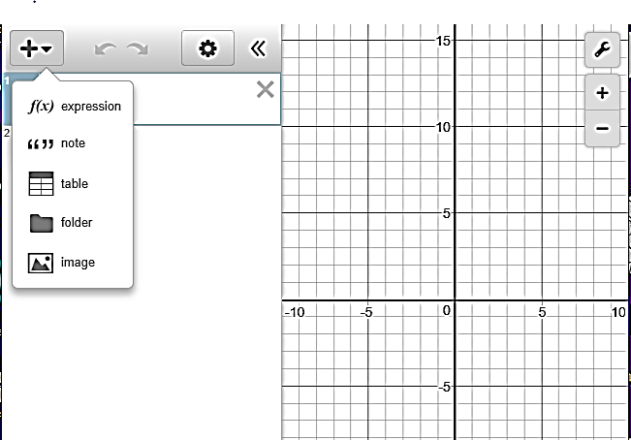
1.) Add a table to cell 1.

2.) Input data that matches the relationship between the structure
number and the number of boxes for Part I into the table.
You may want to make some edits in the settings as shown.
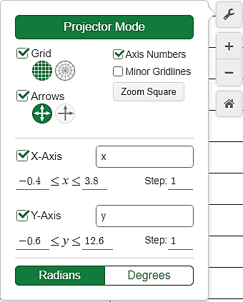
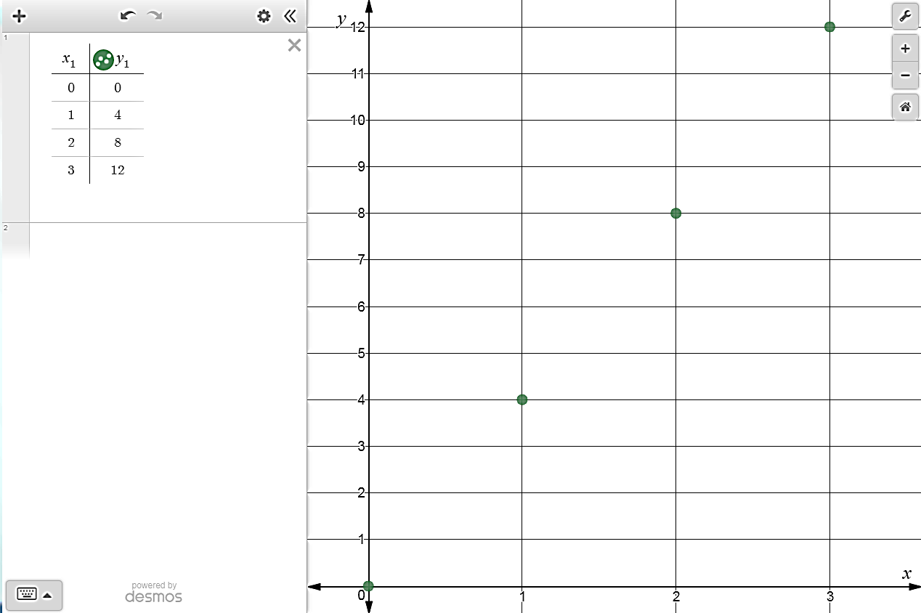

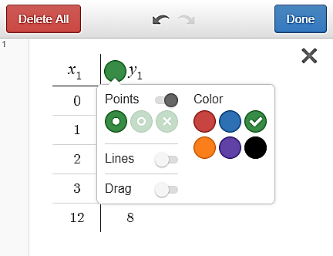
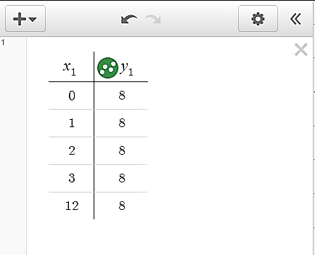
You can use the gear icon
to edit colors, etc.

3.) Although our relationship should be represented as a discrete set of
ordered pairs, we can test the rule for the relationship between the
structure number and the number of boxes in Part I by typing the
expression 4x or the equation y = 4x in cell 2. (You may want to
make the line dotted, by visiting the gear in the left window, as a
reminder that our true graph is simply a set of discrete points.)

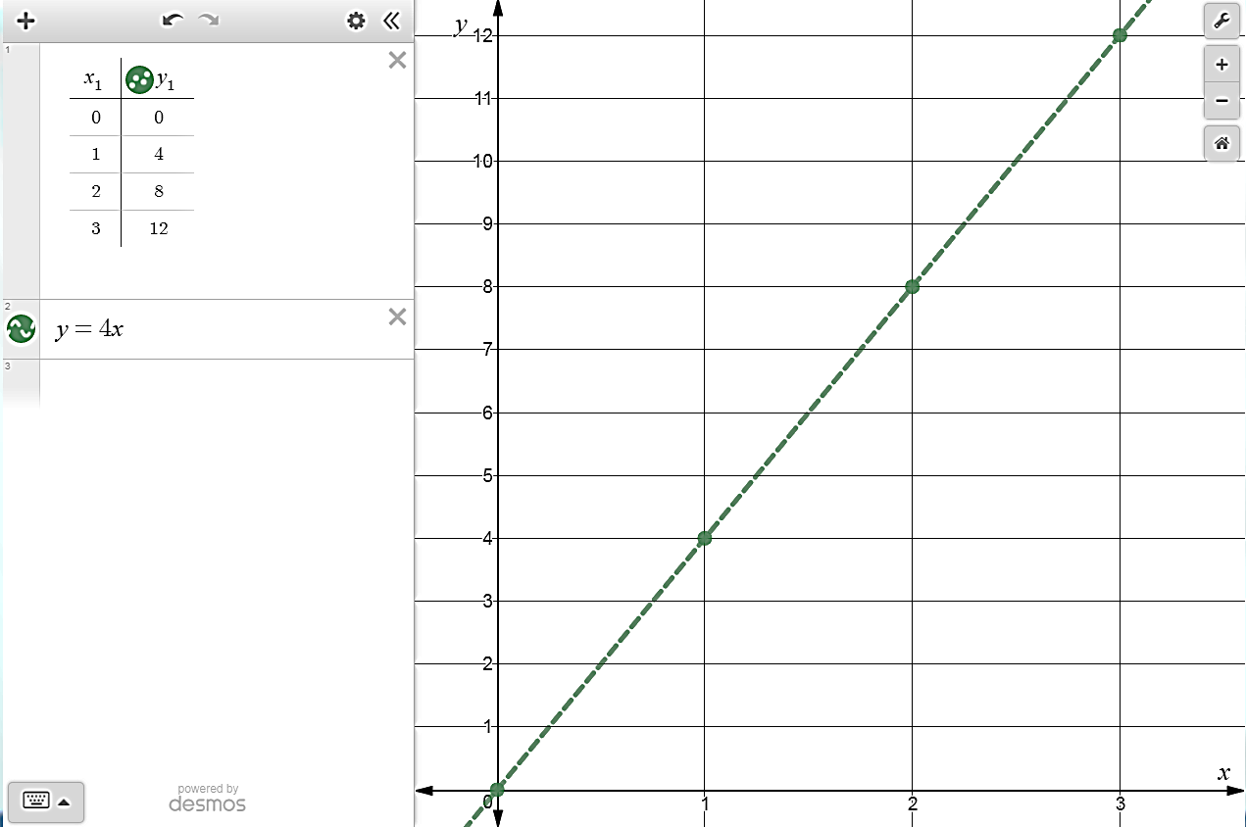

4. Type “y2” in the next column of the table, and enter the data
representing the number of boxes in Part II.
Pressing the circle beside y₁ and the equation y = 4x will hide that data on the graph.
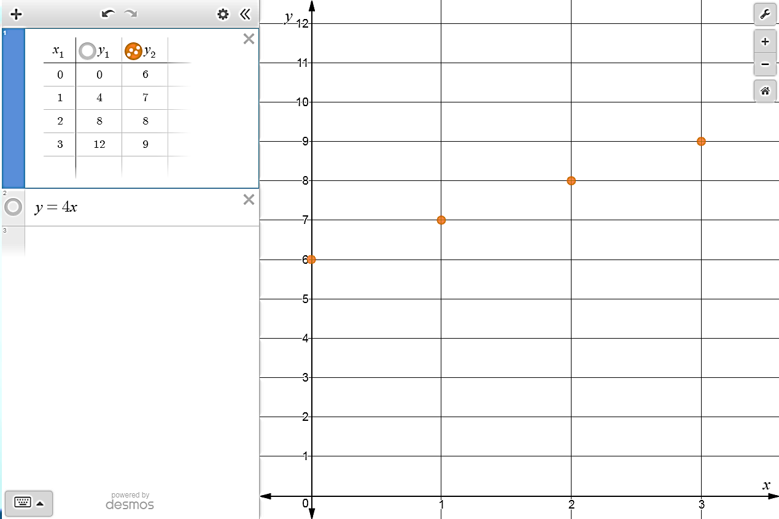

5.) Test the rule for the relationship between the structure number and
the number of boxes in Part II by typing the expression x + 6 or the
equation y = x + 6 in cell 3.

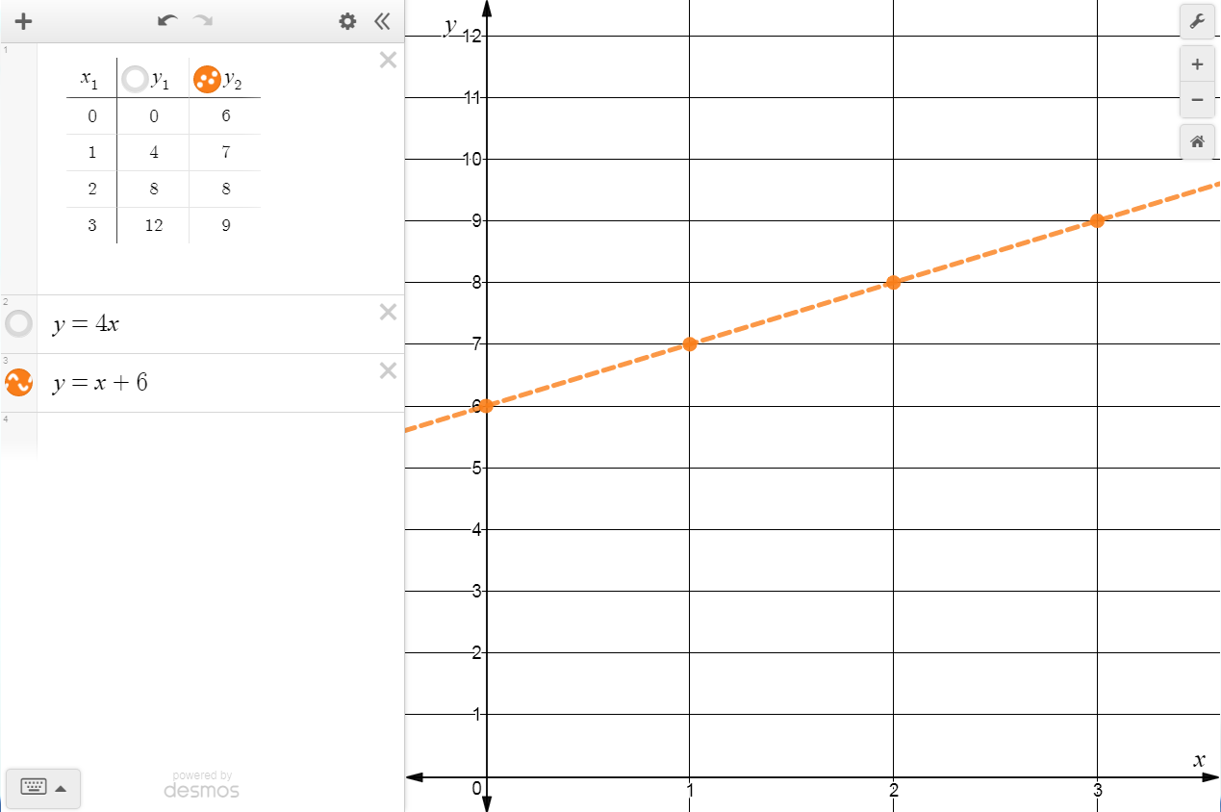

6.) Click on the empty circles beside y₁ and the equation y = x + 6 to see
the data from both Part I and Part II together. Compare and contrast
the relationships presented in the two scenarios.

