THE POLYGON TASK
Sort the following figures into two groups, those that are polygons and those that you believe are not polygons. Explain why you put each figure in the polygon group. Explain why you believe each of the other figures is not a polygon.

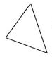  1. | 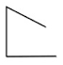  2. | 3. | 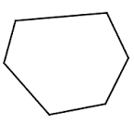  4.
5. | 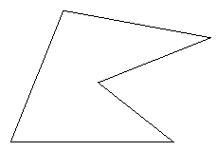  6. | 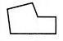  7. | 8.
9. | 10.  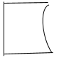 | 11. | 12.

Adapted from Smith, M. S., et al. (2017) Taking Action: Implementing Effective Mathematics Teaching Practices, p. 25, Reston, VA. National Council of Teachers of Mathematics.

