The Half-of-a-Whole Task

Identify all of the figures that have one-half of it shaded and be prepared to explain and justify how you know that one-half of the figure is or is not shaded. Write a description giving your reasons why each figure is or is not showing halves.
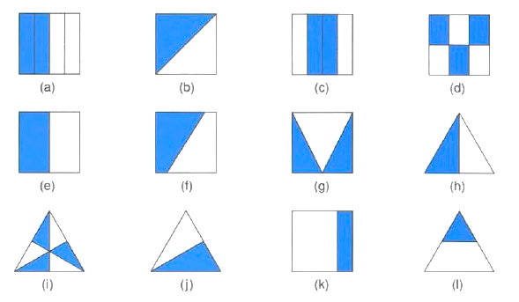

Adapted from: Watanabe, Tad. “Ben’s Understanding of One-half.” Teaching Children Mathematics 2, no. 8 (1996): 460-464.

