Name_____________________________________ Date_____________________
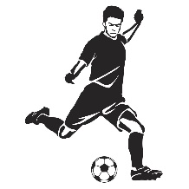
The Soccer Competition
The soccer club is holding a competition to see who can kick the ball the farthest down the soccer field. Students signed up to compete. Various methods for measuring the path that the ball travelled for each kick are being used. The soccer club has decided that the winning kick will have travelled the furthest distance horizontally from the goal line.
Student A - A motion detector was used to track the path of the ball and collected data for Student A while the soccer ball was in the air. The table of the data collected is shown below.
Track of Ball Kicked by Student A
Horizontal Distance from the Goal Line  (in feet) | Vertical Height  (in feet)
2.3 | 8.1
12 | 29.2
28 | 51.6
43.3 | 58.6
62 | 48.2
73 | 31.9
81 | 15.8

Student B - A group of students tracking the path of the ball kicked by Student B determined by the equation
$h\left(d\right)= -0.042d^{2}+3.36d+8$ (Track of Soccer Ball Kicked by Student B)
which represents the path the ball took through the air, where $d$ is the horizontal distance of the ball from the goal line and $h$ is the vertical height of the ball from the ground. Both distances are measured in feet.
Student C – A graph representing the path of the ball kicked by Student C is shown, where the horizontal distance of the ball from the goal line is represented on the x-axis and the height of the ball from the ground is represented on the y-axis.
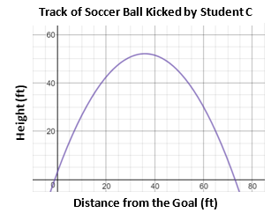

- Based on the data provided for each student participating in the competition, which student won the competition AND at what horizontal distance from the goal line did the ball hit the ground?

- Justify your response with evidence to support your answer.

With only a few minutes left, a fourth student joined the competition.
Student D - Another group of students tracked the path of the ball kicked by Student D determined by the equation
$h\left(d\right)= -0.028d^{2}+2.52d+2.9$ (Track of Soccer Ball Kicked by Student D)
which represents the path the ball took through the air, where $d$ is the horizontal distance of the ball from the goal line and $h$ is the vertical height of the ball from the ground. Both distances are measured in feet.

- Considering this new information, which student won the competition AND at what horizontal distance from the goal line did the ball hit the ground?

- Provide evidence that proves that this student won.

