Name_____________________________________ Date_____________________

Function of a Ride
Below you will find a graph comparing the horizontal and vertical distances of a portion of the roller coaster track, with key points labeled. Consider the point A to be the beginning of the roller coaster track. Also consider curves that look like parabolas, are parabolas (assume the curves are smooth).
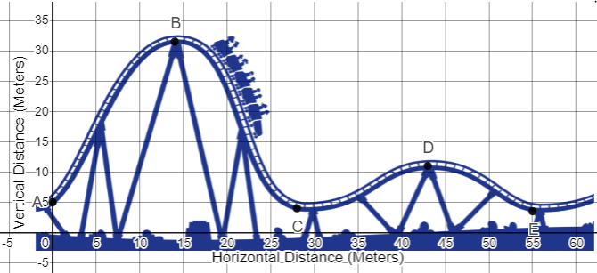
stakeholder management | Productivity Steps
https://images.app.goo.gl/3sieQyMtH3sbWoRk6
View this graph in Desmos

1. What is the domain and range of the function?

Domain Range

2. Find the intervals where the function in increasing and decreasing.

Increasing

Decreasing

How did you find the intervals?

3. At what point on the coaster would you be going the fastest? The slowest? Explain why you chose these points.

Fastest at Slowest at

4. What are the maxima and minima of the function?

Maxima Minima

5. Where would you scream? Describe your ride as you travel the roller coaster. Include in your description your trip from point to point, whether you are moving up or down, and discuss what is happening to your speed.

6. Write the equation of the first “scream”! Find the equation of the first hill – the complete curve up and down again, from point A – C. Show all your work, with explanations when needed.

7. Looking at the first hill and its equation, how HIGH off the ground would you be after you have traveled 5 meters horizontally. Show your work and explain how you got the answer. How does the predicted height compare to the actual height of the roller coaster at that point?

