VDOE 2019 SOL Institute EOC Session -- Reflection

Module I: Overview – Visible Learning, Equity, and Identity
- I can recognize strategies in teaching and learning that have high impacts (effect size) on student achievement.
- I can recognize and support equitable learning opportunities for all students that promote positive student mathematical identity and agency.
- I can describe how to create a classroom environment that supports the development of assessment-capable mathematics learners.
Based on Module I... | In My Classroom | Professional Development for Others
What is one idea that squared with your thinking?

What is a question circling in your mind?

What point(s) would you like to remember, that might impact your work?

Module II: Task Implementation (Before)
- I can identify how teacher clarity about learning intentions and success criteria contributes to student success.
- I can distinguish between tasks that will engage students in higher levels of cognitive demand versus lower levels of cognitive demand.
- I can describe the factors associated with the decline or maintenance of the cognitive level of a rich mathematical task.
- I can anticipate student solution strategies and misconceptions associated with the implementation of a mathematical task.
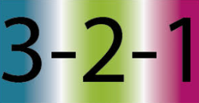  Based on Module II... | In My Classroom | Professional Development for Others
3 things I have learned are...
2 questions I have are...
1 thing I want the presenter to know is...
Module III: Task Implementation (During/After)
- I can implement a rich mathematical task to support deeper learning for all students.
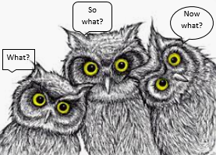  Based on Module III... | In My Classroom | Professional Development for Others
What did we learn
today?
So What? (Why is this
useful or important?)

Now What? (How does this fit into the unit, affect their thinking, or can they predict what comes next.)
Module IV: Assessing Student Understanding
- I can use a rubric to score student work samples and work collaboratively to calibrate my scores.
- I can use success criteria to provide effective feedback to students to deepen student learning.
- I can analyze student work to identify what students know and are able to do in order to plan instruction that moves all students forward as learners.
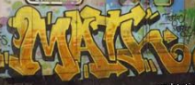  Based on Module IV, graffiti a thought about one of the following: | In My Classroom | Professional Development for Others
Rubric

Calibration Protocol

Feedback

Session Closure
Content:
- I am learning about strategies and approaches that make teaching and learning more visible.
Language:
- I am learning to use the language of a visible learning mathematics classroom.
Social:
- I am learning how to listen and respond to my peers’ ideas in ways that move everyone forward as learners.
Based on today’s presentation… | In My Classroom | Professional Development for Others
One thing I could stop doing is...
One thing I could continue doing is...
One thing I could start doing is...

