**Math Timeline**

Draw a timeline of your mathematical experiences indicating 3-5 distinct high and low points.

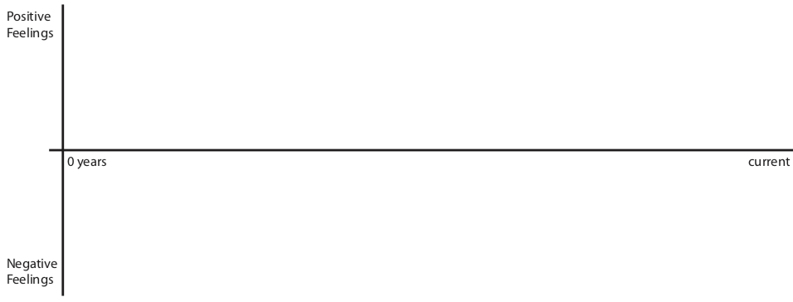

*Adapted from Supporting Math in the AVID Elective, 2011.

Briefly describe one of your low points. What made this a negative mathematical experience?

Briefly describe one of your high points. What made this a positive mathematical experience?

What is the leverage point for a mathematical experience to be positive or negative?

Thinking about your classroom, what beliefs do you hold that promote positive mathematical experiences for students?