VDOE 2019 SOL Institute 3-5 Session -- Reflection

Learning Intentions
- Content Learning Intention: I am learning about strategies and approaches that make teaching and learning more visible.
- Language Learning Intention: I am learning to use the language of a visible learning mathematics classroom.
- Social Learning Intention: I am learning how to listen and respond to my peers’ ideas in ways that move everyone forward as learners.
Module I: Overview – Visible Learning, Equity, and Identity

Success Criteria
- I can recognize and support equitable learning opportunities for all students that promote positive student mathematical identity and agency.
- I can describe how to create a classroom environment that supports the development of assessment-capable mathematics learners.
- I can recognize strategies in teaching and learning that have high impacts (effect size) on student achievement.
Based on Module I... | In My Classroom | Professional Development for Others
What is one idea that squared with your thinking?

What is a question circling in your mind?

What point(s) would you like to remember, that might impact your work?

Module II: Task Implementation (Before)

Success Criteria
- I can identify how teacher clarity about learning intentions and success criteria contributes to student success.
- I can identify strategies, methods or approaches to meet the learning needs of individual students.
- I can distinguish between tasks that will engage students in higher levels of cognitive demand versus lower levels of cognitive demand.
- I can describe the factors associated with the decline or maintenance of the cognitive level of a rich mathematical task.
- I can anticipate student solution strategies and misconceptions associated with the implementation of a mathematical task.

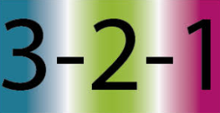  Based on Module II... | In My Classroom | Professional Development for Others
3 things I have learned are...
2 questions I have are...
1 thing I intend to implement is...
Module III: Task Implementation (During/After)

Success Criteria
- I can implement a rich mathematical task to support deeper learning for all students.
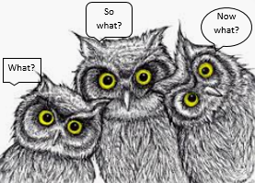  Based on Module III... | In My Classroom | Professional Development for Others
What? (What did you learn?)
So What? (Why is this useful or
important?)

Now What? (How does this support you
you with implementing tasks)
Module IV: Assessing Student Understanding

Success Criteria
- I can use a rubric to score student work samples and work collaboratively to calibrate my scores.
- I can analyze student work to identify what students know and are able to do in order to plan instruction that moves all students forward as learners.
- I can use success criteria to provide effective feedback to students to deepen student learning.
Based on Module IV, jot thought about the following: | In My Classroom | Professional Development for Others
Rubric

Calibration Protocol

Feedback

Session Closure

Learning Intentions
- Content Learning Intention: I am learning about strategies and approaches that make teaching and learning more visible.
- Language Learning Intention: I am learning to use the language of a visible learning mathematics classroom.
- Social Learning Intention: I am learning how to listen and respond to my peers’ ideas in ways that move everyone forward as learners.
Based on today’s presentation… | In My Classroom | Professional Development for Others
One thing I could stop doing is...
One thing I could continue doing is...
One thing I could start doing is...

