# Student A

# How can they be equal?

# First graders were working with the numbers 1 - 9.

# Emma chose two numbers and added them.

# Mike chose two numbers and subtracted them.

# They both ended with the same amount.

# What numbers could Emma and Mike have used?

*Show your thinking using pictures, numbers and/or words.*

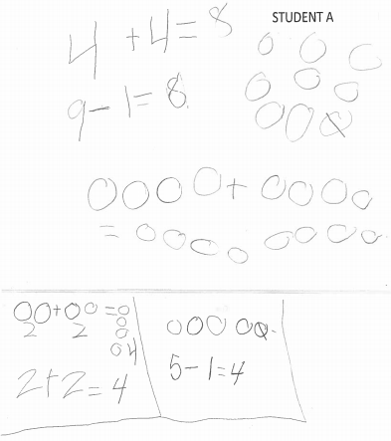



# Student B

# How can they be equal?

# First graders were working with the numbers 1 - 9.

# Emma chose two numbers and added them.

# Mike chose two numbers and subtracted them.

# They both ended with the same amount.

# What numbers could Emma and Mike have used?

*Show your thinking using pictures, numbers and/or words.*

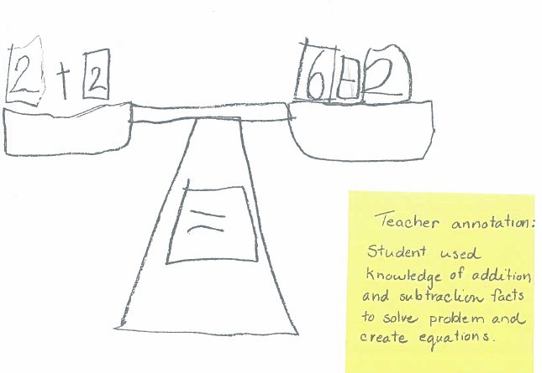

# Student B (continued)

# How can they be equal?

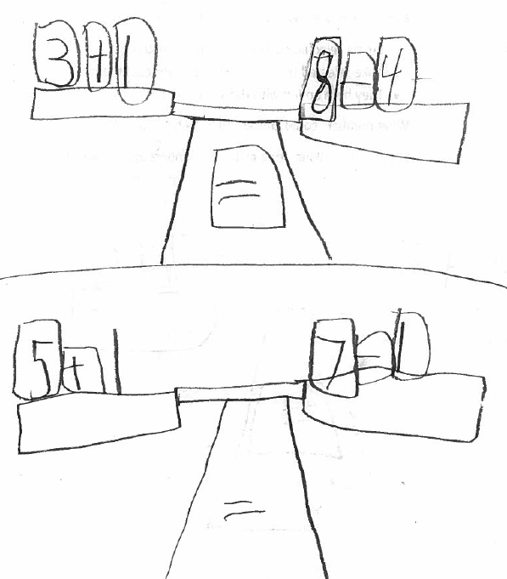

# Student C

# How can they be equal?

# First graders were working with the numbers 1 - 9.

# Emma chose two numbers and added them.

# Mike chose two numbers and subtracted them.

# They both ended with the same amount.

# What numbers could Emma and Mike have used?

*Show your thinking using pictures, numbers and/or words.*

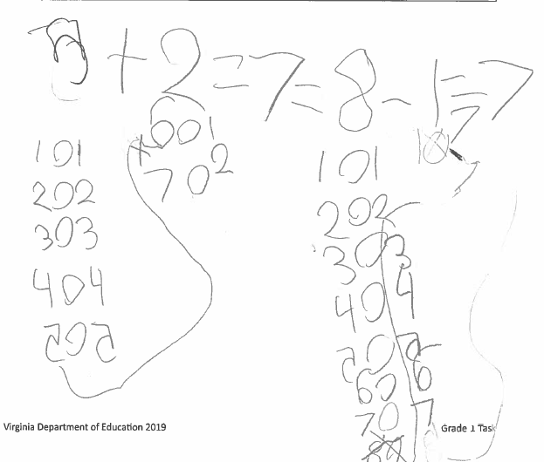

Student D (continued)

# Student C (continued)

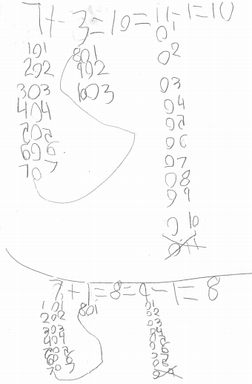

# Student D

# How can they be equal?

# First graders were working with the numbers 1 - 9.

# Emma chose two numbers and added them.

# Mike chose two numbers and subtracted them.

# They both ended with the same amount.

# What numbers could Emma and Mike have used?

*Show your thinking using pictures, numbers and/or words.*

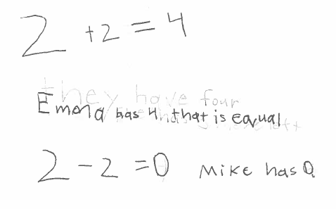

**Student E**

# How can they be equal?

# First graders were working with the numbers 1 - 9.

# Emma chose two numbers and added them.

# Mike chose two numbers and subtracted them.

# They both ended with the same amount.

# What numbers could Emma and Mike have used?

*Show your thinking using pictures, numbers and/or words.*

