Elementary Mathematics Cognitive Demand Task Sort
TASK | High or Low
- Joe saved $121. He saved $63 less than Melvin. How much did Melvin save?
- Sam and Eliza are trying to make a decimal number as close to 70 as possible using the digits 1, 6, 7, 9. Sam wrote the number 71.69. Eliza thinks she can get even closer to 70. Do you agree or disagree? Explain.
- This line plot shows the number of letters in the names of 7 students.
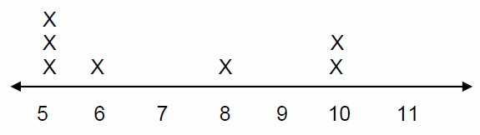
How many people have more than five letters in their name?

- Susan bought 12 flowers. Three-fourths of them were white. How many white flowers did she buy?
- First graders were working with the numbers 1-9.
- Emma chose two numbers and added them.
- Mike chose two numbers and subtracted them.
- They both ended with the same amount.
What numbers could Emma and Mike have used?
Show your thinking using pictures, numbers, and/or words.
- A group of children bought a present for $30. They paid $5 each. How many children were there in the group?
- You will take a bus trip across the country to see a professional football game. You have a choice of two buses. (Both bus trips will arrive the day before the game.)
- Bus A departs at 7:47 am and arrives at 8:14 pm.
- Bus B is 12 hours and 53 minutes in length.
Both trips cost $200. Which bus would you choose, Bus A or Bus B? Why?
Show your thinking using pictures, words, and symbols.
- Order the following decimals from greatest to least.

2.06 2.6 2.601
- Roger plans to buy 5 dozen donuts for the school picnic at $1.25 per dozen. How much change will Roger receive if he pays with a $10 bill?
- Put an x on the number line about where 5/3 would be located.
Explain why you put your x where you did.

│-----------------------------------------------------│
1 2
- Illustrate the product of 4 times 3 on a number line.
- Which is bigger 3/3 or 3/6? How do you know?
- Create a model of a box of marbles where the probability of selecting a black marble is $\frac{4}{8}$. Explain your reasoning.

Characteristics of High Level Tasks: | Characteristics of Low Level Tasks:

